Software Requirements Specification (SRS)

Booking Platform REST API — EN2H Technical Assessment
Date: 9 July 2026 Stack: NestJS, TypeScript, PostgreSQL, Prisma ORM, JWT

1. Introduction

1.1 Purpose
This document specifies the functional and non-functional requirements for a Booking Platform REST API. The platform lets authenticated users manage services and lets customers (authenticated or not) create and manage bookings against those services.

1.2 Scope
The system exposes a REST API only. It covers:
- User registration and login (JWT authentication)
- Service CRUD, restricted to authenticated users
- Booking CRUD, with public booking creation and protected booking management

1.3 Definitions
Term | Meaning
User | A registered account holder who manages services (e.g. a business owner or staff member)
Customer | The person a booking is made for. Not a User account, just name/email/phone on the Booking record
Service | A bookable offering (e.g. "Haircut — 30 min — LKR 1500")
Booking | A reservation of a Service by a Customer for a specific date/time

2. Overall Description

2.1 Actors
- Guest - unauthenticated caller. Can register, log in, view services, and create a booking.
- Registered user - authenticated via JWT. Can additionally create/update/delete services and manage all bookings (view, update status, cancel).

2.2 Assumptions
- There is a single class of registered user (no admin/staff role split).
- A Service optionally records which user created it (createdById), for traceability, but any authenticated user can manage any service.
- Booking read/update endpoints require authentication, since the spec only explicitly makes creation public ("Customers can create bookings without authentication").
- Timezone: all bookingDate/bookingTime are stored and compared in UTC.

3. Use Case Diagram
The diagram above shows the two actors and the eight use cases. Registered users inherit every Guest use case plus service and booking management.

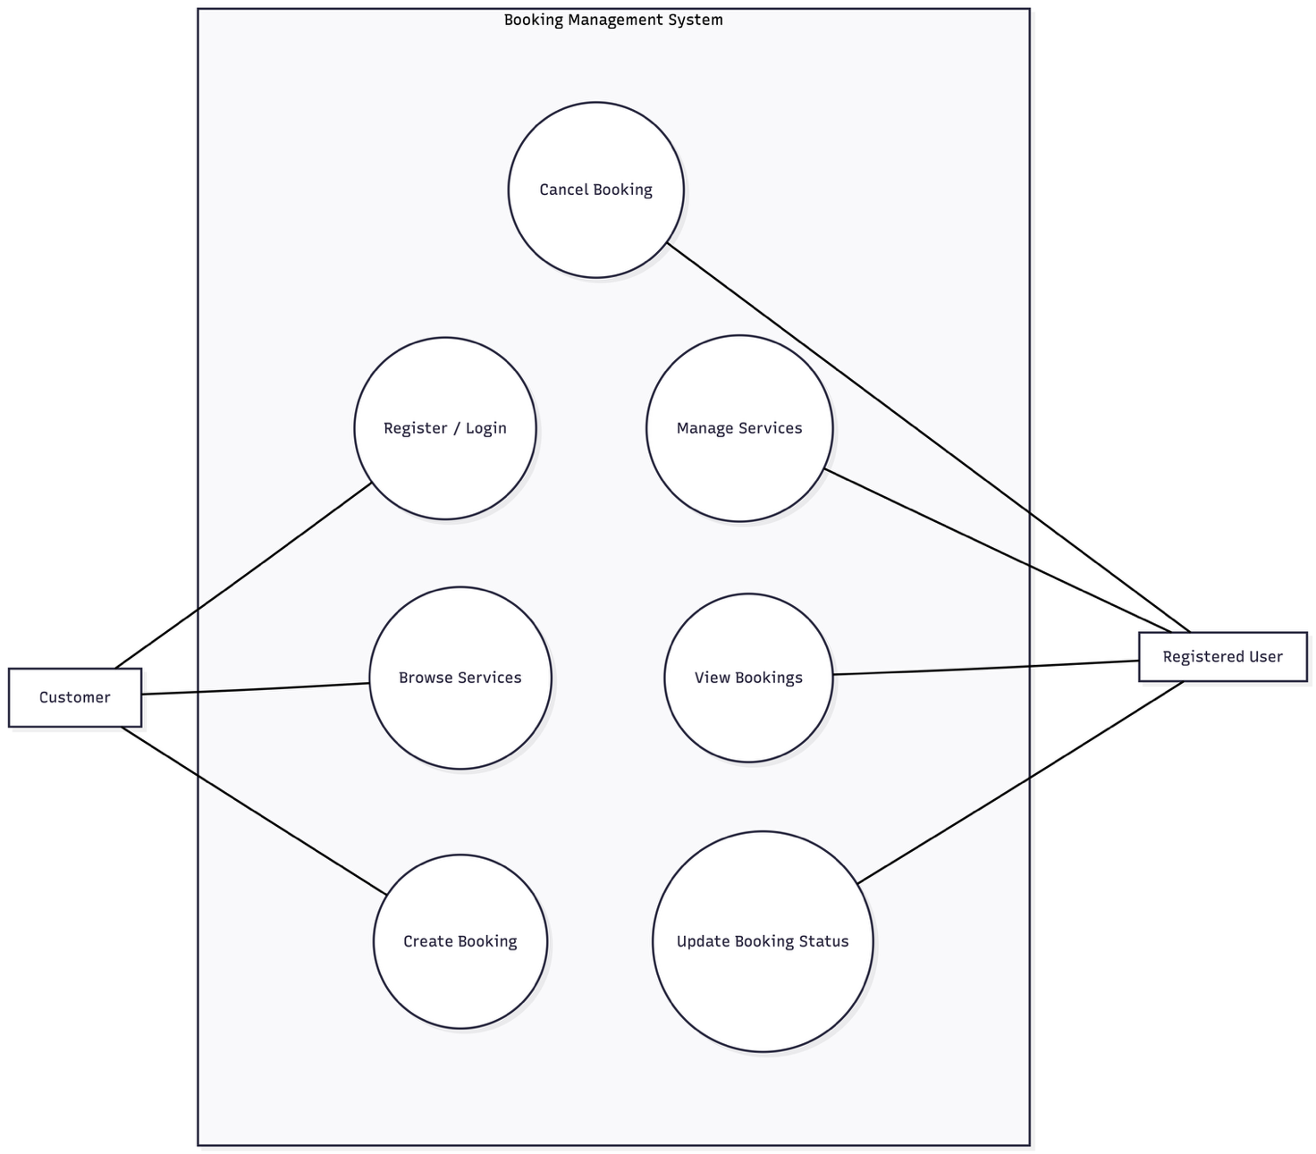

4. Entity-Relationship Diagram
Shown above. Summary:
- User (1) - Service (many): a user may create many services (createdById, nullable to keep service creation decoupled from a hard ownership constraint if the field is dropped later).
- Service (1) - Booking (many): a booking must reference exactly one existing service (serviceId, onDelete: Restrict - User cannot delete a service that has bookings, which protects booking history integrity).
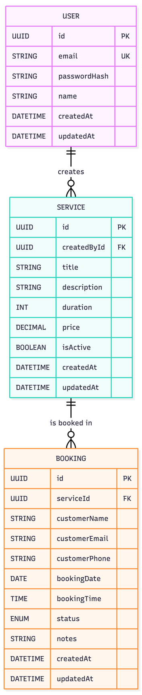

5. System Architecture

