|  |  |  |  |  |  |  |  |  |  |  |
| --- | --- | --- | --- | --- | --- | --- | --- | --- | --- | --- |
| |  |  |  | | --- | --- | --- | |  |  |  | | МИНОБРНАУКИ РОССИИ | | | | Федеральное государственное бюджетное образовательное учреждение  высшего образования  **«МИРЭА – Российский технологический университет»**  **РТУ МИРЭА** | | |   Институт Информационных технологий | |
|  | |
| Кафедра Математического обеспечения и стандартизации информационных технологий | |
|  | |
|  | |

|  |  |
| --- | --- |
| **Практическая работа № 4** | |
| **по дисциплине** | |
| **«**Конфигурационное управление**»** | |
|  | |
| Выполнил студент группы | . |
| Принял преподаватель | . |

|  |  |  |
| --- | --- | --- |
| Лабораторная работа выполнена | «__»_______202__ г. | *(подпись студента)* |
|  |  |  |
| «Зачтено» | «__»_______202__ г. | *(подпись руководителя)* |

Москва 2023

**Оглавление**

**Задача 1** 5

**Задача 2** 11

**Задача 3** 19

**Задача 4** 28

Создать приведенный Makefile и проверить его работоспособность.

|  |
| --- |
| dress: trousers shoes jacket  @echo "All done. Let's go outside!"  jacket: pullover  @echo "Putting on jacket."  pullover: shirt  @echo "Putting on pullover."  shirt:  @echo "Putting on shirt."  trousers: underpants  @echo "Putting on trousers."  underpants:  @echo "Putting on underpants."  shoes: socks  @echo "Putting on shoes."  socks: pullover  @echo "Putting on socks." |

Визуализировать файл [civgraph.txt](https://github.com/true-grue/kisscm/blob/main/pract/civgraph.txt).

***Решение:***

Тестирование примера dress:

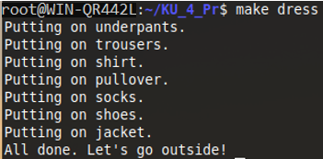

Подготовленный Makefile для civgraph.txt:

|  |
| --- |
| **dress**: **trousers shoes jacket**  @echo "All done. Let's go outside!"  **jacket**: **pullover**  @echo "Putting on jacket."  **pullover**: **shirt**  @echo "Putting on pullover."  **shirt**:  @echo "Putting on shirt."  **trousers**: **underpants**  @echo "Putting on trousers."  **underpants**:  @echo "Putting on underpants."  **shoes**: **socks**  @echo "Putting on shoes."  **socks**: **pullover**  @echo "Putting on socks."  **cv**:  dot -Tpng -O civgraph.gv  open civgraph.gv.png |

Тестирование для civgraph.txt:

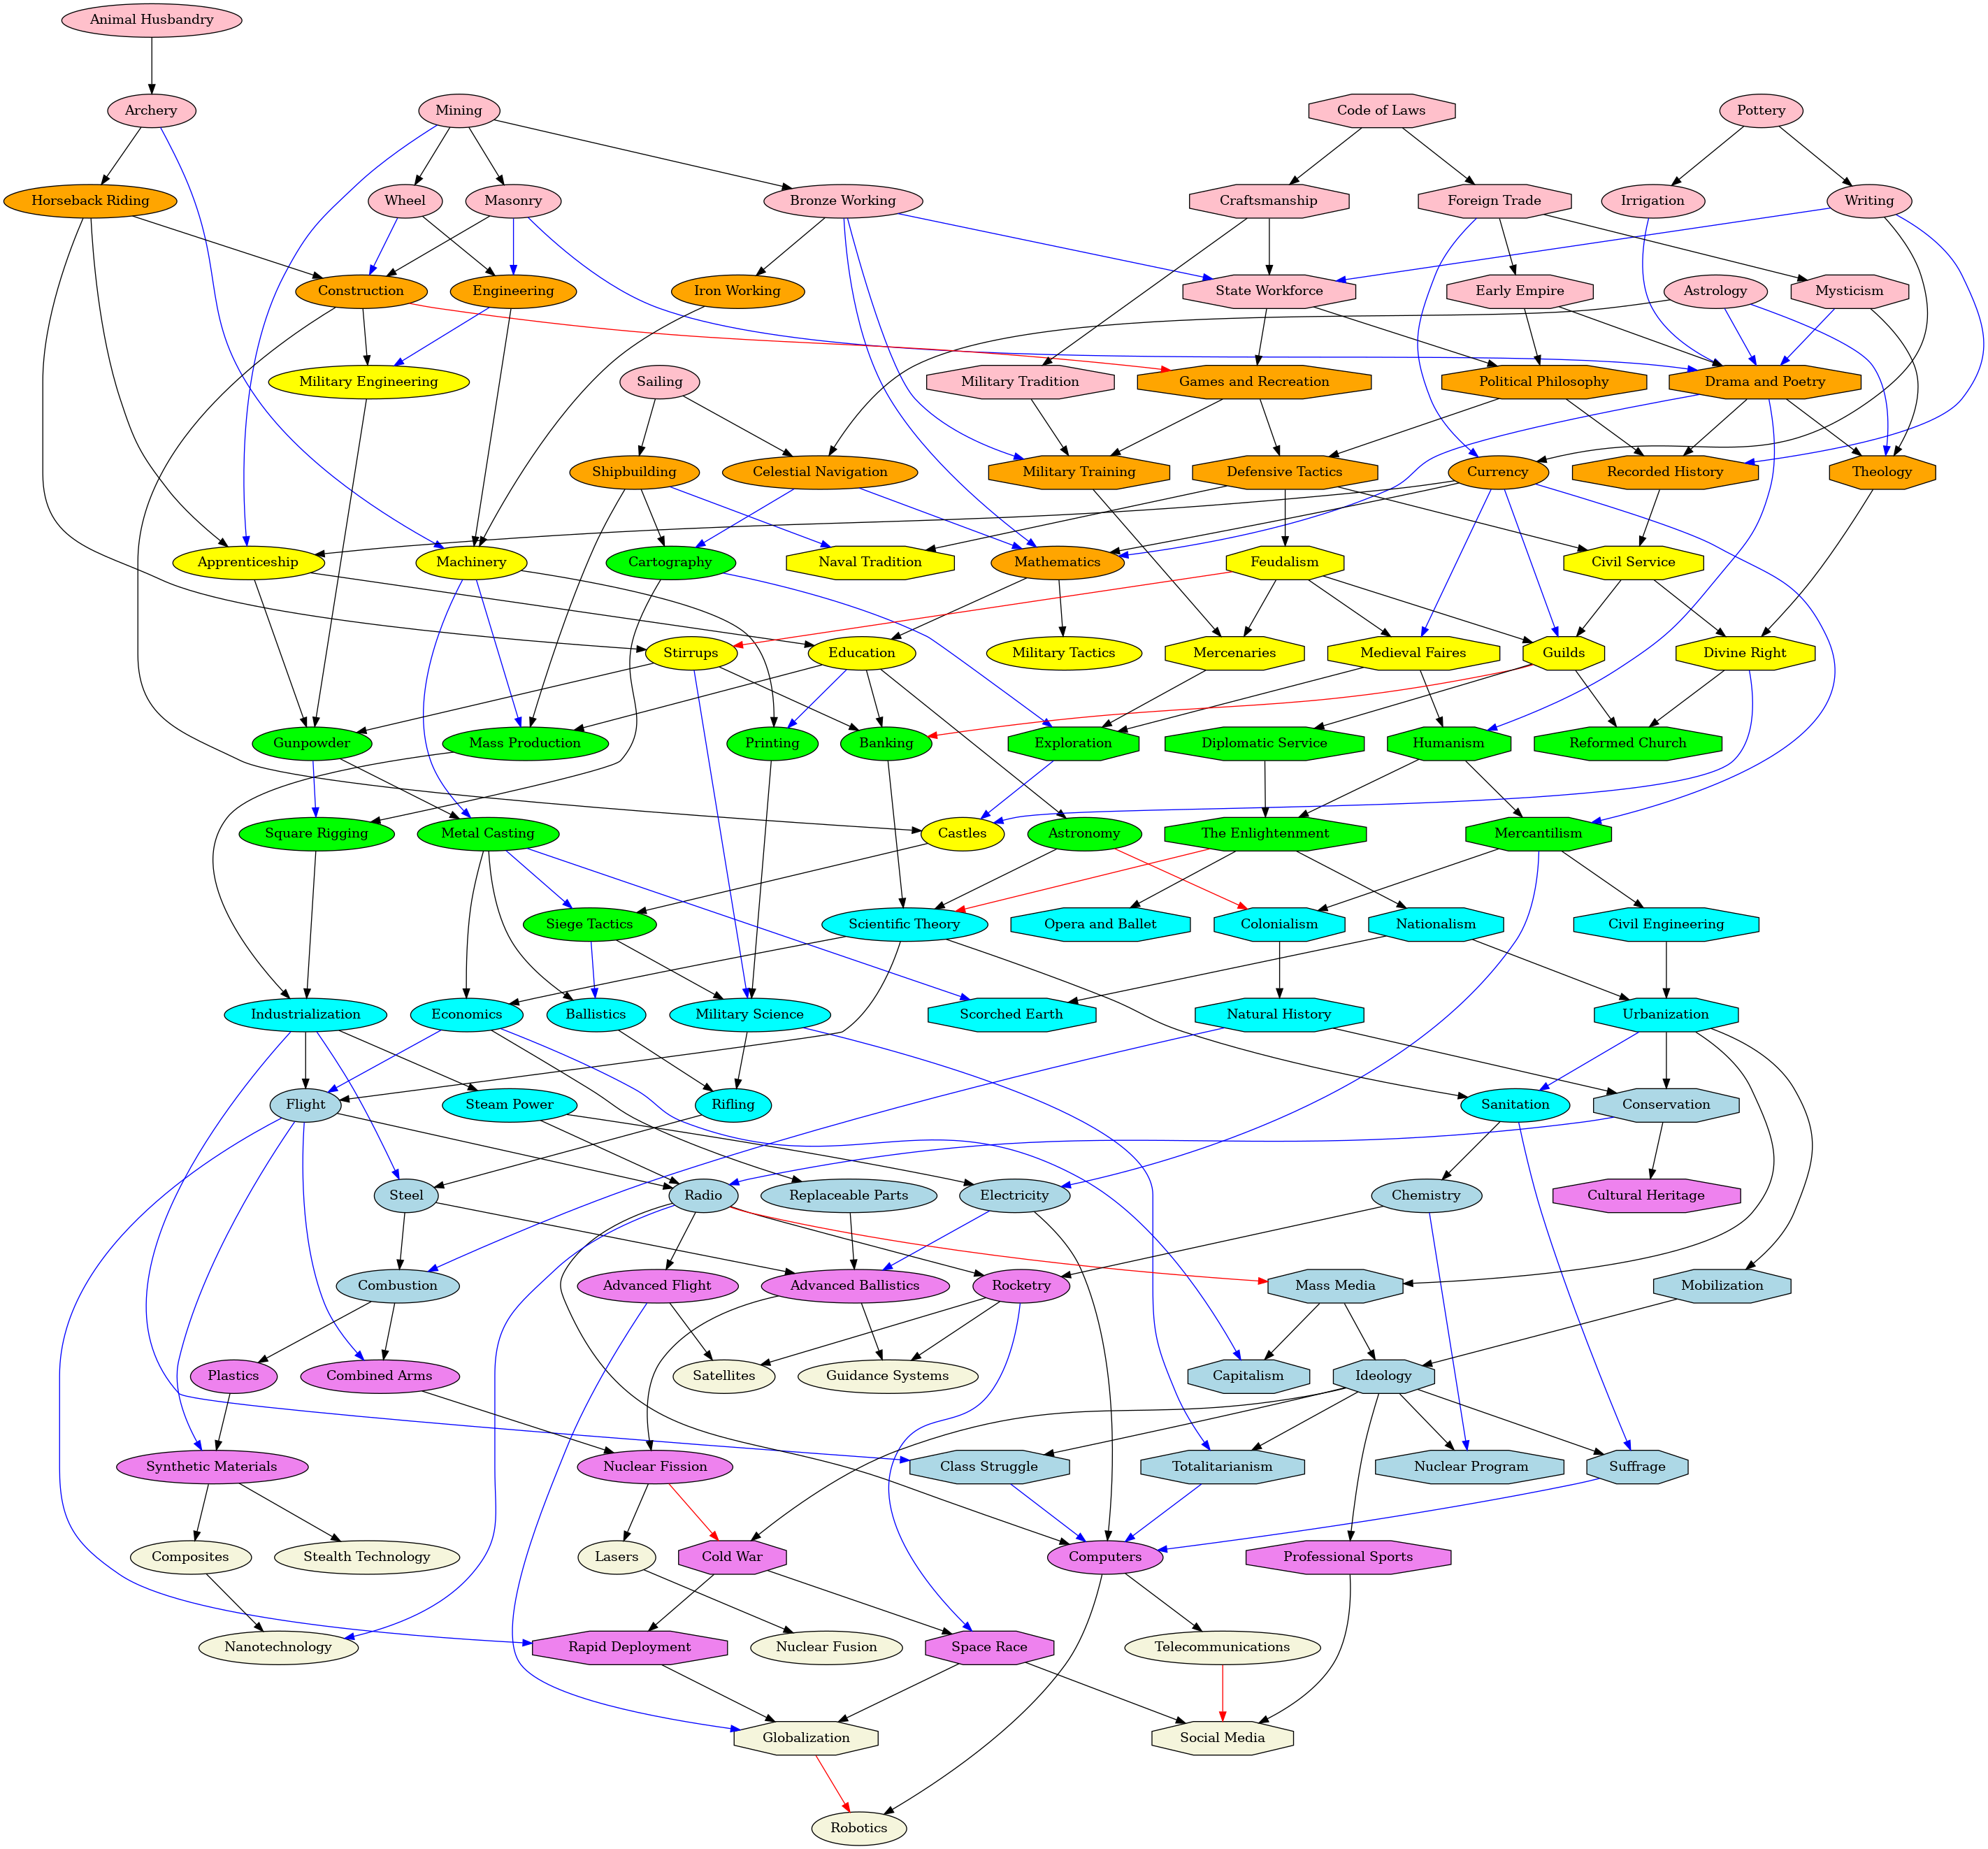

# **Задача 1**

Написать программу на Питоне, которая транслирует граф зависимостей civgraph в makefile в духе примера выше. Для мало знакомых с Питоном используется упрощенный вариант civgraph: [civgraph.json](https://github.com/true-grue/kisscm/blob/main/pract/civgraph.json).

***Решение:***

Python-код генератора Makefile:

|  |
| --- |
| json = {"pottery": [], "irrigation": ["pottery"], "writing": ["pottery"], "animal_husbandry": [], "archery": ["animal_husbandry"], "mining": [], "masonry": ["mining"], "bronze_working": ["mining"], "the_wheel": ["mining"], "apprenticeship": ["mining", "currency", "horseback_riding"], "sailing": [], "celestial_navigation": ["sailing", "astrology"], "shipbuilding": ["sailing"], "astrology": [], "drama_poetry": ["astrology", "irrigation", "masonry", "early_empire", "mysticism"], "theology": ["astrology", "mysticism", "drama_poetry"], "horseback_riding": ["archery"], "machinery": ["archery", "iron_working", "engineering"], "currency": ["writing", "foreign_trade"], "state_workforce": ["writing", "bronze_working", "craftsmanship"], "recorded_history": ["writing", "political_philosophy", "drama_poetry"], "construction": ["masonry", "the_wheel", "horseback_riding"], "engineering": ["masonry", "the_wheel"], "iron_working": ["bronze_working"], "mathematics": ["bronze_working", "celestial_navigation", "currency", "drama_poetry"], "military_training": ["bronze_working", "military_tradition", "games_recreation"], "cartography": ["celestial_navigation", "shipbuilding"], "medieval_faires": ["currency", "feudalism"], "guilds": ["currency", "feudalism", "civil_service"], "mercantilism": ["currency", "humanism"], "stirrups": ["horseback_riding", "feudalism"], "mass_production": ["shipbuilding", "machinery", "education"], "naval_tradition": ["shipbuilding", "defensive_tactics"], "military_tactics": ["mathematics"], "education": ["mathematics", "apprenticeship"], "military_engineering": ["construction", "engineering"], "castles": ["construction", "divine_right", "exploration"], "games_recreation": ["construction", "state_workforce"], "gunpowder": ["apprenticeship", "stirrups", "military_engineering"], "printing": ["machinery", "education"], "metal_casting": ["machinery", "gunpowder"], "banking": ["education", "stirrups", "guilds"], "astronomy": ["education"], "military_science": ["stirrups", "printing", "siege_tactics"], "siege_tactics": ["castles", "metal_casting"], "square_rigging": ["cartography", "gunpowder"], "exploration": ["cartography", "mercenaries", "medieval_faires"], "industrialization": ["mass_production", "square_rigging"], "scientific_theory": ["banking", "astronomy", "the_enlightenment"], "colonialism": ["astronomy", "mercantilism"], "ballistics": ["metal_casting", "siege_tactics"], "economics": ["metal_casting", "scientific_theory"], "scorched_earth": ["metal_casting", "nationalism"], "steam_power": ["industrialization"], "flight": ["industrialization", "scientific_theory", "economics"], "steel": ["industrialization", "rifling"], "class_struggle": ["industrialization", "ideology"], "sanitation": ["scientific_theory", "urbanization"], "rifling": ["ballistics", "military_science"], "totalitarianism": ["military_science", "ideology"], "electricity": ["steam_power", "mercantilism"], "radio": ["steam_power", "flight", "conservation"], "chemistry": ["sanitation"], "suffrage": ["sanitation", "ideology"], "replaceable_parts": ["economics"], "capitalism": ["economics", "mass_media"], "combined_arms": ["flight", "combustion"], "synthetic_materials": ["flight", "plastics"], "rapid_deployment": ["flight", "cold_war"], "advanced_ballistics": ["replaceable_parts", "steel", "electricity"], "combustion": ["steel", "natural_history"], "computers": ["electricity", "radio", "suffrage", "totalitarianism", "class_struggle"], "advanced_flight": ["radio"], "rocketry": ["radio", "chemistry"], "nanotechnology": ["radio", "composites"], "mass_media": ["radio", "urbanization"], "nuclear_program": ["chemistry", "ideology"], "plastics": ["combustion"], "satellites": ["advanced_flight", "rocketry"], "globalization": ["advanced_flight", "rapid_deployment", "space_race"], "guidance_systems": ["rocketry", "advanced_ballistics"], "space_race": ["rocketry", "cold_war"], "nuclear_fission": ["advanced_ballistics", "combined_arms"], "telecommunications": ["computers"], "robotics": ["computers", "globalization"], "lasers": ["nuclear_fission"], "cold_war": ["nuclear_fission", "ideology"], "composites": ["synthetic_materials"], "stealth_technology": ["synthetic_materials"], "social_media": ["telecommunications", "professional_sports", "space_race"], "nuclear_fusion": ["lasers"], "code_of_laws": [], "craftsmanship": ["code_of_laws"], "foreign_trade": ["code_of_laws"], "military_tradition": ["craftsmanship"], "early_empire": ["foreign_trade"], "mysticism": ["foreign_trade"], "political_philosophy": ["state_workforce", "early_empire"], "defensive_tactics": ["games_recreation", "political_philosophy"], "humanism": ["drama_poetry", "medieval_faires"], "mercenaries": ["military_training", "feudalism"], "feudalism": ["defensive_tactics"], "civil_service": ["defensive_tactics", "recorded_history"], "divine_right": ["theology", "civil_service"], "diplomatic_service": ["guilds"], "reformed_church": ["guilds", "divine_right"], "the_enlightenment": ["humanism", "diplomatic_service"], "civil_engineering": ["mercantilism"], "nationalism": ["the_enlightenment"], "opera_ballet": ["the_enlightenment"], "natural_history": ["colonialism"], "urbanization": ["civil_engineering", "nationalism"], "conservation": ["natural_history", "urbanization"], "mobilization": ["urbanization"], "cultural_heritage": ["conservation"], "ideology": ["mass_media", "mobilization"], "professional_sports": ["ideology"]}  f = open("Makefile","w")  content = ""  **for** key **in** json:  content = content + key[:len(key)] + ":" + " ".join(json[key])+"**\n**"  content = content + "**\t**"+ "@echo " + key + "**\n**"  f.write(content)  f.close() |

Сформированный Makefile:

|  |
| --- |
| **pottery**:  @echo pottery  **irrigation**:**pottery**  @echo irrigation  **writing**:**pottery**  @echo writing  **animal_husbandry**:  @echo animal_husbandry  **archery**:**animal_husbandry**  @echo archery  **mining**:  @echo mining  **masonry**:**mining**  @echo masonry  **bronze_working**:**mining**  @echo bronze_working  **the_wheel**:**mining**  @echo the_wheel  **apprenticeship**:**mining currency horseback_riding**  @echo apprenticeship  **sailing**:  @echo sailing  **celestial_navigation**:**sailing astrology**  @echo celestial_navigation  **shipbuilding**:**sailing**  @echo shipbuilding  **astrology**:  @echo astrology  **drama_poetry**:**astrology irrigation masonry early_empire mysticism**  @echo drama_poetry  **theology**:**astrology mysticism drama_poetry**  @echo theology  **horseback_riding**:**archery**  @echo horseback_riding  **machinery**:**archery iron_working engineering**  @echo machinery  **currency**:**writing foreign_trade**  @echo currency  **state_workforce**:**writing bronze_working craftsmanship**  @echo state_workforce  **recorded_history**:**writing political_philosophy drama_poetry**  @echo recorded_history  **construction**:**masonry the_wheel horseback_riding**  @echo construction  **engineering**:**masonry the_wheel**  @echo engineering  **iron_working**:**bronze_working**  @echo iron_working  **mathematics**:**bronze_working celestial_navigation currency drama_poetry**  @echo mathematics  **military_training**:**bronze_working military_tradition games_recreation**  @echo military_training  **cartography**:**celestial_navigation shipbuilding**  @echo cartography  **medieval_faires**:**currency feudalism**  @echo medieval_faires  **guilds**:**currency feudalism civil_service**  @echo guilds  **mercantilism**:**currency humanism**  @echo mercantilism  **stirrups**:**horseback_riding feudalism**  @echo stirrups  **mass_production**:**shipbuilding machinery education**  @echo mass_production  **naval_tradition**:**shipbuilding defensive_tactics**  @echo naval_tradition  **military_tactics**:**mathematics**  @echo military_tactics  **education**:**mathematics apprenticeship**  @echo education  **military_engineering**:**construction engineering**  @echo military_engineering  **castles**:**construction divine_right exploration**  @echo castles  **games_recreation**:**construction state_workforce**  @echo games_recreation  **gunpowder**:**apprenticeship stirrups military_engineering**  @echo gunpowder  **printing**:**machinery education**  @echo printing  **metal_casting**:**machinery gunpowder**  @echo metal_casting  **banking**:**education stirrups guilds**  @echo banking  **astronomy**:**education**  @echo astronomy  **military_science**:**stirrups printing siege_tactics**  @echo military_science  **siege_tactics**:**castles metal_casting**  @echo siege_tactics  **square_rigging**:**cartography gunpowder**  @echo square_rigging  **exploration**:**cartography mercenaries medieval_faires**  @echo exploration  **industrialization**:**mass_production square_rigging**  @echo industrialization  **scientific_theory**:**banking astronomy the_enlightenment**  @echo scientific_theory  **colonialism**:**astronomy mercantilism**  @echo colonialism  **ballistics**:**metal_casting siege_tactics**  @echo ballistics  **economics**:**metal_casting scientific_theory**  @echo economics  **scorched_earth**:**metal_casting nationalism**  @echo scorched_earth  **steam_power**:**industrialization**  @echo steam_power  **flight**:**industrialization scientific_theory economics**  @echo flight  **steel**:**industrialization rifling**  @echo steel  **class_struggle**:**industrialization ideology**  @echo class_struggle  **sanitation**:**scientific_theory urbanization**  @echo sanitation  **rifling**:**ballistics military_science**  @echo rifling  **totalitarianism**:**military_science ideology**  @echo totalitarianism  **electricity**:**steam_power mercantilism**  @echo electricity  **radio**:**steam_power flight conservation**  @echo radio  **chemistry**:**sanitation**  @echo chemistry  **suffrage**:**sanitation ideology**  @echo suffrage  **replaceable_parts**:**economics**  @echo replaceable_parts  **capitalism**:**economics mass_media**  @echo capitalism  **combined_arms**:**flight combustion**  @echo combined_arms  **synthetic_materials**:**flight plastics**  @echo synthetic_materials  **rapid_deployment**:**flight cold_war**  @echo rapid_deployment  **advanced_ballistics**:**replaceable_parts steel electricity**  @echo advanced_ballistics  **combustion**:**steel natural_history**  @echo combustion  **computers**:**electricity radio suffrage totalitarianism class_struggle**  @echo computers  **advanced_flight**:**radio**  @echo advanced_flight  **rocketry**:**radio chemistry**  @echo rocketry  **nanotechnology**:**radio composites**  @echo nanotechnology  **mass_media**:**radio urbanization**  @echo mass_media  **nuclear_program**:**chemistry ideology**  @echo nuclear_program  **plastics**:**combustion**  @echo plastics  **satellites**:**advanced_flight rocketry**  @echo satellites  **globalization**:**advanced_flight rapid_deployment space_race**  @echo globalization  **guidance_systems**:**rocketry advanced_ballistics**  @echo guidance_systems  **space_race**:**rocketry cold_war**  @echo space_race  **nuclear_fission**:**advanced_ballistics combined_arms**  @echo nuclear_fission  **telecommunications**:**computers**  @echo telecommunications  **robotics**:**computers globalization**  @echo robotics  **lasers**:**nuclear_fission**  @echo lasers  **cold_war**:**nuclear_fission ideology**  @echo cold_war  **composites**:**synthetic_materials**  @echo composites  **stealth_technology**:**synthetic_materials**  @echo stealth_technology  **social_media**:**telecommunications professional_sports space_race**  @echo social_media  **nuclear_fusion**:**lasers**  @echo nuclear_fusion  **code_of_laws**:  @echo code_of_laws  **craftsmanship**:**code_of_laws**  @echo craftsmanship  **foreign_trade**:**code_of_laws**  @echo foreign_trade  **military_tradition**:**craftsmanship**  @echo military_tradition  **early_empire**:**foreign_trade**  @echo early_empire  **mysticism**:**foreign_trade**  @echo mysticism  **political_philosophy**:**state_workforce early_empire**  @echo political_philosophy  **defensive_tactics**:**games_recreation political_philosophy**  @echo defensive_tactics  **humanism**:**drama_poetry medieval_faires**  @echo humanism  **mercenaries**:**military_training feudalism**  @echo mercenaries  **feudalism**:**defensive_tactics**  @echo feudalism  **civil_service**:**defensive_tactics recorded_history**  @echo civil_service  **divine_right**:**theology civil_service**  @echo divine_right  **diplomatic_service**:**guilds**  @echo diplomatic_service  **reformed_church**:**guilds divine_right**  @echo reformed_church  **the_enlightenment**:**humanism diplomatic_service**  @echo the_enlightenment  **civil_engineering**:**mercantilism**  @echo civil_engineering  **nationalism**:**the_enlightenment**  @echo nationalism  **opera_ballet**:**the_enlightenment**  @echo opera_ballet  **natural_history**:**colonialism**  @echo natural_history  **urbanization**:**civil_engineering nationalism**  @echo urbanization  **conservation**:**natural_history urbanization**  @echo conservation  **mobilization**:**urbanization**  @echo mobilization  **cultural_heritage**:**conservation**  @echo cultural_heritage  **ideology**:**mass_media mobilization**  @echo ideology  **professional_sports**:**ideology**  @echo professional_sports |

Тестирование посредством сборки для “mathematics”: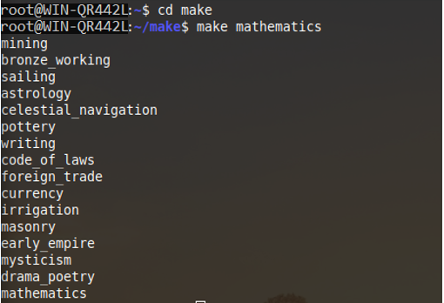

# **Задача 2**

Реализовать вариант трансляции, при котором повторный запуск make не выводит для civgraph на экран уже выполненные "задачи".

***Решение:***

Python-код генератора Makefile:

|  |
| --- |
| json = {"pottery": [], "irrigation": ["pottery"], "writing": ["pottery"], "animal_husbandry": [], "archery": ["animal_husbandry"], "mining": [], "masonry": ["mining"], "bronze_working": ["mining"], "the_wheel": ["mining"], "apprenticeship": ["mining", "currency", "horseback_riding"], "sailing": [], "celestial_navigation": ["sailing", "astrology"], "shipbuilding": ["sailing"], "astrology": [], "drama_poetry": ["astrology", "irrigation", "masonry", "early_empire", "mysticism"], "theology": ["astrology", "mysticism", "drama_poetry"], "horseback_riding": ["archery"], "machinery": ["archery", "iron_working", "engineering"], "currency": ["writing", "foreign_trade"], "state_workforce": ["writing", "bronze_working", "craftsmanship"], "recorded_history": ["writing", "political_philosophy", "drama_poetry"], "construction": ["masonry", "the_wheel", "horseback_riding"], "engineering": ["masonry", "the_wheel"], "iron_working": ["bronze_working"], "mathematics": ["bronze_working", "celestial_navigation", "currency", "drama_poetry"], "military_training": ["bronze_working", "military_tradition", "games_recreation"], "cartography": ["celestial_navigation", "shipbuilding"], "medieval_faires": ["currency", "feudalism"], "guilds": ["currency", "feudalism", "civil_service"], "mercantilism": ["currency", "humanism"], "stirrups": ["horseback_riding", "feudalism"], "mass_production": ["shipbuilding", "machinery", "education"], "naval_tradition": ["shipbuilding", "defensive_tactics"], "military_tactics": ["mathematics"], "education": ["mathematics", "apprenticeship"], "military_engineering": ["construction", "engineering"], "castles": ["construction", "divine_right", "exploration"], "games_recreation": ["construction", "state_workforce"], "gunpowder": ["apprenticeship", "stirrups", "military_engineering"], "printing": ["machinery", "education"], "metal_casting": ["machinery", "gunpowder"], "banking": ["education", "stirrups", "guilds"], "astronomy": ["education"], "military_science": ["stirrups", "printing", "siege_tactics"], "siege_tactics": ["castles", "metal_casting"], "square_rigging": ["cartography", "gunpowder"], "exploration": ["cartography", "mercenaries", "medieval_faires"], "industrialization": ["mass_production", "square_rigging"], "scientific_theory": ["banking", "astronomy", "the_enlightenment"], "colonialism": ["astronomy", "mercantilism"], "ballistics": ["metal_casting", "siege_tactics"], "economics": ["metal_casting", "scientific_theory"], "scorched_earth": ["metal_casting", "nationalism"], "steam_power": ["industrialization"], "flight": ["industrialization", "scientific_theory", "economics"], "steel": ["industrialization", "rifling"], "class_struggle": ["industrialization", "ideology"], "sanitation": ["scientific_theory", "urbanization"], "rifling": ["ballistics", "military_science"], "totalitarianism": ["military_science", "ideology"], "electricity": ["steam_power", "mercantilism"], "radio": ["steam_power", "flight", "conservation"], "chemistry": ["sanitation"], "suffrage": ["sanitation", "ideology"], "replaceable_parts": ["economics"], "capitalism": ["economics", "mass_media"], "combined_arms": ["flight", "combustion"], "synthetic_materials": ["flight", "plastics"], "rapid_deployment": ["flight", "cold_war"], "advanced_ballistics": ["replaceable_parts", "steel", "electricity"], "combustion": ["steel", "natural_history"], "computers": ["electricity", "radio", "suffrage", "totalitarianism", "class_struggle"], "advanced_flight": ["radio"], "rocketry": ["radio", "chemistry"], "nanotechnology": ["radio", "composites"], "mass_media": ["radio", "urbanization"], "nuclear_program": ["chemistry", "ideology"], "plastics": ["combustion"], "satellites": ["advanced_flight", "rocketry"], "globalization": ["advanced_flight", "rapid_deployment", "space_race"], "guidance_systems": ["rocketry", "advanced_ballistics"], "space_race": ["rocketry", "cold_war"], "nuclear_fission": ["advanced_ballistics", "combined_arms"], "telecommunications": ["computers"], "robotics": ["computers", "globalization"], "lasers": ["nuclear_fission"], "cold_war": ["nuclear_fission", "ideology"], "composites": ["synthetic_materials"], "stealth_technology": ["synthetic_materials"], "social_media": ["telecommunications", "professional_sports", "space_race"], "nuclear_fusion": ["lasers"], "code_of_laws": [], "craftsmanship": ["code_of_laws"], "foreign_trade": ["code_of_laws"], "military_tradition": ["craftsmanship"], "early_empire": ["foreign_trade"], "mysticism": ["foreign_trade"], "political_philosophy": ["state_workforce", "early_empire"], "defensive_tactics": ["games_recreation", "political_philosophy"], "humanism": ["drama_poetry", "medieval_faires"], "mercenaries": ["military_training", "feudalism"], "feudalism": ["defensive_tactics"], "civil_service": ["defensive_tactics", "recorded_history"], "divine_right": ["theology", "civil_service"], "diplomatic_service": ["guilds"], "reformed_church": ["guilds", "divine_right"], "the_enlightenment": ["humanism", "diplomatic_service"], "civil_engineering": ["mercantilism"], "nationalism": ["the_enlightenment"], "opera_ballet": ["the_enlightenment"], "natural_history": ["colonialism"], "urbanization": ["civil_engineering", "nationalism"], "conservation": ["natural_history", "urbanization"], "mobilization": ["urbanization"], "cultural_heritage": ["conservation"], "ideology": ["mass_media", "mobilization"], "professional_sports": ["ideology"]}  f = open("Makefile","w")  content = ""  **for** key **in** json:  content = content + key[:len(key)] + ": " + " ".join(json[key])+"**\n**"  content = content + "**\t**"+ "@echo " + key + "**\n**"  content = content + "**\t**"+ "@echo " + " ".join(json[key]) + " > " + key + "**\n**"  f.write(content)  f.close() |

Сформированный Makefile:

|  |
| --- |
| **pottery**:  @echo pottery  @echo > pottery  **irrigation**: **pottery**  @echo irrigation  @echo pottery > irrigation  **writing**: **pottery**  @echo writing  @echo pottery > writing  **animal_husbandry**:  @echo animal_husbandry  @echo > animal_husbandry  **archery**: **animal_husbandry**  @echo archery  @echo animal_husbandry > archery  **mining**:  @echo mining  @echo > mining  **masonry**: **mining**  @echo masonry  @echo mining > masonry  **bronze_working**: **mining**  @echo bronze_working  @echo mining > bronze_working  **the_wheel**: **mining**  @echo the_wheel  @echo mining > the_wheel  **apprenticeship**: **mining currency horseback_riding**  @echo apprenticeship  @echo mining currency horseback_riding > apprenticeship  **sailing**:  @echo sailing  @echo > sailing  **celestial_navigation**: **sailing astrology**  @echo celestial_navigation  @echo sailing astrology > celestial_navigation  **shipbuilding**: **sailing**  @echo shipbuilding  @echo sailing > shipbuilding  **astrology**:  @echo astrology  @echo > astrology  **drama_poetry**: **astrology irrigation masonry early_empire mysticism**  @echo drama_poetry  @echo astrology irrigation masonry early_empire mysticism > drama_poetry  **theology**: **astrology mysticism drama_poetry**  @echo theology  @echo astrology mysticism drama_poetry > theology  **horseback_riding**: **archery**  @echo horseback_riding  @echo archery > horseback_riding  **machinery**: **archery iron_working engineering**  @echo machinery  @echo archery iron_working engineering > machinery  **currency**: **writing foreign_trade**  @echo currency  @echo writing foreign_trade > currency  **state_workforce**: **writing bronze_working craftsmanship**  @echo state_workforce  @echo writing bronze_working craftsmanship > state_workforce  **recorded_history**: **writing political_philosophy drama_poetry**  @echo recorded_history  @echo writing political_philosophy drama_poetry > recorded_history  **construction**: **masonry the_wheel horseback_riding**  @echo construction  @echo masonry the_wheel horseback_riding > construction  **engineering**: **masonry the_wheel**  @echo engineering  @echo masonry the_wheel > engineering  **iron_working**: **bronze_working**  @echo iron_working  @echo bronze_working > iron_working  **mathematics**: **bronze_working celestial_navigation currency drama_poetry**  @echo mathematics  @echo bronze_working celestial_navigation currency drama_poetry > mathematics  **military_training**: **bronze_working military_tradition games_recreation**  @echo military_training  @echo bronze_working military_tradition games_recreation > military_training  **cartography**: **celestial_navigation shipbuilding**  @echo cartography  @echo celestial_navigation shipbuilding > cartography  **medieval_faires**: **currency feudalism**  @echo medieval_faires  @echo currency feudalism > medieval_faires  **guilds**: **currency feudalism civil_service**  @echo guilds  @echo currency feudalism civil_service > guilds  **mercantilism**: **currency humanism**  @echo mercantilism  @echo currency humanism > mercantilism  **stirrups**: **horseback_riding feudalism**  @echo stirrups  @echo horseback_riding feudalism > stirrups  **mass_production**: **shipbuilding machinery education**  @echo mass_production  @echo shipbuilding machinery education > mass_production  **naval_tradition**: **shipbuilding defensive_tactics**  @echo naval_tradition  @echo shipbuilding defensive_tactics > naval_tradition  **military_tactics**: **mathematics**  @echo military_tactics  @echo mathematics > military_tactics  **education**: **mathematics apprenticeship**  @echo education  @echo mathematics apprenticeship > education  **military_engineering**: **construction engineering**  @echo military_engineering  @echo construction engineering > military_engineering  **castles**: **construction divine_right exploration**  @echo castles  @echo construction divine_right exploration > castles  **games_recreation**: **construction state_workforce**  @echo games_recreation  @echo construction state_workforce > games_recreation  **gunpowder**: **apprenticeship stirrups military_engineering**  @echo gunpowder  @echo apprenticeship stirrups military_engineering > gunpowder  **printing**: **machinery education**  @echo printing  @echo machinery education > printing  **metal_casting**: **machinery gunpowder**  @echo metal_casting  @echo machinery gunpowder > metal_casting  **banking**: **education stirrups guilds**  @echo banking  @echo education stirrups guilds > banking  **astronomy**: **education**  @echo astronomy  @echo education > astronomy  **military_science**: **stirrups printing siege_tactics**  @echo military_science  @echo stirrups printing siege_tactics > military_science  **siege_tactics**: **castles metal_casting**  @echo siege_tactics  @echo castles metal_casting > siege_tactics  **square_rigging**: **cartography gunpowder**  @echo square_rigging  @echo cartography gunpowder > square_rigging  **exploration**: **cartography mercenaries medieval_faires**  @echo exploration  @echo cartography mercenaries medieval_faires > exploration  **industrialization**: **mass_production square_rigging**  @echo industrialization  @echo mass_production square_rigging > industrialization  **scientific_theory**: **banking astronomy the_enlightenment**  @echo scientific_theory  @echo banking astronomy the_enlightenment > scientific_theory  **colonialism**: **astronomy mercantilism**  @echo colonialism  @echo astronomy mercantilism > colonialism  **ballistics**: **metal_casting siege_tactics**  @echo ballistics  @echo metal_casting siege_tactics > ballistics  **economics**: **metal_casting scientific_theory**  @echo economics  @echo metal_casting scientific_theory > economics  **scorched_earth**: **metal_casting nationalism**  @echo scorched_earth  @echo metal_casting nationalism > scorched_earth  **steam_power**: **industrialization**  @echo steam_power  @echo industrialization > steam_power  **flight**: **industrialization scientific_theory economics**  @echo flight  @echo industrialization scientific_theory economics > flight  **steel**: **industrialization rifling**  @echo steel  @echo industrialization rifling > steel  **class_struggle**: **industrialization ideology**  @echo class_struggle  @echo industrialization ideology > class_struggle  **sanitation**: **scientific_theory urbanization**  @echo sanitation  @echo scientific_theory urbanization > sanitation  **rifling**: **ballistics military_science**  @echo rifling  @echo ballistics military_science > rifling  **totalitarianism**: **military_science ideology**  @echo totalitarianism  @echo military_science ideology > totalitarianism  **electricity**: **steam_power mercantilism**  @echo electricity  @echo steam_power mercantilism > electricity  **radio**: **steam_power flight conservation**  @echo radio  @echo steam_power flight conservation > radio  **chemistry**: **sanitation**  @echo chemistry  @echo sanitation > chemistry  **suffrage**: **sanitation ideology**  @echo suffrage  @echo sanitation ideology > suffrage  **replaceable_parts**: **economics**  @echo replaceable_parts  @echo economics > replaceable_parts  **capitalism**: **economics mass_media**  @echo capitalism  @echo economics mass_media > capitalism  **combined_arms**: **flight combustion**  @echo combined_arms  @echo flight combustion > combined_arms  **synthetic_materials**: **flight plastics**  @echo synthetic_materials  @echo flight plastics > synthetic_materials  **rapid_deployment**: **flight cold_war**  @echo rapid_deployment  @echo flight cold_war > rapid_deployment  **advanced_ballistics**: **replaceable_parts steel electricity**  @echo advanced_ballistics  @echo replaceable_parts steel electricity > advanced_ballistics  **combustion**: **steel natural_history**  @echo combustion  @echo steel natural_history > combustion  **computers**: **electricity radio suffrage totalitarianism class_struggle**  @echo computers  @echo electricity radio suffrage totalitarianism class_struggle > computers  **advanced_flight**: **radio**  @echo advanced_flight  @echo radio > advanced_flight  **rocketry**: **radio chemistry**  @echo rocketry  @echo radio chemistry > rocketry  **nanotechnology**: **radio composites**  @echo nanotechnology  @echo radio composites > nanotechnology  **mass_media**: **radio urbanization**  @echo mass_media  @echo radio urbanization > mass_media  **nuclear_program**: **chemistry ideology**  @echo nuclear_program  @echo chemistry ideology > nuclear_program  **plastics**: **combustion**  @echo plastics  @echo combustion > plastics  **satellites**: **advanced_flight rocketry**  @echo satellites  @echo advanced_flight rocketry > satellites  **globalization**: **advanced_flight rapid_deployment space_race**  @echo globalization  @echo advanced_flight rapid_deployment space_race > globalization  **guidance_systems**: **rocketry advanced_ballistics**  @echo guidance_systems  @echo rocketry advanced_ballistics > guidance_systems  **space_race**: **rocketry cold_war**  @echo space_race  @echo rocketry cold_war > space_race  **nuclear_fission**: **advanced_ballistics combined_arms**  @echo nuclear_fission  @echo advanced_ballistics combined_arms > nuclear_fission  **telecommunications**: **computers**  @echo telecommunications  @echo computers > telecommunications  **robotics**: **computers globalization**  @echo robotics  @echo computers globalization > robotics  **lasers**: **nuclear_fission**  @echo lasers  @echo nuclear_fission > lasers  **cold_war**: **nuclear_fission ideology**  @echo cold_war  @echo nuclear_fission ideology > cold_war  **composites**: **synthetic_materials**  @echo composites  @echo synthetic_materials > composites  **stealth_technology**: **synthetic_materials**  @echo stealth_technology  @echo synthetic_materials > stealth_technology  **social_media**: **telecommunications professional_sports space_race**  @echo social_media  @echo telecommunications professional_sports space_race > social_media  **nuclear_fusion**: **lasers**  @echo nuclear_fusion  @echo lasers > nuclear_fusion  **code_of_laws**:  @echo code_of_laws  @echo > code_of_laws  **craftsmanship**: **code_of_laws**  @echo craftsmanship  @echo code_of_laws > craftsmanship  **foreign_trade**: **code_of_laws**  @echo foreign_trade  @echo code_of_laws > foreign_trade  **military_tradition**: **craftsmanship**  @echo military_tradition  @echo craftsmanship > military_tradition  **early_empire**: **foreign_trade**  @echo early_empire  @echo foreign_trade > early_empire  **mysticism**: **foreign_trade**  @echo mysticism  @echo foreign_trade > mysticism  **political_philosophy**: **state_workforce early_empire**  @echo political_philosophy  @echo state_workforce early_empire > political_philosophy  **defensive_tactics**: **games_recreation political_philosophy**  @echo defensive_tactics  @echo games_recreation political_philosophy > defensive_tactics  **humanism**: **drama_poetry medieval_faires**  @echo humanism  @echo drama_poetry medieval_faires > humanism  **mercenaries**: **military_training feudalism**  @echo mercenaries  @echo military_training feudalism > mercenaries  **feudalism**: **defensive_tactics**  @echo feudalism  @echo defensive_tactics > feudalism  **civil_service**: **defensive_tactics recorded_history**  @echo civil_service  @echo defensive_tactics recorded_history > civil_service  **divine_right**: **theology civil_service**  @echo divine_right  @echo theology civil_service > divine_right  **diplomatic_service**: **guilds**  @echo diplomatic_service  @echo guilds > diplomatic_service  **reformed_church**: **guilds divine_right**  @echo reformed_church  @echo guilds divine_right > reformed_church  **the_enlightenment**: **humanism diplomatic_service**  @echo the_enlightenment  @echo humanism diplomatic_service > the_enlightenment  **civil_engineering**: **mercantilism**  @echo civil_engineering  @echo mercantilism > civil_engineering  **nationalism**: **the_enlightenment**  @echo nationalism  @echo the_enlightenment > nationalism  **opera_ballet**: **the_enlightenment**  @echo opera_ballet  @echo the_enlightenment > opera_ballet  **natural_history**: **colonialism**  @echo natural_history  @echo colonialism > natural_history  **urbanization**: **civil_engineering nationalism**  @echo urbanization  @echo civil_engineering nationalism > urbanization  **conservation**: **natural_history urbanization**  @echo conservation  @echo natural_history urbanization > conservation  **mobilization**: **urbanization**  @echo mobilization  @echo urbanization > mobilization  **cultural_heritage**: **conservation**  @echo cultural_heritage  @echo conservation > cultural_heritage  **ideology**: **mass_media mobilization**  @echo ideology  @echo mass_media mobilization > ideology  **professional_sports**: **ideology**  @echo professional_sports  @echo ideology > professional_sports |

Тестирование посредством сборки для “mathematics”:

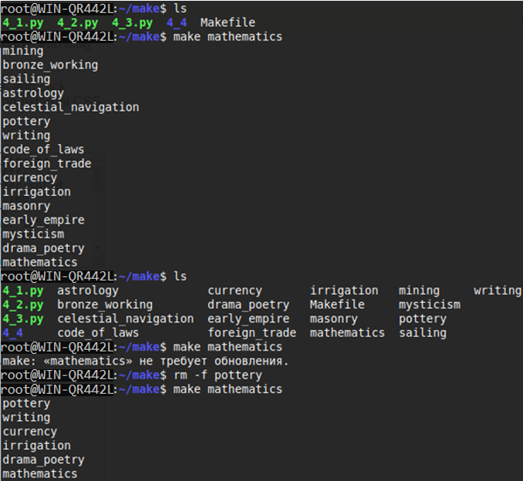

# **Задача 3**

Добавить цель clean, не забыв и про "животное".

***Решение:***

Python-код генератора Makefile:

|  |
| --- |
| json = {"pottery": [], "irrigation": ["pottery"], "writing": ["pottery"], "animal_husbandry": [], "archery": ["animal_husbandry"], "mining": [], "masonry": ["mining"], "bronze_working": ["mining"], "the_wheel": ["mining"], "apprenticeship": ["mining", "currency", "horseback_riding"], "sailing": [], "celestial_navigation": ["sailing", "astrology"], "shipbuilding": ["sailing"], "astrology": [], "drama_poetry": ["astrology", "irrigation", "masonry", "early_empire", "mysticism"], "theology": ["astrology", "mysticism", "drama_poetry"], "horseback_riding": ["archery"], "machinery": ["archery", "iron_working", "engineering"], "currency": ["writing", "foreign_trade"], "state_workforce": ["writing", "bronze_working", "craftsmanship"], "recorded_history": ["writing", "political_philosophy", "drama_poetry"], "construction": ["masonry", "the_wheel", "horseback_riding"], "engineering": ["masonry", "the_wheel"], "iron_working": ["bronze_working"], "mathematics": ["bronze_working", "celestial_navigation", "currency", "drama_poetry"], "military_training": ["bronze_working", "military_tradition", "games_recreation"], "cartography": ["celestial_navigation", "shipbuilding"], "medieval_faires": ["currency", "feudalism"], "guilds": ["currency", "feudalism", "civil_service"], "mercantilism": ["currency", "humanism"], "stirrups": ["horseback_riding", "feudalism"], "mass_production": ["shipbuilding", "machinery", "education"], "naval_tradition": ["shipbuilding", "defensive_tactics"], "military_tactics": ["mathematics"], "education": ["mathematics", "apprenticeship"], "military_engineering": ["construction", "engineering"], "castles": ["construction", "divine_right", "exploration"], "games_recreation": ["construction", "state_workforce"], "gunpowder": ["apprenticeship", "stirrups", "military_engineering"], "printing": ["machinery", "education"], "metal_casting": ["machinery", "gunpowder"], "banking": ["education", "stirrups", "guilds"], "astronomy": ["education"], "military_science": ["stirrups", "printing", "siege_tactics"], "siege_tactics": ["castles", "metal_casting"], "square_rigging": ["cartography", "gunpowder"], "exploration": ["cartography", "mercenaries", "medieval_faires"], "industrialization": ["mass_production", "square_rigging"], "scientific_theory": ["banking", "astronomy", "the_enlightenment"], "colonialism": ["astronomy", "mercantilism"], "ballistics": ["metal_casting", "siege_tactics"], "economics": ["metal_casting", "scientific_theory"], "scorched_earth": ["metal_casting", "nationalism"], "steam_power": ["industrialization"], "flight": ["industrialization", "scientific_theory", "economics"], "steel": ["industrialization", "rifling"], "class_struggle": ["industrialization", "ideology"], "sanitation": ["scientific_theory", "urbanization"], "rifling": ["ballistics", "military_science"], "totalitarianism": ["military_science", "ideology"], "electricity": ["steam_power", "mercantilism"], "radio": ["steam_power", "flight", "conservation"], "chemistry": ["sanitation"], "suffrage": ["sanitation", "ideology"], "replaceable_parts": ["economics"], "capitalism": ["economics", "mass_media"], "combined_arms": ["flight", "combustion"], "synthetic_materials": ["flight", "plastics"], "rapid_deployment": ["flight", "cold_war"], "advanced_ballistics": ["replaceable_parts", "steel", "electricity"], "combustion": ["steel", "natural_history"], "computers": ["electricity", "radio", "suffrage", "totalitarianism", "class_struggle"], "advanced_flight": ["radio"], "rocketry": ["radio", "chemistry"], "nanotechnology": ["radio", "composites"], "mass_media": ["radio", "urbanization"], "nuclear_program": ["chemistry", "ideology"], "plastics": ["combustion"], "satellites": ["advanced_flight", "rocketry"], "globalization": ["advanced_flight", "rapid_deployment", "space_race"], "guidance_systems": ["rocketry", "advanced_ballistics"], "space_race": ["rocketry", "cold_war"], "nuclear_fission": ["advanced_ballistics", "combined_arms"], "telecommunications": ["computers"], "robotics": ["computers", "globalization"], "lasers": ["nuclear_fission"], "cold_war": ["nuclear_fission", "ideology"], "composites": ["synthetic_materials"], "stealth_technology": ["synthetic_materials"], "social_media": ["telecommunications", "professional_sports", "space_race"], "nuclear_fusion": ["lasers"], "code_of_laws": [], "craftsmanship": ["code_of_laws"], "foreign_trade": ["code_of_laws"], "military_tradition": ["craftsmanship"], "early_empire": ["foreign_trade"], "mysticism": ["foreign_trade"], "political_philosophy": ["state_workforce", "early_empire"], "defensive_tactics": ["games_recreation", "political_philosophy"], "humanism": ["drama_poetry", "medieval_faires"], "mercenaries": ["military_training", "feudalism"], "feudalism": ["defensive_tactics"], "civil_service": ["defensive_tactics", "recorded_history"], "divine_right": ["theology", "civil_service"], "diplomatic_service": ["guilds"], "reformed_church": ["guilds", "divine_right"], "the_enlightenment": ["humanism", "diplomatic_service"], "civil_engineering": ["mercantilism"], "nationalism": ["the_enlightenment"], "opera_ballet": ["the_enlightenment"], "natural_history": ["colonialism"], "urbanization": ["civil_engineering", "nationalism"], "conservation": ["natural_history", "urbanization"], "mobilization": ["urbanization"], "cultural_heritage": ["conservation"], "ideology": ["mass_media", "mobilization"], "professional_sports": ["ideology"]}  f = open("Makefile","w")  content = ""  **for** key **in** json:  content = content + key[:len(key)] + ": " + " ".join(json[key])+"**\n**"  content = content + "**\t**"+ "@echo " + key + "**\n**"  content = content + "**\t**"+ "@echo " + " ".join(json[key]) + " > " + key + "**\n**"  content = content + ".PHONY: clean**\n**clean: **\n\t**@rm -f "  **for** key **in** json:  content = content + " ".join(json[key]) + " "  f.write(content)  f.close() |

Сформированный Makefile:

|  |
| --- |
| **pottery**:  @echo pottery  @echo > pottery  **irrigation**: **pottery**  @echo irrigation  @echo pottery > irrigation  **writing**: **pottery**  @echo writing  @echo pottery > writing  **animal_husbandry**:  @echo animal_husbandry  @echo > animal_husbandry  **archery**: **animal_husbandry**  @echo archery  @echo animal_husbandry > archery  **mining**:  @echo mining  @echo > mining  **masonry**: **mining**  @echo masonry  @echo mining > masonry  **bronze_working**: **mining**  @echo bronze_working  @echo mining > bronze_working  **the_wheel**: **mining**  @echo the_wheel  @echo mining > the_wheel  **apprenticeship**: **mining currency horseback_riding**  @echo apprenticeship  @echo mining currency horseback_riding > apprenticeship  **sailing**:  @echo sailing  @echo > sailing  **celestial_navigation**: **sailing astrology**  @echo celestial_navigation  @echo sailing astrology > celestial_navigation  **shipbuilding**: **sailing**  @echo shipbuilding  @echo sailing > shipbuilding  **astrology**:  @echo astrology  @echo > astrology  **drama_poetry**: **astrology irrigation masonry early_empire mysticism**  @echo drama_poetry  @echo astrology irrigation masonry early_empire mysticism > drama_poetry  **theology**: **astrology mysticism drama_poetry**  @echo theology  @echo astrology mysticism drama_poetry > theology  **horseback_riding**: **archery**  @echo horseback_riding  @echo archery > horseback_riding  **machinery**: **archery iron_working engineering**  @echo machinery  @echo archery iron_working engineering > machinery  **currency**: **writing foreign_trade**  @echo currency  @echo writing foreign_trade > currency  **state_workforce**: **writing bronze_working craftsmanship**  @echo state_workforce  @echo writing bronze_working craftsmanship > state_workforce  **recorded_history**: **writing political_philosophy drama_poetry**  @echo recorded_history  @echo writing political_philosophy drama_poetry > recorded_history  **construction**: **masonry the_wheel horseback_riding**  @echo construction  @echo masonry the_wheel horseback_riding > construction  **engineering**: **masonry the_wheel**  @echo engineering  @echo masonry the_wheel > engineering  **iron_working**: **bronze_working**  @echo iron_working  @echo bronze_working > iron_working  **mathematics**: **bronze_working celestial_navigation currency drama_poetry**  @echo mathematics  @echo bronze_working celestial_navigation currency drama_poetry > mathematics  **military_training**: **bronze_working military_tradition games_recreation**  @echo military_training  @echo bronze_working military_tradition games_recreation > military_training  **cartography**: **celestial_navigation shipbuilding**  @echo cartography  @echo celestial_navigation shipbuilding > cartography  **medieval_faires**: **currency feudalism**  @echo medieval_faires  @echo currency feudalism > medieval_faires  **guilds**: **currency feudalism civil_service**  @echo guilds  @echo currency feudalism civil_service > guilds  **mercantilism**: **currency humanism**  @echo mercantilism  @echo currency humanism > mercantilism  **stirrups**: **horseback_riding feudalism**  @echo stirrups  @echo horseback_riding feudalism > stirrups  **mass_production**: **shipbuilding machinery education**  @echo mass_production  @echo shipbuilding machinery education > mass_production  **naval_tradition**: **shipbuilding defensive_tactics**  @echo naval_tradition  @echo shipbuilding defensive_tactics > naval_tradition  **military_tactics**: **mathematics**  @echo military_tactics  @echo mathematics > military_tactics  **education**: **mathematics apprenticeship**  @echo education  @echo mathematics apprenticeship > education  **military_engineering**: **construction engineering**  @echo military_engineering  @echo construction engineering > military_engineering  **castles**: **construction divine_right exploration**  @echo castles  @echo construction divine_right exploration > castles  **games_recreation**: **construction state_workforce**  @echo games_recreation  @echo construction state_workforce > games_recreation  **gunpowder**: **apprenticeship stirrups military_engineering**  @echo gunpowder  @echo apprenticeship stirrups military_engineering > gunpowder  **printing**: **machinery education**  @echo printing  @echo machinery education > printing  **metal_casting**: **machinery gunpowder**  @echo metal_casting  @echo machinery gunpowder > metal_casting  **banking**: **education stirrups guilds**  @echo banking  @echo education stirrups guilds > banking  **astronomy**: **education**  @echo astronomy  @echo education > astronomy  **military_science**: **stirrups printing siege_tactics**  @echo military_science  @echo stirrups printing siege_tactics > military_science  **siege_tactics**: **castles metal_casting**  @echo siege_tactics  @echo castles metal_casting > siege_tactics  **square_rigging**: **cartography gunpowder**  @echo square_rigging  @echo cartography gunpowder > square_rigging  **exploration**: **cartography mercenaries medieval_faires**  @echo exploration  @echo cartography mercenaries medieval_faires > exploration  **industrialization**: **mass_production square_rigging**  @echo industrialization  @echo mass_production square_rigging > industrialization  **scientific_theory**: **banking astronomy the_enlightenment**  @echo scientific_theory  @echo banking astronomy the_enlightenment > scientific_theory  **colonialism**: **astronomy mercantilism**  @echo colonialism  @echo astronomy mercantilism > colonialism  **ballistics**: **metal_casting siege_tactics**  @echo ballistics  @echo metal_casting siege_tactics > ballistics  **economics**: **metal_casting scientific_theory**  @echo economics  @echo metal_casting scientific_theory > economics  **scorched_earth**: **metal_casting nationalism**  @echo scorched_earth  @echo metal_casting nationalism > scorched_earth  **steam_power**: **industrialization**  @echo steam_power  @echo industrialization > steam_power  **flight**: **industrialization scientific_theory economics**  @echo flight  @echo industrialization scientific_theory economics > flight  **steel**: **industrialization rifling**  @echo steel  @echo industrialization rifling > steel  **class_struggle**: **industrialization ideology**  @echo class_struggle  @echo industrialization ideology > class_struggle  **sanitation**: **scientific_theory urbanization**  @echo sanitation  @echo scientific_theory urbanization > sanitation  **rifling**: **ballistics military_science**  @echo rifling  @echo ballistics military_science > rifling  **totalitarianism**: **military_science ideology**  @echo totalitarianism  @echo military_science ideology > totalitarianism  **electricity**: **steam_power mercantilism**  @echo electricity  @echo steam_power mercantilism > electricity  **radio**: **steam_power flight conservation**  @echo radio  @echo steam_power flight conservation > radio  **chemistry**: **sanitation**  @echo chemistry  @echo sanitation > chemistry  **suffrage**: **sanitation ideology**  @echo suffrage  @echo sanitation ideology > suffrage  **replaceable_parts**: **economics**  @echo replaceable_parts  @echo economics > replaceable_parts  **capitalism**: **economics mass_media**  @echo capitalism  @echo economics mass_media > capitalism  **combined_arms**: **flight combustion**  @echo combined_arms  @echo flight combustion > combined_arms  **synthetic_materials**: **flight plastics**  @echo synthetic_materials  @echo flight plastics > synthetic_materials  **rapid_deployment**: **flight cold_war**  @echo rapid_deployment  @echo flight cold_war > rapid_deployment  **advanced_ballistics**: **replaceable_parts steel electricity**  @echo advanced_ballistics  @echo replaceable_parts steel electricity > advanced_ballistics  **combustion**: **steel natural_history**  @echo combustion  @echo steel natural_history > combustion  **computers**: **electricity radio suffrage totalitarianism class_struggle**  @echo computers  @echo electricity radio suffrage totalitarianism class_struggle > computers  **advanced_flight**: **radio**  @echo advanced_flight  @echo radio > advanced_flight  **rocketry**: **radio chemistry**  @echo rocketry  @echo radio chemistry > rocketry  **nanotechnology**: **radio composites**  @echo nanotechnology  @echo radio composites > nanotechnology  **mass_media**: **radio urbanization**  @echo mass_media  @echo radio urbanization > mass_media  **nuclear_program**: **chemistry ideology**  @echo nuclear_program  @echo chemistry ideology > nuclear_program  **plastics**: **combustion**  @echo plastics  @echo combustion > plastics  **satellites**: **advanced_flight rocketry**  @echo satellites  @echo advanced_flight rocketry > satellites  **globalization**: **advanced_flight rapid_deployment space_race**  @echo globalization  @echo advanced_flight rapid_deployment space_race > globalization  **guidance_systems**: **rocketry advanced_ballistics**  @echo guidance_systems  @echo rocketry advanced_ballistics > guidance_systems  **space_race**: **rocketry cold_war**  @echo space_race  @echo rocketry cold_war > space_race  **nuclear_fission**: **advanced_ballistics combined_arms**  @echo nuclear_fission  @echo advanced_ballistics combined_arms > nuclear_fission  **telecommunications**: **computers**  @echo telecommunications  @echo computers > telecommunications  **robotics**: **computers globalization**  @echo robotics  @echo computers globalization > robotics  **lasers**: **nuclear_fission**  @echo lasers  @echo nuclear_fission > lasers  **cold_war**: **nuclear_fission ideology**  @echo cold_war  @echo nuclear_fission ideology > cold_war  **composites**: **synthetic_materials**  @echo composites  @echo synthetic_materials > composites  **stealth_technology**: **synthetic_materials**  @echo stealth_technology  @echo synthetic_materials > stealth_technology  **social_media**: **telecommunications professional_sports space_race**  @echo social_media  @echo telecommunications professional_sports space_race > social_media  **nuclear_fusion**: **lasers**  @echo nuclear_fusion  @echo lasers > nuclear_fusion  **code_of_laws**:  @echo code_of_laws  @echo > code_of_laws  **craftsmanship**: **code_of_laws**  @echo craftsmanship  @echo code_of_laws > craftsmanship  **foreign_trade**: **code_of_laws**  @echo foreign_trade  @echo code_of_laws > foreign_trade  **military_tradition**: **craftsmanship**  @echo military_tradition  @echo craftsmanship > military_tradition  **early_empire**: **foreign_trade**  @echo early_empire  @echo foreign_trade > early_empire  **mysticism**: **foreign_trade**  @echo mysticism  @echo foreign_trade > mysticism  **political_philosophy**: **state_workforce early_empire**  @echo political_philosophy  @echo state_workforce early_empire > political_philosophy  **defensive_tactics**: **games_recreation political_philosophy**  @echo defensive_tactics  @echo games_recreation political_philosophy > defensive_tactics  **humanism**: **drama_poetry medieval_faires**  @echo humanism  @echo drama_poetry medieval_faires > humanism  **mercenaries**: **military_training feudalism**  @echo mercenaries  @echo military_training feudalism > mercenaries  **feudalism**: **defensive_tactics**  @echo feudalism  @echo defensive_tactics > feudalism  **civil_service**: **defensive_tactics recorded_history**  @echo civil_service  @echo defensive_tactics recorded_history > civil_service  **divine_right**: **theology civil_service**  @echo divine_right  @echo theology civil_service > divine_right  **diplomatic_service**: **guilds**  @echo diplomatic_service  @echo guilds > diplomatic_service  **reformed_church**: **guilds divine_right**  @echo reformed_church  @echo guilds divine_right > reformed_church  **the_enlightenment**: **humanism diplomatic_service**  @echo the_enlightenment  @echo humanism diplomatic_service > the_enlightenment  **civil_engineering**: **mercantilism**  @echo civil_engineering  @echo mercantilism > civil_engineering  **nationalism**: **the_enlightenment**  @echo nationalism  @echo the_enlightenment > nationalism  **opera_ballet**: **the_enlightenment**  @echo opera_ballet  @echo the_enlightenment > opera_ballet  **natural_history**: **colonialism**  @echo natural_history  @echo colonialism > natural_history  **urbanization**: **civil_engineering nationalism**  @echo urbanization  @echo civil_engineering nationalism > urbanization  **conservation**: **natural_history urbanization**  @echo conservation  @echo natural_history urbanization > conservation  **mobilization**: **urbanization**  @echo mobilization  @echo urbanization > mobilization  **cultural_heritage**: **conservation**  @echo cultural_heritage  @echo conservation > cultural_heritage  **ideology**: **mass_media mobilization**  @echo ideology  @echo mass_media mobilization > ideology  **professional_sports**: **ideology**  @echo professional_sports  @echo ideology > professional_sports  **.PHONY**: **clean**  **clean**:  @rm -f pottery pottery animal_husbandry mining mining mining mining currency horseback_riding sailing astrology sailing astrology irrigation masonry early_empire mysticism astrology mysticism drama_poetry archery archery iron_working engineering writing foreign_trade writing bronze_working craftsmanship writing political_philosophy drama_poetry masonry the_wheel horseback_riding masonry the_wheel bronze_working bronze_working celestial_navigation currency drama_poetry bronze_working military_tradition games_recreation celestial_navigation shipbuilding currency feudalism currency feudalism civil_service currency humanism horseback_riding feudalism shipbuilding machinery education shipbuilding defensive_tactics mathematics mathematics apprenticeship construction engineering construction divine_right exploration construction state_workforce apprenticeship stirrups military_engineering machinery education machinery gunpowder education stirrups guilds education stirrups printing siege_tactics castles metal_casting cartography gunpowder cartography mercenaries medieval_faires mass_production square_rigging banking astronomy the_enlightenment astronomy mercantilism metal_casting siege_tactics metal_casting scientific_theory metal_casting nationalism industrialization industrialization scientific_theory economics industrialization rifling industrialization ideology scientific_theory urbanization ballistics military_science military_science ideology steam_power mercantilism steam_power flight conservation sanitation sanitation ideology economics economics mass_media flight combustion flight plastics flight cold_war replaceable_parts steel electricity steel natural_history electricity radio suffrage totalitarianism class_struggle radio radio chemistry radio composites radio urbanization chemistry ideology combustion advanced_flight rocketry advanced_flight rapid_deployment space_race rocketry advanced_ballistics rocketry cold_war advanced_ballistics combined_arms computers computers globalization nuclear_fission nuclear_fission ideology synthetic_materials synthetic_materials telecommunications professional_sports space_race lasers code_of_laws code_of_laws craftsmanship foreign_trade foreign_trade state_workforce early_empire games_recreation political_philosophy drama_poetry medieval_faires military_training feudalism defensive_tactics defensive_tactics recorded_history theology civil_service guilds guilds divine_right humanism diplomatic_service mercantilism the_enlightenment the_enlightenment colonialism civil_engineering nationalism natural_history urbanization urbanization conservation mass_media mobilization ideology |

Тестирование посредством сборки для “mathematics” и последующей очисткой clean:

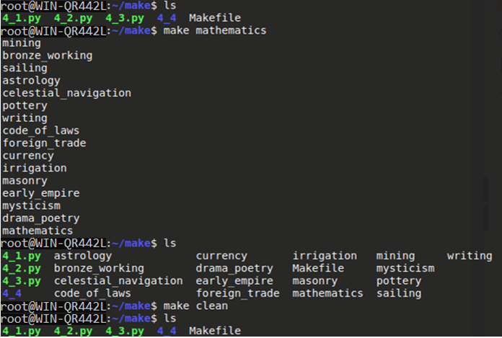

# **Задача 4**

Написать makefile для следующего скрипта сборки:

|  |
| --- |
| gcc prog.c data.c -o prog  dir /B > files.lst  7z a distr.zip *.* |

Вместо gcc можно использовать другой компилятор командной строки, но на вход ему должны подаваться два модуля: prog и data. Если используете не Windows, то исправьте вызовы команд на их эквиваленты из вашей ОС. В makefile должны быть, как минимум, следующие задачи: all, clean, archive. Обязательно покажите на примере, что уже сделанные подзадачи у вас не перестраиваются.

***Решение:***

Подготовленный Makefile:

|  |
| --- |
| **.PHONY**: **all clean**  **all**: **prog files.lst distr.zip**  **clean**:  @rm -rf prog files.lst distr.zip  **prog**: **prog.c data.c**  gcc prog.c data.c -o prog  **files.lst**:  @dir > files.lst  **distr.zip**:  zip -u distr.zip *.* |

Тестирование посредством сборки проекта (make all) и очистки clean:

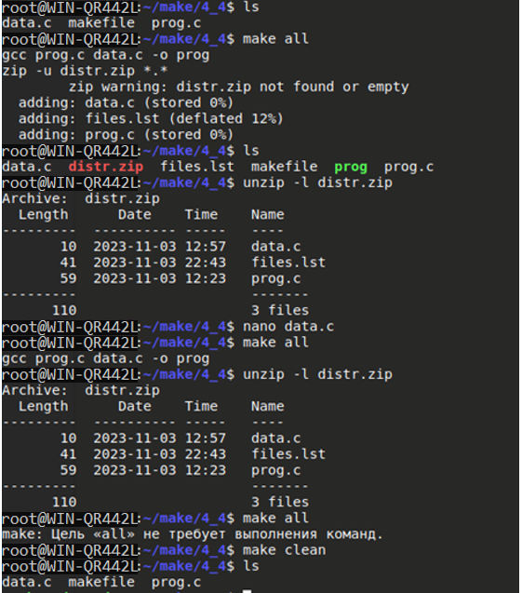

Содержимое файла data.c до вызова команды “nano data.c” (редактирование):



Содержимое файла data.c после вызова команды “nano data.c” (после редактирования):

