#Q1

mtcars_small <- data.frame(

+ car = c("Ferrari Dino", "Hornet Sportabout", "Merc 280", "Toyota Corona"),

+ mpg = c(19.7, 18.7, 19.2, 21.5),

+ gears = c(5, 3, 4, 3)

+ )

mtcars_small

car mpg gears

1 Ferrari Dino 19.7 5

2 Hornet Sportabout 18.7 3

3 Merc 280 19.2 4

4 Toyota Corona 21.5 3

**Q1 Answer:**

subset(mtcars_small,mpg>19)

car mpg gears

1 Ferrari Dino 19.7 5

3 Merc 280 19.2 4

4 Toyota Corona 21.5 3

#Q2

|  |
| --- |
| x<-c(8,1,15,18,5,10)  x  [1] 8 1 15 18 5 10  x[x>=8]  [1] 8 15 18 10  **Q2 Answer:** |

#Q3

**Q3 Answer:**

x <- matrix(c("A", "B", "C", "D"), nrow = 1, ncol = 4, byrow = FALSE)

attributes(x)

$dim

[1] 1 4

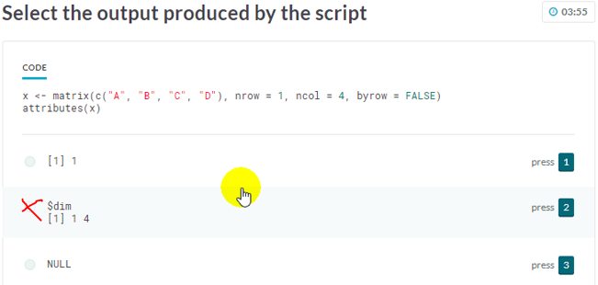

#Q4

df <- data.frame(x = c(8, 10, 5), y = c(TRUE, FALSE, FALSE))

**Q4 Answer:**

names(df) <- c("Aug","Oct")

df

Aug Oct

1 8 TRUE

2 10 FALSE

3 5 FALSE

#Q5

> plot(col.main = "green")

Error in xy.coords(x, y, xlabel, ylabel, log) :

argument "x" is missing, with no default

Q5 Answer is: main.col

#Q6

x <- matrix(1:4, nrow = 2, byrow = TRUE,

+ dimnames = list(c("P", "Q"), c("A", "B")))

rowMeans(x)

P Q

1.5 3.5

> x <- matrix(1:4, nrow = 2, byrow = TRUE,

+ dimnames = list(c("P", "Q"), c("A", "B")))

> colMeans(x)

A B

2 3

> x <- matrix(1:4, nrow = 2, byrow = TRUE,

+ dimnames = list(c("P", "Q"), c("A", "B")))

> colSums(x)

A B

4 6

> #7

> x <- c(2, 1, 3, 4)

> y <- c(NA, FALSE, NA, FALSE)

> cbind(x,y)

x y

[1,] 2 NA

[2,] 1 0

[3,] 3 NA

[4,] 4 0

> rbind(x,y)

[,1] [,2] [,3] [,4]

x 2 1 3 4

y NA 0 NA 0

#8

#correct answer is ylim

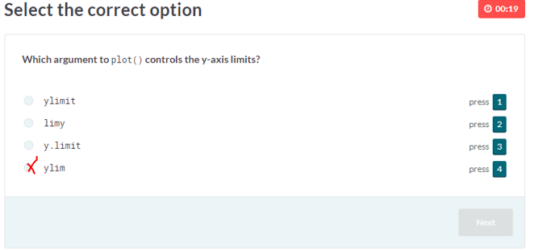

#9

#answer is comment #

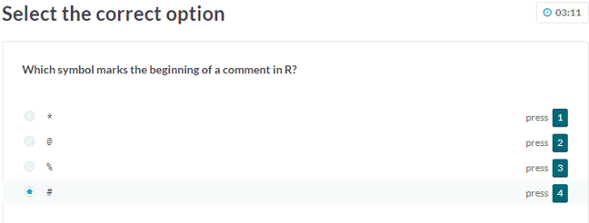

#10

store <- list(Product = c("C", "D"), Cost = c(20, 12))

store$Cost

[1] 20 12

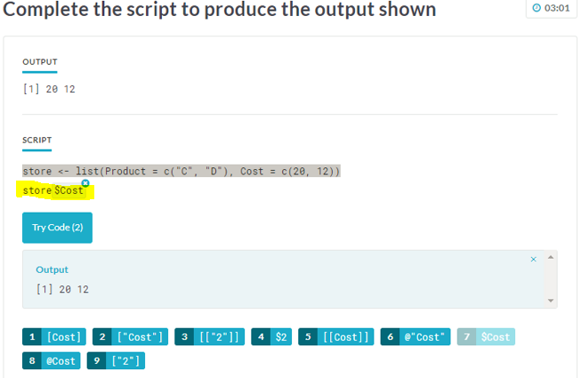

#11

z <- cbind(c(2, 4, 8), c(4, 8, 4))

z-4

[,1] [,2]

[1,] -2 0

[2,] 0 4

[3,] 4 0

#Answer is z-4 (B)

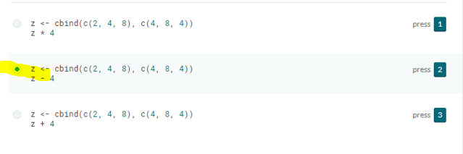

#12

sample_list <- list(5:6, c("A", "B"), 10:12)

str(sample_list)

List of 3

$ : int [1:2] 5 6

$ : chr [1:2] "A" "B"

$ : int [1:3] 10 11 12

#13

#A.

x <- c(2, 13, 1, 3, 5, 12)

x[c(TRUE, FALSE, FALSE, TRUE, TRUE, FALSE)]

[1] 2 3 5

#B.

x <- c(2, 13, 1, 3, 5, 12)

x[c(FALSE, TRUE)]

[1] 13 3 12

#C.

x <- c(2, 13, 1, 3, 5, 12)

x[c(TRUE, TRUE, FALSE, TRUE)]

[1] 2 13 3 5 12

#correct answer is A(1)

#2 3 5

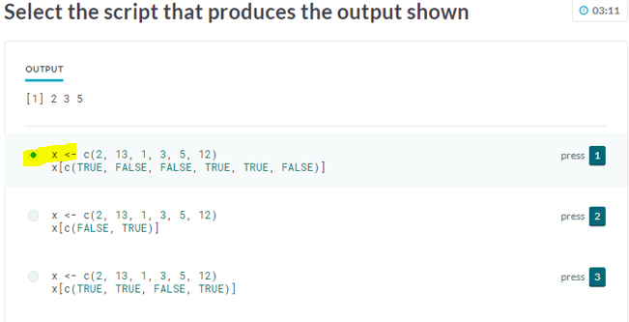

#14

object_1 <- -1.2

object_2 <- "45"

object_3 <- NA

object_4 <- FALSE

rm(object_2, object_4)

ls()

[1] "object_1" "object_3"

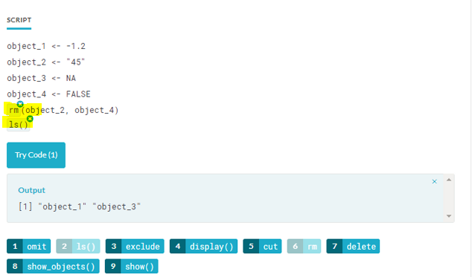

#15

x <- c(4, 8, 2)

y <- c(2, 4, NA)

x + y

[1] 6 12 NA

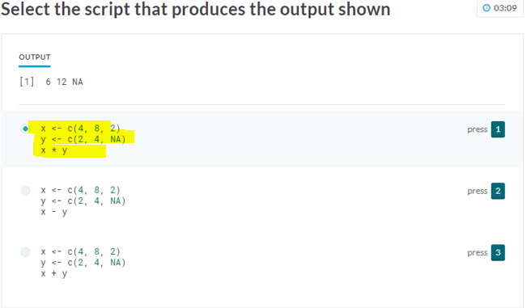

#16

x <- matrix(10:18, nrow = 3, ncol = 3, byrow = FALSE)

dimnames(x) <- list(c("A", "B", "C"), paste0("W", 1:3))

x

W1 W2 W3

A 10 13 16

B 11 14 17

C 12 15 18

**Q16 Answer:**

x[c("A","C"),c("W3","W1","W2")]

W3 W1 W2

A 16 10 13

C 18 12 15

#17

df <- data.frame(x = c(1.5, -2, 3.5), y = c("Sun", "Mon", "Tue"), z = c(2, 1, 3))

df

x y z

1 1.5 Sun 2

2 -2.0 Mon 1

3 3.5 Tue 3

df[order(df$z,decreasing=TRUE),]

x y z

3 3.5 Tue 3

1 1.5 Sun 2

2 -2.0 Mon 1

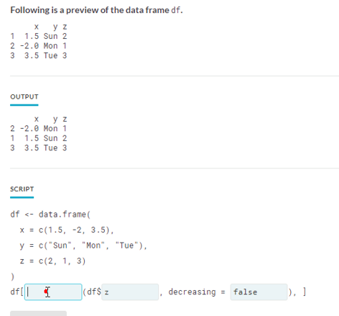

> #18

> x <- c(TRUE, FALSE, NA)

> y <- c(2.0, 3.0, -1)

> c(is.integer(x), is.numeric(y))

[1] FALSE TRUE

> x <- c(TRUE, FALSE, NA)

> y <- c("Apples", "Oranges", FALSE)

> c(is.integer(x), is.numeric(y))

[1] FALSE FALSE

> x <- c(1L, 0L, 5L)

> y <- c(2.0, 3.0, -1)

> c(is.integer(x), is.numeric(y))

[1] TRUE TRUE

> #correct answer is B(2)

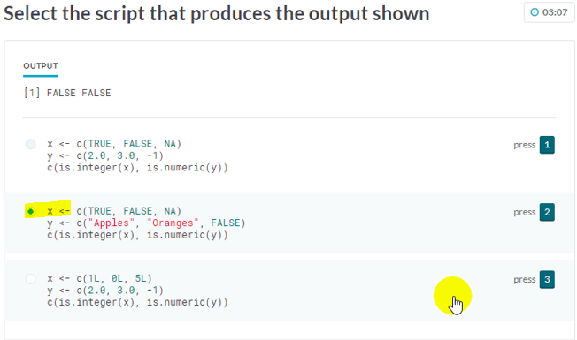

> #19

> iris_small <- data.frame(

+ species = c("virginica", "virginica", "setosa", "versicolor"),

+ sepal_length = c(6.4, 6.1, 4.8, 6.3),

+ petal_length = c(5.3, 4.9, 1.9, 4.4)

+ )

>

**Q19 Answer:**

> iris_small[["petal_length"]]

[1] 5.3 4.9 1.9 4.4

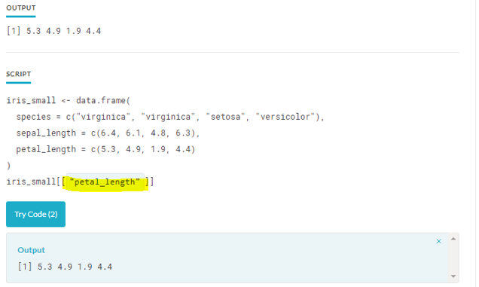

> #20

> matrix_a <- matrix(c(4, 2, 4, 2), nrow = 2, byrow = FALSE)

> matrix_b <- matrix(c(2, 1, 2, 1), nrow = 2, byrow = FALSE)

> matrix_a / matrix_b

[,1] [,2]

[1,] 2 2

[2,] 2 2

#Answer is A

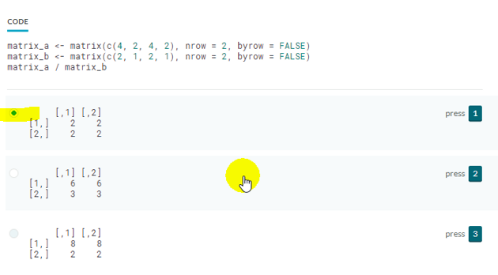

#21

x <- c(2, 3.5, 6.0, 1)

y <- c(1, 6)

x < y

[1] FALSE TRUE FALSE TRUE

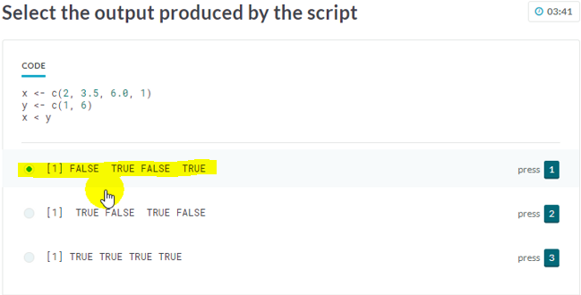

#22

x <- c(2, 25, 27, 24, 4, 22)

y <- c("Jul", "Aug", "Sep", "Oct", "Nov", "Dec")

names(x) <- y

x

Jul Aug Sep Oct Nov Dec

2 25 27 24 4 22

**Q20 Answer:**

x[c("Nov","Dec","Aug")]

Nov Dec Aug

4 22 25

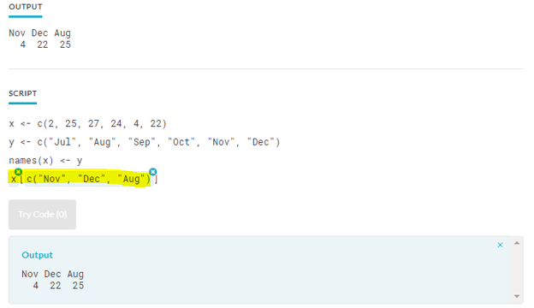

#23

> credit_score <- c("G", "F", "B", "E", "G")

> credit_score

[1] "G" "F" "B" "E" "G"

> credit_score <- factor(credit_score,levels=c("B","F","G","E"),labels=c("Bad","Fair","Good","Excellent"),ordered=TRUE)

> credit_score

[1] Good Fair Bad Excellent Good

Levels: Bad < Fair < Good < Excellent

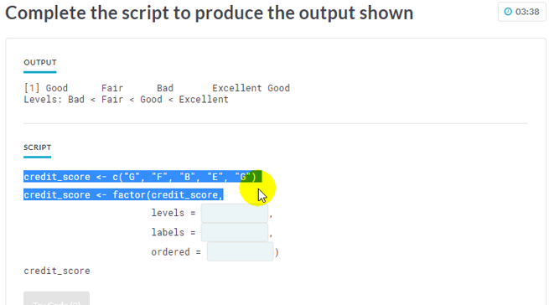

> #24

> x <- c(1, 4)

> y <- c(2, 4, 2, 1)

> x + y

[1] 3 8 3 5

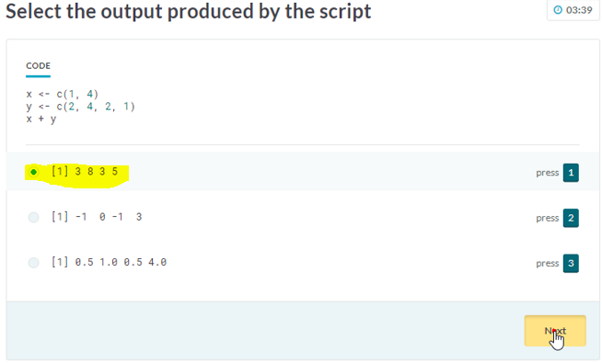

> #25

> x <- c(16, 4, 8, 6, 20, 14)

> x[3:1]

[1] 8 4 16

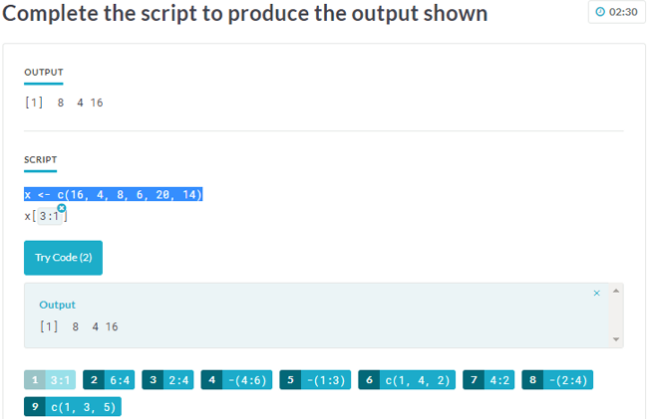

> #26

> df <- data.frame(X = 1:3, Y = c("A", "B", "C"), Z = 4:6)

> df[-2,3:1]

Z Y X

1 4 A 1

3 6 C 3

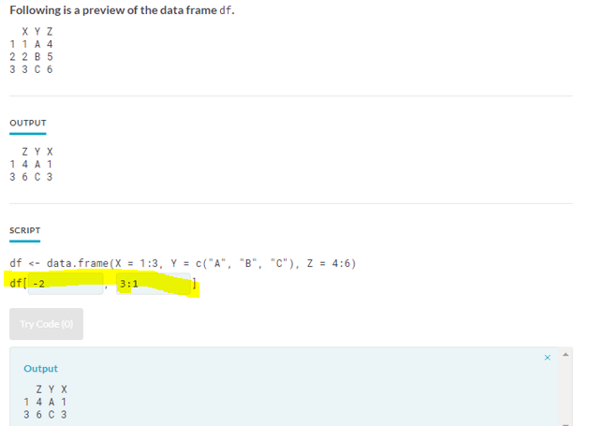

> #27

> object_1 <- list(x = c("TRUE", "FALSE", "TRUE"),y = c(NA))

>

> str(object_1)

List of 2

$ x: chr [1:3] "TRUE" "FALSE" "TRUE"

$ y: logi NA

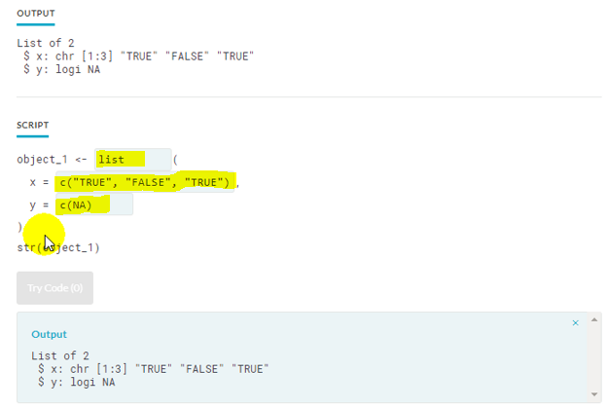

> #28

> #When using rbind(), both matrices should contain equal number of columns. TRUE

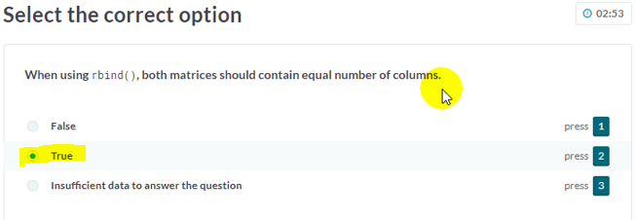

> #29

> x <- -20L

> y <- NA

> c(class(x), class(y))

[1] "integer" "logical"

> x <- 4.3

> y <- NaN

> c(class(x), class(y))

[1] "numeric" "numeric"

> x <- list(a = 1:5, b = c("Apples", "Oranges"))

> y <- NA

> c(class(x), class(y))

[1] "list" "logical"

> #A(1) is correct answer

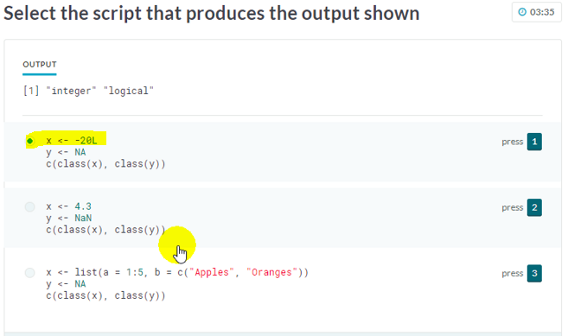

> #30

> x <- c(-12L, 3L, -5L)

> y <- NA

> c(is.character(x), is.logical(y))

[1] FALSE TRUE

> x <- c("A", "2", "C")

> y <- c(1L, 2, 3L)

> c(is.integer(x), is.logical(y))

[1] FALSE FALSE

> x <- c("A", "2", "C")

> y <- NA

> c(is.character(x), is.numeric(y))

[1] TRUE FALSE

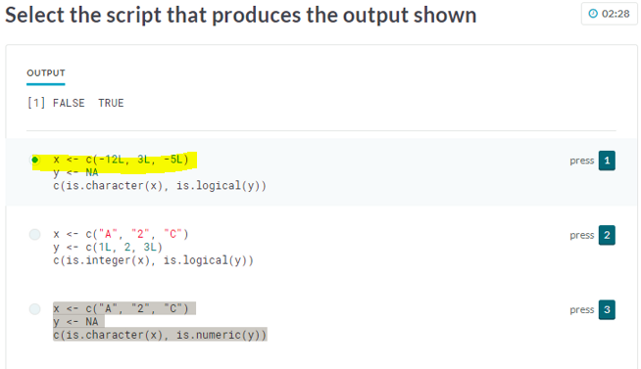

#31

x <- list(p = 3:4, q = c("d", "e"))

y <- c(20, 30)

x

$p

[1] 3 4

$q

[1] "d" "e"

#Answer is

x$e <- y

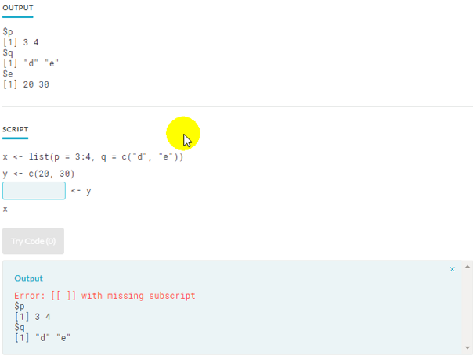

> #32

> plot(c(0, 20, 40, 60, 80), 1:100, xlab = "X", ylab = "Y", color = "red")

Error in xy.coords(x, y, xlabel, ylabel, log) :

'x' and 'y' lengths differ

> plot(c(0, 20, 40, 60, 80, 100), c(0, 20, 40, 60, 80), color = "red")

Error in xy.coords(x, y, xlabel, ylabel, log) :

'x' and 'y' lengths differ

> plot(1:100, c(0, 20, 40, 60, 80), xlab = "X", ylab = "Y", col = "red")

Error in xy.coords(x, y, xlabel, ylabel, log) :

'x' and 'y' lengths differ

> plot(1:100, xlab = "X", ylab = "Y", col = "red")

> #answer is D(4)

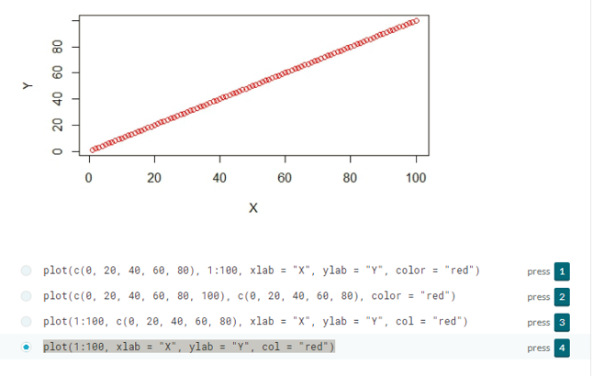

> #33

> x <- list(FALSE, TRUE, c(FALSE, FALSE), c(TRUE, NA))

> x[c(FALSE, TRUE)]

[[1]]

[1] TRUE

[[2]]

[1] TRUE NA

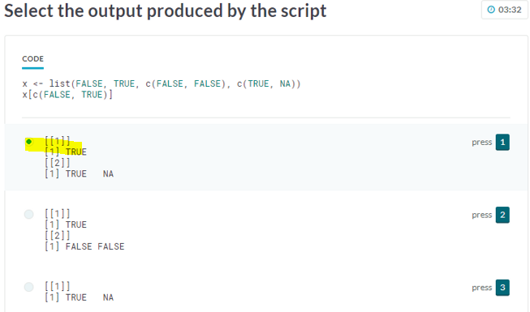

#34

x <- c(1, 3, 5, 7)

y <- c(5, 6, 7, 8)

#should use matrix

> matrix(c(x,y),nrow=2,ncol=4,byrow=TRUE)

[,1] [,2] [,3] [,4]

[1,] 1 3 5 7

[2,] 5 6 7 8

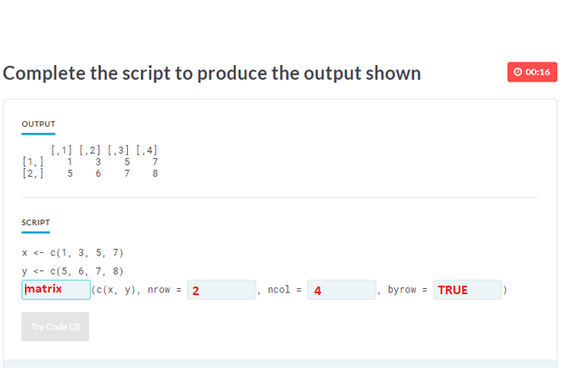

#35

df <- data.frame(X = c(6, 12, 18), Y = c(24, 30, 36))

df

X Y

1 6 24

2 12 30

3 18 36

df[c(FALSE, FALSE, TRUE), c("X", "Y")]

X Y

3 18 36

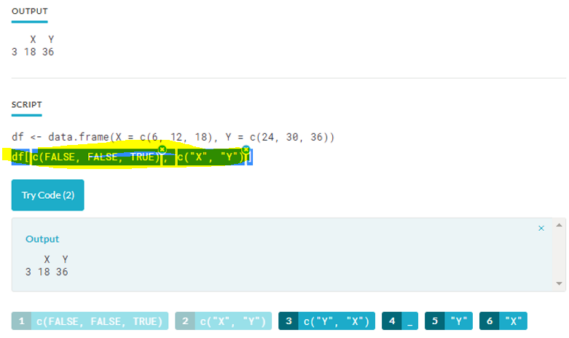

|  |  |  |  |  |
| --- | --- | --- | --- | --- |
| #36  new_list <- list(x1 = c(5, 6), x2 = list(y = c("d", "e"), z = c("D", "F")))  new_list  $x1  [1] 5 6  $x2  $x2$y  [1] "d" "e"  $x2$z  [1] "D" "F"  new_list$x2$z  [1] "D" "F"    #37 (no correct answer yet)  x <- list(p = c(3, 9))  y <- c(8, 4)  list(x,y)  [[1]]  [[1]]$p  [1] 3 9  [[2]]  [1] 8 4  str(x,y)  List of 1  $ p: num [1:2] 3 9    #38  #A. hist(1:100, breaks = 20, xlab = "", main = "", col = "blue")  #B. hist(1:100, breaks = 5, ylab = "Frequency", col = "blue")  #C. hist(c(0, 20, 40, 60, 80, 100), ylab = "Frequency", border = "blue")  #D. hist(1:100, breaks = 5, xlab = "", main = "", border = "blue")  #Answer is D(4)    #39  x <- list(p = c(5, 10, 15), q = c(20, 25, 30), r = c(35, 40, 45))  x[[3]][[2]]  [1] 40    #40  #When two continuous variables are passed to the plot() function, which of the following charts is produced :  #Answer is scatter plot    #41  x <- c(4, 2.5)  y <- c(4, 2, 5, NA)  z<-list(x,y)  str(z)  List of 2  $ : num [1:2] 4 2.5  $ : num [1:4] 4 2 5 NA    #42  df <- data.frame(x = 1:2, y = c("A", "B"))  df  x y  1 1 A  2 2 B  df$z <- c(1.2,2.4)  df  x y z  1 1 A 1.2  2 2 B 2.4    #43  #A. x <- c(NA, 0.1, 1, 0)  as.logical(x)  [1] NA TRUE TRUE FALSE  #B. x <- c(NA, 0.1, 0, 1)  as.logical(x)  [1] NA TRUE FALSE TRUE  #C. x <- c(NA, 0, 0, 0)  as.logical(x)  [1] NA FALSE FALSE FALSE  #answer is C(3)    #44  x <- c(NA, "1", "1.5", "2.0")  x  [1] NA "1" "1.5" "2.0"  as.integer(x)  [1] NA 1 1 2    #45  list_1 <- list(x = c(2.5, 1), y = c(TRUE, NA), z = c(6, FALSE))  list_1  $x  [1] 2.5 1.0  $y  [1] TRUE NA  $z  [1] 6 0  list_1[1]  $x  [1] 2.5 1.0  list_1[2]  $y  [1] TRUE NA    #46  #A.  y <- matrix(LETTERS[1:9], nrow = 3, ncol = 3, byrow = FALSE)  y[c(TRUE, FALSE, TRUE), c(TRUE, FALSE)]  [,1] [,2]  [1,] "A" "G"  [2,] "C" "I"  #B.  y <- matrix(LETTERS[1:9], nrow = 3, ncol = 3, byrow = FALSE)  y[c(2, 1), -3]  [,1] [,2]  [1,] "B" "E"  [2,] "A" "D"  #C.  y <- matrix(LETTERS[1:9], nrow = 3, ncol = 3, byrow = FALSE)  y[c(TRUE, FALSE, TRUE), -3]  [,1] [,2]  [1,] "A" "D"  [2,] "C" "F"  #Answer is B(2)    #47  x <- c(2, 4, 6, 8)  # Find the average of x  mean(x)  [1] 5    #48  df <- data.frame(  + x = c(4, 14, 2, 1, 8, 9, 5, 15),  + y = c("X", "B", "C", "V", "J", "K", "E", "W")  + )  df  x y  1 4 X  2 14 B  3 2 C  4 1 V  5 8 J  6 9 K  7 5 E  8 15 W  head(df, 3)  x y  1 4 X  2 14 B  3 2 C    #49  #Which of the following is an ordinal categorical variable?  #Answer: Credit Score (Bad, Fair, Good, Excellent)    #50  region <- c("South", "South", "East", "West", "West", "North")   |  | | --- | | > region <- c("South", "South", "East", "West", "West", "North")  > region_factor <- factor(region,levels=c("North","South","East","West"))  > region_factor  [1] South South East West West North  Levels: North South East West | |  | | |  | | --- | | > | | |
|  |
| |  | | --- | |  | |