Sensitivity of MPA rasters to MPA size

*Compiled on Sun Apr 7 11:32:58 2019 by ohara*

Table of Contents

To calculate marine protected area global distribution, we rasterized vector spatial data (polygon features) from the World Database on Protected Areas [WDPA, @iucn_2018a] to eliminate double-counting due to overlapping protected areas. However, while rasterization enables convenient comparison of spatial data, it necessarily loses some information particularly when the resolution of the raster is significantly larger than the scale of polygon features. Our primary analysis of marine biodiversity risk was assessed at cells of 100 km2; however, many marine protected areas are far smaller than this size, so for MPA coverage, we chose a finer resolution, 1 km2, to calculate proportional coverage within each larger analysis cell. To assess the ability of this scale to capture the vast majority of MPAs relevant to the status of global marine biodiversity, we focused on three questions:

* How many small MPAs exist that are at or below the resolution of the 1 km2 raster resolution, and to what extent does the total area of these MPAs contribute to the global MPA estate?
* How significant is the result of small MPAs potentially dropped by the rasterization process, i.e., total number, proportional count, and proportion of total protected area of MPAs not included in the raster output?
* How closely does the resulting MPA raster output reflect the protected area indicated by the MPA polygons input?

### Small MPA coverage as a proportion of global MPA estate

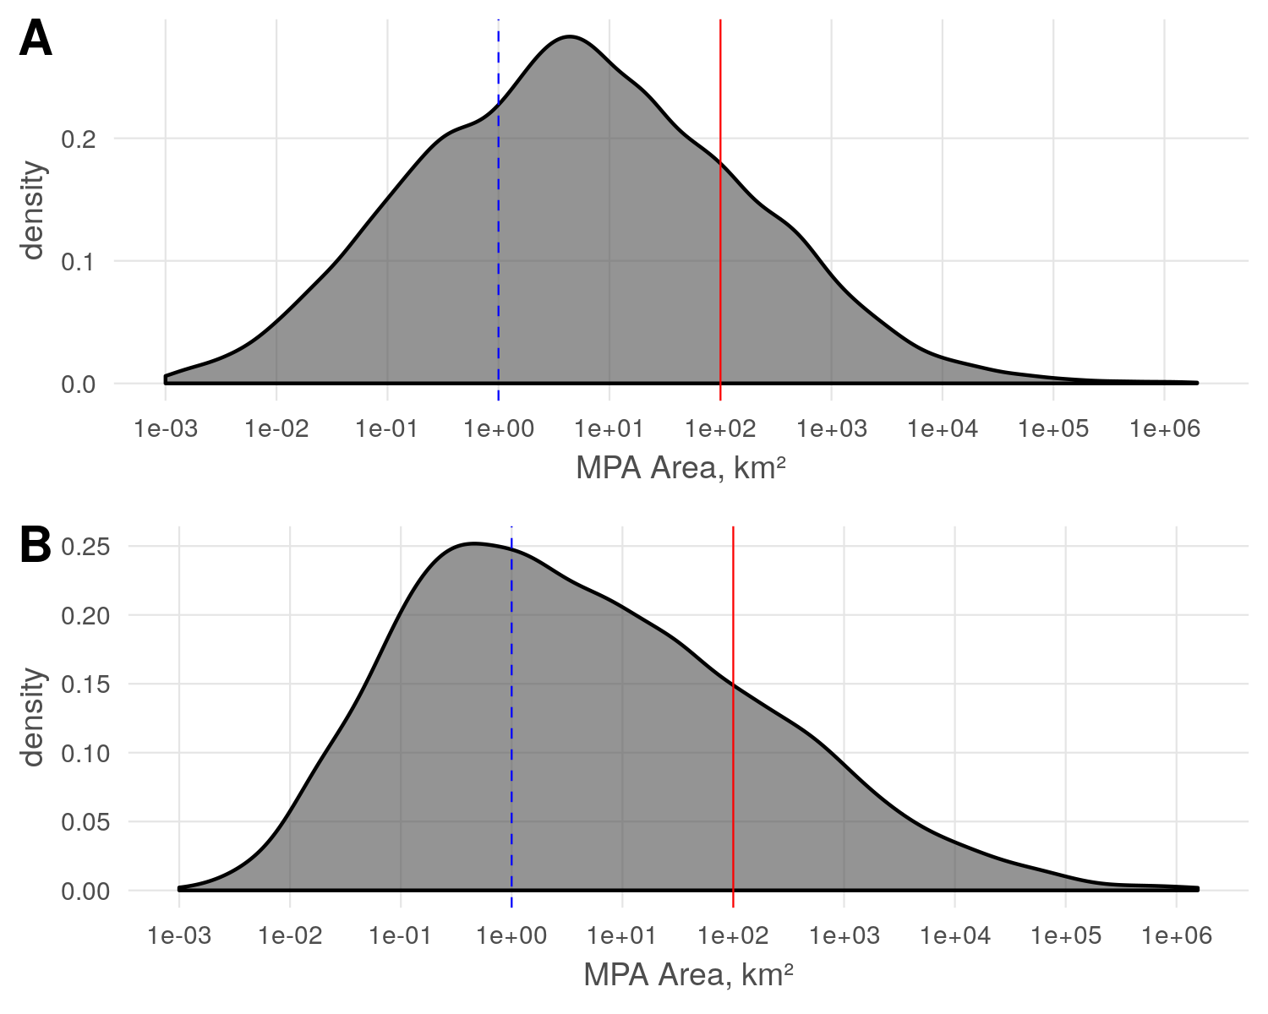

Figure SM1: Distribution of MPAs by size, based on original WDPA polygon data. A) all protection categories are included. B) only no-take marine protected areas are included. The red solid line indicates MPA size 100 km2, i.e., the resolution of the biodiversity risk data; the blue dashed line indicates MPA size 1 km2. Note that overlapping polygons are not resolved in this plot, and result in some double-counting.

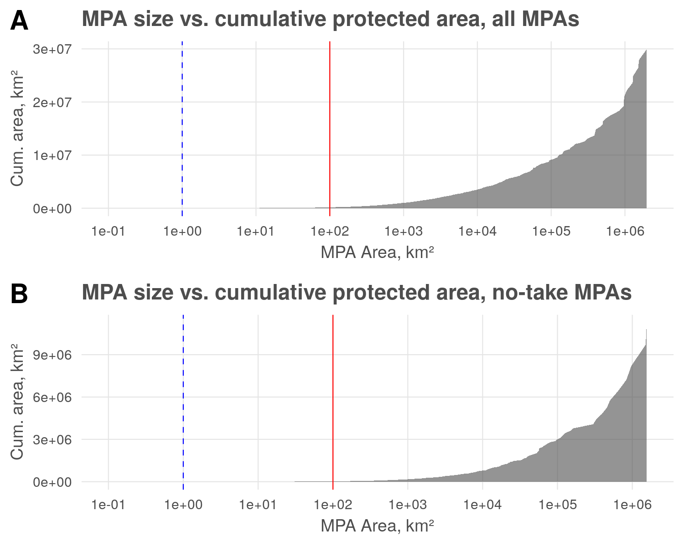

Figure SM2: Contribution of protected area of different sizes to the cumulative global MPA estate, based on original WDPA polygon data. A) all protection categories are included. B) only no-take marine protected areas are included. The red solid line indicates MPA size 100 km2, i.e., the resolution of the biodiversity risk data; the blue dashed line indicates MPA size 1 km2. Note that overlapping polygons are not resolved and result in some double-counting.

Figure SM1 shows that smaller MPAs make up a large proportion of the designated protected areas. However, Figure SM2 shows that despite the large number of small MPAs, the proportion of MPA coverage from small MPAs (< 1 km2 and < 100 km2) is miniscule.

Table SM1: All protected areas

|  |  |  |  |  |
| --- | --- | --- | --- | --- |
| MPA size | A total, km² | N | % MPA by count | % MPA by area |
| < 1 km^2 | 1513.703 | 5677 | 31.653192 | 0.0050580 |
| < 100 km^2 | 162141.387 | 8737 | 48.714804 | 0.5417953 |
| < 1000 km^2 | 852239.779 | 2447 | 13.643713 | 2.8477586 |
| >= 1000 km^2 | 28910791.811 | 1074 | 5.988291 | 96.6053881 |

Table SM1 shows that when examining all MPAs ( $n$ = 17,935), there are more than 14,000 MPAs smaller than 100 km2, comprising 80% of MPAs but a total area of only 0.55% of all marine protection of any category; MPAs smaller than 1 km2 (as small as 5.0 m2) comprise only 0.005% of all marine protection. The 3,521 MPAs larger than 100 km2 encompass 99.45% of all marine protection.

Table SM2: No-take protection only

|  |  |  |  |  |
| --- | --- | --- | --- | --- |
| MPA size | A total, km² | N | % MPA by count | % MPA by area |
| < 1 km^2 | 339.231 | 1287 | 38.648649 | 0.0030129 |
| < 100 km^2 | 24461.060 | 1356 | 40.720721 | 0.2172490 |
| < 1000 km^2 | 144854.132 | 409 | 12.282282 | 1.2865108 |
| >= 1000 km^2 | 11089803.108 | 278 | 8.348348 | 98.4932274 |

The pattern is even more pronounced for no-take MPAs ( $n$ = 3,330, Table SM2) than for the entire collection of MPAs regardless of category: no-take MPAs smaller than 100 km2 make up 79% by count but contribute only 0.22% of the global no-take MPA estate, while those smaller than 1 km2 contribute only 0.003%.

### Effect of rasterization on inclusion of small MPAs

To facilitate comparison between polygon area calculations and raster area calculations, we created a representative sample polygon dataset. This dataset included only no-take MPAs (i.e., IUCN category I or II or designated no-take area greater than 75% of the total area). To eliminate double-counting of protected area, these no-take MPA features were filtered to remove overlapping polygons; since our concern is the effects of rasterization on small MPAs, we removed the larger of any pair of overlapping polygons, resulting in 2,862 distinct no-take MPA features. While this dataset differs from that used above and in the primary analysis of the manuscript, it is a representative sample for the sake of testing the effects of the rasterization process on inclusion and total area.

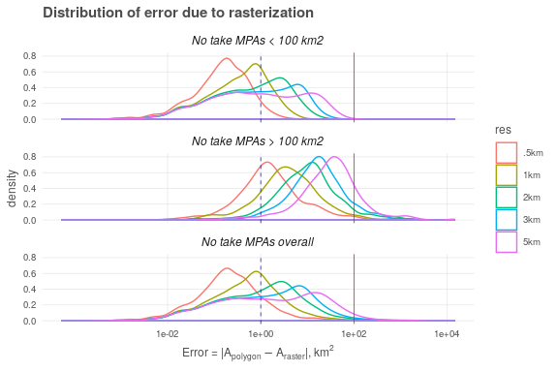

### Proportional error by size class

Proportional error calculated as $∑(A_{polygon}−A_{raster})/∑(A_{polygon})$. Negative differences and positive errors may offset each other; the aggregate is the total difference in MPA coverage.

Table SM3: Proportional total difference in area by size class

|  |  |  |  |  |  |  |
| --- | --- | --- | --- | --- | --- | --- |
| Size class | Area in class, km² (polygons) | ∆ Area in class, % (.5km cells) | ∆ Area in class, % (1km cells) | ∆ Area in class, % (2km cells) | ∆ Area in class, % (3km cells) | ∆ Area in class, % (5km cells) |
| < .001 | 0.004 | 100.000 | 100.000 | 100.000 | 100.000 | 100.000 |
| < .01 | 0.216 | -15.513 | 100.000 | 100.000 | 100.000 | 100.000 |
| < .1 | 20.137 | -8.009 | 5.647 | -58.910 | 10.613 | -24.148 |
| < 1 | 295.625 | -0.211 | -2.495 | 21.522 | -0.465 | -9.936 |
| < 3 | 620.089 | -1.276 | -1.598 | 2.595 | -8.855 | 3.240 |
| < 10 | 1945.573 | 0.672 | 1.880 | -2.181 | 2.856 | 7.482 |
| < 100 | 17036.072 | -0.236 | -0.129 | 0.705 | 1.051 | 1.679 |
| >= 100 | 6760307.542 | -0.148 | -0.135 | -0.172 | -0.158 | -0.257 |
| Total | 6780225.259 | -0.148 | -0.135 | -0.169 | -0.155 | -0.250 |

Table SM3 shows that the rasterization process results in a total calculated area that differs from the original dataset by only 0.13%, when positive and negative errors are allowed to balance out.

### RMS error by size class

Proportional RMS error in area calculated as $\sqrt{\frac{1}{N}\sum_{i=1}^{N}{(}\frac{A_{polygon}−A_{raster}}{A_{polygon}})^{2}}$.

Table SM4: RMS proportional error in area by size class

|  |  |  |  |  |  |  |
| --- | --- | --- | --- | --- | --- | --- |
| Size class | Area in class, km² (polygons) | RMSE(∆ Area) in class, % (.5km cells) | RMSE(∆ Area) in class, % (1km cells) | RMSE(∆ Area) in class, % (2km cells) | RMSE(∆ Area) in class, % (3km cells) | RMSE(∆ Area) in class, % (5km cells) |
| < .001 | 0.004 | 15.560 | 15.560 | 15.560 | 15.560 | 15.560 |
| < .01 | 0.216 | 17.975 | 2.623 | 2.623 | 2.623 | 2.623 |
| < .1 | 20.137 | 0.503 | 1.028 | 2.697 | 3.055 | 6.019 |
| < 1 | 295.625 | 0.069 | 0.181 | 0.353 | 0.619 | 1.097 |
| < 3 | 620.089 | 0.058 | 0.141 | 0.363 | 0.606 | 1.054 |
| < 10 | 1945.573 | 0.028 | 0.070 | 0.174 | 0.319 | 0.575 |
| < 100 | 17036.072 | 0.006 | 0.014 | 0.037 | 0.058 | 0.115 |
| >= 100 | 6760307.542 | 0.008 | 0.009 | 0.009 | 0.010 | 0.010 |
| Total | 6780225.259 | 0.003 | 0.004 | 0.004 | 0.004 | 0.004 |

Table SM4 shows that if high and low errors due to rasterization are counted as a positive difference, then the rasterization process results in a total error of 0.36% relative to the original dataset.

### Number of MPAs dropped due to rasterization

MPA presence within a cell is determined by the overlap of the MPA polygon and the center of the cell. For very small MPAs, or MPAs with narrow aspect ratios, the polygon may not overlap the center, and thus may not be counted.

Table SM5: Percent of MPAs dropped by size class

|  |  |  |  |  |  |  |  |
| --- | --- | --- | --- | --- | --- | --- | --- |
| Size class | N | Area in class, km² | % dropped (.5km cells) | % dropped (1km cells) | % dropped (2km cells) | % dropped (3km cells) | % dropped (5km cells) |
| < .001 | 7 | 4.449600e-03 | 100.00000 | 100.000000 | 100.0000000 | 100.000000 | 100.00000 |
| < .01 | 41 | 2.164264e-01 | 97.56098 | 100.000000 | 100.0000000 | 100.000000 | 100.00000 |
| < .1 | 425 | 2.013718e+01 | 80.00000 | 95.529412 | 98.1176471 | 99.529412 | 99.76471 |
| < 1 | 756 | 2.956252e+02 | 20.63492 | 64.814815 | 92.3280423 | 95.634921 | 98.28042 |
| < 3 | 350 | 6.200887e+02 | 0.00000 | 9.714286 | 61.1428571 | 78.857143 | 93.42857 |
| < 10 | 326 | 1.945573e+03 | 0.00000 | 0.000000 | 14.1104294 | 46.932515 | 79.44785 |
| < 100 | 473 | 1.703607e+04 | 0.00000 | 0.000000 | 0.2114165 | 3.805497 | 23.67865 |
| >= 100 | 484 | 6.760308e+06 | 0.00000 | 0.000000 | 0.0000000 | 0.000000 | 0.00000 |
| Total | 2862 | 6.780225e+06 | 18.97275 | 34.171908 | 49.7554158 | 57.337526 | 66.84137 |

Table SM5: Percent of MPA area dropped by size class

|  |  |  |  |  |  |  |  |
| --- | --- | --- | --- | --- | --- | --- | --- |
| Size class | N | Area in class, km² | % area dropped (.5km cells) | % area dropped (1km cells) | % area dropped (2km cells) | % area dropped (3km cells) | % area dropped (5km cells) |
| < .001 | 7 | 4.449600e-03 | 100.0000000 | 100.0000000 | 100.0000000 | 100.0000000 | 100.0000000 |
| < .01 | 41 | 2.164264e-01 | 98.3626950 | 100.0000000 | 100.0000000 | 100.0000000 | 100.0000000 |
| < .1 | 425 | 2.013718e+01 | 74.9140193 | 94.8514340 | 97.5916349 | 99.3396904 | 99.8047883 |
| < 1 | 756 | 2.956252e+02 | 10.7124634 | 53.0208291 | 88.7282337 | 94.3046066 | 97.7301973 |
| < 3 | 350 | 6.200887e+02 | 0.0000000 | 7.5386508 | 58.3292774 | 77.8897496 | 92.2197407 |
| < 10 | 326 | 1.945573e+03 | 0.0000000 | 0.0000000 | 9.5469433 | 41.9886681 | 76.5098893 |
| < 100 | 473 | 1.703607e+04 | 0.0000000 | 0.0000000 | 0.0671742 | 1.4061992 | 12.5913895 |
| >= 100 | 484 | 6.760308e+06 | 0.0000000 | 0.0000000 | 0.0000000 | 0.0000000 | 0.0000000 |
| Total | 2862 | 6.780225e+06 | 0.0006928 | 0.0032862 | 0.0124045 | 0.0271153 | 0.0665865 |

Table SM5 shows that, indeed, many small MPAs are not included in the final raster depending on the cell resolution. Unsurprisingly, the smaller the MPA, the more likely to be dropped. Dropped MPAs will result in a certain underestimate of MPA coverage globally, though this is quite small: even at 5 km x 5 km cell resolution, the total difference due to these dropped MPAs is only 0.067% of the MPA coverage of this sample dataset, and only 0.0007% at 0.5 km x 0.5 km resolution. These results overestimate the loss, since many of these small MPAs would be overlapped by larger MPAs (and thus accounting for that protection). Additionally, this sample dataset removes larger MPAs that would obscure smaller MPAs, thus the total area of the sample dataset is biased toward smaller MPAs, inflating the relative proportion of dropped area.

## Calculating protected area at 100 km2 analysis resolution

The biodiversity risk analysis is performed at a resolution of 10 km x 10 km cells. To determine the proportional coverage of MPAs at this analysis resolution, we count the number of protected cells at the MPA raster resolution that fall within a single 10 km x 10 km analysis cell, multiply by the MPA raster cell area, and divide by the analysis cell area, i.e. 100 km2. This results in a proportional protection from 0 to 1 in each 10 km x 10 km analysis cell.

$$\text{MPA protection}=\frac{N_{cells,MPA}*A_{cell,MPA}}{A_{cell,analysis}}=\frac{N_{cells,MPA}*.25km^{2}}{100km^{2}}$$