SD Assignment 1

Tennis schedule

Calinescu Mirela | 2024

# Database Diagram

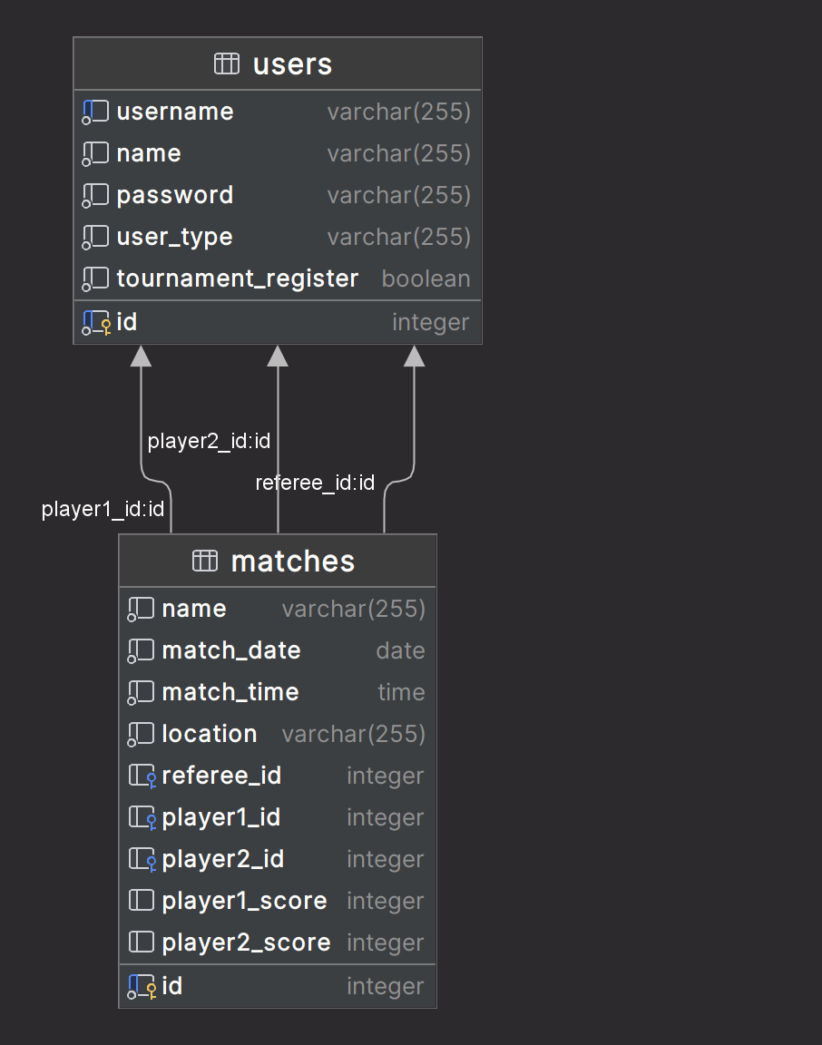

# Use-case Diagram

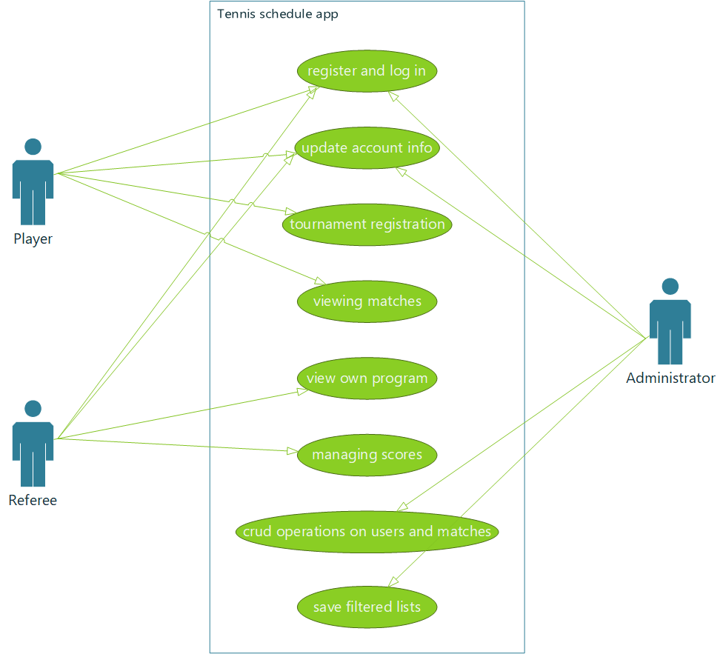

# Class Diagram

