STUDY GUIDE
Assignment 4: Predicting PM2.5 Air Quality from AirQo Sensor Data
CSC3119 AI Deployment & Scalability · Uganda Christian University
What this guide is for
It explains what was done, why, and how to talk about it: the EDA, every model and hyperparameter, what each metric means and what decisions it supports, how Evidently AI monitoring works, and step-by-step instructions to run and host the model on RunPod.
Every number in this guide comes from the executed notebook PM25_AirQo_Pipeline.ipynb (outputs/metrics.json and outputs/model_comparison.csv).
Section 12 lists likely questions from a lecturer or panel with short model answers.

Deliverable | File | Notes
Code (full pipeline) | PM25_AirQo_Pipeline.ipynb | Runs end-to-end in about 3 minutes on 2 CPUs
Saved best model | best_pm25_model.joblib | Random Forest pipeline + μ/σ for inverse Z-score
Presentation | PM25_AirQo_Presentation.pptx | UCU template; add your name and RunPod screenshots
Study guide | this document | Not a submission item; for your preparation
Report (LaTeX) | not included | Required by the brief; this guide's sections map directly onto it
Contents

If the table of contents is empty, right-click it in Word and choose Update Field.

1. The big picture
PM2.5 are particles of 2.5 micrometres or less. They pass the nose and throat filters, reach deep into the lungs and can enter the bloodstream. Kampala's annual mean (39 µg/m³ in 2018–2021) is about eight times the WHO guideline of 5 µg/m³, and an estimated 7,257 deaths over that period were attributed to long-term exposure. A model that predicts PM2.5 turns a sparse network of sensors into an early-warning tool for the health sector, NEMA, the Ministry of Energy and the Ministry of Works and Transport.
The assignment asks for a complete, deployable pipeline. The notebook follows eight stages, and each stage feeds the next:
# | Stage | What happens | Key output
1 | Load & audit | Read 14,600 rows; count empty cells and zeros that are really nulls | Audit table
2 | Clean | Zeros → null, fix coordinates, physical limits, flag outliers, fix data types | Clean table
3 | Hourly resample | Every sensor × every hour, 1 Jan–31 Jul 2026; offline hours kept as missing; gaps ≤ 3 h interpolated | 758,112-row grid
4 | EDA | 5 Kampala sensors: distributions, box plots, AQI time series, calendar, Z-score, correlation | Figures + insights
5 | Model | 5 models + 2 ensembles, each tuned with RandomizedSearchCV | Comparison table
6 | Save | Best pipeline re-fitted on all data and saved with μ and σ | best_pm25_model.joblib
7 | Forecast | Daily (3–16 Aug) and hourly (1 Aug) PM2.5, inverse Z-scored | CSV files + plots
8 | Monitor & deploy | Evidently drift reports; logs and metrics for RunPod | HTML reports, pipeline_log.txt

2. The data, and the surprise inside it
The CSV has 14,600 hourly rows from 149 sensors at 145 sites (two hardware networks: AirQo and AirGradient). Columns: site name, timestamp (UTC, marked with a Z), frequency, network, latitude, longitude, temperature, humidity, calibrated PM2.5, calibrated PM10, site_id and device_name.
Key finding you must be able to explain
Although the file is labelled January–July 2026, readings exist for only three short windows: 1–3 January, 1–2 April and 1–3 June (147 distinct hours, about 8 calendar days). There is nothing in July.
After building the full hourly grid, only 1.9 % of sensor-hours are observed. We keep the other 98 % as missing, not absent, exactly as the brief requires, and add an is_observed flag (the 'sensor off' status suggested in the class meeting).
Consequence: the models cannot learn seasons or weekday patterns, and validation must be designed carefully (Section 5).

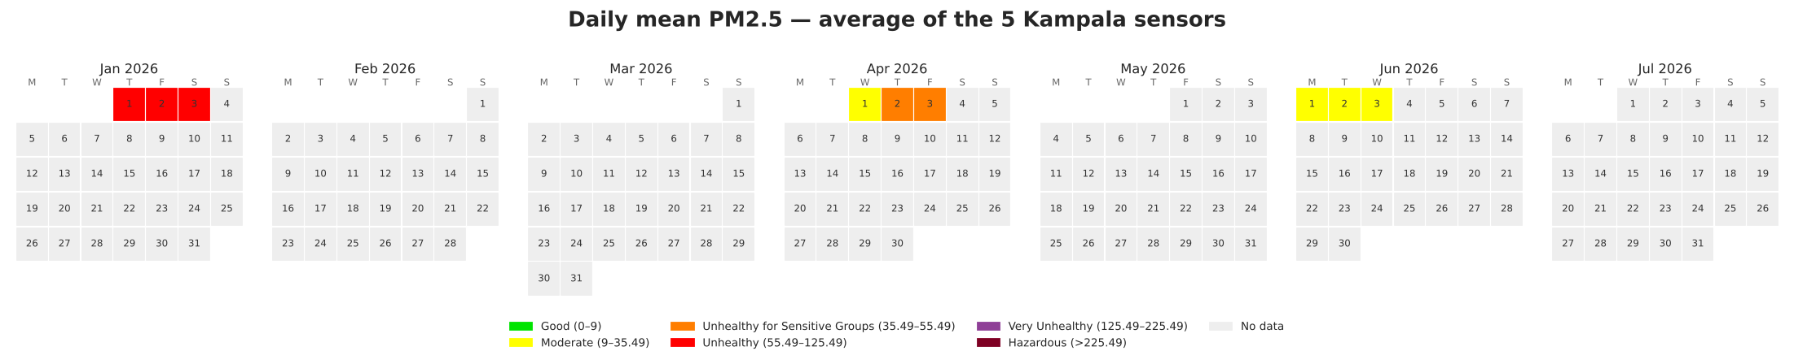
Figure 1. Daily mean PM2.5 of the five Kampala sensors, January–July 2026, AQI colours. Grey = no data.

2.1 Audit of problems
Column | Problem found | % of rows affected
temperature, humidity | Zeros (impossible in Uganda) plus a few empty cells | ≈ 28 % and 30 %
latitude, longitude | Zeros plus GPS values far from the device's usual position | ≈ 21 %
pm2_5_calibrated_value | Empty cells; a long tail up to 998 µg/m³ | 2.2 % empty
site_id | Empty for half the rows; duplicates device_name | 51 %
frequency | Always 'hourly': no information | —

3. Data preparation: every decision and why
The brief asks for a statistically justified treatment of nulls, not blind deletion. The guiding idea from the literature is the distinction between short gaps and long gaps. PM2.5 is strongly autocorrelated from hour to hour, so a gap of one to three hours can be filled by linear interpolation with little error; Junninen et al. (2004) found simple linear interpolation to be the most reliable method for short gaps in air-quality series, with accuracy falling as gaps grow. Long outages (days or months) must stay missing, because interpolating them would invent data. AirQo's own studies (Okure et al., 2022; Adong et al., 2022) work with hourly calibrated low-cost data, remove physically implausible values and keep site identity because sensors differ systematically.
Step | Rule applied | Why | Effect in our data
Zeros → null | temp, humidity, PM2.5, PM10, lat, lon = 0 become NaN | Brief §5: zero means no reading | ≈ 4,100 temp and 4,200 RH zeros
Coordinates | Use each device's median position; reject fixes > 0.05° (~5.5 km) from it; geocode 6 devices that never reported a position from their site name | A fixed monitor does not move; median ignores corrupt GPS fixes | 103 bad fixes; 6 devices geocoded (e.g. Kalerwe, Ntinda, Kabale)
Physical limits | PM2.5 > 500 µg/m³, temp outside 5–45 °C, RH outside 1–100 % → NaN | Above instrument range = error, not pollution | 3 PM2.5 values removed (e.g. 793 and 998)
Statistical outliers | Per-sensor robust Z (median/MAD) > 3.5 → flagged but kept | Spikes line up with traffic and cooking peaks; they are real events | 1,161 flagged
Uninformative columns | Drop site_id, frequency | 51 % empty / constant | device_name is the key
Data types | Timestamps parsed as UTC then converted to Kampala time (UTC+3); numbers as float64; IDs as category | Consistent types; local time for traffic/cooking patterns | —
Hourly grid | Reindex every sensor to every hour 1 Jan–31 Jul | Brief: offline hours must be missing, not absent | 149 × 5,088 = 758,112 rows
Gap filling | Linear interpolation only inside gaps of ≤ 3 h | Short-gap rule from the literature | 1,976 hours filled; 741,864 stay missing

Why local time matters
The raw timestamps end in 'Z' (UTC). Kampala is UTC+3, so 05:00Z is 08:00 in Kampala. If you forget to convert, the morning traffic peak appears at 5 am and every hour-of-day feature is shifted.

4. Exploratory Data Analysis: how to read each plot
Five Kampala sensors with the most data were chosen: Nakasero II (aq_66), Civic Centre (aq_g5_37), Bukoto I (aq_47), Lower Nsooba (aq_g507) and Salama Road (ag_588c81267534, an AirGradient unit). They cover the city centre and Kawempe and include both hardware networks.

4.1 Distributions: skewness
A distribution (density) plot shows how often each value occurs. PM2.5 is right-skewed (skewness 1.74): most hours are 15–60 µg/m³, but a long tail stretches past 250 µg/m³. In a right-skewed variable the mean is larger than the median, because the few large values pull the average up.
- What large skewness means for us: averages exaggerate typical exposure; medians describe the typical hour better, but the tail is where the health risk is.
- Decision: keep the tail (it is real pollution), prefer models that are robust to extreme values (trees), and report RMSE alongside MAE so big misses are visible.
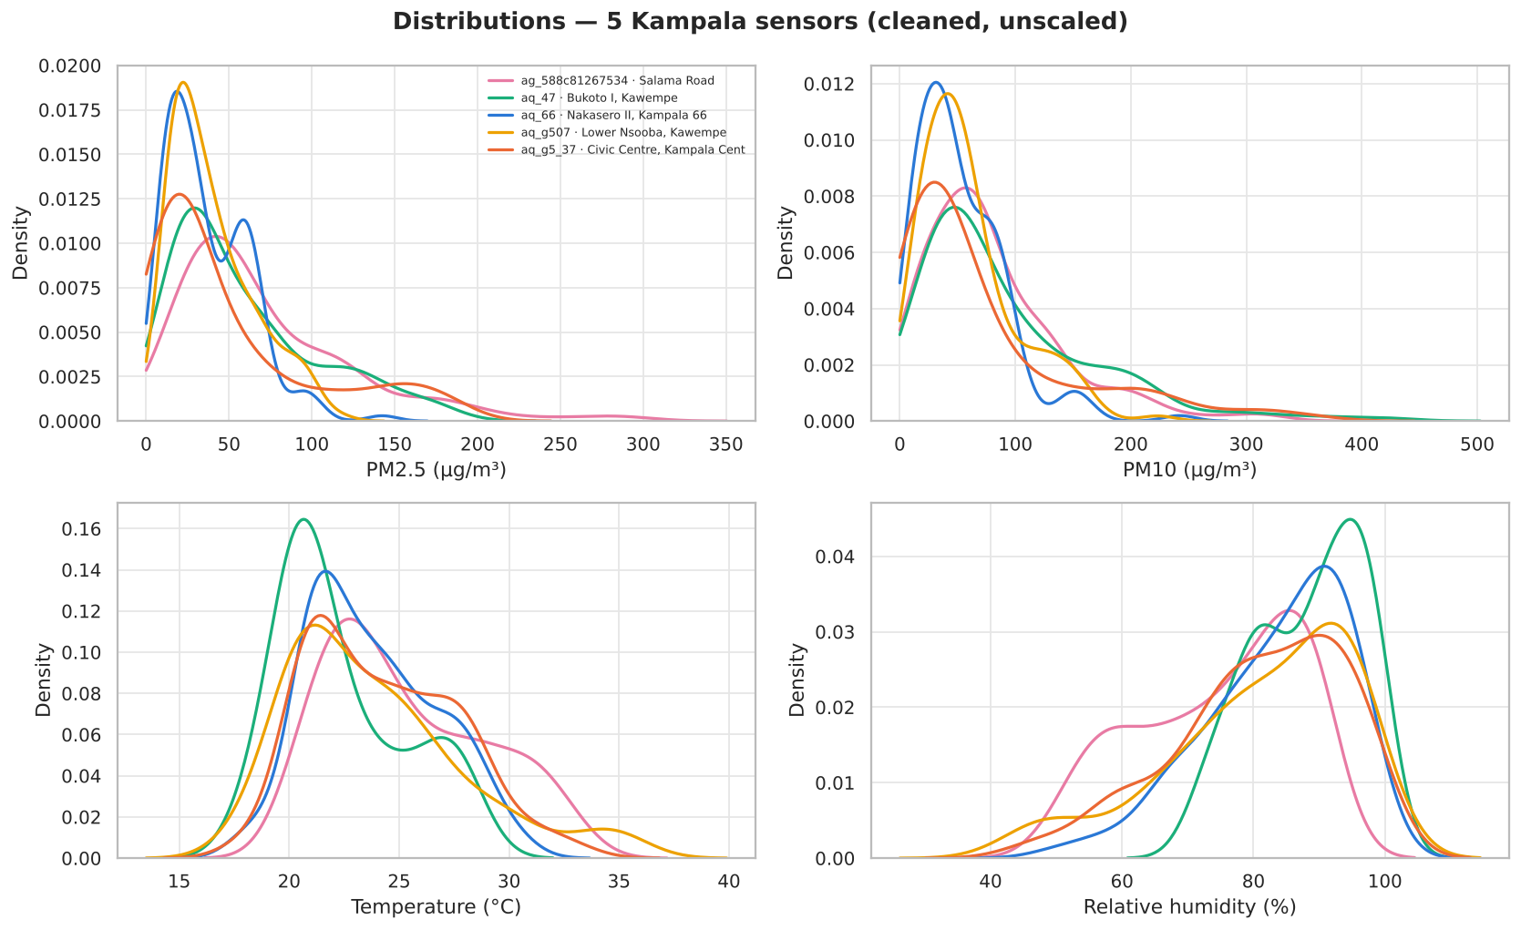
Figure 2. Distributions of PM2.5, PM10, temperature and humidity for the five sensors.

4.2 Box plots and outliers
A box plot shows the median (line), the middle 50 % of values (the box, from Q1 to Q3) and whiskers up to 1.5 × IQR. Dots beyond the whiskers are IQR outliers. We also computed a robust Z-score per sensor using the median and MAD (median absolute deviation), which is not distorted by the outliers themselves.
Sensor | Hours | IQR outliers | Robust-Z outliers | Max PM2.5
Salama Road | 142 | 5 | 5 | 291
Bukoto I | 145 | 6 | 6 | 186
Nakasero II | 147 | 1 | 1 | 142
Lower Nsooba | 144 | 1 | 0 | 116
Civic Centre | 147 | 17 | 25 | 188
Treatment and its justification: we flag but keep statistical outliers. They happen at 7–10 am and 7–11 pm, which is when traffic and cooking peak, so they are plausible pollution events rather than faults. Only values outside the instrument's physical range (> 500 µg/m³) were removed. Deleting real peaks would teach the model that Kampala is cleaner than it is, which is the dangerous direction for a health warning system.

4.3 Time series with AQI bands
Each line is a sensor; the coloured background bands are the AQI categories from the brief (green Good, yellow Moderate, orange Unhealthy for Sensitive Groups, red Unhealthy, purple Very Unhealthy, maroon Hazardous). A break in a line is an hour when the sensor was offline.
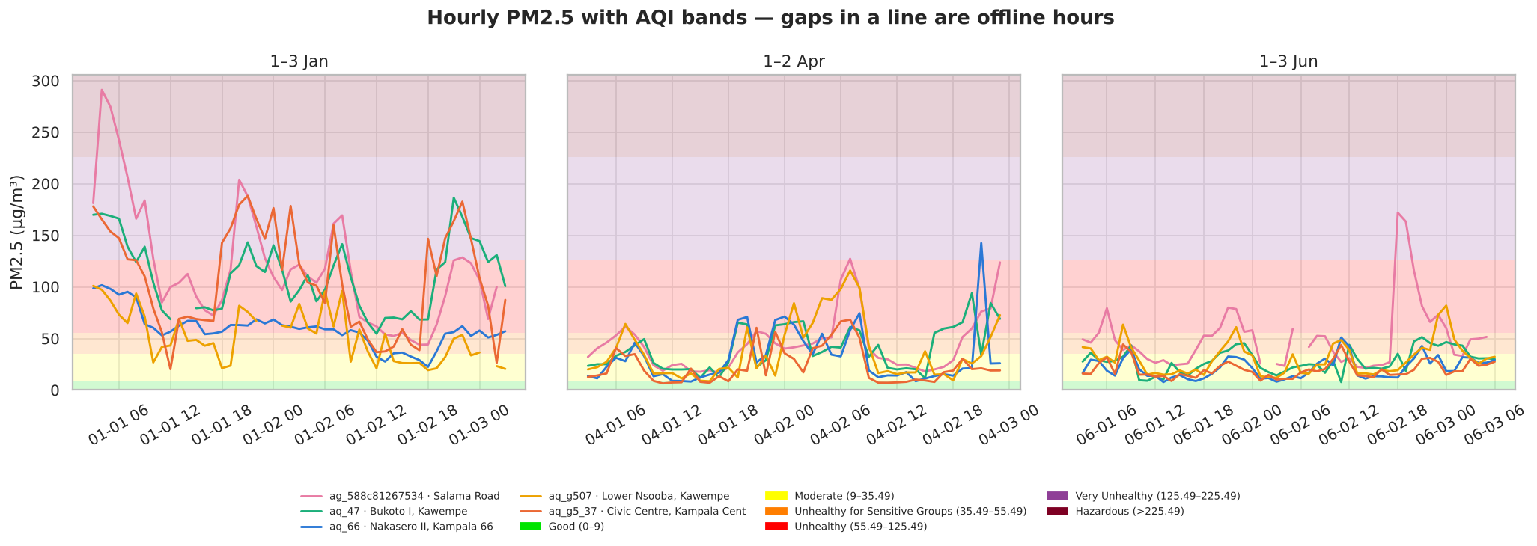
Figure 3. Hourly PM2.5 for the five Kampala sensors with AQI bands.
- January is far worse: mean 48.7 µg/m³ with many hours in the red Unhealthy band; April and June average about 24 µg/m³ and sit mostly in Moderate.
- Decision: a single season cannot represent the year. Any model needs a way to capture this level shift (we use the month feature) and its validation must include every window.

4.4 Calendar plot
The calendar plot (Figure 1) colours each day by its mean PM2.5 using the AQI scale. It answers 'which days were safe?' at a glance. Here it also makes the data gaps obvious: only 8 days are coloured; everything grey is a period with no data.

4.5 Diurnal cycle
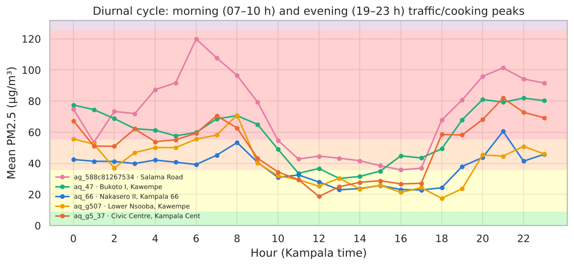
Figure 4. Mean PM2.5 by hour of day (Kampala time).
Two peaks: morning (about 6–10 am) and evening (about 7–11 pm), with a minimum around 1–4 pm. Morning and evening combine emissions (traffic, charcoal cooking) with a shallow, stable atmospheric boundary layer that traps pollutants near the ground. In the afternoon the sun heats the ground, the mixing layer deepens and PM2.5 is diluted. Decision: hour of day is an essential feature, encoded as sine and cosine so that 23:00 and 00:00 are treated as neighbours.

4.6 Z-score transformation
The Z-score expresses each value as a number of standard deviations from the mean: z = (x − μ) / σ. Using the cleaned PM2.5 of all sensors, μ = 32.53 µg/m³ and σ = 27.86 µg/m³. The inverse, used after prediction, is x = z × σ + μ.
z | PM2.5 (µg/m³) | AQI category | Meaning
−1 | 4.7 | Good | one SD cleaner than the network average
0 | 32.5 | Moderate | an average hour
+1 | 60.4 | Unhealthy | one SD dirtier than average
+3 | 116.1 | Unhealthy | a rare, very polluted hour
+5 | 171.8 | Very Unhealthy | extreme event
- AQI thresholds in z-units: USG begins at z = 0.11, Unhealthy at z = 0.82, Very Unhealthy at z = 3.34. So any positive z already means 'Unhealthy for Sensitive Groups' or worse.
- Because PM2.5 cannot be negative, z cannot go below -1.17; but because of the long right tail, z can reach +15. The Z-score does not change the shape or the ranking of values; it only re-centres and re-scales.
- Why use it as the target? Distance-based models (KNN, SVR) and regularised linear models (Ridge) behave better when the target is on a unit scale, and errors in z-units are comparable across datasets. Large |z| = unusual hour worth attention; z near 0 = typical.
- Per-sensor average z shows which sites are persistently dirty (e.g. ag_588c81266dc8 in Nansana, mean z ≈ +2.1) or clean (aq_g5_93, mean z ≈ −0.7).
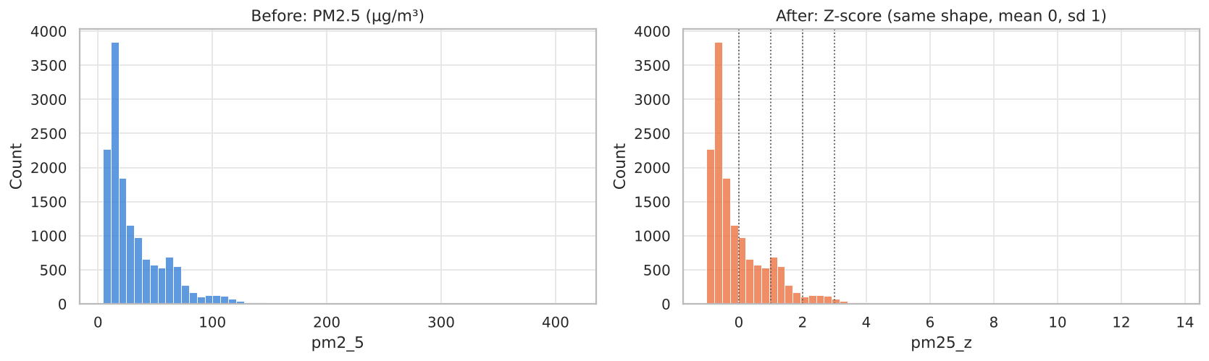
Figure 5. PM2.5 before and after Z-scoring: same shape, new scale.

4.7 Correlation of temperature and humidity with PM2.5
Pearson correlation measures straight-line association; Spearman measures whether two variables rise and fall together in rank, so it is better for skewed data like PM2.5. Both range from −1 (perfect opposite movement) to +1 (perfect same-direction movement); 0 means no monotonic relationship.
Sensor | Pearson temp | Pearson RH | Spearman temp | Spearman RH
Salama Road | −0.51 | +0.41 | −0.56 | +0.48
Bukoto I | −0.25 | +0.26 | −0.17 | +0.28
Nakasero II | −0.13 | +0.16 | −0.13 | +0.26
Lower Nsooba | −0.32 | +0.35 | −0.33 | +0.40
Civic Centre | −0.07 | −0.03 | −0.09 | +0.04
All 5 pooled | −0.16 | +0.08 | −0.16 | +0.14
- Interpretation: warmer hours have less PM2.5 (deeper mixing layer); more humid hours have more PM2.5 (stable night air, particle growth by water uptake). This matches the physics in brief §2.
- Magnitude: 0.1–0.3 is weak, 0.3–0.5 moderate, above 0.5 strong. Correlations are moderate at best, so weather alone cannot predict PM2.5; it must be combined with time of day and site.
- Pooled correlations are weaker than per-sensor ones because each site has a different baseline level; mixing them hides the within-site relationship (a mild case of Simpson's paradox).
- PM10 has ρ ≈ 0.98 with PM2.5. It is measured at the same moment, so using it to predict PM2.5 would be leakage: it would not be available when forecasting the future. That is why PM10 is excluded.
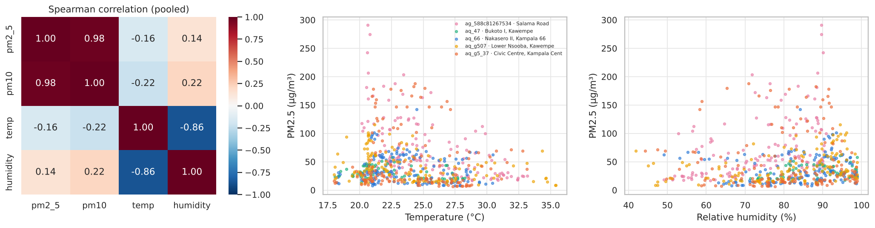
Figure 6. Spearman correlation matrix and scatter plots against temperature and humidity.

5. Features and validation design

5.1 Which fields enter the model
Input | Used? | Reason
temp, humidity | Yes | Physically linked to PM2.5; correlated in the EDA
hour of day (sin, cos) | Yes | Captures the double daily peak
month | Yes | Captures the January vs April/June level shift
latitude, longitude | Yes | Spatial differences between towns and neighbourhoods
network (AirQo / AirGradient) | Yes | Different hardware and calibration
device_name (target-encoded) | Yes | Each site's typical level (roadside, market, residential)
PM10 | No | Leaks the answer; not known in the future
day of week, dry-season flag | No (tested) | Only 8 days exist, so they act as date identifiers and made test errors worse
site_id, frequency, site_name | No | Empty / constant / duplicate of device_name
Target encoding replaces each sensor ID with the average target value seen for that sensor in training. scikit-learn's TargetEncoder uses internal cross-fitting, so a row's own value is never used to encode it (no leakage). Unknown sensors get the overall mean.
Missing values inside the model: temperature and humidity are still missing for some observed hours. Every pipeline starts with a median imputer plus a missing-indicator column. This answers the question raised in the class meeting: the deployed model will not crash when the API sends nulls, and it can learn whether 'sensor did not report weather' itself carries information.

5.2 How the data was split, and why
A random train/test split would be misleading: neighbouring hours are almost identical, so the model would be tested on near-copies of its training data. We therefore used a blocked temporal split:
- Train: the first day of each window (1 Jan, 1 Apr, 1 Jun): 6,126 hours.
- Test (hold-out): the later days (2–3 Jan, 2 Apr, 2–3 Jun): 8,146 hours, each in the future of its own training day.
- Hyperparameter tuning: RandomizedSearchCV with GroupKFold over 6-hour blocks, so neighbouring hours are never split between training and validation folds.
The experiment that did not work, and why it is useful
First design: train on January + April, test on June. Every model scored R² at or below zero on June, meaning no better than always predicting the mean.
Cause: January is twice as polluted as April and June, and with only two training snapshots no feature can explain that jump. Tree models trained with a dry-season flag (which groups January with June) predicted June far too high.
This is a real example of data drift and is analysed with Evidently in Section 9 (Run B). Mention it: it shows you tested assumptions rather than only reporting the best number.

6. The models and their hyperparameters
A hyperparameter is a setting chosen before training (e.g. the number of trees), as opposed to a parameter learnt from data (e.g. a regression coefficient). Tuning tries many settings and keeps the one with the lowest cross-validated RMSE. We used RandomizedSearchCV (25 random combinations per model, 12 for the slow SVR and Random Forest) because it explores wide ranges far more cheaply than a full grid.
Model | Idea in one line | Tuned | Best values found
Ridge regression | Straight-line fit with an L2 penalty that shrinks coefficients | alpha | alpha = 660
K-Nearest Neighbours | Average of the K most similar past hours | n_neighbors, weights, p | K = 11, distance-weighted, Manhattan (p = 1)
SVR (RBF kernel) | Fits a smooth curve, ignoring errors smaller than ε | C, epsilon, gamma | C = 1.33, ε = 0.49, γ = 0.157
Decision Tree | One tree of yes/no splits | max_depth, min_samples_leaf, min_samples_split, max_features | depth 13, leaf 52, split 58, 50 % features
Random Forest (bagging ensemble) | Average of many trees, each on a bootstrap sample and random features | n_estimators, max_depth, max_features, min_samples_leaf | 393 trees, depth 12, 33 % features, leaf 2
HistGradientBoosting (boosting ensemble) | Trees built one after another, each fixing the previous errors | learning_rate, max_iter, max_leaf_nodes, max_depth, l2_regularization, min_samples_leaf | lr 0.0175, 426 iterations, 16 leaves, l2 0.015, leaf 10
Stacking (ensemble) | Ridge combines predictions of KNN, RF and HGB | meta-learner alpha | alpha = 10

6.1 What each hyperparameter does, large vs small
Hyperparameter | Small value | Large value | What our result tells us
Ridge alpha | ≈ ordinary regression, may overfit correlated inputs | coefficients shrink toward 0, underfit | alpha = 660 is large: a linear model can only use a few strong, stable signals here
KNN n_neighbors (K) | noisy, memorises individual hours | over-smoothed, misses local patterns | K = 11 with distance weighting: local averaging of similar site-hours
SVR C | smooth, tolerant fit | chases every point (outliers) | C ≈ 1.3: moderate; outliers not chased
SVR epsilon | every small error penalised | wide tube, simpler model | ε ≈ 0.49 z (≈ 14 µg/m³): small errors deliberately ignored
SVR / RBF gamma | very smooth surface | very wiggly, overfits | γ ≈ 0.16: moderately local
Tree max_depth | too simple (underfit) | memorises (overfit) | Single tree needed big leaves (52) to stay stable
min_samples_leaf | leaves fit single noisy hours | smoother, may miss detail | RF uses 2 (averaging handles noise); DT needs 52
RF n_estimators | unstable average | stable but slower; plateaus | 393 trees; beyond ~200 gains are tiny
RF max_features | diverse, decorrelated trees | similar trees | 33 % of features per split gave the best diversity
GB learning_rate × max_iter | slow learning, needs many trees | fast but overfits | 0.0175 × 426: 'go slow, generalise well'
l2_regularization | leaf values unconstrained | leaf values shrunk | small (0.015): little extra shrinkage needed

7. The evaluation metrics: what they mean and what to do with them
All metrics are computed on the hold-out days. Because the model predicts z-scores, we report RMSE and MAE in z units (what the model optimises) and in µg/m³ after inverse-transforming (what people understand). The two are linked exactly: RMSE(µg/m³) = RMSE(z) × σ.
Metric | Formula / definition | Our best model | Small value means | Large value means | Decision it supports
RMSE (primary) | √ mean (pred − obs)²; squares errors so big misses dominate | 20.8 µg/m³ (z 0.747) | few large misses; trustworthy for spikes | some big misses, e.g. missed pollution episodes | Choose the model; decide if alerts are reliable enough
MAE | mean |pred − obs|; typical error size | 14.2 µg/m³ | typical hour is predicted closely | every-day predictions are off | Communicate 'usually within ±14 µg/m³'
RMSE vs MAE gap | RMSE ≥ MAE always; the gap grows with outlier errors | 20.8 vs 14.2 | errors are uniform | a few very large errors (spikes) | Our gap is notable → focus improvements on spikes
R² | 1 − SSE/SST: share of variance explained vs predicting the mean | 0.37 | ≤ 0: no better than the mean | → 1: explains nearly all variation | 0.37 = useful but modest; do not use for single-hour precision
Bias (mean error) | mean (pred − obs) | +3.4 µg/m³ | near 0: unbiased | + over-predicts (false alarms); − under-predicts (missed danger) | Slight + bias is the safer direction for health
AQI category accuracy | share of hours placed in the correct AQI band | 64 % | wrong colour band often | right colour band most of the time | What NEMA / hospitals actually act on
CV RMSE vs test RMSE | error during tuning vs on untouched data | 0.732 vs 0.747 | close → stable, not overfit | test ≫ CV → overfit to the CV folds | RF is stable; Stacking was not (0.720 → 0.823)

7.1 Why RMSE was chosen as the main metric
- For public health, missing a 150 µg/m³ episode is far worse than being 5 µg/m³ off on a clean day. RMSE squares errors, so it punishes exactly those big misses.
- It is in the same units as PM2.5 (after inverse transform), so it is easy to communicate.

7.2 When a different metric would be better
- MAE or median absolute error if the big spikes were sensor glitches rather than real events: then you would not want them to dominate.
- MAPE (percentage error) is unusable on z-scores (dividing by values near 0) and unstable on very clean hours, so it was avoided. Evidently's MAPE on z-scores is therefore meaningless; ignore it.
- Recall / F1 for 'Unhealthy or worse' if the product is an alert system: what matters then is catching bad hours (recall) without too many false alarms (precision).
- Pinball (quantile) loss if you wanted prediction intervals rather than a single number.
Turning metric values into decisions
RMSE ≈ 21 µg/m³ is larger than the width of the Moderate-to-USG band (≈ 20 µg/m³). So a single hourly prediction near a boundary cannot be trusted to the exact category; use daily means or add a safety margin before issuing alerts.
R² = 0.37 means about a third of the hour-to-hour variation is explained. Good enough to rank sites and times of day (where and when is it worst?), not good enough to replace a sensor reading.
Bias +3.4 µg/m³ means the model leans slightly high: acceptable for warnings, but subtract it if you need unbiased averages for reporting.
64 % AQI accuracy with most errors in a neighbouring band: present forecasts as 'Moderate, possibly USG' rather than a single label.

8. Model performance results
Model | RMSE (µg/m³) | MAE (µg/m³) | R² | AQI acc. | CV RMSE (z)
RandomForest | 20.8 | 14.2 | 0.367 | 64 % | 0.732
HistGradientBoosting | 21.5 | 14.7 | 0.324 | 63 % | 0.738
SVR | 22.2 | 15.7 | 0.283 | 62 % | 0.801
KNN | 22.5 | 15.2 | 0.264 | 62 % | 0.843
Ridge | 22.7 | 16.6 | 0.245 | 53 % | 0.893
Stacking | 22.9 | 15.8 | 0.232 | 63 % | 0.720
DecisionTree | 23.1 | 15.9 | 0.225 | 59 % | 0.825
Baseline: predict mean | 26.2 | 20.3 | -0.003 | 61 % | —
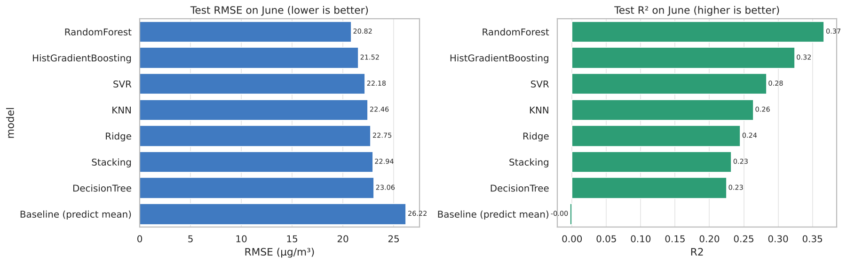
Figure 7. Test RMSE and R² for every model.

8.1 How to interpret the ranking
- Random Forest is best: RMSE 20.8 µg/m³, about 21 % lower than the baseline (26.2) that always predicts the average. Averaging hundreds of decorrelated trees handles the noisy, skewed data and the interactions (site × hour × month) better than any single model.
- HistGradientBoosting is a close second; with more data it often overtakes Random Forest.
- Ridge and the single Decision Tree are weakest: Ridge cannot represent interactions; a single tree is unstable (high variance).
- Stacking had the best CV score but a worse test score. With only 12 CV blocks the meta-learner overfitted the CV predictions. Lesson: with little data, simpler ensembles generalise better; always trust the untouched test set over CV for the final choice.
- Every model beats the baseline, so the features carry real signal; but R² ≈ 0.2–0.37 shows the ceiling set by only 8 days of data.

8.2 Diagnostics of the best model
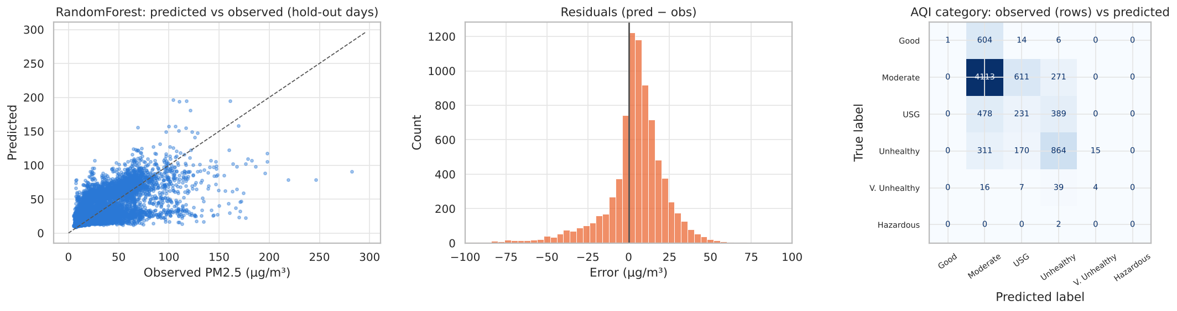
Figure 8. Predicted vs observed, residual distribution and AQI confusion matrix.
- Predicted vs observed: points follow the diagonal but are compressed: low hours slightly over-predicted, spikes above ~120 µg/m³ under-predicted. This is 'regression to the mean', typical when inputs cannot see the cause of a spike (a fire, a traffic jam).
- Residuals are centred near zero with a long negative tail (the missed spikes).
- Confusion matrix: most mistakes are one band away (e.g. USG predicted as Moderate), rarely two.

8.3 What drives the predictions (permutation importance)
Shuffle one input on the test set and measure how much RMSE gets worse. month (0.285) matters most: it carries the January vs April/June level shift. device_name (0.151) is next: each site's baseline. Then hour_sin/hour_cos (≈ 0.04 each), network, location, temperature and humidity (0.01–0.04). Decision: more months of data and better weather inputs would help much more than a more complex model.

9. August 2026 forecasts

9.1 How the forecast was made
- Load best_pm25_model.joblib (the Random Forest pipeline re-fitted on all observed hours, plus μ and σ).
- Build a table for every sensor × every hour from 1 to 16 August 2026 (Kampala time).
- Fill known inputs: sensor ID, location, network, hour, month = 8.
- Temperature and humidity in August are unknown, so use each sensor's hour-of-day median (climatology) from its observed data. In production, plug in a weather forecast.
- Predict z, then inverse-transform: PM2.5 = z × σ + μ, and clip at 0.
- Hourly forecast = Saturday 1 August (first full day). Daily forecast = mean of the hourly predictions per day for Monday 3 to Sunday 16 August (1 August is a Saturday, so the first two full weeks start on the 3rd). Change DAILY_START to 2026-08-01 for a 1–14 August window.
Worked example of the inverse transform
If the model predicts z = 0.873 for Kyebando on 3 August: PM2.5 = 0.873 × 27.86 + 32.53 = 56.9 µg/m³ → AQI 'Unhealthy' (55.49–125.49).

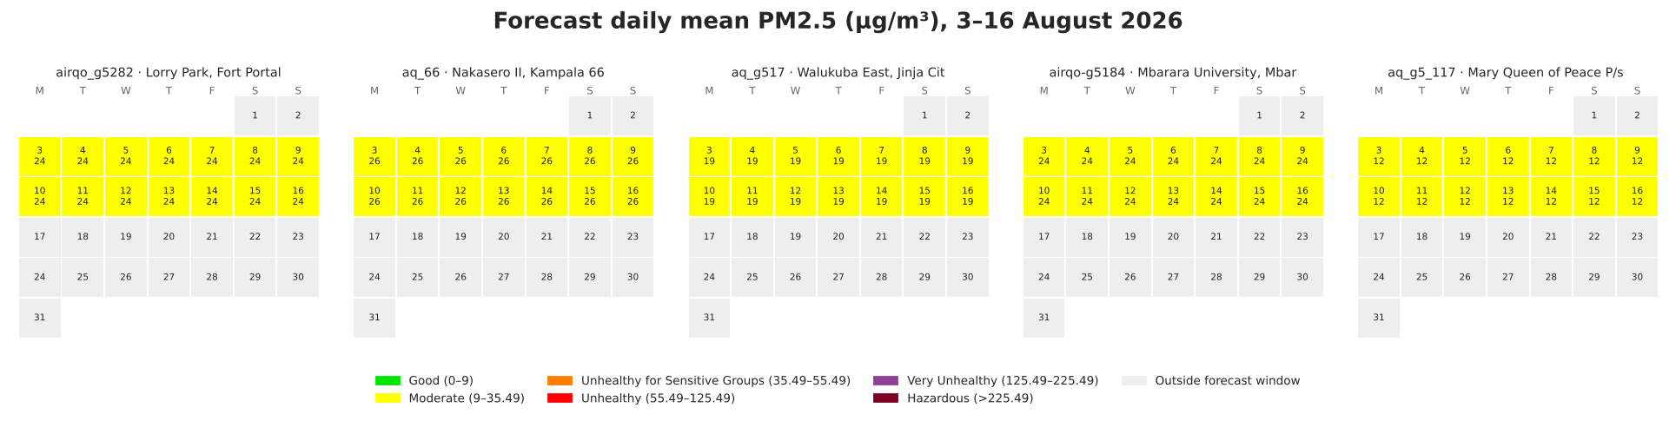
Figure 9. Forecast daily mean PM2.5, 3–16 August 2026, for five sensors (one per zone).
Across all 149 sensors and 14 days: 1,862 sensor-days Moderate, 154 USG and 70 Unhealthy, none Very Unhealthy. The five showcase sensors (Fort Portal, Kampala-Nakasero, Jinja, Mbarara, Gulu) were chosen with K-means on coordinates so the zones are balanced.
- Why the daily values are flat: nothing that changes from day to day is known for August (weather, weekday effects could not be learnt from 8 days). The model gives each sensor its typical August day. The information is in the differences between places. Be ready to explain this; it is honest behaviour, not a bug.
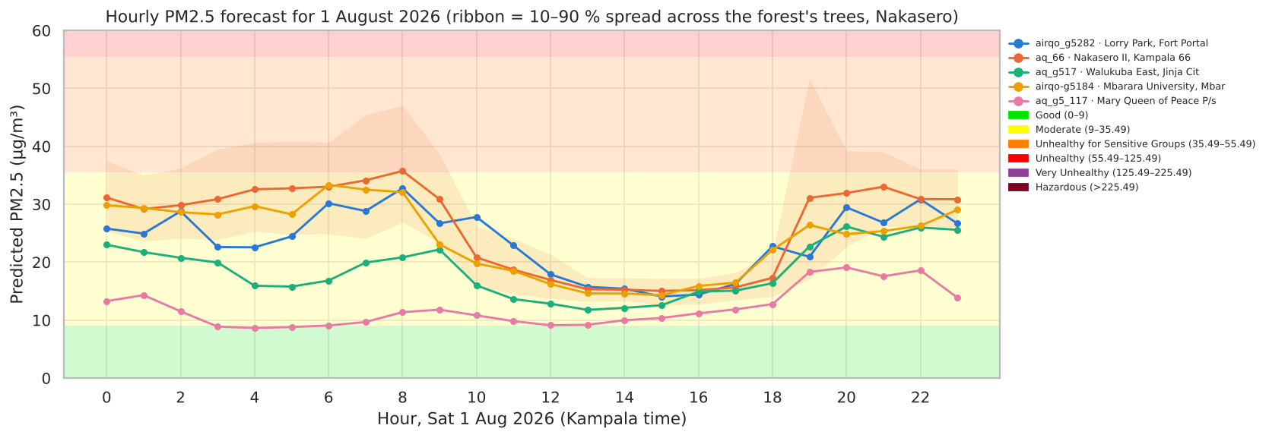
Figure 10. Hourly forecast for 1 August 2026; ribbon = 10–90 % spread across the forest's trees (Nakasero).
The hourly forecast reproduces the double peak. Nakasero approaches the USG threshold around 8 am. The ribbon shows the spread of the individual trees: a rough sense of uncertainty, not a calibrated confidence interval.

9.2 Bonus map
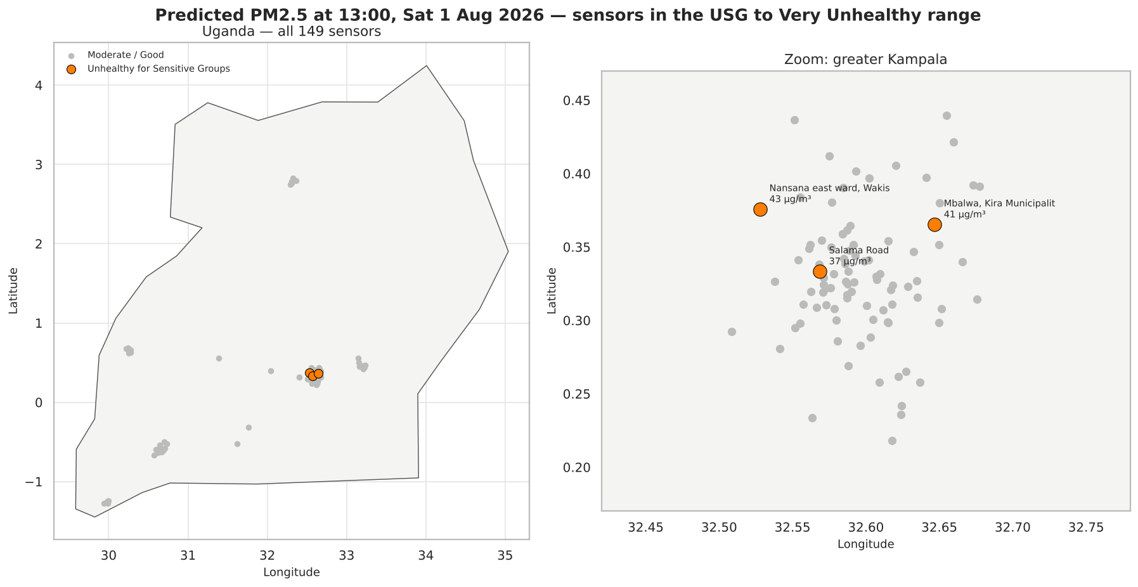
Figure 11. Sensors predicted in the USG to Very Unhealthy range at 13:00 on 1 August 2026.
At 1 pm, normally the cleanest time of day, three sensors are predicted in Unhealthy for Sensitive Groups, all in greater Kampala: Nansana East (43 µg/m³), Mbalwa in Kira (41) and Salama Road (37). The notebook writes a Uganda boundary shapefile (Natural Earth, public domain) and reads it with geopandas; for district borders, drop a GADM or UBOS shapefile into the shapefiles/ folder.

10. Model monitoring with Evidently AI
A deployed model is trained on the past but used on the future. Data drift = the inputs change (e.g. a hotter, drier season). Concept or target drift = the relationship or the target itself changes (e.g. new burning practices). Model drift = the model's error grows as a result. Evidently compares a reference dataset with a current dataset and reports these changes.

10.1 What each Evidently number means
Evidently output | What it is | How to read it
Wasserstein distance (normed) | How far the current distribution must be 'moved' to match the reference, divided by the reference standard deviation. Used for numeric columns with > 1,000 rows. | 0 = identical. Above the threshold 0.1 = drift detected. 0.79 = very different distributions.
K-S p-value | Kolmogorov–Smirnov test for smaller samples: probability of seeing a difference this large if nothing changed. | p < 0.05 = drift detected. Very small p = strong evidence of change.
Drifted columns count / share | How many monitored columns drifted, and what fraction. | Dataset-level drift is declared when share ≥ 0.5 (default).
RMSE, MAE (regression preset) | Error of predictions vs actual values on that dataset. | Compare reference vs current: a clear rise = model drift.
Mean error | Average of (prediction − actual). | Moves away from 0 = the model has become biased.
R² | Variance explained on that dataset. | Depends on how variable the current data is; read together with RMSE.
Abs max error | Single worst error. | Sensitive to one outlier; use only as a warning sign.
Prediction drift | Drift of the model's output column. | Early warning that works before ground truth arrives.

10.2 Run A: training hours vs hold-out hours (model monitoring)
Column | Wasserstein | Drift?
temp | 0.160 | Yes
humidity | 0.261 | Yes
latitude | 0.005 | No
longitude | 0.003 | No
hour_sin | 0.179 | Yes
hour_cos | 0.340 | Yes
pm25_z | 0.084 | No
prediction | 0.186 | Yes

Quality metric (z units) | Reference (out-of-fold) | Current (hold-out)
RMSE | 0.730 | 0.747
MAE | 0.470 | 0.510
MeanError | -0.033 | 0.124
R2Score | 0.538 | 0.367
- Weather and hour features drifted (5 of 8 columns, share 0.62): the hold-out includes partial days (e.g. 3 June ends at 06:00), so hour distributions differ. This is a sampling artefact, a good example of drift that is real statistically but harmless.
- The target (pm25_z) did not drift (0.084 < 0.1) and RMSE rose only from 0.730 to 0.747. R² fell from 0.54 to 0.37 because the hold-out has less variance, not because errors grew. Decision: no retraining needed; keep monitoring.
- Reference predictions are out-of-fold (each training hour predicted by a model that did not see it), otherwise the reference error would be unrealistically low and every comparison would look like drift.

10.3 Run B: January vs June (seasonal drift case study)
Column | Wasserstein | Drift?
temp | 0.368 | Yes
humidity | 0.588 | Yes
hour_sin | 0.026 | No
hour_cos | 0.018 | No
pm25_z | 0.787 | Yes
- Temperature (0.37), humidity (0.59) and PM2.5 itself (0.79) drifted strongly; hour of day did not (same sampling). Mean PM2.5 fell from 48.7 to 24.2 µg/m³.
- Decision: a model trained only in January would fail in June. That is exactly why our Jan+Apr → June experiment scored R² ≤ 0. In production: trigger retraining with recent data when target or prediction drift appears, and keep versioned model files so you can roll back if a new model performs worse (the rollback idea from the class meeting).
The HTML reports (evidently_data_drift.html, evidently_model_quality.html, evidently_seasonal_drift_jan_vs_jun.html) open in any browser and contain the full plots. The Evidently cell is wrapped in try/except, so if it fails on RunPod (version mismatch) the rest of the pipeline still runs, as the brief requires.

11. Deploying and hosting on RunPod
RunPod rents GPU or CPU machines by the second. The brief asks you to run the full pipeline on a Pod within $5, and capture metrics and runtime logs. Our pipeline uses scikit-learn, which runs on CPU; the GPU is simply what the Pod comes with, so choose the cheapest available GPU.

11.1 Before you start (do this at home, free)
- Run the notebook locally from top to bottom (Kernel → Restart & Run All). It finishes in about 3 minutes and must show no errors. Debugging on RunPod costs money.
- Put these files in one folder: PM25_AirQo_Pipeline.ipynb and Sensor Data Jan - July 2026.csv (the name must match exactly, or set the DATA_PATH environment variable).
- Note your local scikit-learn version (printed in the first log line). The joblib model must be loaded with the same version.

11.2 Create and configure the Pod
- Go to runpod.io, sign up and add credit (Billing → add $5–10). Credit is prepaid, so you cannot overspend it.
- Click Pods → Deploy. Choose Community Cloud (cheaper than Secure Cloud).
- Pick an affordable, available GPU. At the time of writing, RunPod lists an RTX A5000 at about $0.27/hour and an RTX 3090 or L4 at about $0.50/hour. Check the price in the pod summary before you confirm.
- Template: RunPod PyTorch (comes with Python and JupyterLab).
- Storage: container disk about 20 GB; a volume disk is optional (you will download results before terminating).
- Review the pricing summary (GPU $/h + storage) and click Deploy On-Demand. Wait until the status is Running.
- Click Connect → Connect to Jupyter Lab (HTTP port 8888).

11.3 Run the pipeline and capture evidence
- In JupyterLab, drag and drop the notebook and the CSV into the file browser (/workspace).
- Open a Terminal (File → New → Terminal) and install the packages (the notebook also installs missing ones automatically):
cd /workspace
pip install -q pandas scikit-learn==1.9.1 matplotlib seaborn joblib scipy evidently geopandas pyarrow
nvidia-smi # screenshot: shows the GPU you rented
python -c "import sklearn; print(sklearn.__version__)"
- Run the notebook either by opening it and choosing Run → Run All Cells, or headless from the terminal so the log is saved to a file:
jupyter nbconvert --to notebook --execute PM25_AirQo_Pipeline.ipynb \
--output PM25_executed_runpod.ipynb --ExecutePreprocessor.timeout=3600 2>&1 | tee runpod_console.log
tail -n 25 outputs/pipeline_log.txt # stage timings, best model, PIPELINE COMPLETE
cat outputs/metrics.json | head -40
- Screenshots to take for the presentation and report: the pod summary (GPU, price), nvidia-smi, the last cells of the notebook, the tail of pipeline_log.txt and metrics.json.
- Download results: right-click the outputs folder → Download, or zip it first:
zip -r runpod_outputs.zip outputs PM25_executed_runpod.ipynb runpod_console.log
- Stop and then Terminate the pod (Pods page → ⋮ → Stop, then Terminate). A stopped pod still bills for its disk; only Terminate ends all charges.

11.4 Budget
Item | Estimate
GPU pod, 1 hour (setup + run + downloads) | $0.27 – $0.50
Container disk 20 GB for one day | ≈ $0.07 (at $0.10/GB/month)
Safety margin for a second attempt | ≈ $0.50
Total | about $1, well under the $5 limit
Prices change; confirm them on runpod.io/gpu-instance/pricing and the pod summary before deploying.

11.5 Troubleshooting
- Evidently import or version error: the cell is already in try/except, so the pipeline continues; mention it in your report. To fix, pip install the same Evidently version as locally (0.7.x).
- FileNotFoundError for the CSV: check the exact file name (spaces included) or run with DATA_PATH set: DATA_PATH="/workspace/yourfile.csv" jupyter nbconvert ...
- Slow tuning on a small pod: set N_ITER=10 (fewer random combinations) as an environment variable before running.
- 'InconsistentVersionWarning' when loading the joblib file: install the same scikit-learn version that saved it.

11.6 Optional: host the model as a live prediction API
The brief only requires running the pipeline on a Pod. If you want to show the model serving predictions, the simplest way is a small FastAPI app on the same Pod, exposed through RunPod's HTTP proxy. When deploying, add 8000 to 'Expose HTTP ports'. Save this as app.py next to outputs/:
import joblib, numpy as np, pandas as pd
from fastapi import FastAPI
from pydantic import BaseModel

B = joblib.load("outputs/best_pm25_model.joblib")
app = FastAPI(title="AirQo PM2.5 predictor")

class Reading(BaseModel):
device_name: str
datetime: str # Kampala local time, e.g. "2026-08-01 08:00"
latitude: float
longitude: float
network: str = "airqo"
temp: float | None = None # nulls are fine: the pipeline imputes them
humidity: float | None = None

@app.post("/predict")
def predict(r: Reading):
t = pd.Timestamp(r.datetime)
X = pd.DataFrame([{
"temp": r.temp, "humidity": r.humidity, "latitude": r.latitude, "longitude": r.longitude,
"hour_sin": np.sin(2*np.pi*t.hour/24), "hour_cos": np.cos(2*np.pi*t.hour/24),
"month": t.month, "network_airqo": int(r.network == "airqo"), "device_name": r.device_name}])
z = float(B["model"].predict(X[B["features"]])[0])
pm = max(0.0, z * B["pm25_std"] + B["pm25_mean"])
cat = B["aqi_labels"][int(np.digitize(pm, B["aqi_bins"][1:-1]))]
return {"pm25_z": z, "pm25_ugm3": round(pm, 1), "aqi": cat}
pip install fastapi uvicorn
uvicorn app:app --host 0.0.0.0 --port 8000
Test it from your laptop (replace POD_ID with your pod's ID, shown on the Pods page):
curl -X POST https://POD_ID-8000.proxy.runpod.net/predict \
-H "Content-Type: application/json" \
-d '{"device_name":"aq_66","datetime":"2026-08-01 08:00","latitude":0.3223,"longitude":32.5758}'
The interactive documentation is at https://POD_ID-8000.proxy.runpod.net/docs. For always-on hosting that bills only per request, RunPod Serverless endpoints run a Docker image with a handler function (import runpod; define handler(job) that reads job["input"] and returns the prediction; runpod.serverless.start({"handler": handler})). That needs a Docker image pushed to a registry, so it is beyond the $5 assignment scope; mention it as the production path.

12. Likely questions and model answers
Q: Why didn't you drop all rows with missing values?
A: That would remove ~30 % of rows (missing weather) and hide when sensors were offline. Short gaps (≤ 3 h) were interpolated, which the literature supports; long gaps stay missing; remaining missing inputs are imputed inside the model with a missing-indicator.
Q: Why is your R² only 0.37?
A: There are only 8 days of data across three seasons, and no input can see sudden events such as fires. The model still beats the mean baseline by 21 % in RMSE and gets the AQI band right 64 % of the time. More continuous data and weather forecasts are the main improvements.
Q: Why not a random train/test split?
A: Neighbouring hours are nearly identical; a random split leaks information and inflates scores. We trained on the first day of each window and tested on the later days, and tuned with GroupKFold over 6-hour blocks.
Q: Why did you exclude PM10?
A: It is measured at the same time as PM2.5 (ρ ≈ 0.98), so it would not be available when forecasting, and it would leak the answer. The brief also says PM10 should not be modelled the same way.
Q: What does a z-score of +2 mean?
A: Two standard deviations above the network mean: 88.3 µg/m³, which is in the Unhealthy band.
Q: Why is Random Forest best?
A: Averaging many decorrelated trees reduces variance on noisy, skewed data and captures interactions such as site × hour × month without manual feature engineering.
Q: Why did Stacking do worse on test than in CV?
A: With only 12 CV blocks the meta-learner overfitted the base models' CV predictions. CV and test disagree when data are scarce; the untouched test set decides.
Q: Why are the daily August forecasts flat?
A: No day-to-day input is known for August: weather is unknown and weekday effects cannot be learnt from 8 days. Each sensor gets its typical August day. Feeding a weather forecast would add day-to-day variation.
Q: What is data drift vs model drift?
A: Data drift is a change in input distributions; model drift is a drop in model performance. Inputs can drift without hurting the model (Run A) or drift badly and break it (Run B, January vs June).
Q: How would you know when to retrain?
A: Schedule Evidently on new data; retrain when target or prediction drift is detected and RMSE on fresh labelled data rises meaningfully above the reference; keep versioned models to roll back.
Q: Why RMSE and not MAPE?
A: MAPE divides by the true value: undefined for z-scores near 0 and unstable for very clean hours. RMSE penalises the large misses that matter for health.
Q: Why use a GPU pod if the model runs on CPU?
A: The brief requires a Pod; RunPod pods come with GPUs. We chose the cheapest GPU and the total cost was well under $5. A CPU pod or serverless endpoint would be the cost-efficient production choice.

13. Glossary
Term | Meaning
AQI band | Colour category of PM2.5 concentration used for public communication
Bagging | Training many models on bootstrap samples and averaging them (Random Forest)
Boosting | Training models in sequence, each correcting the previous errors (Gradient Boosting)
Cross-validation (CV) | Repeatedly training on part of the training data and validating on the rest
Data leakage | Information from the test set or the future sneaking into training, inflating scores
Hyperparameter | Setting chosen before training (e.g. number of trees)
Imputation | Filling missing values with an estimate (e.g. median)
Interpolation | Filling a gap using the values on either side of it in time
IQR | Inter-quartile range, Q3 − Q1; used to define box-plot outliers
MAD | Median absolute deviation; robust measure of spread
Out-of-fold prediction | Prediction for a row made by a model that did not train on that row
Permutation importance | Drop in performance when one input is randomly shuffled
Target encoding | Replacing a category with the average target value for that category
Wasserstein distance | Amount of 'work' needed to turn one distribution into another

14. References
Adong, P., Bainomugisha, E., Okure, D., & Sserunjogi, R. (2022). Applying machine learning for large scale field calibration of low-cost PM2.5 and PM10 air pollution sensors. Applied AI Letters, 3(3), e76.
Junninen, H., Niska, H., Tuppurainen, K., Ruuskanen, J., & Kolehmainen, M. (2004). Methods for imputation of missing values in air quality data sets. Atmospheric Environment, 38(18), 2895–2907.
Okure, D., Ssematimba, J., Sserunjogi, R., Gracia, N. L., Soppelsa, M. E., & Bainomugisha, E. (2022). Characterization of ambient air quality in selected urban areas in Uganda using low-cost sensing and measurement technologies. Environmental Science & Technology, 56(6), 3324–3339.
Pedregosa, F. et al. (2011). Scikit-learn: Machine learning in Python. Journal of Machine Learning Research, 12, 2825–2830.
Evidently AI documentation: data drift and regression presets. docs.evidentlyai.com
RunPod GPU pricing. runpod.io/gpu-instance/pricing (accessed October 2026).
Uganda Christian University (2026). CSC3119 Assignment 4 brief and regression hyperparameter guide.
Check each citation against the original paper before submitting your report.

