Mirette Georgy
Machine Learning Engineer role | Spotter Freight Assessment

Methodology

Framing and Objective
The objective is to predict the freight rate: the dollar price of moving a given load. Because the development data is labeled with posted_rate, this is a supervised learning problem. Because the target is continuous, it is framed as a regression task.
Deliverables produced from this workflow: (1) validation_predictions.csv for 12,000 blind loads, (2) filled December fixed-lane predictions and the scorer chart candidate_december.png, (3) reproducible code and reasoning in the project notebook.

Data

Train / test development set (train-test.csv)
- 48,000 labeled loads from 2025-01-01 through 2025-10-31.
- Features include route cities and coordinates, distance, equipment, weight, date, market_index, quote_signal, and the target posted_rate.
- load_id is an identifier only and is never used as a model feature.

Blind validation set (validation.csv)
- 12,000 unlabeled loads with IDs TE-000001 to TE-012000.
- Date range 2025-11-01 through 2025-12-31 (strictly after the labeled development window).
- Same feature schema as development data, without posted_rate.
- Used only for final submission predictions, not for model selection.

December chart inputs (fixed lane)
- 31 rows for Lexington → Fort Wayne, 360 miles, Dry Van, 32,000 lb; only the date changes across December 2025.
- Template does not include market_index / quote_signal; those were filled from training statistics for inference only.
- Purpose: visualize how predicted rate evolves over time on a controlled lane for the report chart.

EDA
Key findings from exploratory analysis:
- Schema: 14 columns (1 id, 3 categoricals — pickup/delivery/equipment, 1 date, remaining numeric including target).
- Equipment has three levels: Dry Van (majority), Reefer, Flatbed — suitable for one-hot encoding.
- Pickup/delivery city sets largely overlap between development and blind validation (no major category shock).
- Target posted_rate is right-skewed; rate_per_mile = posted_rate / distance was used for EDA only and never as a model feature (would leak the label).
- Distance dominates linear correlation with posted_rate (~0.91). market_index and quote_signal are weak in raw correlation with total dollars but are retained as intended market signals available at prediction time on the blind set.
- City coordinates are stable (each city maps to a unique lat/lon); no duplicate feature fingerprints with conflicting rates.
Leakage checks: load_id is unique; market signals exist on blind validation so they are treated as legitimate features, not label leakage. Temporal leakage is the main risk and is handled via time-ordered validation and split.

Data Cleaning
- Missingness: weight ~0.625% null; market_index ~0.779% null.
- Data-quality issue: 292 negative weight values — treated as invalid/missing before imputation.
- No non-positive distances or posted_rate values in the labeled set.
- Weight imputation: inspected median weight by equipment on the training fold; medians differed by <0.25% from the global median, so a global training median was used for simplicity.
- market_index imputation: median by calendar month fit on training data only, with global training median as fallback for unseen months.
- All imputation statistics are fit on training (or full labeled data at final refit) and applied to holdout / blind / December rows. No fitting on the blind target labels (there are none).

Feature Engineering
Encoding and transforms applied consistently through a reusable pipeline:
- Equipment: one-hot encoding with a fixed category set learned from training (Dry Van, Flatbed, Reefer).
- Date parts: month, dayofweek, is_weekend; plus cyclical sin/cos encodings for month and dayofweek.
- City names were not one-hot encoded (high cardinality). Coordinates were experimented with and ultimately excluded from the final feature set after testing; distance and engineered haul indicators carry most geographic structure.
- Additional engineered features: weight_per_mile, payload_utilization, market_tightness (market_index × quote_signal), market_to_distance, equipment interactions (reefer_distance, flatbed_weight), short/long haul indicators.
Final model feature count: 22 columns (distance, weight, market signals, equipment OHE, calendar features, and engineered interactions).
Excluded from modeling: load_id, pickup, delivery, raw date, posted_rate, rate_per_mile, and lat/lon.

Data Split
Blind validation is entirely in the future relative to labeled data (Nov–Dec 2025 vs Jan–Oct 2025). A random split of train-test.csv would train on future loads and overstate accuracy. Therefore model selection used a time-ordered holdout inside the labeled file:
- Sort by date; hold out the last ~20% of rows by time.
- Internal split date: 2025-08-31 (inclusive for holdout).
- Train fold: 38,330 rows (2025-01-01 → 2025-08-30).
- Internal validation fold: 9,670 rows (2025-08-31 → 2025-10-31).
- Asserted no date overlap between folds.
- Naive baseline (predict training-mean rate) on internal valid: RMSE ≈ 1523.

Modeling
Multiple model families were trained on the same features and compared on the time-ordered holdout (selection metric: lowest validation RMSE):
- Ordinary least squares LinearRegression (with StandardScaler).
- Ridge regression (linear + L2; with StandardScaler).
- RandomForestRegressor (bagged trees).
- HistGradientBoostingRegressor (boosted trees) — strong tabular default, fast on ~50k rows, native in scikit-learn.
Internal validation results (approximate):
Model | Valid RMSE | Valid MAE | Valid R² | Valid MAPE
HistGradientBoosting | 635.8 | 132.0 | 0.826 | 5.83%
RandomForest | 637.8 | 136.6 | 0.825 | 6.10%
Ridge | 645.0 | 166.7 | 0.821 | 10.13%
LinearRegression (OLS) | 645.0 | 166.9 | 0.821 | 10.15%
Selected model: HistGradientBoostingRegressor (valid RMSE 635.8 vs baseline ~1523). Train/valid gap is moderate (train RMSE ~560, R² ~0.86 → valid R² ~0.83), indicating useful generalization without severe overfit. Linear models underperform tree ensembles, confirming meaningful nonlinear structure (especially distance and interactions). RandomForest is close but slightly worse on valid RMSE and shows a larger train/valid gap.
Residual analysis on the internal holdout: typical errors are small (median residual near ~17), but heavy tails exist (large absolute residuals on a minority of loads). RMSE is therefore more sensitive to extremes than MAE/MAPE (~5.8%).

Validation & Final Inference
After selecting HistGradientBoosting on the time-ordered holdout:
- Refit the same model configuration on all 48,000 labeled rows with imputation stats recomputed on the full labeled set.
- Generate predictions for all 12,000 blind validation loads → validation_predictions.csv (load_id, predicted_rate). Predictions clipped to a small positive floor to satisfy scorer constraints.
- December chart: because the template lacks market_index/quote_signal, those fields were filled with the last labeled month’s market_index median (2025-10) and Dry Van quote_signal median, then passed through the same feature pipeline. This keeps market context roughly constant so the chart mainly reflects date-driven variation on the fixed lane without dropping market features from the main model (those features are present on blind validation and improve that primary task).
- Ran the provided score.py successfully: validated 12,000 predictions and 31 December rows; wrote scorer_results/candidate_december.png.

Evaluation on Validation (Internal Holdout) — Metrics
- Primary selection metric: RMSE on time-ordered internal validation.
- Also reported: MAE, R², MAPE.
- Selected model internal valid: RMSE 635.8 | MAE 132.0 | R² 0.826 | MAPE 5.83%.

December Prediction Chart
Fixed inputs: Lexington to Fort Wayne | 360 miles | Dry Van | 32,000 lb | only date changes. Predicted rates for December 2025 are tightly clustered around ~$858 (small day-to-day movement from calendar features under constant market fills).
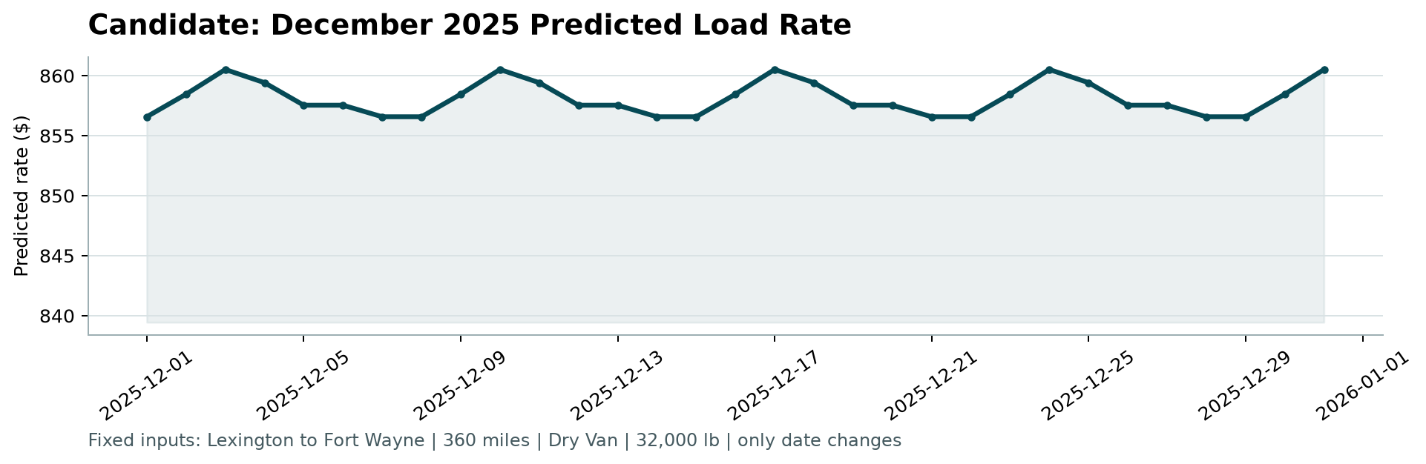
Figure: candidate_december.png produced by score.py

Improvements / Future Work
Better model
- Add better city/route features if some lanes are consistently off
- Use a loss that is less thrown off by a few extreme prices
- Consider separate models for short vs long trips
- Show a confidence range with each prediction, not only one number
- Light hyperparameter search or early stopping on a rolling time series CV.

Cleaner data
- Mark missing values explicitly if “missing” itself means something
- For the December chart, estimate market conditions over time instead of using a flat fill
Putting it in production
- Turn the notebook into a repeatable training + prediction pipeline
- Roll out a new model carefully next to the old one before switching fully
- Save model versions and make it easy to roll back
Watching it after launch
- Check if new loads look different from training data (distances, equipment mix, market signals)
- Track prediction error once real rates come in
- Alert if predicted prices suddenly shift for no clear reason
- Monitor by segment (equipment type, region, trip length)
- Alert on broken inputs, missing fields, or slow scoring
- Retrain when accuracy drops or the data changes enough
Business use
- Flag high-uncertainty or high-value loads for human review
- Make sure rare routes don’t silently get poor quotes

