Contact number: 490-4880                                                                                                06/29/2025

[genobiaadrian@gmail.com](mailto:genobiaadrian@gmail.com)

**920 ENTERPRISE**

ATTENTION: SIR LEO DELA TORRE

Subject: Aircon Requirements

Dear Sir /Madamme: please see attached billing statement

|  |  |  |  |  |  |
| --- | --- | --- | --- | --- | --- |
| DATE SERVICES | AC TYPE | DETAILS | QTY | UNIT PRICE | TOTAL AMOUNT |
| 05/10/25 -  06/10/25 | FAHU | GENERAL CLEANING | 2 | 1,900.00 | 3,800.00 |
|  | MASTER AND SLAVE | GENERAL CLEANING | 8 | 1,400.00 | 11,200.00 |
|  | CEILLING CASSETTE | GENERAL CLEANING | 74 | 1,300.00 | 96,200.00 |
| **TOTAL AMOUNT** | | | | | 111,200.00 |

Payable to:  *3RS Airconditioning Solution*

We hope that you find our offer in order and we look forward to be of service to you.

Very truly yours,

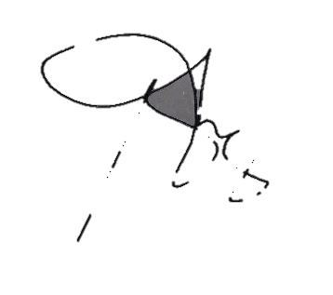

Adrian N. Genobia                                              Conformed by: ________________________

Proprietor                                                                                                          Name&Date             0927-137-4570