Prueba de estilo aprobada y lote de cofres
CyberGrid: Breach & Sync · Para: Astra · Octubre 2026
Cofre de la Forja en estilo caricatura: APROBADO. Este es el estilo oficial del juego. Ya está integrado con sus tres estados: se abre, se saquea y queda vacío.
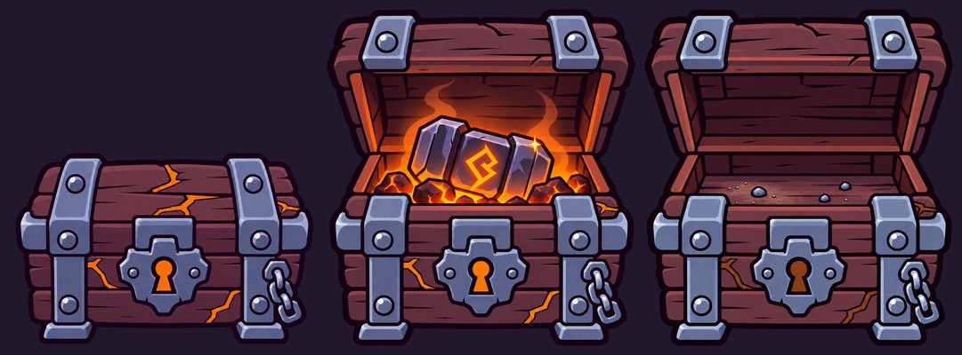
Cofre de la Forja aprobado · cerrado, abierto y vacío

1. Qué se aprueba y se vuelve estándar
- Contorno grueso de tinta, formas simples y algo exageradas, colores planos con 2–3 tonos.
- Paleta saturada por material, con el color de magia reservado.
- Lectura clara de los tres estados a tamaño pequeño, incluido el vacío con la magia apagada.
- Paquete con QA a 80 px, SHA256 y LEEME: mantener este formato.
Desde ahora, la imagen aprobada del Cofre de la Forja es la referencia de estilo principal (imagen de entrada 3) para todos los assets, junto con las referencias 1 y 2.

2. Único ajuste: registro del cuerpo
En la prueba, el cuerpo del cofre abierto y vacío salió un poco más grande que en el cerrado. Lo corregimos al integrarlo, pero en este lote el cuerpo, los pies y la base deben quedar exactamente del mismo tamaño y en la misma posición en los tres estados. Los prompts incluyen ahora un bloque BODY LOCK para eso.
Los anchos de base son una guía de escala; si quedan ±4% del valor pedido es aceptable, siempre que los tres estados de un mismo cofre coincidan entre sí.

3. Lote solicitado
Cofre | Uso | Magia | Ancho de base
Sarcófago Rúnico (rehacer) | Bóvedas mayores | Verde esmeralda | 76%
Arcón Ornamentado | Cámaras menores | Violeta + blanco perla | 62%
Relicario Antiguo | Bóveda Antigua | Magenta + cristal violeta | 70%
Cada cofre en 3 estados (cerrado, abierto, vacío), PNG 1254×1254, un ZIP por cofre con el mismo formato de la prueba aprobada.

4. Prompts
Entradas de estilo en cada generación: referencia 1, referencia 2 y el Cofre de la Forja aprobado (cerrado).

4.1. Sarcófago Rúnico (rehacer en el nuevo estilo)
Archivos: forja_cofre_sarcofago_cerrado.png, forja_cofre_sarcofago_abierto.png, forja_cofre_sarcofago_vacio.png · Ancho de base: 76%

Cerrado
Create ONE standalone CLOSED Rune Sarcophagus sprite for CyberGrid.
STYLE IS CRITICAL: match EXACTLY the approved Forge Chest cartoon test (input image 3) and style references 1 and 2. Bold graphic cartoon style of a hand-inked indie action-RPG: VERY THICK dark plum ink outline around the silhouette with slight line-weight variation, thinner ink lines inside; chunky simplified shapes with charming, slightly exaggerated proportions and softly rounded corners; FLAT color fills with only 2 to 3 cel-shaded tones per material and a crisp highlight edge; NO noisy texture, NO grainy or realistic rendering; details are a FEW clear ink strokes. Rich saturated palette: stone cool violet-blue (never neutral grey), wood deep plum-brown, metal blue-grey slate, magic vivid. Same outline thickness, same shading steps and same level of detail as the approved Forge Chest. Must read clearly at 80 pixels wide.
CAMERA: identical to the approved Forge Chest. FRONT-FACING elevated camera, yaw EXACTLY ZERO, pitch down about 45 degrees; front face parallel to the screen, top visible, all horizontal edges horizontal, NO side faces, NO isometric angle.
Design: an ancient stone sarcophagus chest on a low heavy pedestal, cool violet-blue stone blocks, a thick beveled lid slab with a few big fractured sections, a tapered body with small feet, wide recessed cracks and a centered keyhole frame, a couple of simple carved spiral marks.
Magic (emerald green) is crisp saturated flat color inside its shapes with NO bloom, NO halo, NO haze; that color appears nowhere else on the object. Any moss is muted dark olive.
SQUARE CANVAS 1254x1254 AND REGISTRATION: upper third EMPTY for the open lid; chest in the lower two thirds; base baseline at 88% height, centered at 50% width, base width 76% of the canvas. Genuine transparent PNG background.
No scene, no floor plane, no cast shadow, no text, no UI, no watermark, no alternate views, no comparison sheet. Not photorealistic, not a 3D render, not painterly-realistic. Exactly ONE asset.

Abierto (edición del cerrado)
Precise-object-edit of the approved CLOSED sprite into its OPEN state. Same canvas and same cartoon ink style. BODY LOCK: the lower body, front decorations, feet and base must keep EXACTLY the same size, outline and position as in the source sprite; do not enlarge, shrink or shift them. Only the lid and the interior above the front rim change: hinge the lid up and back around its rear edge to about 75 degrees inside the empty upper area, showing its underside. Inside: emerald light from the bottom and a partly hidden arcane medallion with one bright mint glint. A little translucent emerald mist strictly inside the opening. Magic stays crisp, no bloom. Exactly ONE sprite.

Vacío (edición del abierto)
Precise-object-edit of the approved OPEN sprite into its EMPTY / LOOTED state. Same canvas and same cartoon ink style. BODY LOCK: the lower body, front decorations, feet and base must keep EXACTLY the same size, outline and position as in the source sprite; do not enlarge, shrink or shift them. The lid also stays exactly in place. Only the interior changes: remove the relic, treasure and mist completely; show the bare bottom of the cavity with a little dust and two or three small pebbles. The magic is SPENT: cracks, runes and lock keep the same hue but become dark and dim, no bright cores. Exactly ONE sprite.

4.2. Arcón Ornamentado
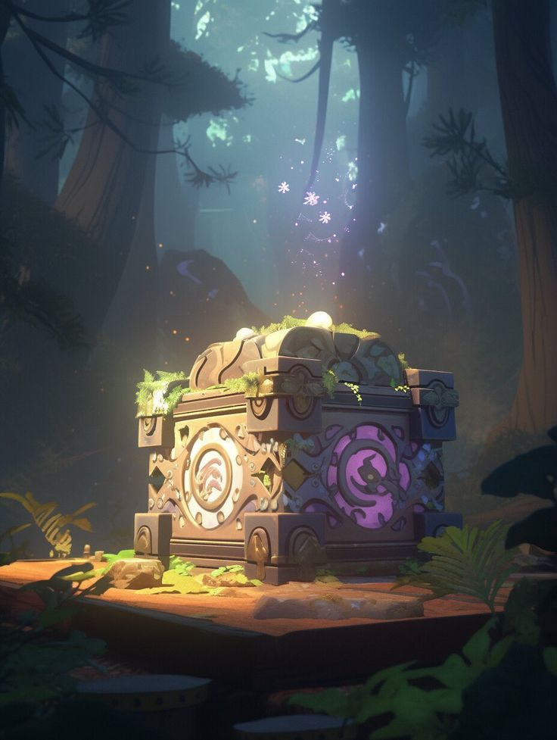
Diseño de referencia del Arcón: adaptar a la cámara frontal y al estilo caricatura aprobado
Archivos: forja_cofre_ornamentado_cerrado.png, forja_cofre_ornamentado_abierto.png, forja_cofre_ornamentado_vacio.png · Ancho de base: 62%

Cerrado
Create ONE standalone CLOSED Ornate Rune Chest sprite for CyberGrid.
STYLE IS CRITICAL: match EXACTLY the approved Forge Chest cartoon test (input image 3) and style references 1 and 2. Bold graphic cartoon style of a hand-inked indie action-RPG: VERY THICK dark plum ink outline around the silhouette with slight line-weight variation, thinner ink lines inside; chunky simplified shapes with charming, slightly exaggerated proportions and softly rounded corners; FLAT color fills with only 2 to 3 cel-shaded tones per material and a crisp highlight edge; NO noisy texture, NO grainy or realistic rendering; details are a FEW clear ink strokes. Rich saturated palette: stone cool violet-blue (never neutral grey), wood deep plum-brown, metal blue-grey slate, magic vivid. Same outline thickness, same shading steps and same level of detail as the approved Forge Chest. Must read clearly at 80 pixels wide.
CAMERA: identical to the approved Forge Chest. FRONT-FACING elevated camera, yaw EXACTLY ZERO, pitch down about 45 degrees; front face parallel to the screen, top visible, all horizontal edges horizontal, NO side faces, NO isometric angle.
Design: a sturdy ornate chest of dark violet carved stone and aged bronze, a rounded lid with a few bold swirl engravings, chunky reinforced corner blocks with bronze rivets, a big round violet medallion on the front with a pearl-white inner ring, two small pearl-white diamond gems on the front sides.
Magic (violet medallion and pearl-white gems) is crisp saturated flat color inside its shapes with NO bloom, NO halo, NO haze; that color appears nowhere else on the object. Any moss is muted dark olive.
SQUARE CANVAS 1254x1254 AND REGISTRATION: upper third EMPTY for the open lid; chest in the lower two thirds; base baseline at 88% height, centered at 50% width, base width 62% of the canvas. Genuine transparent PNG background.
No scene, no floor plane, no cast shadow, no text, no UI, no watermark, no alternate views, no comparison sheet. Not photorealistic, not a 3D render, not painterly-realistic. Exactly ONE asset.

Abierto (edición del cerrado)
Precise-object-edit of the approved CLOSED sprite into its OPEN state. Same canvas and same cartoon ink style. BODY LOCK: the lower body, front decorations, feet and base must keep EXACTLY the same size, outline and position as in the source sprite; do not enlarge, shrink or shift them. Only the lid and the interior above the front rim change: hinge the lid up and back around its rear edge to about 75 degrees inside the empty upper area, showing its underside. Inside: violet light from the bottom and a partly hidden pearl orb with one bright white glint. A little translucent violet mist strictly inside the opening. Magic stays crisp, no bloom. Exactly ONE sprite.

Vacío (edición del abierto)
Precise-object-edit of the approved OPEN sprite into its EMPTY / LOOTED state. Same canvas and same cartoon ink style. BODY LOCK: the lower body, front decorations, feet and base must keep EXACTLY the same size, outline and position as in the source sprite; do not enlarge, shrink or shift them. The lid also stays exactly in place. Only the interior changes: remove the relic, treasure and mist completely; show the bare bottom of the cavity with a little dust and two or three small pebbles. The magic is SPENT: cracks, runes and lock keep the same hue but become dark and dim, no bright cores. Exactly ONE sprite.

4.3. Relicario Antiguo
Archivos: forja_cofre_relicario_cerrado.png, forja_cofre_relicario_abierto.png, forja_cofre_relicario_vacio.png · Ancho de base: 70%

Cerrado
Create ONE standalone CLOSED Ancient Reliquary sprite for CyberGrid.
STYLE IS CRITICAL: match EXACTLY the approved Forge Chest cartoon test (input image 3) and style references 1 and 2. Bold graphic cartoon style of a hand-inked indie action-RPG: VERY THICK dark plum ink outline around the silhouette with slight line-weight variation, thinner ink lines inside; chunky simplified shapes with charming, slightly exaggerated proportions and softly rounded corners; FLAT color fills with only 2 to 3 cel-shaded tones per material and a crisp highlight edge; NO noisy texture, NO grainy or realistic rendering; details are a FEW clear ink strokes. Rich saturated palette: stone cool violet-blue (never neutral grey), wood deep plum-brown, metal blue-grey slate, magic vivid. Same outline thickness, same shading steps and same level of detail as the approved Forge Chest. Must read clearly at 80 pixels wide.
CAMERA: identical to the approved Forge Chest. FRONT-FACING elevated camera, yaw EXACTLY ZERO, pitch down about 45 degrees; front face parallel to the screen, top visible, all horizontal edges horizontal, NO side faces, NO isometric angle.
Design: a legendary reliquary chest on a stepped stone altar, translucent violet crystal panels framed by bold dark-gold filigree, a pointed ornamental lid crowned with a small crystal, magenta runes along the gold frame like circuitry.
Magic (magenta runes and violet crystal panels) is crisp saturated flat color inside its shapes with NO bloom, NO halo, NO haze; that color appears nowhere else on the object. Any moss is muted dark olive.
SQUARE CANVAS 1254x1254 AND REGISTRATION: upper third EMPTY for the open lid; chest in the lower two thirds; base baseline at 88% height, centered at 50% width, base width 70% of the canvas. Genuine transparent PNG background.
No scene, no floor plane, no cast shadow, no text, no UI, no watermark, no alternate views, no comparison sheet. Not photorealistic, not a 3D render, not painterly-realistic. Exactly ONE asset.

Abierto (edición del cerrado)
Precise-object-edit of the approved CLOSED sprite into its OPEN state. Same canvas and same cartoon ink style. BODY LOCK: the lower body, front decorations, feet and base must keep EXACTLY the same size, outline and position as in the source sprite; do not enlarge, shrink or shift them. Only the lid and the interior above the front rim change: hinge the lid up and back around its rear edge to about 75 degrees inside the empty upper area, showing its underside. Inside: magenta light rising from velvet-lined depths and a partly hidden crowned relic with one bright magenta glint. A little translucent magenta mist strictly inside the opening. Magic stays crisp, no bloom. Exactly ONE sprite.

Vacío (edición del abierto)
Precise-object-edit of the approved OPEN sprite into its EMPTY / LOOTED state. Same canvas and same cartoon ink style. BODY LOCK: the lower body, front decorations, feet and base must keep EXACTLY the same size, outline and position as in the source sprite; do not enlarge, shrink or shift them. The lid also stays exactly in place. Only the interior changes: remove the relic, treasure and mist completely; show the bare bottom of the cavity with a little dust and two or three small pebbles. The magic is SPENT: cracks, runes and lock keep the same hue but become dark and dim, no bright cores. Exactly ONE sprite.

5. Lista de verificación por cofre
# | Verificar
1 | Mismo estilo que el Cofre de la Forja aprobado: grosor de contorno, tonos y nivel de detalle
2 | Cámara frontal idéntica; sin caras laterales
3 | Cuerpo, pies y base idénticos en tamaño y posición en los 3 estados
4 | Vacío sin botín ni niebla, magia apagada del mismo color
5 | Magia nítida sin halo, color exclusivo del cofre
6 | Se entiende a 80 px; PNG transparente; un ZIP por cofre con QA y SHA256

