Project GitHub Link:
https://github.com/MirfayzIrgashevv/SOSC314_CourseProject/commit/64ccff73d1dd7c5fd603c5714534841db5f79a91
Division of Responsibilities
For this project stage, each group member was responsible for the following components:

Mirfayz Irgashev: sentiment analysis with TextBlob, adding new columns, filtering
Dilnoza Tirkashova: Data cleaning, writing progress report

Progress Report
The third week’s aim was mainly about preparing the dataset for further analysis by using sentiment analysis, creating additional features, and data cleaning. Compared to last week, this week we focused more on turning unstructured data into practical variables for modelling than on research. We checked every column of the dataset to detect the missing values. According to the inspection, it was found that the two columns, ProfileName and Summary, had missing values.
Since the week’s third primary goal is preparing the dataset, our focus was on enhancing the dataset by creating new numerical features that better capture review quality and structure. One key addition was the helpfulness_ratio, calculated as the ratio of HelpfulnessNumerator to HelpfulnessDenominator. This feature was designed to reflect how helpful a review is relative to the total number of votes it received.
During the implementation of this feature, we discovered that many reviews had a denominator value of zero, meaning that no helpfulness votes had been cast for them. Instead of rejecting these reviews, we decided to consider them as reviews with no documented helpfulness by filling the resulting undefined values with 0. By implementing that approach, we were able to keep a significant amount of the dataset while maintaining the new feature's accessibility and use.
After that, the number of words in the text of each review was counted to create the review_length feature. This feature was added to record the level of information or detail in a review. After reviewing the distribution of review lengths, a filtering decision was made: reviews with fewer than 15 words were removed because very short reviews often contain limited information (for example, “Good product” or “Did not like it”) and can add noise to text-based analysis. After applying this filter, the dataset was reduced to 566,484 reviews.
TextBlob is used for sentiment analysis because it is simple, fast, and easy to implement, making it suitable for initial sentiment extraction and feature construction without significant computational overhead. This allows sentiment polarity to be incorporated early in the analysis while keeping the modeling pipeline lightweight. For each review, a sentiment polarity score was calculated within the range of -1 to 1. To improve interpretability, each score was also mapped to a categorical sentiment label: POSITIVE, NEGATIVE, or NEUTRAL. In this step, two new variables were added: sentiment_score and sentiment_label, which track sentiment's direction and effectiveness. These qualities help with numerous analyses, such as comparisons of star ratings and numerical sentiment levels.
To determine whether emotionally expressive reviews or informational reviews are more helpful to consumers, a transformer-based model (DistilBERT) will be used in later stages because it captures contextual and nuanced emotional expression in long-form text more effectively than rule-based approaches. The resulting emotional features will be analyzed using regression models, which are chosen for their interpretability and ability to quantify the relationship between emotional expressiveness and review helpfulness.
To examine whether review length increases perceived credibility and helpfulness, linear regression models will be employed because review length is a continuous, interpretable variable, and regression allows for a direct estimation of its effect size on helpfulness outcomes.
Finally, to assess whether negative reviews are perceived as more helpful than positive reviews, sentiment polarity predicted by DistilBERT will be combined with logistic or linear regression models, as these models are well-suited for estimating how categorical sentiment differences influence the probability or magnitude of perceived helpfulness.
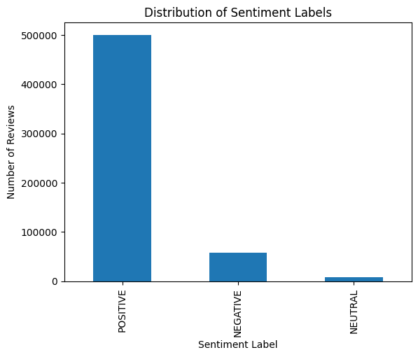
This bar chart shows how many reviews fall into each sentiment category. Most of the reviews are positive, with more than 500,000 entries, which is much higher than the other categories. Negative reviews are far fewer, at around 58,000. Neutral reviews are very rare, with only about 8,000. This means the data is not evenly balanced and mostly contains positive opinions.

