Project GitHub Link:
https://github.com/MirfayzIrgashevv/SOSC314_CourseProject/commit/5fb5437bf28f39927881e8cec0824b3f21ee1845
Division of Responsibilities
For this project stage, each group member was responsible for the following components:

Mirfayz Irgashev: answering to research questions, comparison of different models (Linear Regression and Random Forest Regressor), model training and evaluating
Dilnoza Tirkashova: text preprocessing, writing report

Progress Report
Fourth week’s work mainly focused on text preprocessing and analysing how textual and sentiment features affect review helpfulness. The first step in the process was converting all reviews to lowercase letters to prevent the model from interpreting the same word in different cases (like “Good” and “good”) as separate tokens. Next, we used regular expressions to remove punctuation, numbers, and non-alphabetic symbols. In natural language processing tasks, these elements often generate unnecessary noise and offer barely useful linguistic information, particularly when the objective is to fully understand the semantic connection between review content and helpfulness.
We updated the Natural Language Toolkit's (NLTK) English stopword list by adding a few more general terms (“and”, “a”) to make it more precise. This enables models to concentrate on the more relevant, content-rich words that genuinely influence meaning and sentiment. Also used the PorterStemmer, which reduces words to their fundamental form, after the stopwords were eliminated. For example, words like "bought," "buying," and "buys" all originate from "buy." This method simplifies the vocabulary and increases the speed of computation by treating similar word variations as only one feature. All the things mentioned above were in function named preprocess_text and I created new column named “clean_text” applying this function.
Before addressing the research question “Does review length increase perceived credibility and helpfulness?”, we first examined the correlation between review length and the helpfulness ratio. The correlation coefficient was 0.123, indicating a weak positive relationship between the two variables. This suggests that longer reviews tend to be perceived as slightly more helpful. Then, we prepared data for Linear Regression, after training model we got results: regression coefficient is 0.00071 meaning for each additional word in a review, the helpfulness ratio increases by ~0.0007. Review length explains only ~1.5% of the variance in perceived helpfulness, since we got R² score: 0.015.
As a second mode, I chose a Random Forest Regressor since it can identify the most influential characteristics and capture nonlinear relationships. To verify reliability, the model was tested on 20% of the dataset after being trained on 80% of it. It achieved an R² of 0.023, which was slightly higher than the linear regression model, but still showed that review length and sentiment together explain only a small portion of helpfulness variance.
According to feature important statistics, sentiment score only contributed 3.3% of predictive power, while review length accounted for 96.7%. This gives a clear response to the first question: although the effect is small, review length does boost perceived credibility and helpfulness.
Second research question was “Are negative reviews perceived as more helpful than positive reviews?”, we started the work by calculating average helpfulness ratio by sentiment. Positive reviews (0.409) were rated somewhat higher than negative reviews (0.405), but neutral reviews (0.347) had the lowest average helpfulness ratio by sentiment. We performed a two-sample t-test comparing positive and negative evaluations to officially test these differences (t = -1.93, p = 0.0536). The t-test comparing negative and positive reviews produced a t-statistic of −1.93, indicating that negative reviews tend to have slightly higher helpfulness than positive reviews. However, the p-value of 0.0536 is just above the conventional 0.05 significance threshold, meaning that this difference is not statistically significant, although it is very close and suggests a weak but notable trend.
Figure 1 shows the average helpfulness ratio across positive, negative, and neutral reviews. Both positive and negative reviews exhibit similarly higher helpfulness ratios than neutral reviews:
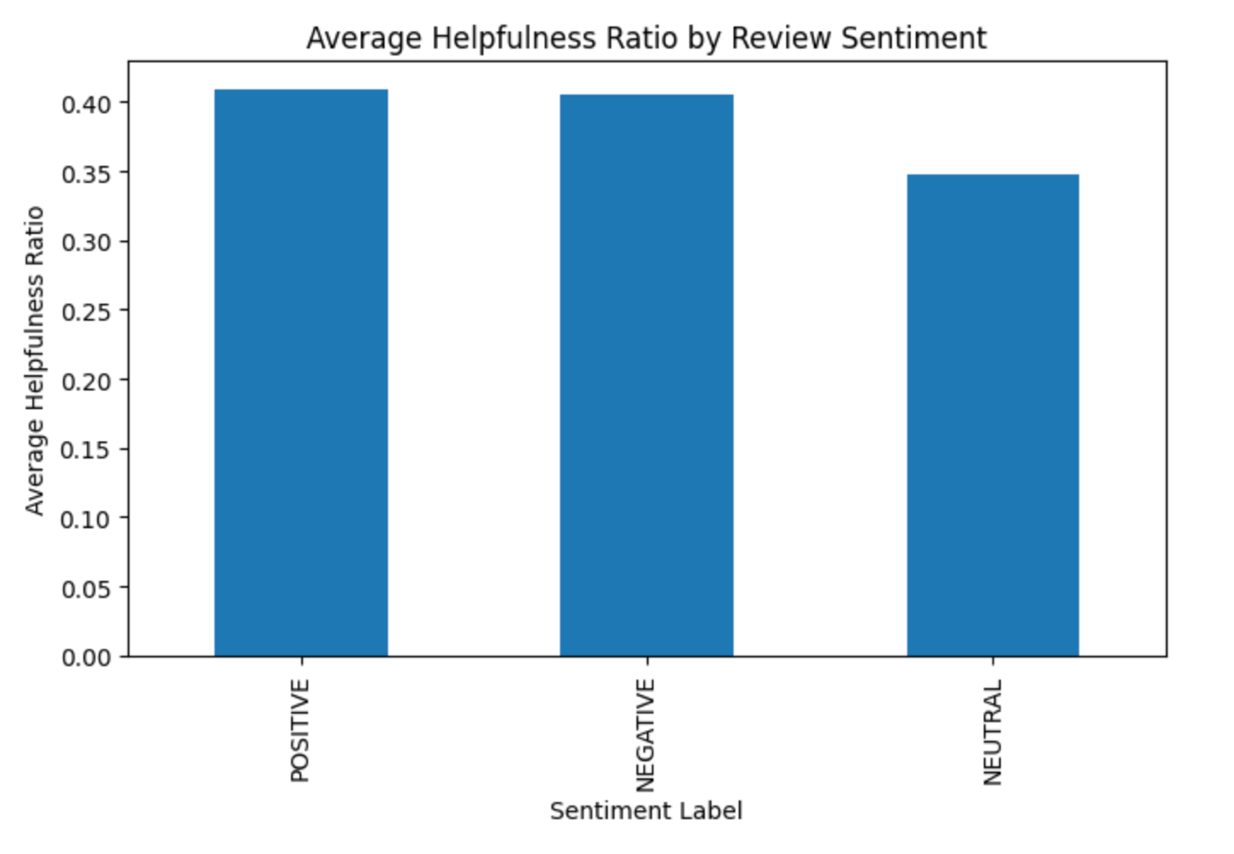
Figure 1: Average Helpfulness Ratio by Review Sentiment

