Project GitHub Link:
https://github.com/MirfayzIrgashevv/SOSC314_CourseProject/commit/5102249b7803acf80e1c0b551ec063483dc5fa60
Division of Responsibilities
For this project stage, each group member was responsible for the following components:

Mirfayz Irgashev: diagnosing and interpreting results, robustness check by checking different subjectivity thresholds
Dilnoza Tirkashova: writing report, answering to last research question about (Are emotionally expressive reviews or informational reviews more helpful to consumers) by creating columns using TextBlob
Progress Report
Week fifth's main goal was about diagnostics, robustness and validity checks as well as finding answer to third question “Are emotionally expressive reviews or informational reviews more helpful to consumers?”. This project phase aimed to find out whether readers consider more informational or emotional reviews differently when voting on helpfulness, rather than relying only on opposite views or rating scores.
Each review was given a subjectivity score using the TextBlob library to measure how strongly the author expresses their personal views about the product. This number, usually ranges from 0.0 to 1.0, indicates how much a review is based on personal views rather than factual data. While reviews that emphasis on factual details, product features, or usage data tends to receive lower scores, ratings with greater subjectivity values tend to emphasize personal experiences, feelings, or responses such as enjoyment, frustration, or disappointment. The subjectivity score was calculated using the full review text, allowing it to serve as a numerical representation of how expressive or opinion-driven each review is.
To distinguish between emotionally expressive and informational reviews, we created a new column called ‘expressiveness_type’ based on the subjectivity scores obtained from TextBlob. Subjectivity values range from 0 to 1, where higher scores indicate more personal and opinion-based language. Reviews with a subjectivity score greater than or equal to 0.5 were labeled as EMOTIONAL, while those with scores below 0.5 were classified as INFORMATIONAL.
We then examined the relationship between review expressiveness and helpfulness by comparing the average helpfulness ratios across the two categories. The results show that the average helpfulness ratio for informational reviews (0.424) is higher than that for emotionally expressive reviews (0.399). This suggests that, on average, consumers perceive reviews that focus on factual details, explanations, and practical information as slightly more helpful than those that rely primarily on emotional expression.

In the figure below you can see visual presentation of the distribution of expressiveness helpfulness:
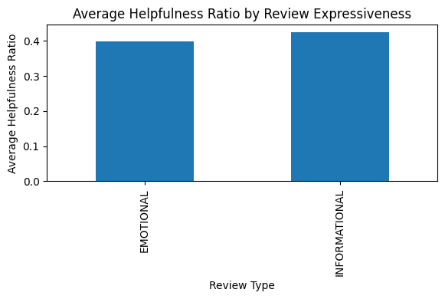
Figure 1: Average Helpfulness Ratio by Review Expressiveness
To formally test whether the observed difference in helpfulness between emotionally expressive and informational reviews is statistically meaningful, we applied an independent two-sample t-test using “ttest_ind(emotional, informational, equal_var=False)”. This test is appropriate because we are comparing the mean helpfulness ratios of two independent groups, and the “equal_var=False” option (Welch’s t-test) was used to account for the possibility that the two groups may have unequal variances. The test produced a t-statistic of −19.45 and a p-value of 3.43 × 10⁻⁸⁴, which is far below conventional significance levels (e.g., 0.05). This indicates that the difference in helpfulness between emotional and informational reviews is statistically significant, and the negative t-value shows that emotionally expressive reviews are perceived as less helpful than informational reviews.
To assess the robustness of our main findings, we redefined helpfulness as a binary outcome and created a new indicator “helpful_binary” based on whether a review received at least one helpful vote. First, for expressiveness, the average helpfulness for informational reviews (0.456) remained higher than for emotionally expressive reviews (0.427). This result is consistent with earlier analyses using the continuous helpfulness ratio. Second, when examining sentiment categories, negative reviews (0.444) had the highest probability of being perceived as helpful, followed by positive reviews (0.437). This pattern suggests that reviews expressing a clear opinion, especially negative ones tend to provide more useful information to consumers than neutral reviews.
To further check robustness, we varied the subjectivity threshold used to classify reviews as EMOTIONAL or INFORMATIONAL. Instead of relying on a single cutoff, we tested thresholds of 0.4, 0.5, and 0.6 to examine whether the relationship between expressiveness and helpfulness is sensitive to how emotional reviews are defined. Across all thresholds, informational reviews consistently show equal or higher average helpfulness ratios compared to emotionally expressive reviews. As the threshold increases, the gap becomes more pronounced, indicating that reviews classified as highly emotional tend to be less helpful on average. As shown in the figure below, this pattern remains stable across different cutoff values, supporting the robustness of the conclusion that informational reviews are generally perceived as more helpful than emotional ones.
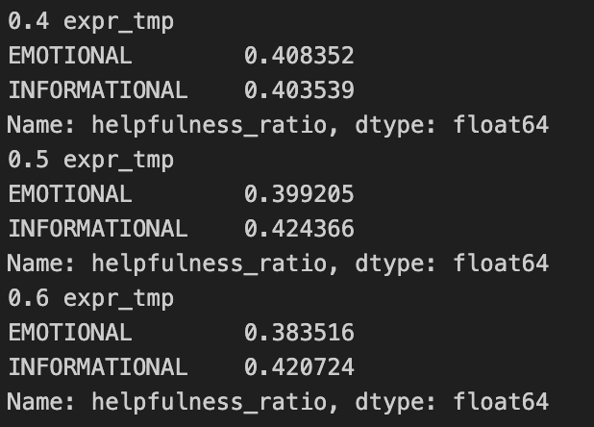
Figure 2: Robustness Check: Average Helpfulness Ratio by Review Expressiveness Across Different Subjectivity Thresholds

