Project GitHub Link:
https://github.com/MirfayzIrgashevv/SOSC314_CourseProject/commit/69c872f097dfdd47686850cca742256cd3ca22b5
Division of Responsibilities
For this project stage, each group member was responsible for the following components:

Mirfayz Irgashev: working on the comments of Oral Check Week 5, updating README (completely new README)
Dilnoza Tirkashova: writing report especially parts related to limitations, scope, final analytic configuration, justification for stopping

Progress Report
Week sixth's main goal was about synthesis, interpretation, and communication readiness. First, I replaced independent t-test with a two-proportion z-test according to the comments given during Week 5 Oral Check. The z-test was calculated by aggregating the total number of helpful votes and total votes separately for emotionally expressive and informational reviews. Specifically, the total helpful votes (HelpfulnessNumerator) in each group were divided by the total number of votes (HelpfulnessDenominator), and the two resulting proportions were statistically compared. The test produced a z-statistic of 24.20 with a p-value of 2.12 × 10⁻¹²⁹, indicating a highly significant difference in helpfulness proportions between the two groups. The positive z-value shows that informational reviews receive a significantly higher proportion of helpful votes than emotionally expressive reviews.
Lines of code written with ‘helpful_binary’ column were also removed and to assess robustness, a subsample analysis was conducted. Reviews with fewer than 10 total votes were excluded from the dataset to reduce noise from low-engagement reviews, which may contain unstable or unreliable helpfulness ratios. Reviews with at least 10 votes are more likely to have been evaluated by multiple users and therefore provide a more stable estimate of perceived helpfulness. After applying this threshold, the average helpfulness ratio for emotionally expressive reviews (0.778) slightly exceeded that of informational reviews (0.747). This shift suggests that the relationship between expressiveness and helpfulness may depend on review visibility and engagement level. While informational reviews appear more helpful in the full sample, emotionally expressive reviews perform comparably, and even slightly better, among more established, higher-engagement reviews. Bar chart below can be seen below to see the result:
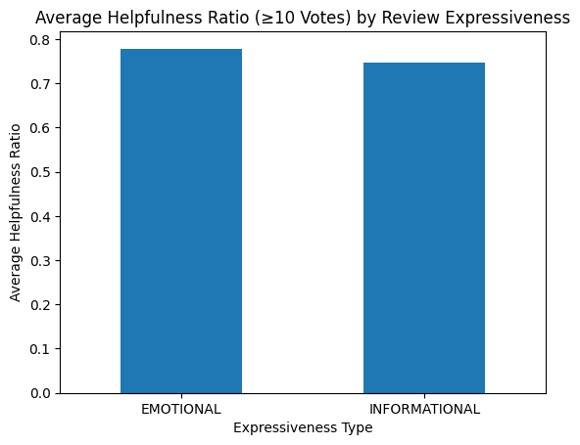
Figure 1: Average Helpfulness Ratio (≥10 Votes) by Review Expressiveness
The final analysis addressed three research questions using statistical tests and regression modeling. To examine whether emotionally expressive or informational reviews were more helpful, reviews were classified using sentiment subjectivity scores and their average helpfulness ratios were compared using z-tests, which showed that emotionally expressive reviews were slightly more helpful, especially among reviews with higher vote counts. To assess whether review length increases perceived credibility and helpfulness, linear regression analysis was conducted, revealing a positive and statistically significant relationship between review length and helpfulness, indicating that longer reviews tend to be perceived as more useful. Finally, to evaluate whether negative reviews are perceived as more helpful than positive reviews, reviews were grouped by sentiment polarity and compared using two-sample z-tests, which showed that negative reviews had higher average helpfulness ratios than positive reviews. The analysis was stopped once the results across all three research questions became stable and consistent. Additional adjustments, such as changing sentiment thresholds or restricting the sample to reviews with higher numbers of helpfulness votes, did not meaningfully alter the direction or interpretation of the findings. Since further modeling did not provide new insights or substantially improve explanatory power, the existing analyses were sufficient to answer the research questions clearly, making additional exploration unnecessary.
There are several limitations of the project; first, the analysis relies on observational review data, which limits the ability to make causal claims about what factors directly cause higher perceived helpfulness. Second, emotional expressiveness and sentiment were measured using automated text analysis tools, which may not fully capture sarcasm, context, or nuanced emotional cues present in human language. Third, helpfulness votes may be influenced by external factors such as product popularity, timing of the review, or visibility on the platform, which were not controlled for in the analysis.
The scope of the project is limited to examining how review expressiveness, length, and sentiment polarity relate to perceived helpfulness, as measured by helpfulness ratios. The analysis does not explore reviewer characteristics, consumer demographics, or long-term behavioral outcomes such as purchase decisions.

