Project GitHub Link:
https://github.com/MirfayzIrgashevv/STATS201_CourseProject/commit/593f052cc9e4b9561fa21b4f1a25f4cb7adbdbb7
Division of Responsibilities
For this project stage, each group member was responsible for the following components:
Mirfayz Irgashev:
Primary responsibility: baseline model and evaluation
Specific tasks completed this week: data cleaning, train/test setup, encoding, baseline model, evaluation
Progress Report
Third week’s aim was mainly about baseline modeling and evaluation strategy. I started the work by cleaning dataset, since I have mentioned in previous report that dataset has some missing values. I found out that dataset has 362 missing values in ‘statement’ feature, there is no missing values in ‘status’. After dropping rows with missing values, I wanted to show what is inside ‘statement’ feature by randomly getting statements for each mental health status. Example:
- Status: Suicidal
- Statement: I finally understood what I lack in life, and what I tried to get for all my life - sense of community and also love. Never had those, and my life is really empty. I do not want to go further alone. It gives me nothing but pain. So, just finishing last stuff, experiencing last drops of warm sun rays later this August, and I will happily and calmly kill myself. Without drama, without rush. I will be ok then. I do not want to go further alone. I will never have community or love, though things which are badly missing in my life, so I will end it by Fall.
To capture structural differences in how mental health conditions are expressed, we added features measuring the number of characters and number of sentences in each statement. These variables provide interpretable information about language length and complexity that is not captured by word-based features alone. These two features will later be included as additional input variables (X) to examine whether structural aspects of language, such as length and sentence count, improve classification performance beyond semantic content alone.
Since this week is only for baseline model, I set only ‘statement’ feature as input variable (X) and ‘status’ as target variable (y), later other features will be added as input variables as I mentioned earlier. I divided dataset into two subsets: 80% for training and 20% for test. 80/20 split was chosen because it represents a standard and widely accepted practice in machine learning. Since there is imbalance in ‘status’ feature, stratify=y parameter is also added to train test split to keep the class distribution balanced.
Before training baseline model, it is important to encode categories in ‘status’. With the help of label encoding, I converted categories into integers. Since machine learning models cannot work with raw text, values in ‘statement’ column were also converted to numerical features with the help of TF-IDF vectorizer. It is standard baseline method in social science, and it converts text into numerical features based on how often word appears in a document, how unique it is across documents. By adding ngram_range=(1, 2) parameter in TF-IDF, I am telling to vectorizer to use both single words and two-word phrases. With max_features=20000, I am limiting vocabulary size to 20000, since it is only baseline model.
After encoding text data and target labels, I trained Logistic Regression model on data, setting max_iter parameter to 1000 and class_weight is balanced since classes are imbalanced. The reasons why I chose Logistic Regression is that Logistic Regression is simple, fast and suitable for being baseline model. For the evaluation metrics, accuracy, classification report, and confusion matrix were chosen because accuracy provides an overall measure of correctness; precision indicates how reliable the model’s predictions are; recall shows how effectively the model detects each mental health status; and the F1-score balances precision and recall. These metrics are particularly important when classes are imbalanced or when misclassification has significant social consequences. Additionally, the confusion matrix helps visualize which mental health statuses are most often mistaken for one another.
Overall accuracy is 77.8% indicating model correctly predicts the mental health status for about 78% of statements in the test set.
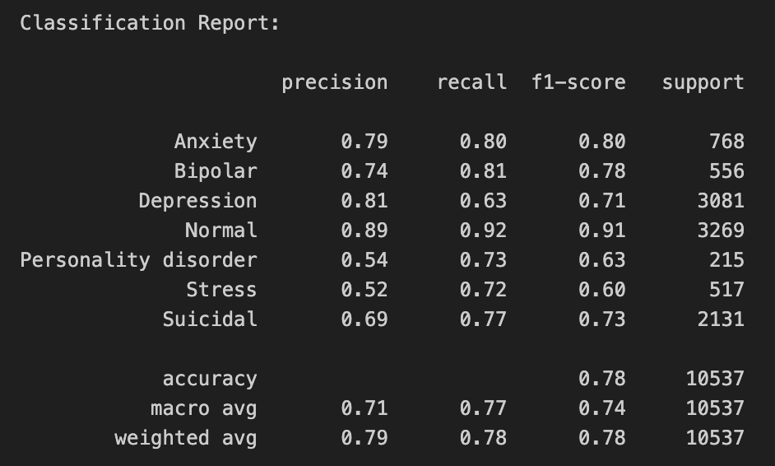
Figure 1: Classification Report
Interpretation of classification report shown in Figure 1:
- Normal has the strongest performance (F1 = 0.91), meaning neutral language is highly distinctive and easy for the model to recognize.
- Anxiety and Bipolar are also classified well (F1 ≈ 0.78–0.80), suggesting consistent and recognizable language patterns.
- Depression has high precision (0.81) but lower recall (0.63), meaning the model is confident when it predicts depression, but it misses many depressed statements, often confusing them with other conditions.
- Suicidal shows moderate performance (F1 = 0.73), indicating overlap in language with depression and distress-related categories.
- Stress and Personality disorder have the lowest F1-scores (0.60–0.63), likely due to smaller sample sizes and less distinctive language.
The confusion matrix shows the number of correct and incorrect predictions for each mental health status. Normal is classified most accurately, with 3,133 correct predictions, and very few errors. Anxiety has 1,899 correct predictions but is frequently confused with Stress (376 cases) and Depression (201 cases), indicating strong linguistic overlap in expressions of worry and emotional strain. Depression shows 928 correct predictions but is often misclassified as Suicidal (327 cases) and Anxiety (201 cases). Suicidal statements are correctly identified 615 times, yet 284 are predicted as Depression. Stress has 406 correct predictions but is commonly confused with Anxiety (376 cases) and Depression (142 cases), reflecting shared vocabulary related to pressure and overwhelm. Personality disorder is the most challenging category, with only 220 correct predictions. Many of its statements are misclassified as Depression (132 cases) or Anxiety (98 cases), likely due to limited data.
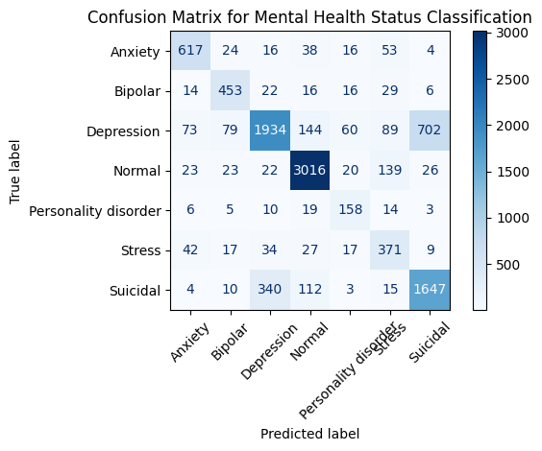
Figure 2: Confusion Matrix

