Project GitHub Link:
https://github.com/MirfayzIrgashevv/STATS201_CourseProject/commit/2ce7a520bc01746b8a4fb08a80bb72ab17103d35
Division of Responsibilities
For this project stage, each group member was responsible for the following components:
Mirfayz Irgashev:
Primary responsibility: feature engineering and model comparison
Specific tasks completed this week: text preprocessing, XGBoostClassifier, Multinomial Naïve Bayes, working with bigrams
Progress Report
Fourth week’s aim was mainly about feature engineering and comparison of different models. I started the work by working with the text, specifically with ‘statement’ column. First thing I did was converting all statements to lowercase to avoid treating the same word as different features. Then I removed URLs, markdown-style links, handles, punctuation and other special characters, so I can have less noise that doesn’t carry mental health meaning. Also, I tokenized ‘statements’ column and placed tokens into ‘tokens’ column, so machine learning models will not have any problems with understanding data. I used PorterStemmer because it reduces words to their root form in a simple and efficient way, which helps standardize different word variations like ‘argues,’ ‘argued,’ ‘arguing’ → ‘argu’. Stemming is important because it reduces vocabulary size, prevents the model from treating similar words as different features, and helps the classifier focus on the core meaning of words rather than grammatical variations. Stemmed tokens were places into new column named ‘tokens_stemmed’.
I also included word clouds for each mental health status to visually explore the most frequent and distinctive words used in each class. Word clouds are useful because they help to identify class-specific language patterns. Below, word cloud for anxiety is presented:
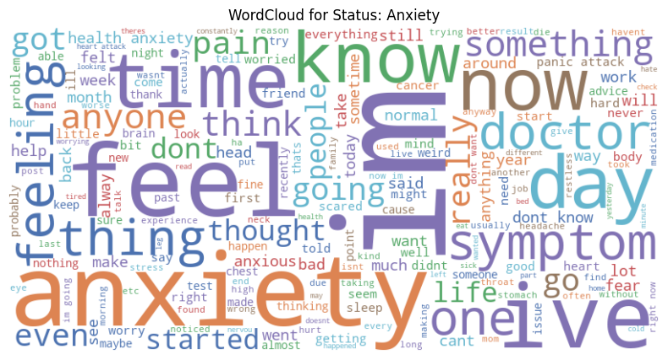
Figure 1: WordCloud for Status: Anxiety
Since one of the most important things in my project is to work with bigrams, I also created ‘bigrams’ column and put bigrams inside. For visual exploration, word cloud was used with bigrams. Word cloud for depression can be seen below:
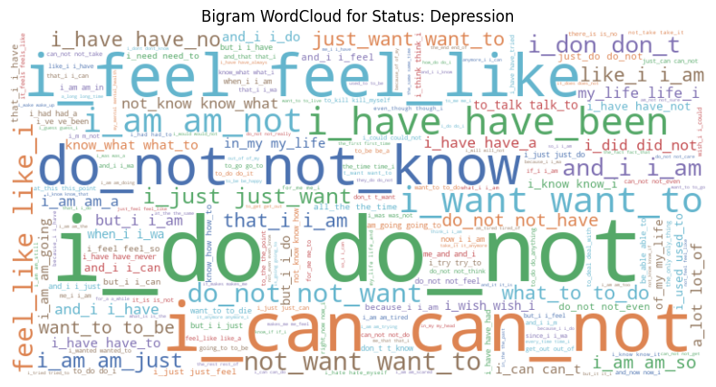
Figure 2: Bigram WordCloud for Status: Depression
While splitting the dataset into training and test sets, X was changed to ‘tokens_stemmed’. Even though I did not change encoding and vectorization models, I changed max_features=50000 in TF-IDF vectorizer to get a richer and more diverse vocabulary from the text. This allows the model to learn from more informative words and phrases.
When it comes to choosing models, I chose Multinomial Naive Bayes because it works very well for text data with TF-IDF features. For parameters, I chose alpha=0.5, it applies smoothing to reduce the effect of rare words and prevent zero probabilities while improving generalization and fit_prior=False treats all classes equally, helping reduce bias caused by class imbalance. For the evaluation metrics, accuracy, classification report, and confusion matrix were chosen because accuracy provides an overall measure of correctness; precision indicates how reliable the model’s predictions are; recall shows how effectively the model detects each mental health status; and the F1-score balances precision and recall. These metrics are particularly important when classes are imbalanced or when misclassification has significant social consequences. Additionally, the confusion matrix helps visualize which mental health statuses are most often mistaken for one another.
Overall accuracy of Multinomial Naive Bayes is 69.6% indicating model correctly predicts the mental health status for about 69% of statements in the test set.
Interpretation of classification report for Multinomial Naive Bayes shown in Figure 3:
- Normal shows the strongest performance (F1 = 0.82), indicating that neutral language is highly distinctive and easy for the model to identify.
- Bipolar and Suicidal have moderate and stable performance (F1 = 0.69 for both), suggesting some consistent linguistic patterns but noticeable overlap with other mental health categories.
- Anxiety is classified reasonably well (F1 = 0.67), though confusion with stress and depression-related language remains.
- Depression achieves moderate performance (F1 = 0.65), indicating that depressive language is partially captured but still overlaps with suicidal and stress-related expressions.
- Stress performs poorly (F1 = 0.37), showing that its language is less distinctive and frequently confused with anxiety or depression.
- Personality disorder has the weakest performance (F1 = 0.25), largely due to very low recall, likely caused by limited data.
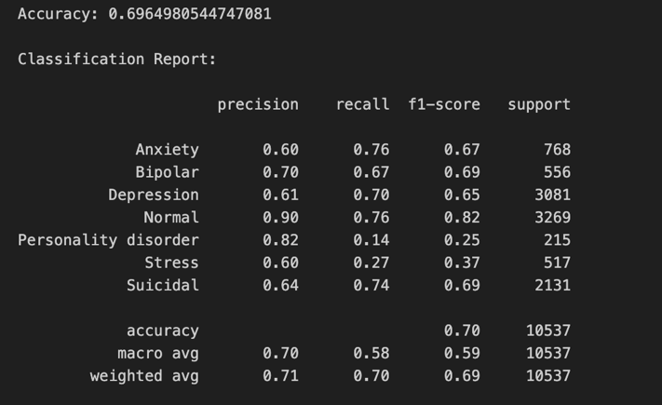
Figure 3: Classification report for Multinomial Naive Bayes
The confusion matrix shows the number of correct and incorrect predictions for each mental health status. Normal is classified most accurately, with 2,471 correct predictions, though some statements are misclassified as Depression (325 cases) and Anxiety (199 cases). Anxiety has 587 correct predictions but is frequently confused with Depression (98 cases) and Normal (47 cases), indicating linguistic overlap in expressions of worry and emotional distress. Depression shows strong performance with 2,165 correct predictions, yet it is often misclassified as Suicidal (692 cases), highlighting substantial overlap between depressive and suicidal language. Suicidal statements are correctly identified 1,572 times, but 506 cases are predicted as Depression. Stress has only 138 correct predictions and is commonly confused with Depression (210 cases) and Anxiety (77 cases), reflecting shared vocabulary related to pressure and overwhelm. Personality disorder is the most challenging category, with just 31 correct predictions, and many of its statements are misclassified as Depression (140 cases), likely due to limited data.
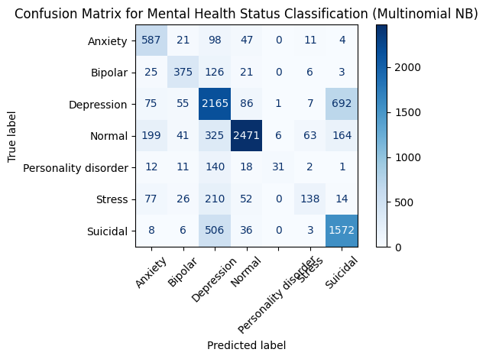
Figure 4: Confusion Matrix for Mental Health Status Classification (Multinomial NB)
For the second model I chose XGBoost, since it is a powerful gradient boosting algorithm that performs well on structured data and can model complex, non-linear relationships. During initial experiments, XGBoost was run with learning_rate=0.2, max_depth=7, and n_estimators=500, but this caused very long training times (≈5 minutes) and damage to my laptop. To improve efficiency, the parameters were revised. tree_method="hist" was used to speed up training. The learning_rate was set to 0.1 to ensure stable learning, while max_depth=5 and n_estimators=150 reduced model complexity and runtime. subsample=0.8 and colsample_bytree=0.8 introduced randomness to prevent overfitting. n_jobs=-1 enabled full CPU parallelization, and eval_metric="logloss" was chosen for proper probabilistic evaluation.
Overall accuracy of XGBoost is 77% indicating model correctly predicts the mental health status for about 77% of statements in the test set. Compared to Multinomial Naive Bayes (≈70% accuracy), XGBoost achieves better overall performance, showing its stronger ability to capture complex and non-linear patterns in text data. This improvement is also reflected in higher F1-scores for several key classes, such as Normal (F1 = 0.89 vs. 0.82) and Bipolar (F1 = 0.80 vs. 0.69), indicating a better balance between precision and recall. The confusion matrix further supports this result, as XGBoost shows stronger diagonal values (more correct predictions) and reduced confusion between closely related classes, particularly between Depression and Suicidal, compared to Naive Bayes. With more extensive hyperparameter tuning, XGBoost’s performance could likely be improved even further, potentially achieving substantially higher accuracy and class-level F1-scores.

