Project GitHub Link:
https://github.com/MirfayzIrgashevv/STATS201_CourseProject/commit/07cd182b3ffe520c710c45ab96bbd6b3b6a481c5
Division of Responsibilities
For this project stage, each group member was responsible for the following components:
Mirfayz Irgashev:
Primary responsibility: diagnosing model behavior, errors, and robustness
Specific tasks completed this week: analysis of confusion matrices, diagnostics of train/test performance, analysis on misclassified samples, extraction of top unigrams and bigrams for each mental health status
Progress Report
Fifth week’s aim was mainly about diagnosing model behavior, errors, and robustness. I started the work by presenting the distribution of mental health statuses, as we can see the dataset contains 16,351 statements labeled as Normal, 15,404 as Depression, and 10,653 as Suicidal, which together make up most observations. The remaining categories are smaller, with 3,888 statements labeled as Anxiety, 2,877 as Bipolar, 2,669 as Stress, and 1,201 as Personality disorder. This distribution shows imbalance between classes, and it is important to take into consideration this information.
After doing some analysis on misclassified samples, I found that the most common error across all models is Suicidal statements being predicted as Depression and vice versa. This occurs because both conditions use highly similar language expressing sadness, hopelessness, and emotional distress, making them difficult to separate using text features alone. Another most common error is Personality disorder being misclassified as Depression or Anxiety, which is likely due to its smaller sample size (1201 statements) and lack of distinctive vocabulary. Anxiety, Stress, and Bipolar are also frequently predicted as Depression, showing that depression-related language dominates and absorbs overlapping emotional expressions. Logistic Regression and XGBoost misclassify the same statements because both models rely on identical TF-IDF text representations, and when different mental health conditions use overlapping vocabulary, their feature vectors become nearly indistinguishable.

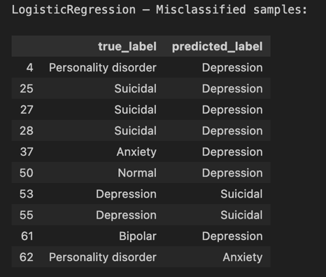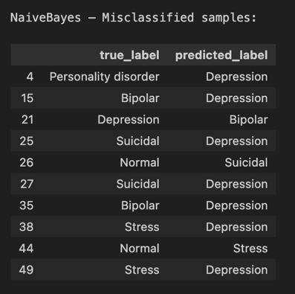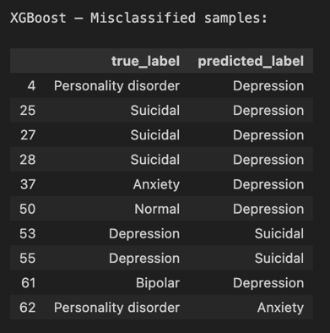
Figure 1: Table of misclassified samples across all three models
Across all three models, the dominant error pattern is confusion between Depression and Suicidal, which indicates strong linguistic overlap between these conditions rather than model-specific failure. Logistic Regression misclassifies 708 Suicidal as Depression and 380 Depression as Suicidal, while Naive Bayes shows even stronger confusion with 692 Depression as Suicidal and 506 Suicidal as Depression. XGBoost reduces this overlap (576 and 538, respectively) but does not eliminate it, showing that added model complexity helps but cannot fully separate these classes when text features overlap. Naive Bayes consistently performs worst on minority and nuanced classes because it relies on strong independence assumptions and word frequencies. This is visible in Personality disorder, where Naive Bayes correctly predicts only 31 cases and misclassifies 140 as Depression, indicating that rare classes are overwhelmed by dominant depression-related vocabulary. Logistic Regression and XGBoost perform better on this class (164 and 141 correct, respectively), suggesting that discriminative and tree-based models better handle subtle feature interactions. For Stress and Anxiety, all models show confusion because these categories share short, repetitive language related to pressure and worry. Confusion matrices can be seen below:
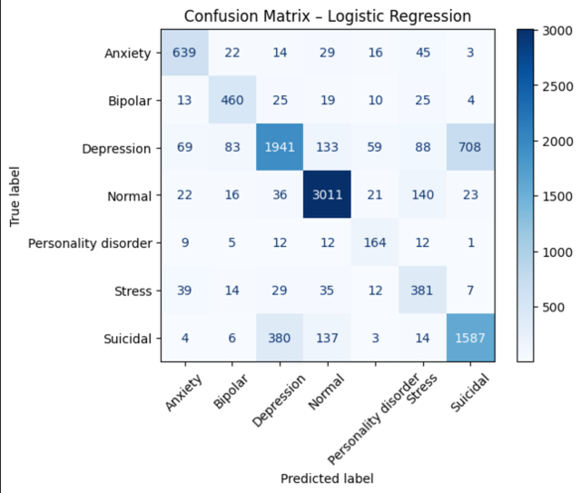
Figure 2: Confusion Matrix for Logistic Regression
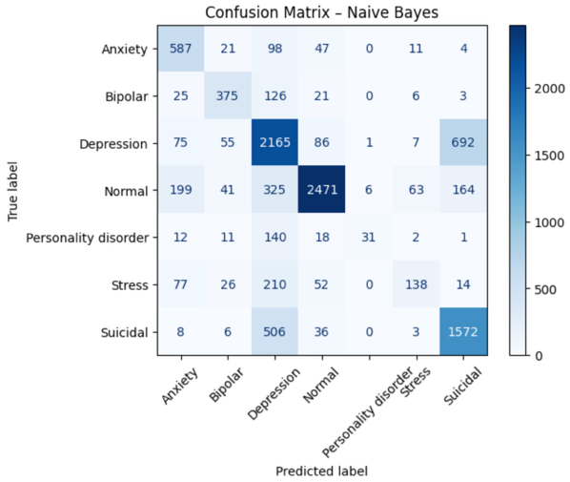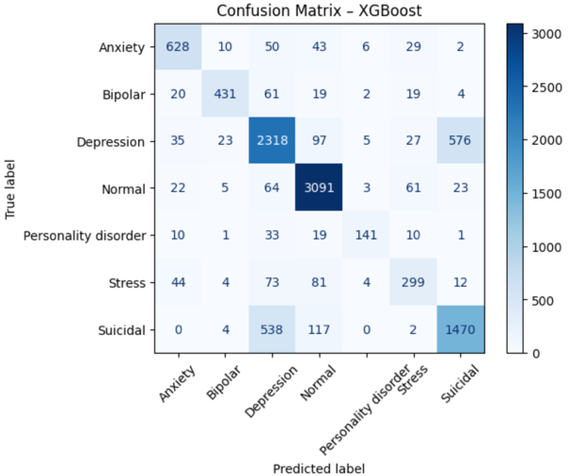
Figure 3: Confusion Matrices for Naive Bayes and XGBoost
After analyzing confusion matrices, I checked train and test performance to see whether models overfitting or underfitting. Among the three models, Logistic Regression achieved the best bias–variance trade-off, meaning it balances model simplicity and flexibility in a way that generalizes well to unseen data. Its training and test performance are close (train accuracy ≈ 0.86 vs test accuracy ≈ 0.78; train F1 ≈ 0.86 vs test F1 ≈ 0.78). XGBoost model showed clear overfitting, with near-perfect training performance but a substantially lower test performance (train accuracy ≈ 0.99 vs test accuracy ≈ 0.80). To overcome this problem, I adjusted hyperparameters of XGBoost to the number of trees (n_estimators = 200) and learning rate (learning_rate = 0.05) were reduced to slow learning and prevent overly aggressive fitting. Tree complexity was constrained using max_depth = 5 and min_child_weight = 5, limiting deep, noise-driven splits. Randomization was introduced through subsample = 0.8 and colsample_bytree = 0.8 to reduce variance. Additional penalties (gamma = 1.0, reg_alpha = 0.5, and reg_lambda = 1.0) discouraged complex splits and enforced regularization. After these changes, overfitting was substantially reduced. Training and test performance became much closer (train accuracy ≈ 0.81 vs test accuracy ≈ 0.76; train F1 ≈ 0.81 vs test F1 ≈ 0.76), indicating improved generalization. While peak accuracy decreased compared to the overfit XGBoost model, the reduced gap shows that the model is no longer memorizing the training data and instead learning more stable and transferable patterns.
Now it is time to work on answering main question of the project which is “Are certain words uniquely associated with specific mental health conditions?” I first looped over each mental health status and filtered the dataset so that only statements belonging to one status were analyzed at a time, which ensures that word extraction is condition specific. Then, TF-IDF vectorization was applied to the filtered statements, converting each statement into a numerical matrix where columns represent words or bigrams and values represent their importance within that status. Next, I calculated the mean TF-IDF value for each word or bigram across all statements of the same status, which measures how consistently important that term is rather than how often it appears in a single statement. I then ranked these mean scores and selected the top 20 unigrams and bigrams, producing lists of the most representative terms for each mental health condition. TF-IDF was chosen because it weights terms based on both frequency and distinctiveness. All the results were plotted, and some of the plots can be seen below:
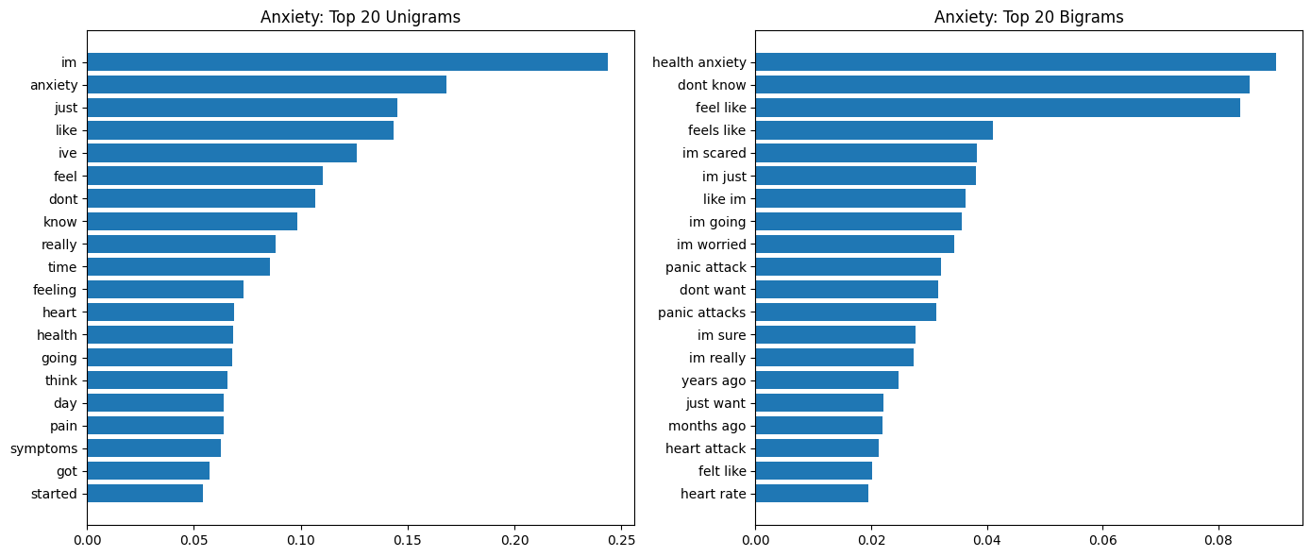
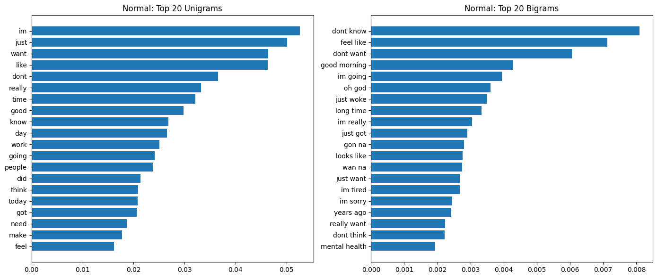
Figure 4: Top 20 Unigrams and Bigrams for Normal and Anxiety
The values shown on the x-axis (e.g., 0.25, 0.20, 0.10) represent the average TF-IDF score of each unigram or bigram for that mental health status. A higher TF-IDF value means that the word or phrase appears frequently and consistently within that specific status while being less common in general language. For Normal, the top unigrams are general conversational words such as “im,” “just,” “want,” “like,” “good,” “time,” and “day”. These words are neutral and non-clinical, reflecting everyday speech rather than emotional distress. The bigrams reinforce this pattern with phrases like “dont know,” “feel like,” “good morning,” “just woke,” and “im going,” which describe routine activities and casual thoughts. For Anxiety, the unigram distribution shifts toward emotion and symptom-related language. Words such as “anxiety,” “feel,” “heart,” “health,” “symptoms,” and “pain” appear most, indicating physical and emotional concern. The bigrams are much more diagnostic than in the Normal class, including “health anxiety,” “panic attack,” “panic attacks,” “im scared,” “im worried,” “heart rate,” and “heart attack.” These phrases directly describe anxiety-specific experiences and fears.

