Project GitHub Link:
https://github.com/MirfayzIrgashevv/STATS201_CourseProject/commit/ce40a3c23c656cb98973bb38b68e7cf834a3a3f5
Division of Responsibilities
For this project stage, each group member was responsible for the following components:
Mirfayz Irgashev:
Primary responsibility: consolidation, interpretation, and preparation for final presentation
Specific tasks completed this week: working on the comments given during Oral Check of the Week 5 (improving readability of misclassified samples, removing unigrams), extraction of top 20 words using fighting words method, interpretation of it, writing about limitations and scope.
Progress Report
Sixth week’s aim was mainly about consolidation, interpretation, and preparation for final presentation. First, I started to work with the comments given on the Oral Check of the Week 5. I removed extraction of top unigrams, and focused only on bigrams, since bigrams give more information compared to unigrams. To improve readability and facilitate comparison across models, misclassified samples were visually highlighted using a color-coded scheme: samples that were misclassified by all three models were marked in red, while those misclassified by exactly two models were marked in orange. Samples misclassified by only one model were left unhighlighted. This highlighting was implemented using simple conditional statements and the result can be seen below:
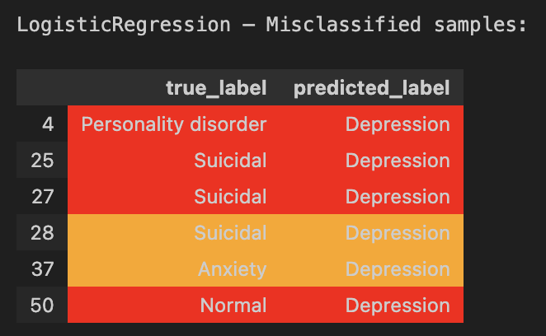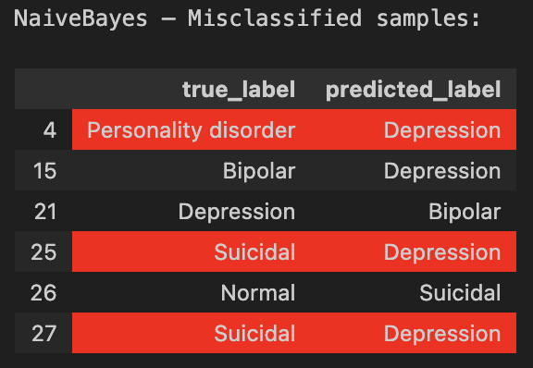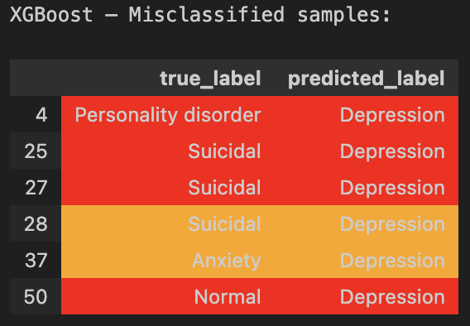
Figure 1: Table of misclassified samples across all three models
The original Fighting Words method discussed in class did not work as expected, despite multiple attempts to implement it directly. For this reason, I used AI assistance to generate a working version of the Fighting Words approach adapted for bigrams, while preserving the core idea of identifying language that distinguishes one group from another. First, it flattens the bigram lists and counts how often each bigram appears in the target class and in the comparison group. It then computes a log-odds ratio with smoothing, which measures how strongly a bigram is associated with the target class relative to others, while avoiding zero-count issues. For each bigram, a z-score is calculated by scaling the log-odds by its estimated variance. This standardization allows bigrams to be ranked by how statistically distinctive they are. Finally, the bigrams are sorted by their z-scores, and the top 20 most distinguishing bigrams are returned. Then, I applied fighting words method to each mental health status. First, it gets all unique mental health labels from the dataset. Then, for each label, it separates the data into two groups: bigrams that belong to the current mental health status, and bigrams that belong to all other statuses combined. This creates a clear comparison between one class and the rest of the data. Next, the fighting_words_bigrams function is called using these two groups. The function calculates which bigrams are most strongly associated with the current mental health status compared to others. The top 20 most distinctive bigrams for each status are then stored in a dictionary. Finally, I displayed the results with the help of matplotlib, and graphs can be seen below:
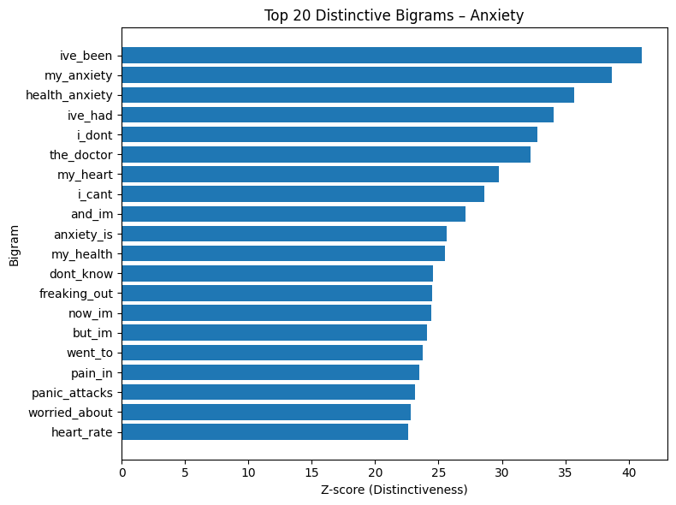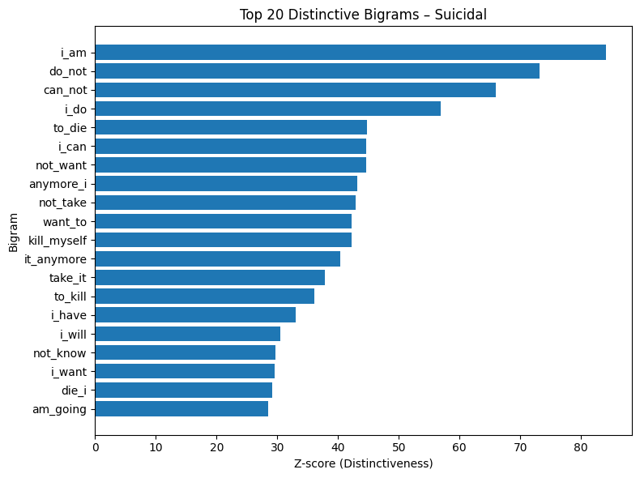
Figure 2: Top 20 Distinctive Bigrams: Anxiety and Suicidal
It is visible that these two graphs show very different language patterns. For Anxiety, the most distinctive bigrams focus on fear, physical sensations, and uncertainty. Phrases like “health_anxiety,” “panic_attacks,” “heart_rate,” “the_doctor,” and “worried_about” reflect concern about bodily symptoms and reassurance-seeking. The language is centered on worry and monitoring, not on intent or final decisions. The z-scores are high but relatively clustered, showing consistent anxiety-related themes. For Suicidal, the bigrams are much more direct, personal, and action oriented. Phrases such as “i_am,” “do_not,” “can_not,” “not_want,” “want_to,” “to_kill,” and “die_i” indicate loss of control, hopelessness, and explicit references to self-harm.

Comparison of the models used to extract top 20 bigrams for each mental health status: while TF-IDF Vectorizer identifies words and bigrams that are frequent and representative within each mental health status, Fighting Words method directly compares one mental health status against all others and calculates which bigrams are statistically more distinctive for that group. I stopped trying new models after applying both because together they provide a complete picture: TF-IDF shows what language is common, while Fighting Words confirms what language is uniquely associated with each mental health status. Using additional methods would likely repeat the same patterns rather than add new insight. I think TF-IDF can be seen as the primary method because it presents clear, human-readable language patterns that help non-native speakers distinguish between mental health conditions, while the Fighting Words method was used as a robustness check to confirm statistical distinctiveness.
When it comes to scope of the project, the models are designed to identify how people express their feelings in text, not to determine whether someone clinically has a specific mental health condition. As such, the results should be interpreted as patterns in language, not medical diagnoses. The analysis is intended for exploratory and educational purposes, including helping readers, especially non-native English speakers, better understand how different mental health experiences are commonly described.
One of the limitations of the project is that most of the statements are self-reported, which may contain noise, exaggeration, or incomplete descriptions of mental health experiences. Label quality is another limitation, as mental health statuses are often complex and overlapping, and some statements may not cleanly fit into a single category. Finally, the models analyze text at the statement level and do not capture broader personal or situational context. Short or ambiguous texts may lack sufficient information, leading to misclassification or unclear language patterns.

