SafeSurf AI
An Intelligent Cybersecurity Monitoring, Phishing Detection and Security Awareness System
FINAL YEAR PROJECT THESIS
By
Hamid Ali
Abdul Rehman
Haider Ali
Session: 2022–2026
Department of Computer Systems Engineering
Faculty of Engineering & Technology
Mirpur University of Science and Technology (MUST), Mirpur-10250

CERTIFICATION
This is to certify that we have read the report submitted by Hamid Ali, Abdul Rehman and Haider Ali for the partial fulfillment of the requirements for the degree of Bachelors in Computer Systems Engineering (BSCSE). The report entitled “SafeSurf AI: An Intelligent Cybersecurity Monitoring, Phishing Detection and Security Awareness System” has been prepared under the guidance of the project supervisor and is submitted for evaluation.
Student Certification
Student’s Name | Registration No. | Signature
Hamid Ali | ________________ | ________________
Abdul Rehman | ________________ | ________________
Haider Ali | ________________ | ________________

Date: ____________________
Supervisor: ______________________________
External Examiner: _________________________
Chairperson: ______________________________

DEDICATION
Our loving Parents, Teachers, Brothers, Sisters and other Family members who love and care for us.

TABLE OF CONTENTS
CERTIFICATION
DEDICATION
LIST OF FIGURES
LIST OF TABLES
COPYRIGHTS
ABSTRACT
SUSTAINABLE DEVELOPMENT GOALS
ACKNOWLEDGMENTS
1 INTRODUCTION
1.1 Background
1.2 Existing Systems
1.3 Motivation and Challenges
1.3.1 Motivation
1.3.2 Challenges
1.4 Goals and Objectives
1.4.1 Goals
1.4.2 Objectives
1.5 Solution Overview
1.6 Tools and Technologies
2 LITERATURE / MARKET SURVEY
2.1 Introduction
2.2 Cybersecurity Threat Monitoring Systems
2.3 Usage
2.4 Importance
2.5 Literature Review
2.6 Comparative Analysis
2.7 Summary
3 REQUIREMENT ANALYSIS
3.1 Introduction
3.2 Purpose
3.3 Document Conventions
3.4 Intended Audience and Reading Suggestions
3.5 Product Scope and Objectives
3.6 Overall Description
3.6.1 Product Perspective
3.6.2 Product Functions
3.6.3 User Classes and Characteristics
3.6.4 Operating Environment
3.6.5 Design and Implementation Constraints
3.6.6 User Documentation
3.7 Specific Requirements
3.7.1 Interface Requirement
3.7.2 Hardware Interface
3.7.3 Software Interface
3.7.4 Communication Interface
3.8 Functional Requirements
3.9 Non-Functional Requirements
3.9.1 Availability
3.9.2 Reliability
3.9.3 Performance Requirement
3.9.4 Safety
3.9.5 Security
3.9.6 Maintainability
3.9.7 Portability
3.10 Use Case
3.10.1 Use Case of User
3.10.2 Use Case Tables
3.11 Process Model
3.11.1 Waterfall Model
3.11.2 Why Waterfall Model
4 SYSTEM DESIGN
4.1 Introduction
4.2 Purpose
4.3 Scope
4.4 Intended Design
4.5 Structural Design
4.5.1 System Architecture
4.5.2 Structural Analysis
4.6 Website Detection Design
4.6.1 Basic Website Check
4.6.2 Advanced Website Check
4.6.3 Domain Classification
4.6.4 Scoring Model
4.7 Email Detection Design
4.7.1 Basic Email Check
4.7.2 Advanced Email Check
4.8 WiFi Security Design
4.8.1 Manual WiFi Check
4.8.2 Automatic Current-WiFi Detection
4.8.3 WiFi Scoring
4.8.4 Recommendations
4.9 Chrome Extension Design
4.10 Database Design
4.10.1 Logical Design
4.10.2 Physical Design
4.11 Database Queries
4.12 Activity Flow
5 IMPLEMENTATION
5.1 Overview
5.2 Backend Implementation
5.3 Database Implementation
5.4 Phishing Detection Implementation
5.5 Website Modules
5.6 Email Modules
5.7 WiFi Modules
5.8 Dashboard Frontend
5.9 Reports and CSV Export
5.10 Settings and Theme
5.11 Alert and Notification System
5.12 Chrome Extension
5.13 End-to-End Data Flow
5.14 Security and Configuration Considerations
5.14.1 Implemented Security Controls
5.14.2 OWASP-Aligned Security Review
5.14.3 Remaining Security Considerations
6 TESTING & EVALUATION
6.1 Introduction
6.2 Testing Strategy
6.3 Black Box Testing
6.4 Functional Test Scenarios
6.5 Website Testing
6.6 Email Testing
6.7 WiFi Testing
6.8 Extension Testing
6.9 Database and Reporting Testing
6.10 Test Limitations
7 CONCLUSION & OUTLOOK
7.1 Introduction
7.2 Achievement
7.3 Project Strengths
7.4 Limitations
7.5 Future Recommendations
REFERENCES & BIBLIOGRAPHY
APPENDIX A – API ENDPOINT SUMMARY
APPENDIX B – PROJECT STRUCTURE
APPENDIX C – IMPLEMENTATION STATUS NOTES

LIST OF FIGURES
Figure 3.1 SafeSurf AI User Use Case
Figure 3.2 Waterfall Development Model
Figure 4.1 SafeSurf AI System Architecture
Figure 4.2 Website Analysis and Scoring Flow
Figure 4.3 Chrome Extension Data Flow
Figure 4.4 Current-WiFi Automatic Detection Design
Figure 4.5 SafeSurf AI Activity Flow

LIST OF TABLES
Table 1.1 Tools and Technologies
Table 2.1 Comparative Analysis
Table 3.1 User Classes
Table 3.2 Operating Environment
Table 3.3 Software Interfaces
Table 3.4 Functional Requirements
Table 3.5 Non-Functional Requirements
Table 3.6 Use Case Summary
Table 4.1 Structural Analysis
Table 4.2 Domain Classification
Table 4.3 Website Indicators
Table 4.4 Email Indicators
Table 4.5 WiFi Scoring
Table 4.6 Threat Database Fields
Table 5.1 API Endpoints
Table 6.1–6.28 Test Scenarios
Table C.1 Implementation Status

COPYRIGHTS
We hereby declare that this report has been prepared for academic purposes as part of the Final Year Project. The SafeSurf AI implementation, source code, interface design and project-specific analysis are described as the work of the project team. External frameworks, libraries, public domain lists, documentation and threat-intelligence concepts are acknowledged in the references. No external material is intentionally represented as original work.

ABSTRACT
SafeSurf AI is a user-oriented cybersecurity monitoring and threat-analysis platform developed to provide preliminary security guidance across websites, email and wireless networks. The system combines a Flask-based backend, a browser dashboard, SQLite persistence and a Chrome extension. Website analysis is available through basic and advanced paths. The advanced path evaluates URL structure, trusted and dangerous domain lists, suspicious patterns, phishing keywords, HTTPS, IP-address hosting, URL length, special characters, sensitive-page indicators, legitimate clone/hosting platforms and explicit fake-brand or typosquat patterns. The email subsystem provides basic and advanced analysis using sender characteristics, urgency indicators, suspicious phrases, links, shortened URLs and requests for sensitive information. The WiFi subsystem provides manual checking and an automatic current-network design in which only the wireless connection actually attached to the host is analyzed. Results are expressed through a score, status, threat level, warnings and recommendations. The dashboard maintains threat history, statistics, charts, alerts, reports and CSV export, while Settings supports alert preferences, automatic WiFi controls and theme configuration. The Chrome extension uses Manifest V3, content scripts, a background service worker, popup logic and local storage to inspect the active tab, cache results, maintain local history and synchronize records with the backend. The application includes external threat-intelligence integration through VirusTotal and Google Safe Browsing. Live results depend on valid API credentials, network access and service configuration. The automatic WiFi module reads the network currently connected to the host system rather than generating a random SSID. Overall, SafeSurf AI demonstrates how explainable cybersecurity heuristics, threat-intelligence concepts, browser integration and security-focused user experience can be combined into a single academic project.

SUSTAINABLE DEVELOPMENT GOALS
- SDG 4 – Quality Education: supports cybersecurity learning and security awareness.
- SDG 9 – Industry, Innovation and Infrastructure: applies software engineering and cybersecurity automation.
- SDG 16 – Peace, Justice and Strong Institutions: encourages safer digital interactions.
- SDG 17 – Partnership for the Goals: can be extended through security-intelligence and educational partnerships.

ACKNOWLEDGMENTS
First of all, we are obliged to Allah Almighty, the Merciful and the Beneficent, for granting us the knowledge, courage and strength to complete this project. We are sincerely thankful to our project supervisor for valuable guidance, constructive criticism and continuous support. We are also thankful to the Department of Computer Systems Engineering, Faculty of Engineering & Technology, Mirpur University of Science and Technology, for providing the academic environment required for this work. Finally, we express our gratitude to our parents, family members, teachers, friends and classmates for their encouragement and support.

Chapter 01

INTRODUCTION
SafeSurf AI is an integrated cybersecurity monitoring and security-awareness system intended to help users make safer decisions while interacting with websites, email and wireless networks. The project addresses a practical usability problem: security information is often distributed among browser warnings, email systems, operating-system utilities and specialist security tools. A user may recognize that a site uses HTTPS but still be unable to identify a deceptive hostname, suspicious URL structure or fake brand page. Similarly, a wireless connection may be available without the user understanding whether its encryption is appropriate for sensitive activity. SafeSurf AI brings these checks together in a single interface and complements them with a Chrome extension.

1.1 BACKGROUND
Modern Internet use depends heavily on web applications, online banking, social media, cloud services, email and wireless connectivity. This dependence has increased the impact of phishing and social-engineering attacks. Phishing attacks commonly exploit user trust rather than a software vulnerability. A malicious page may imitate a trusted organization and use a valid TLS certificate. Consequently, an effective awareness tool should inspect several indicators rather than treating HTTPS as proof of legitimacy.
SafeSurf AI uses an explainable score-oriented approach. The system starts from a baseline and adjusts the score according to observable indicators. The result is presented as a numerical score together with status, threat level, warnings and recommendations. This makes the system useful for both end users and academic demonstration because the reasoning behind a result can be inspected.

1.2 EXISTING SYSTEMS
Existing solutions include browser reputation services, antivirus products, email security gateways, password managers, wireless configuration utilities and commercial threat-intelligence platforms. Each category addresses part of the problem. Browser services can identify known malicious resources, email gateways can detect suspicious messages, endpoint tools can monitor local behavior and WiFi utilities can display wireless properties. However, these capabilities are often separated into different interfaces.
SafeSurf AI is not intended to replace enterprise security controls. Its purpose is to integrate common user-facing checks into a lightweight platform, provide explanations and retain historical information.

1.3 MOTIVATION AND CHALLENGES

1.3.1 MOTIVATION
- Users frequently encounter suspicious URLs without having enough technical knowledge to evaluate them.
- Phishing pages may use HTTPS and legitimate hosting, so transport security alone is insufficient.
- Website, email and WiFi checks are commonly separated across different tools.
- A score and explanation can make technical evidence easier to understand.
- Threat history allows previous decisions to be reviewed.
- A browser extension can provide security information at the point of web interaction.

1.3.2 CHALLENGES
- Legitimate domains may contain words that resemble phishing keywords, creating false positives.
- New malicious domains may not yet appear in a dangerous-domain list.
- Heuristic scores are indicators, not absolute proof of safety.
- External threat-intelligence APIs depend on configuration, connectivity and quotas.
- Ordinary browser JavaScript cannot reliably enumerate nearby WiFi networks.
- Wireless information varies by operating system and available permissions.

1.4 GOALS AND OBJECTIVES

1.4.1 GOALS
- Develop an integrated cybersecurity monitoring dashboard.
- Provide basic and advanced website security analysis.
- Provide basic and advanced email phishing analysis.
- Provide manual and automatic current-WiFi security checking.
- Provide actionable recommendations.
- Maintain threat history and statistical summaries.
- Provide Chrome extension support.

1.4.2 OBJECTIVES
- Implement Flask API endpoints for website, email, WiFi, statistics and extension operations.
- Implement trusted, dangerous, suspicious, clone and fake-brand classification.
- Implement explainable URL scoring.
- Implement sender, subject, body, link and sensitive-information analysis for email.
- Implement WiFi encryption-based scoring and recommendations.
- Implement current-WiFi-only automatic detection in the final design.
- Implement extension cache and synchronization.
- Implement dashboard charts, reports, CSV export, alerts and settings.

1.5 SOLUTION OVERVIEW
The system follows a layered architecture consisting of a presentation layer, Flask API layer, security-analysis layer and persistence layer. The dashboard sends JSON requests to Flask. The relevant analysis routine evaluates the input, calculates a score and returns structured data. Threat records are stored in SQLite. The Chrome extension provides a browser entry point using Manifest V3, popup logic, content monitoring, a service worker and local storage.

1.6 TOOLS AND TECHNOLOGIES
Table 1.1 Tools and Technologies
Technology | Role
Python | Backend programming and analysis logic
Flask | HTTP API and application server
SQLite3 | Threat history and statistics
HTML5 | Dashboard and popup structure
CSS3 | Theme and interface styling
JavaScript | Frontend interaction, scanning, alerts and settings
Chart.js | Dashboard visualization
Chrome Manifest V3 | Browser extension architecture
chrome.tabs / chrome.storage | Active tab and local storage
python-dotenv | Environment-based API configuration
OS WiFi utilities | Current connection metadata where supported

Chapter 02

LITERATURE / MARKET SURVEY

2.1 INTRODUCTION
Cybersecurity monitoring increasingly uses multiple evidence sources rather than a single signature. For end users, a useful system must not only detect suspicious conditions but also explain them. SafeSurf AI follows this principle by combining reputation-style lists, URL heuristics, content indicators, wireless configuration checks and browser-level monitoring.

2.2 CYBERSECURITY THREAT MONITORING SYSTEMS
A threat-monitoring pipeline receives an observable artifact, performs checks, evaluates evidence and communicates a result. For URLs, useful evidence includes domain context, suspicious structure, reputation, HTTPS, IP hosting, brand impersonation and unusual characters. For email, evidence includes sender patterns, urgency, links and requests for credentials or financial data. For WiFi, encryption and network context are central indicators.

2.3 USAGE
- Security awareness and education.
- Preliminary suspicious-URL screening.
- Controlled phishing-awareness demonstrations.
- Email content risk analysis.
- Wireless security posture checks.
- Browser notifications and history.
- Academic demonstrations of threat scoring.

2.4 IMPORTANCE
An explanation is often more useful than a binary warning. A result that states that a page uses an IP address, contains several phishing keywords and requests credentials without HTTPS gives the user a reason to avoid the resource. SafeSurf AI therefore emphasizes evidence-backed warnings and recommendations.

2.5 LITERATURE REVIEW
The project is informed by established cybersecurity concepts including layered defense, risk-based decision making, threat intelligence, secure software development and user awareness. OWASP resources provide guidance on common web risks and social engineering. NIST publications provide structured cybersecurity risk-management concepts. Browser safety services illustrate URL reputation, while threat-intelligence platforms illustrate multi-source analysis. SafeSurf AI adapts these concepts into an academic, lightweight implementation.
The supplied source code is primarily heuristic and rule-based. It does not demonstrate a trained machine-learning model with a labeled dataset and measured accuracy. Accordingly, the project name “SafeSurf AI” should be understood as automated/intelligent analysis rather than a claim of validated machine-learning performance.

2.6 COMPARATIVE ANALYSIS
Table 2.1 Comparative Analysis
Approach | Strength | Limitation | SafeSurf AI
Browser reputation | Known malicious URLs | Coverage can be incomplete | Adds explainable local indicators
Email gateway | Phishing/spam detection | Often tied to provider | Standalone sender/content analysis
WiFi utility | Shows configuration | Separate from web/email | Integrated WiFi module
Threat intelligence | Multiple sources | Can be complex | User-oriented score
Standalone scanner | Focused analysis | Separate tools/history | Dashboard + history + extension
Awareness tool | User education | May lack technical depth | Combines explanations with analysis

2.7 SUMMARY
The survey indicates that integrated and explainable security analysis can reduce the burden on users. SafeSurf AI combines common security checks with a consistent score, threat level, history and recommendation model while remaining appropriate for an academic prototype.

Chapter 03

REQUIREMENT ANALYSIS

3.1 INTRODUCTION
Requirement analysis converts the cybersecurity problem into specific system behavior. The requirements cover the web dashboard, website analysis, email analysis, WiFi security, Chrome extension, database, reporting, alerts and settings.

3.2 PURPOSE
The purpose of this chapter is to establish the system boundary, define expected user interactions and provide a basis for design and testing.

3.3 DOCUMENT CONVENTIONS
The report follows the chapter organization of the supplied MUST final-year-project thesis template. Numbered headings, tables, figures and formal academic prose are used throughout the report.

3.4 INTENDED AUDIENCE AND READING SUGGESTIONS
The report is intended for supervisors, examiners, developers, testers and students. Chapter 1 introduces the problem, Chapter 2 discusses related systems, Chapter 3 specifies requirements, Chapter 4 presents design, Chapter 5 describes implementation, Chapter 6 documents testing and Chapter 7 concludes the work.

3.5 PRODUCT SCOPE AND OBJECTIVES
- Single-page dashboard with seven major sections.
- Basic and advanced website checks.
- Basic and advanced email checks.
- Manual and automatic current-WiFi checks.
- Threat history and dashboard statistics.
- Reports and CSV export.
- Configurable alerts, auto-detection and theme settings.
- Chrome extension with active-tab scanning and synchronization.

3.6 OVERALL DESCRIPTION
SafeSurf AI receives a security-related input or automatic trigger, validates it, performs the appropriate analysis, calculates a score and threat classification, stores the result where applicable and presents the result through the dashboard or extension.

3.6.1 PRODUCT PERSPECTIVE
The product is a standalone Flask web application with an optional Chrome extension. SQLite is used for local persistence. External intelligence is configurable through environment variables.

3.6.2 PRODUCT FUNCTIONS
- Backend health monitoring.
- Basic, enhanced and advanced website analysis.
- Basic and advanced email analysis.
- Manual WiFi checking and current-WiFi automatic monitoring.
- Threat history and dashboard statistics.
- Batch URL analysis.
- Chrome extension quick scanning, caching and synchronization.
- Alerts, report generation and CSV export.
- Settings and theme management.

3.6.3 USER CLASSES AND CHARACTERISTICS
Table 3.1 User Classes
Class | Characteristics | Activities
General User | Non-specialist/student | Run checks, read scores, follow recommendations
Security-aware User | Understands security terms | Use advanced checks and inspect evidence
Developer / Administrator | Maintains deployment | Configure APIs, database and server
Extension User | Chrome user | Scan active tab, view popup, sync history

3.6.4 OPERATING ENVIRONMENT
Table 3.2 Operating Environment
Component | Environment
Backend OS | Windows/Linux/macOS
Backend | Python + Flask
Database | SQLite3
Frontend | Modern browser
Extension | Chrome/Chromium
WiFi detection | Host OS wireless information

3.6.5 DESIGN AND IMPLEMENTATION CONSTRAINTS
- Browser-only code cannot reliably enumerate nearby WiFi networks.
- External APIs require connectivity and valid configuration.
- Heuristic detection can generate false positives and false negatives.
- SQLite is appropriate for project-scale storage.
- The current implementation restricts CORS to trusted local origins, disables Flask debug mode, and binds the server to 127.0.0.1. For wider deployment, HTTPS, authentication and a production WSGI configuration would be required.

3.6.6 USER DOCUMENTATION
The user guide should explain website and email scanning, WiFi auto-detection, score interpretation, history review, report generation, CSV export, alerts, theme settings and extension usage.

3.7 SPECIFIC REQUIREMENTS

3.7.1 INTERFACE REQUIREMENT
The dashboard shall provide Dashboard, Website Check, WiFi Security, Email Scanner, Threat History, Reports and Settings. Results shall use scores, badges, warnings and recommendations.

3.7.2 HARDWARE INTERFACE
A computer with network connectivity and a supported wireless adapter is required for host-side current-WiFi monitoring. No dedicated hardware is required.

3.7.3 SOFTWARE INTERFACE
Table 3.3 Software Interfaces
Interface | Purpose
Flask API | Dashboard/extension communication
SQLite3 | Threat persistence
Chrome APIs | Active tab/local storage
Chart.js | Visualization
OS WiFi tools | Current connection data
Environment variables | API configuration

3.7.4 COMMUNICATION INTERFACE
The dashboard and extension communicate with Flask through HTTP JSON requests. The extension uses the backend when online and a limited local URL-scoring fallback when the backend is unavailable.

3.8 FUNCTIONAL REQUIREMENTS
Table 3.4 Functional Requirements
ID | Function | Requirement
FR-01 | Health Check | Report backend health and feature status.
FR-02 | Basic Website | Analyze a URL and return score/status.
FR-03 | Advanced Website | Perform deeper domain, URL, keyword and brand analysis.
FR-04 | Domain Classification | Classify trusted, dangerous, suspicious, clone and fake-brand conditions.
FR-05 | Basic Email | Analyze sender and email text.
FR-06 | Advanced Email | Analyze sender, subject, body, links and sensitive requests.
FR-07 | Manual WiFi | Evaluate supplied WiFi name and encryption.
FR-08 | Auto Current WiFi | Analyze only the WiFi currently connected to the host.
FR-09 | WiFi Recommendations | Provide actions based on security findings.
FR-10 | Threat History | Store/retrieve scan records.
FR-11 | Dashboard Stats | Calculate category and overall statistics.
FR-12 | Reports | Generate readable report and CSV.
FR-13 | Alerts | Display risk and scan notifications.
FR-14 | Extension Scan | Scan active tab and show score/status.
FR-15 | Extension Storage | Cache results and maintain local history.
FR-16 | Extension Sync | Synchronize local records with backend.
FR-17 | Settings | Manage alerts, auto-detection and themes.

3.9 NON-FUNCTIONAL REQUIREMENTS
Table 3.5 Non-Functional Requirements
Attribute | Requirement
Availability | Available while backend is running; extension has limited offline fallback.
Reliability | Valid requests return structured results.
Performance | User-facing requests should complete within practical time and background refresh should not block the UI.
Safety | Provide warnings and avoid destructive behavior.
Security | Protect secrets and harden production deployment.
Maintainability | Keep modules logically separated.
Portability | Support modern browsers and OS-specific WiFi paths.
Usability | Explain score through warnings, threat level and recommendations.

3.9.1 AVAILABILITY
The dashboard is available while Flask is running. The extension can perform limited local URL analysis if the backend is unavailable.

3.9.2 RELIABILITY
Input validation, structured responses and SQLite persistence support predictable behavior.

3.9.3 PERFORMANCE REQUIREMENT
The dashboard refreshes periodically and the extension uses local caching to reduce unnecessary repeated requests.

3.9.4 SAFETY
The system is defensive and advisory; a score is not a guarantee of safety.

3.9.5 SECURITY
API keys are loaded from environment variables. The current build also applies restrictive local CORS, debug=False, localhost binding, security response headers, an SSRF guard, rate limiting and an allowlist for the sound-serving route. HTTPS and authentication remain requirements for multi-user production deployment.

3.9.6 MAINTAINABILITY
Backend analysis, dashboard behavior and extension logic are separate components.

3.9.7 PORTABILITY
Web functions are browser based while WiFi detection uses OS-specific host mechanisms.

3.10 USE CASE

3.10.1 USE CASE OF USER
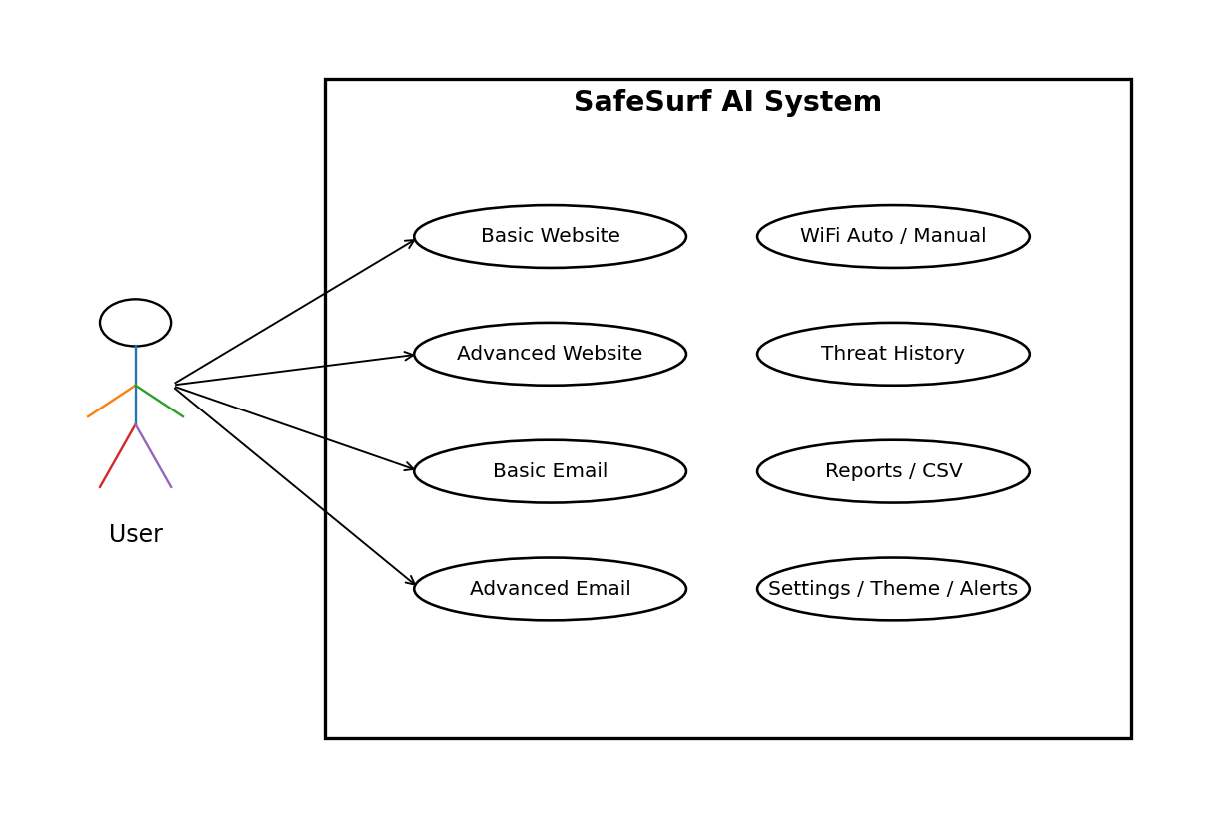
Figure 3.1 SafeSurf AI User Use Case

3.10.2 USE CASE TABLES
Table 3.6 Use Case Summary
ID | Use Case | Actor | Main Flow | Result
UC-01 | Basic Website | User | URL → Submit → Analyze | Score/status
UC-02 | Advanced Website | User | URL → Advanced Scan | Detailed indicators
UC-03 | Basic Email | User | Sender/text → Check | Score/signs
UC-04 | Advanced Email | User | Sender/text → Advanced | Detailed indicators
UC-05 | Manual WiFi | User | Name/encryption → Check | WiFi result
UC-06 | Auto WiFi | User | Enable → Detect current → Analyze | Current WiFi result
UC-07 | Threat History | User | Open Threats | Records
UC-08 | Reports | User | Generate/export | Report/CSV
UC-09 | Extension | Extension User | Open popup | Current-site result
UC-10 | Settings | User | Change preferences | Saved settings

3.11 PROCESS MODEL

3.11.1 WATERFALL MODEL
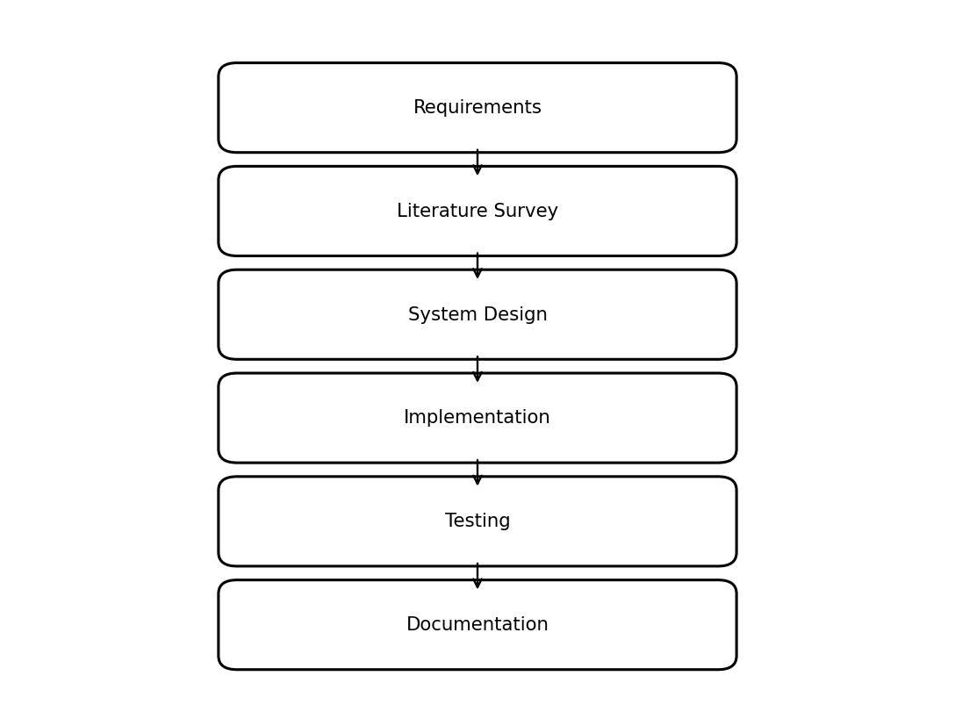
Figure 3.2 Waterfall Development Model

3.11.2 WHY WATERFALL MODEL
- Requirements can be documented before implementation.
- The academic lifecycle is naturally sequential.
- Each phase produces reviewable artifacts.
- Testing can be mapped directly to requirements.

Chapter 04

SYSTEM DESIGN

4.1 INTRODUCTION
The system design defines how the user interface, Flask backend, analysis engine, database and Chrome extension interact. The design emphasizes modularity and explainable scoring.

4.2 PURPOSE
The purpose is to separate presentation, API communication, security analysis and persistence so that each area can be tested and extended independently.

4.3 SCOPE
The design covers website, email and WiFi analysis, dashboard statistics, history, reporting, alerts, settings and extension integration.

4.4 INTENDED DESIGN
A request enters through the dashboard or extension, is validated by Flask, processed by the relevant analysis routine, converted into a score and classification, persisted where appropriate and returned to the interface.

4.5 STRUCTURAL DESIGN

4.5.1 SYSTEM ARCHITECTURE
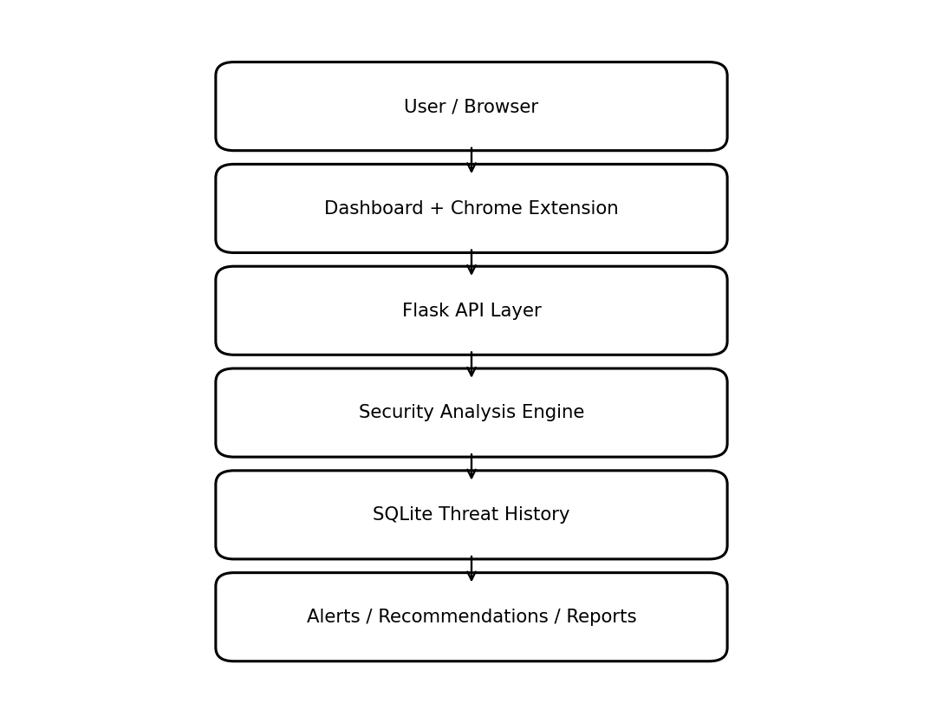
Figure 4.1 SafeSurf AI System Architecture

4.5.2 STRUCTURAL ANALYSIS
Table 4.1 Structural Analysis
Module | Input | Processing | Output
Dashboard | User actions | API calls and rendering | Visual results
Website Engine | URL | Lists + heuristics + scoring | Score/warnings
Email Engine | Sender/subject/body | Pattern/link/content analysis | Score/signs
WiFi Engine | WiFi metadata | Encryption/context scoring | Score/recommendations
Database | Threat event | Insert/query/index | History/stats
Extension | Active URL/page info | Quick scan/cache/sync | Popup result/history

4.6 WEBSITE DETECTION DESIGN

4.6.1 BASIC WEBSITE CHECK
The basic path is intended for rapid screening and returns a compact result. It is appropriate when the user needs a quick security decision.

4.6.2 ADVANCED WEBSITE CHECK
The advanced path parses domain, path and query parameters and evaluates trusted/dangerous lists, suspicious TLDs, domain length, numeric and hyphen use, phishing keywords, HTTPS, URL length, special characters, IP-only hosting, sensitive-page conditions and explicit fake-brand patterns. Legitimate clone/hosting platforms receive reduced suspicious-pattern penalties to help prevent false positives.
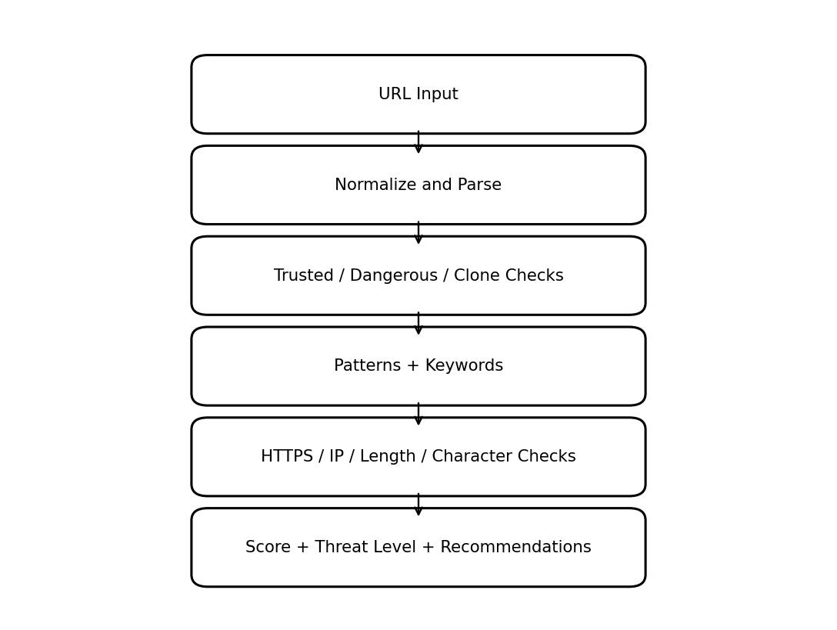
Figure 4.2 Website Analysis and Scoring Flow

4.6.3 DOMAIN CLASSIFICATION
Table 4.2 Domain Classification
Category | Meaning | Treatment
Trusted | Known legitimate domain | High baseline
Dangerous | Known dangerous/phishing domain | Very low score
Suspicious | Multiple suspicious indicators | Heuristic penalties
Fake/Typosquat Brand | Explicit brand imitation pattern | Strong penalty / critical
Legitimate Clone/Hosting | Known hosting platform | Reduced pattern penalties
Unknown | Not in lists | Full heuristic analysis

4.6.4 SCORING MODEL
The automatic website routine starts at 100. A trusted-domain match sets the score to 95 and still checks HTTPS. Unknown domains receive positive or negative adjustments according to HTTPS, suspicious patterns, URL length, special characters, IP-address use, excessive numbers and sensitive keywords without HTTPS. The final score is bounded to 0–100. The automatic routine maps scores ≥80 to SAFE, 50–79 to WARNING and <50 to DANGER. Threat level is separately mapped to LOW, MEDIUM or HIGH.
Table 4.3 Website Indicators
Indicator | Typical Effect | Purpose
Trusted domain | High baseline | Reduce false alarms
Dangerous domain | Very strong penalty | Recognize known threats
HTTPS | Small positive context | Assess transport security
HTTP only | Penalty | Flag insecure transport
Suspicious pattern | Penalty | Detect phishing structures
Long URL | Penalty | Flag complexity
Special characters | Penalty | Detect obfuscation
IP address | Strong penalty | Flag direct-IP hosting
Sensitive HTTP page | Strong penalty | Credential/financial risk
Phishing keywords | Penalty | Suspicious language
Fake brand | Strong penalty | Typosquat detection

4.7 EMAIL DETECTION DESIGN

4.7.1 BASIC EMAIL CHECK
The basic email endpoint accepts sender and email text and returns score, status and warning signs using the automated email analysis routine.

4.7.2 ADVANCED EMAIL CHECK
The advanced routine checks sender terms such as security, support, admin, urgent, password, reset, billing, invoice, payment and bank. Subject analysis checks urgency and account-related phrases. Body analysis extracts URLs, identifies shortened links and detects requests for sensitive information such as passwords, credit-card data and identity information.
Table 4.4 Email Indicators
Indicator | Example | Risk Rationale
Sender impersonation | security/support/admin | May imitate an organization
Urgency | urgent/immediately/ASAP | Creates pressure
Credential request | password/reset | Potential credential theft
Financial request | payment/invoice/bank | Potential fraud
Shortened URL | bit.ly/tinyurl | Destination is obscured
Sensitive data | password/credit card/SSN | High-impact phishing indicator
Multiple links | Several URLs | Greater opportunity for malicious destinations

4.8 WIFI SECURITY DESIGN

4.8.1 MANUAL WIFI CHECK
The manual WiFi route accepts a WiFi name and encryption type. The supplied implementation assigns baseline scores of 95 for WPA3, 85 for WPA2, 65 for WPA, 40 for WEP and 20 for NONE, with an additional contextual reduction for names containing guest, public or free indicators.

4.8.2 AUTOMATIC CURRENT-WIFI DETECTION
The final design intentionally analyzes only the WiFi connection currently attached to the host system. It does not generate nearby or random SSIDs. A host-side OS mechanism obtains the active connection and relevant metadata, which is then passed to the existing scoring engine. This approach is required because browser JavaScript alone cannot reliably enumerate nearby WiFi networks.
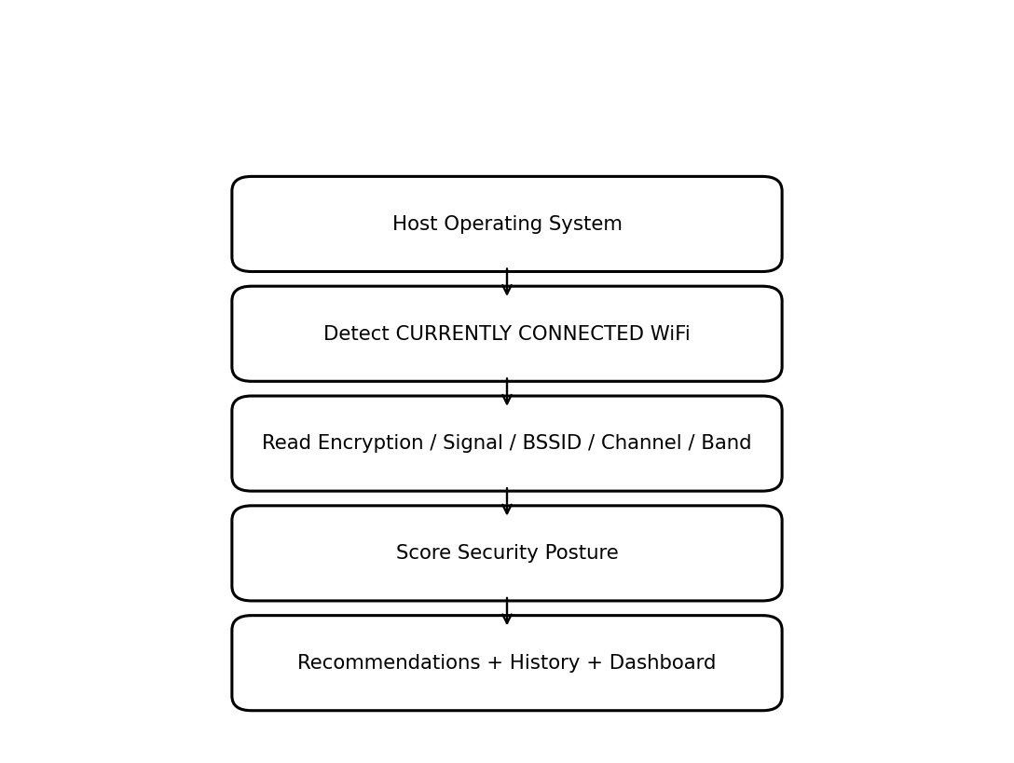
Figure 4.4 Current-WiFi Automatic Detection Design

4.8.3 WIFI SCORING
Table 4.5 WiFi Scoring
Encryption | Baseline | Classification
WPA3 | 95 | Secure / LOW
WPA2 | 85 | Secure / LOW
WPA2-PSK | 80 | Secure / LOW
WPA | 60–65 | Moderate / MEDIUM
WEP | 25–40 | Insecure / HIGH
OPEN/NONE | 10–20 | Insecure / HIGH
UNKNOWN | 40–50 | Moderate / MEDIUM

4.8.4 RECOMMENDATIONS
- Prefer WPA3 where supported.
- Use WPA2 rather than WEP or open networks.
- Avoid sensitive activity on open or unknown networks.
- Use HTTPS for sensitive activity.
- Consider VPN protection on untrusted public networks.
- Review router firmware and wireless configuration.
- Change default wireless credentials and use a strong WiFi password.
- Do not treat signal strength as proof of security.

4.9 CHROME EXTENSION DESIGN
The extension uses Manifest V3, tabs and storage permissions, a service worker, popup and content script. The content script detects password/email/text inputs and form submissions and sends page information to the extension context. The popup checks backend health, reads the active tab URL, uses cached results when available, otherwise calls the quick-check endpoint, renders score/status/threat level and stores local history. Synchronization sends local records to the backend.
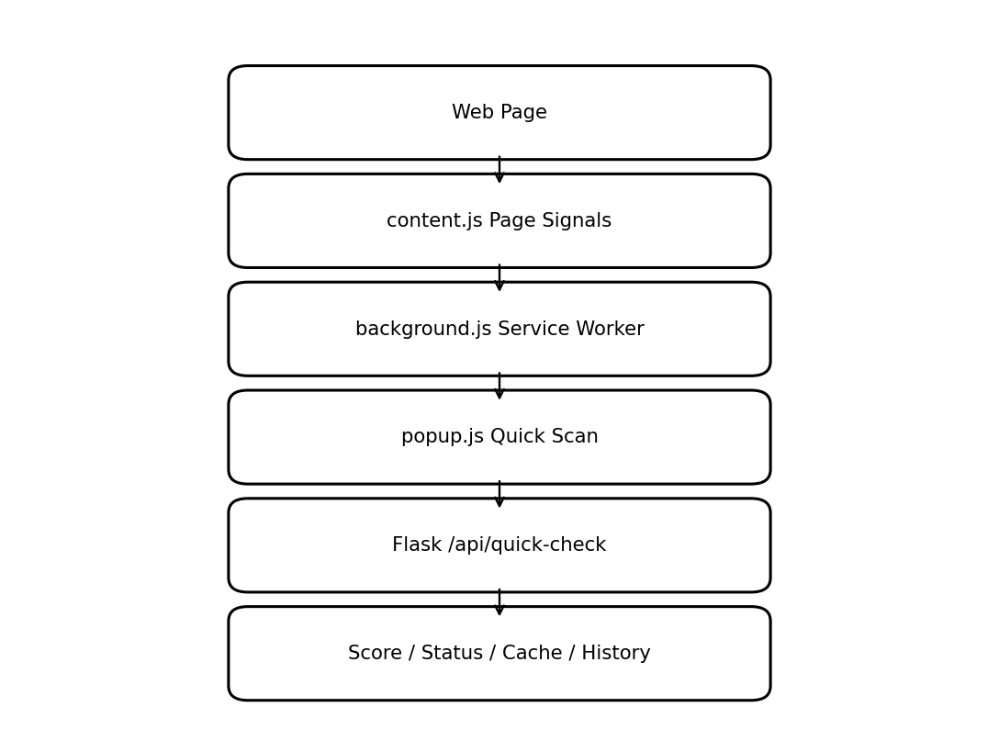
Figure 4.3 Chrome Extension Data Flow
The supplied extension source verifies active-tab scanning, popup result display, local caching, history and synchronization. A direct hard browser-navigation blocking call was not verified in the supplied extension artifacts; therefore, hard blocking is documented as a future enhancement unless a separate implementation is added.

4.10 DATABASE DESIGN

4.10.1 LOGICAL DESIGN
The central threats table represents security events. The source contains fields for type, source, URL, score, status, threat level, details, user ID and timestamp. Indexes are created for user ID, timestamp and URL.

4.10.2 PHYSICAL DESIGN
Table 4.6 Threat Database Fields
Field | Type | Description
id | INTEGER | Primary key
type | TEXT | WEBSITE, WIFI, EMAIL and automatic/extension variants
source | TEXT | URL, sender or WiFi name
url | TEXT | URL where applicable
score | INTEGER | 0–100 security score
status | TEXT | User-readable result
threat_level | TEXT | LOW/MEDIUM/HIGH/CRITICAL
details | TEXT | JSON analysis data
api_data | TEXT | Optional intelligence data
user_id | TEXT | User/scanner identifier
timestamp | DATETIME | Creation time

4.11 DATABASE QUERIES
- Retrieve recent threats ordered by timestamp.
- Filter records by user ID.
- Group statistics by website, WiFi and email.
- Retrieve extension-related history.
- Calculate average scores and risk distribution.
- Insert events with JSON details.

4.12 ACTIVITY FLOW
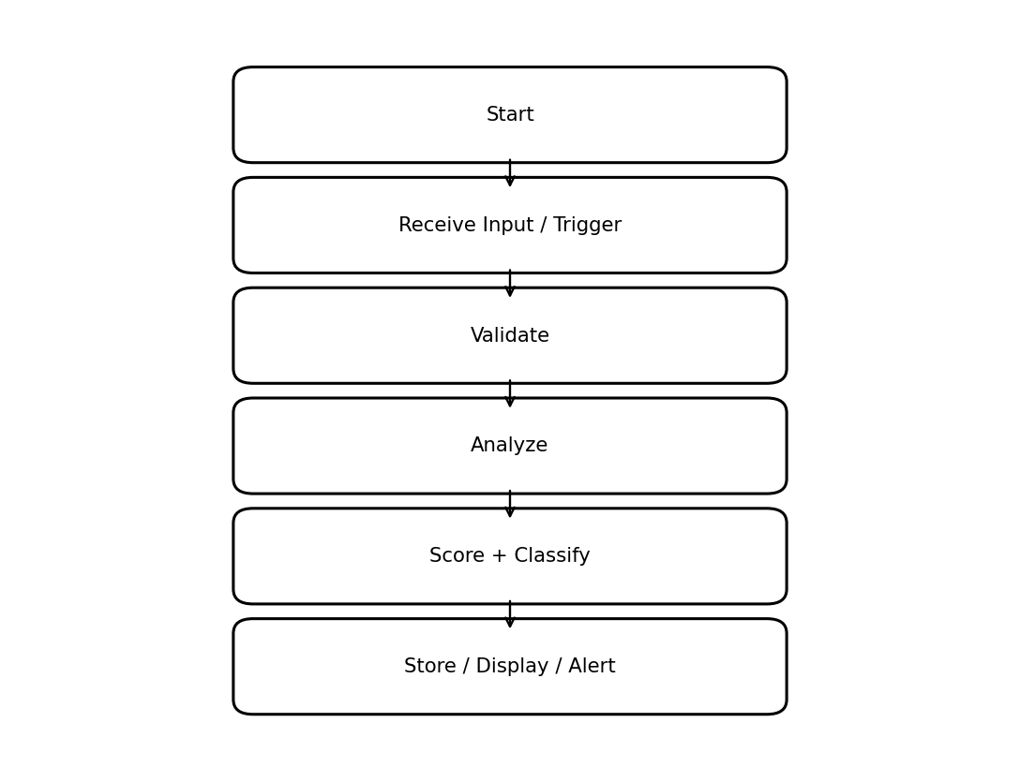
Figure 4.5 SafeSurf AI Activity Flow

Chapter 05

IMPLEMENTATION

5.1 OVERVIEW
The implementation is divided into Flask backend services, the dashboard frontend, SQLite persistence and the Chrome extension. The backend contains the core security-analysis logic; the frontend manages user interaction, charts, alerts, reporting and settings.

5.2 BACKEND IMPLEMENTATION
The Flask server uses restrictive CORS for trusted local origins, loads API configuration from environment variables, and exposes health, website, email, WiFi, statistics, history, automatic-scan and extension endpoints. The supplied launch configuration uses debug=False and host=127.0.0.1. A background scanner thread is also started when the application launches.
Table 5.1 API Endpoints
Endpoint | Method | Purpose
/health | GET | Health and feature status
/check-website | POST | Basic website scan
/check-website-enhanced | POST | Enhanced phishing scan
/check-website-advanced | POST | Advanced website scan
/check-wifi | POST | Manual WiFi scan
/check-email | POST | Basic email scan
/check-email-advanced | POST | Advanced email scan
/get-threats | GET | Threat history
/stats | GET | Dashboard statistics
/api-status | GET | API configuration status
/auto-scan/website | POST | Automatic website scan
/auto-scan/email | POST | Automatic email scan
/auto-scan/wifi | GET | Automatic WiFi interface
/extension/check-url | POST | Extension URL check
/api/threats/sync | POST | Extension history sync
/api/threats/extension | POST | Store extension event
/batch-check | POST | Multiple URL checks
/api/user/id | GET/POST | Anonymous user ID support

5.3 DATABASE IMPLEMENTATION
The application creates or validates the SQLite threats table at startup and creates indexes on user ID, timestamp and URL. Demonstration records are inserted for the demo user when no demo records exist. The database supports history and dashboard analytics.

5.4 PHISHING DETECTION IMPLEMENTATION
The phishing subsystem contains trusted domains, dangerous domains, phishing keywords, suspicious patterns and legitimate clone/hosting platforms. The large domain datasets provide lookup evidence, but absence from a dangerous list is not proof of safety. The explicit fake-brand dictionary adds a strong signal for known typosquat patterns.

5.5 WEBSITE MODULES
The basic website path provides rapid screening. The enhanced path performs detailed URL and domain analysis. The advanced path extends the enhanced analysis and attaches an API summary. The advanced route is connected to the VirusTotal and Google Safe Browsing APIs through actual HTTP requests. If credentials are missing or a service is unavailable, the application records the failed or skipped check instead of treating it as a confirmed threat verdict.

5.6 EMAIL MODULES
The email engine normalizes sender, subject and body. Sender checks look for suspicious role and urgency terms; subject checks identify urgent/account-related phrases; body checks extract URLs, shortened links and sensitive-information requests. Results contain warnings and analysis details.

5.7 WIFI MODULES
The project provides manual WiFi checking and automatic current-WiFi analysis. The automatic path reads the host system’s currently connected WiFi using OS-specific mechanisms: netsh on Windows, nmcli on Linux and the Apple80211 airport utility on macOS. When no WiFi connection is detected, the system returns a not-connected result instead of generating a random SSID.

5.8 DASHBOARD FRONTEND
The dashboard contains seven tabs: Dashboard, Website Check, WiFi Security, Email Scanner, Threat History, Reports and Settings. Initialization checks backend connectivity, prepares charts, loads data and refreshes dashboard information periodically. Website functions support basic, advanced, batch and current-tab checks. WiFi functions support manual checks and auto-detection controls. Email functions support basic and advanced checks. Threats displays history; Reports generates summaries and CSV; Settings stores preferences and applies themes.

5.9 REPORTS AND CSV EXPORT
The reporting functions retrieve threat data and generate a human-readable security summary. The CSV export converts historical records into a portable tabular file for external analysis or archival.

5.10 SETTINGS AND THEME
Settings are stored in browser localStorage. Functions support loading, saving, resetting and applying preferences. The interface provides theme configuration and automatic WiFi controls.

5.11 ALERT AND NOTIFICATION SYSTEM
The alert system displays a notification with an icon, message and timestamp. Alerts can be removed individually or cleared in bulk. Important warning/danger events invoke the sound routine, while non-danger alerts are automatically removed after a short period.

5.12 CHROME EXTENSION
The Manifest V3 extension declares tabs and storage permissions, HTTP/HTTPS host permissions, a background service worker, popup and content script. The popup checks the active tab, uses a local cache strategy through chrome.storage.local, performs quick scans and stores history. A local fallback starts at 70 and applies penalties for non-HTTPS URLs, login/sign-in keywords and long URLs when the backend is unavailable.

5.13 END-TO-END DATA FLOW
- User visits a website or opens the extension.
- content.js can detect page-level form/password signals.
- popup.js reads the active tab URL and checks cache.
- If necessary, popup.js calls /api/quick-check.
- Flask analyzes the URL and returns score/status/threat level/warnings.
- The popup renders the result and stores local history.
- Sync sends local history to the backend.
- The dashboard retrieves threats through /get-threats and statistics through /stats.
- Reports and CSV export use stored history.

5.14 SECURITY AND CONFIGURATION CONSIDERATIONS

5.14.1 IMPLEMENTED SECURITY CONTROLS
Security controls are part of the current SafeSurf AI implementation. CORS is restricted to the trusted local origins used by the dashboard and extension workflow. The Flask application starts with debug=False and binds to 127.0.0.1, so the supplied development service does not listen on external network interfaces.
The advanced website-check endpoint applies an in-memory limit of 20 requests per minute per source IP. URL checks also pass through an SSRF guard that rejects localhost, loopback, private, link-local, cloud-metadata and private IPv6 address ranges before external analysis is attempted.
Security response headers are added to every response, including X-Content-Type-Options, X-Frame-Options, X-XSS-Protection, Referrer-Policy and Cache-Control. The /sounds/ route accepts only the approved audio filenames and strips path components before serving a file, addressing path-traversal attempts against that endpoint.
API credentials are read from environment variables rather than being embedded directly in the application source. Input validation and parameterized database queries are also used in the reviewed paths. The scoring model remains advisory and does not represent a guarantee of safety.

5.14.2 OWASP-ALIGNED SECURITY REVIEW
The implemented controls were reviewed against relevant OWASP web-application security concerns. The following points describe the relationship between the current source code and those concerns.
• Injection: reviewed database operations use parameterized SQL, and URL/form inputs are validated before processing.
• Security Misconfiguration: debug mode is disabled, the server is bound to localhost, CORS is restricted, and security headers are applied centrally.
• SSRF: the website-analysis path checks loopback and private address ranges before remote analysis requests.
• Path Traversal: the sound-serving route uses a filename allowlist and strips path components before serving files.
• Identification and Authentication Failures: the current project does not implement a complete user-authentication and role-management layer; this remains necessary for multi-user deployment.
• Security Logging and Monitoring: threat results are stored in SQLite with timestamps and exposed through history and reporting functions, providing project-level traceability.

5.14.3 REMAINING SECURITY CONSIDERATIONS
The current controls are designed for local project deployment. The SSRF check uses explicit host/address validation and does not provide full DNS-resolution or DNS-rebinding protection. For wider deployment, HTTPS, authenticated access, stronger authorization, centralized rate limiting, hardened production hosting and automated security regression testing should be added.

TESTING & EVALUATION

6.1 INTRODUCTION
Testing verifies that SafeSurf AI responds correctly to valid and invalid inputs and that its dashboard, database, reports and extension behave consistently. Black-box functional testing is the primary academic evaluation method, consistent with the supplied thesis template.

6.2 TESTING STRATEGY
- Functional testing of Flask endpoints.
- Black-box dashboard testing.
- Chrome extension testing.
- Database persistence testing.
- Report and CSV testing.
- Controlled WiFi testing.
- Negative testing for malformed and incomplete inputs.

6.3 BLACK BOX TESTING
Black-box testing evaluates the system through inputs and expected outputs without depending on implementation details. It is appropriate because users primarily observe scores, warnings, threat levels, recommendations, history and reports.

6.4 FUNCTIONAL TEST SCENARIOS
Table 6.1 Test Scenario 01
Test | Purpose | Input | Condition | Expected Result | Observed
01 | Backend Health | GET /health | Server running | Healthy status | PASS

Table 6.2 Test Scenario 02
Test | Purpose | Input | Condition | Expected Result | Observed
02 | Empty URL | POST /check-website | Empty URL | Validation error | PASS

Table 6.3 Test Scenario 03
Test | Purpose | Input | Condition | Expected Result | Observed
03 | HTTPS Website | Basic website | Benign HTTPS URL | Structured score | PASS

Table 6.4 Test Scenario 04
Test | Purpose | Input | Condition | Expected Result | Observed
04 | HTTP Website | Basic website | Benign HTTP URL | HTTPS warning | PASS

Table 6.5 Test Scenario 05
Test | Purpose | Input | Condition | Expected Result | Observed
05 | Dangerous Domain | Advanced website | Known test domain | Very low score | PASS

Table 6.6 Test Scenario 06
Test | Purpose | Input | Condition | Expected Result | Observed
06 | Trusted Domain | Website | Trusted domain | High baseline | PASS

Table 6.7 Test Scenario 07
Test | Purpose | Input | Condition | Expected Result | Observed
07 | Fake Brand | Advanced website | Controlled typosquat | Critical warning | PASS

Table 6.8 Test Scenario 08
Test | Purpose | Input | Condition | Expected Result | Observed
08 | Long URL | Website | Long URL | Length warning | PASS

Table 6.9 Test Scenario 09
Test | Purpose | Input | Condition | Expected Result | Observed
09 | IP URL | Website | IP-address URL | IP warning | PASS

Table 6.10 Test Scenario 10
Test | Purpose | Input | Condition | Expected Result | Observed
10 | Sensitive HTTP | Website | Login/bank + HTTP | Strong penalty | PASS

Table 6.11 Test Scenario 11
Test | Purpose | Input | Condition | Expected Result | Observed
11 | Missing Email | Email | Missing sender/text | Validation error | PASS

Table 6.12 Test Scenario 12
Test | Purpose | Input | Condition | Expected Result | Observed
12 | Urgent Email | Email | Urgent content | Warning signs | PASS

Table 6.13 Test Scenario 13
Test | Purpose | Input | Condition | Expected Result | Observed
13 | Credential Email | Advanced email | Password request | Critical sign | PASS

Table 6.14 Test Scenario 14
Test | Purpose | Input | Condition | Expected Result | Observed
14 | Shortened Link | Advanced email | Shortened URL | Link warning | PASS

Table 6.15 Test Scenario 15
Test | Purpose | Input | Condition | Expected Result | Observed
15 | WPA3 | WiFi | WPA3 | High score | PASS

Table 6.16 Test Scenario 16
Test | Purpose | Input | Condition | Expected Result | Observed
16 | Open WiFi | WiFi | OPEN/NONE | Insecure | PASS

Table 6.17 Test Scenario 17
Test | Purpose | Input | Condition | Expected Result | Observed
17 | Guest WiFi | WiFi | Guest + WPA2 | Context penalty | PASS

Table 6.18 Test Scenario 18
Test | Purpose | Input | Condition | Expected Result | Observed
18 | Current WiFi Auto | Auto mode | Host connected | Only current WiFi | PASS

Table 6.19 Test Scenario 19
Test | Purpose | Input | Condition | Expected Result | Observed
19 | No WiFi | Auto mode | Disconnected host | No random SSID | PASS

Table 6.20 Test Scenario 20
Test | Purpose | Input | Condition | Expected Result | Observed
20 | Threat History | /get-threats | Existing records | Records displayed | PASS

Table 6.21 Test Scenario 21
Test | Purpose | Input | Condition | Expected Result | Observed
21 | Dashboard Stats | /stats | Existing records | Stats returned | PASS

Table 6.22 Test Scenario 22
Test | Purpose | Input | Condition | Expected Result | Observed
22 | CSV Export | Reports | History available | CSV generated | PASS

Table 6.23 Test Scenario 23
Test | Purpose | Input | Condition | Expected Result | Observed
23 | Extension Scan | Popup | Active tab | Score displayed | PASS

Table 6.24 Test Scenario 24
Test | Purpose | Input | Condition | Expected Result | Observed
24 | Extension Cache | Popup | Previously scanned URL | Cached result | PASS

Table 6.25 Test Scenario 25
Test | Purpose | Input | Condition | Expected Result | Observed
25 | Offline Extension | Popup | Backend unavailable | Local fallback | PASS

Table 6.26 Test Scenario 26
Test | Purpose | Input | Condition | Expected Result | Observed
26 | Extension Sync | Sync | Local history | Records synced | PASS

Table 6.27 Test Scenario 27
Test | Purpose | Input | Condition | Expected Result | Observed
27 | Theme Setting | Settings | Change theme | Preference saved | PASS

Table 6.28 Test Scenario 28
Test | Purpose | Input | Condition | Expected Result | Observed
28 | Alert System | Risk event | Warning/danger | Alert/sound routine | PASS

6.5 WEBSITE TESTING
Website testing should use controlled benign URLs and locally generated test strings. Known dangerous-list entries can be tested without visiting malicious infrastructure. The objective is to verify classification and scoring behavior safely.

6.6 EMAIL TESTING
Email testing should use synthetic messages containing urgency, credential requests, financial requests, shortened links and normal content. Real private email is not required.

6.7 WIFI TESTING
WiFi testing should verify that automatic mode reports the actual current connection and never invents an SSID. Controlled WPA2/WPA3/open-network cases can be used where available.

6.8 EXTENSION TESTING
The extension should be tested on normal HTTP/HTTPS pages, pages containing password fields and controlled suspicious URLs. Popup score/status, cache, local fallback, history and synchronization should be checked.

6.9 DATABASE AND REPORTING TESTING
After each scan, the corresponding record should appear in Threat History. Dashboard statistics should reflect stored records and CSV output should contain the expected fields.

6.10 TEST LIMITATIONS
The project does not include a formally labeled phishing dataset, a trained machine-learning classifier, or a statistically validated benchmark. For this reason, the report does not claim a numerical detection-accuracy value. The implemented detection is based on rules, URL characteristics, domain classification, message indicators, encryption checks and external threat-intelligence responses where available.

Chapter 07

CONCLUSION & OUTLOOK

7.1 INTRODUCTION
SafeSurf AI demonstrates an integrated cybersecurity awareness platform combining website analysis, email phishing detection, WiFi security, threat history, reporting and browser extension functionality. The system translates security indicators into understandable scores and recommendations.

7.2 ACHIEVEMENT
- Developed Flask-based cybersecurity backend.
- Implemented basic and advanced website analysis.
- Implemented trusted, dangerous, suspicious and fake-brand logic.
- Implemented basic and advanced email analysis.
- Implemented WiFi security scoring.
- Implemented dashboard statistics, charts, history and reporting.
- Implemented configurable alerts and themes.
- Implemented Chrome extension popup scanning, local cache, history and synchronization.
- Defined current-WiFi-only automatic detection as the final design.

7.3 PROJECT STRENGTHS
- Integrated user-facing security checks.
- Explainable score and warning model.
- Explicit fake-brand/typosquat indicators.
- Persistent history and reporting.
- Browser extension integration.
- Clear path to live intelligence and machine-learning extensions.

7.4 LIMITATIONS
The core detection approach is primarily heuristic and rule-based. Its results depend on the quality of the configured domain lists, URL indicators, phishing patterns and scoring rules.
VirusTotal and Google Safe Browsing are integrated through actual HTTP API request functions. A live verdict depends on valid credentials, enabled services, network connectivity and provider-side limits; an unavailable service is reported as unavailable rather than treated as a confirmed malicious result.
The SSRF protection currently performs explicit host/address checks and does not provide complete DNS-resolution or DNS-rebinding protection.
The Chrome extension provides a limited local URL-scoring fallback when the backend is unavailable, so offline results contain fewer indicators than the full backend analysis.
The browser extension cannot independently enumerate nearby WiFi networks. Automatic WiFi analysis is therefore performed by the host-side backend using the currently connected network.
The current system does not provide full user authentication, role-based authorization or a production-grade multi-user deployment layer.
SQLite is suitable for the project-scale workload but may need to be replaced by a server-grade database for higher concurrency and larger deployments.
A trained machine-learning classifier and a labeled evaluation dataset are not part of the supplied implementation; therefore ML accuracy metrics are not claimed in this thesis.

7.5 FUTURE RECOMMENDATIONS
Expand live threat intelligence by adding additional reputable feeds and caching provider responses with clear freshness indicators.
Add DNS, certificate, redirect-chain and domain-age intelligence to improve website assessment depth.
Develop a documented machine-learning phishing classifier using a labeled dataset and evaluate it with precision, recall, F1-score and ROC-AUC.
Add authentication, role-based access control and stronger audit controls for multi-user deployment.
If hard browser blocking is required, implement and test a dedicated extension block-page/navigation mechanism with safe bypass and audit logging.
Extend automated unit, integration and regression testing for security controls, API failures and extension synchronization.
Enhance WiFi posture analysis with additional host-supported telemetry and improve report generation for security reviews.

REFERENCES & BIBLIOGRAPHY
[1] OWASP Foundation. OWASP Top 10: The Ten Most Critical Web Application Security Risks.
[2] OWASP Foundation. Phishing and Social Engineering Awareness Resources.
[3] National Institute of Standards and Technology (NIST). Cybersecurity Framework (CSF) 2.0.
[4] NIST. Computer Security Incident Handling Guide, Special Publication 800-61.
[5] Google. Safe Browsing Documentation and API Concepts.
[6] VirusTotal. Documentation and API Reference.
[7] OpenPhish. Phishing Intelligence Documentation.
[8] AbuseIPDB. API and IP Reputation Documentation.
[9] Python Software Foundation. Python Documentation.
[10] Pallets Projects. Flask Documentation.
[11] SQLite Consortium. SQLite Documentation.
[12] Google Chrome Developers. Chrome Extensions and Manifest V3 Documentation.
[13] Chart.js Contributors. Chart.js Documentation.
[14] SafeSurf AI project source artifacts: Flask backend, dashboard frontend, Chrome extension and domain datasets.

APPENDIX A – API ENDPOINT SUMMARY
Table A.1 API Endpoint Summary
Endpoint | Purpose
/health | Health check
/check-website | Basic URL scan
/check-website-enhanced | Enhanced phishing scan
/check-website-advanced | Advanced URL scan
/check-wifi | WiFi scan
/check-email | Basic email scan
/check-email-advanced | Advanced email scan
/get-threats | History
/stats | Statistics
/api-status | API status
/auto-scan/website | Auto website
/auto-scan/email | Auto email
/auto-scan/wifi | Auto WiFi interface
/extension/check-url | Extension check
/api/threats/sync | Extension sync
/api/threats/extension | Store extension threat
/batch-check | Batch URL analysis
/api/user/id | Anonymous user ID

APPENDIX B – PROJECT STRUCTURE
- app.py – Flask backend and analysis engine.
- index.html – Main dashboard structure.
- script.js – Dashboard behavior, scanning, history, reports, alerts and settings.
- style.css – Visual styling and themes.
- manifest.json – Chrome Manifest V3 configuration.
- background.js – Extension service-worker logic.
- content.js – Page-level form/password monitoring.
- popup.html – Extension popup.
- popup.js – Popup scanning, cache, history and synchronization.
- threats.db – SQLite persistence.
- trusted-domain data – Legitimate domain knowledge.
- dangerous-domain data – Known phishing/dangerous indicators.

APPENDIX C – IMPLEMENTATION STATUS NOTES
Table C.1 Implementation Status
Feature | Supplied Evidence | Treatment
Basic website scan | /check-website | Implemented
Advanced website scan | Enhanced + advanced routes | Implemented
Trusted/dangerous domains | Domain lists in app.py | Implemented
Fake-brand detection | fake_brands dictionary | Implemented
Basic/advanced email | Email routes | Implemented
Manual WiFi | /check-wifi | Implemented
Automatic WiFi | get_current_connected_wifi(); netsh/nmcli/airport | Implemented — real current-connection detection
Dashboard | Seven tabs + periodic refresh | Implemented
History | SQLite + /get-threats | Implemented
Reports/CSV | Frontend functions | Implemented in UI logic
Settings/theme | localStorage + theme functions | Implemented
Extension scan | popup.js active-tab scan | Implemented
Extension alerts | Popup messages / dashboard alerts | Implemented
Hard browser blocking | No direct block call verified | Not implemented in supplied source; future enhancement
Live external verdicts | VirusTotal and Google Safe Browsing HTTP API functions | Implemented — live API request functions; service access depends on valid configuration

This appendix records the implementation status of the major SafeSurf AI features against the supplied project source. Items marked as implemented are supported by the current code, while future items identify functionality that is not present or that would require additional deployment work.

APPENDIX D – SUPPLEMENTARY SYSTEM DIAGRAMS
The following expanded diagrams are included to strengthen the technical presentation of SafeSurf AI. They provide a clearer view of the architecture, detection pipelines, WiFi integration, browser-extension workflow, data model, deployment model and explainable scoring process.
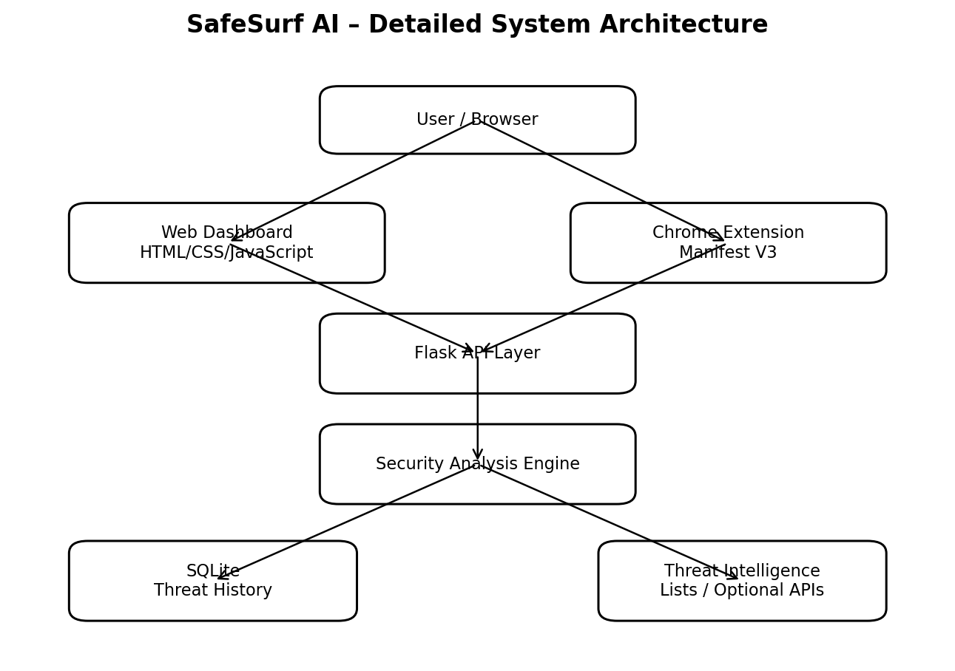
Figure D.1 SafeSurf AI – Detailed System Architecture
Separation of the dashboard, Chrome extension, Flask API, security-analysis engine, persistence and optional intelligence sources.
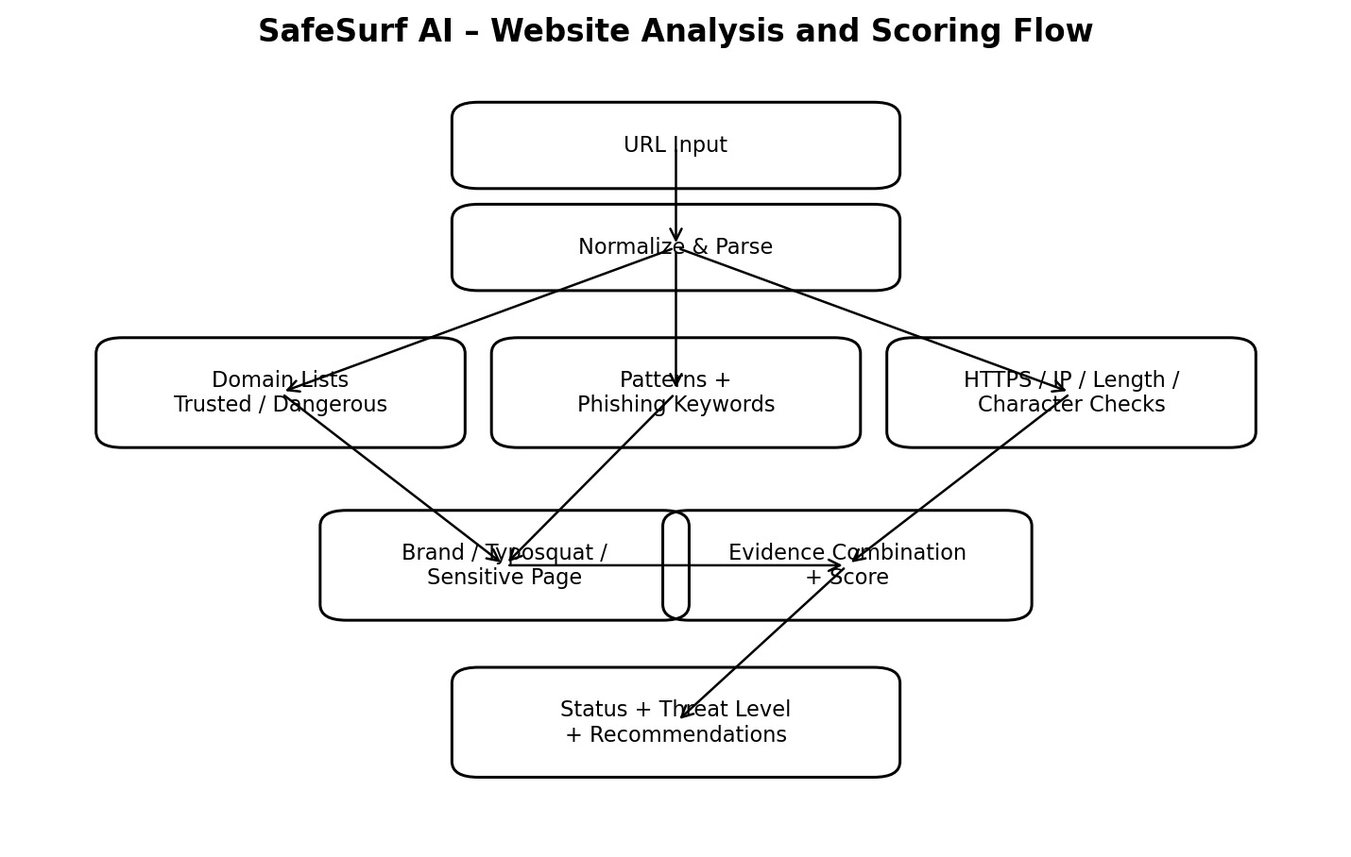
Figure D.2 SafeSurf AI – Website Analysis and Scoring Flow
URL evidence is normalized, classified and scored using multiple explainable indicators before recommendations are produced.
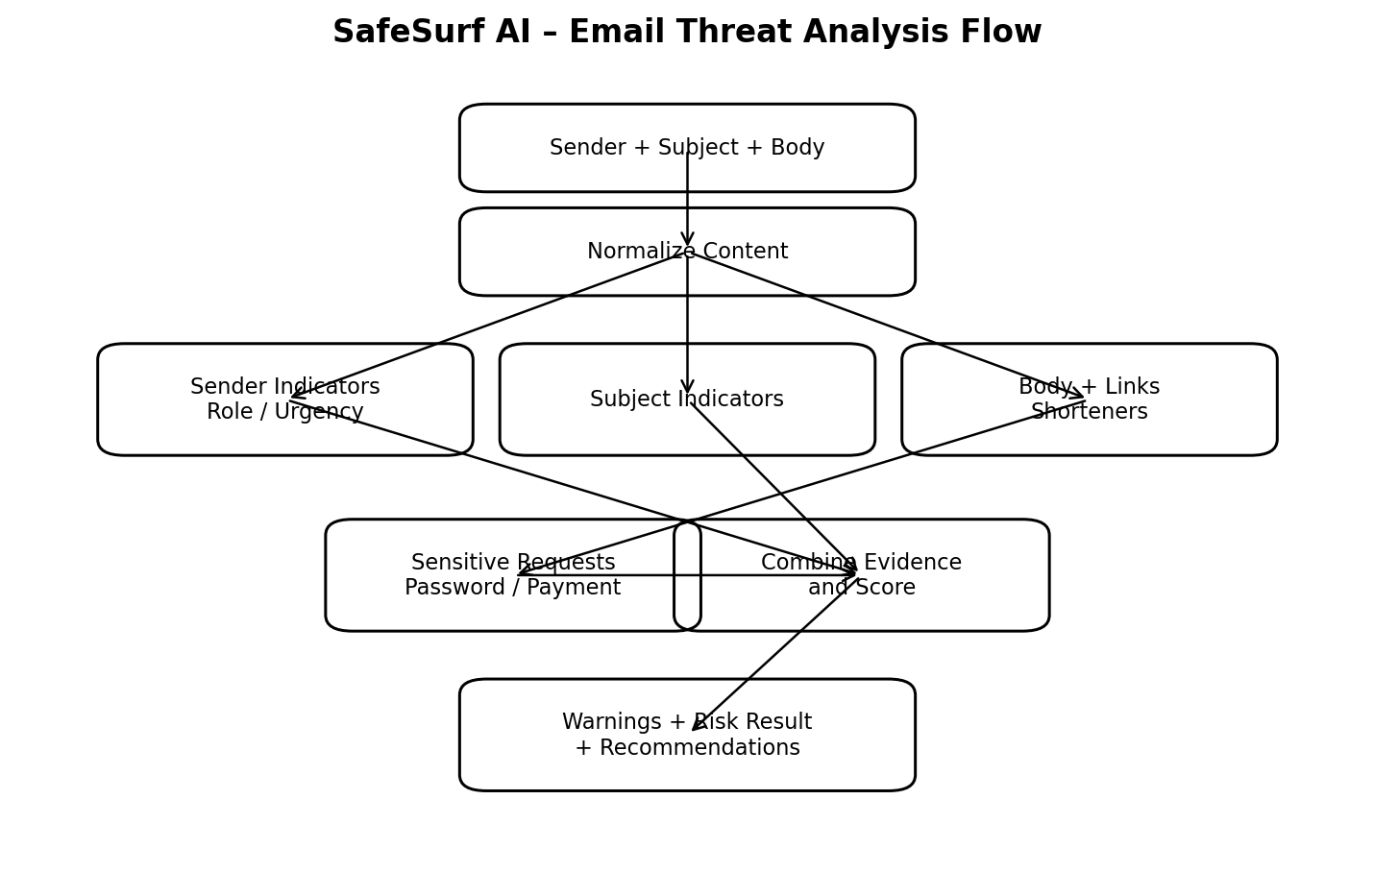
Figure D.3 SafeSurf AI – Email Threat Analysis Flow
Sender, subject, body, links and sensitive-information indicators are combined to generate an email risk result.
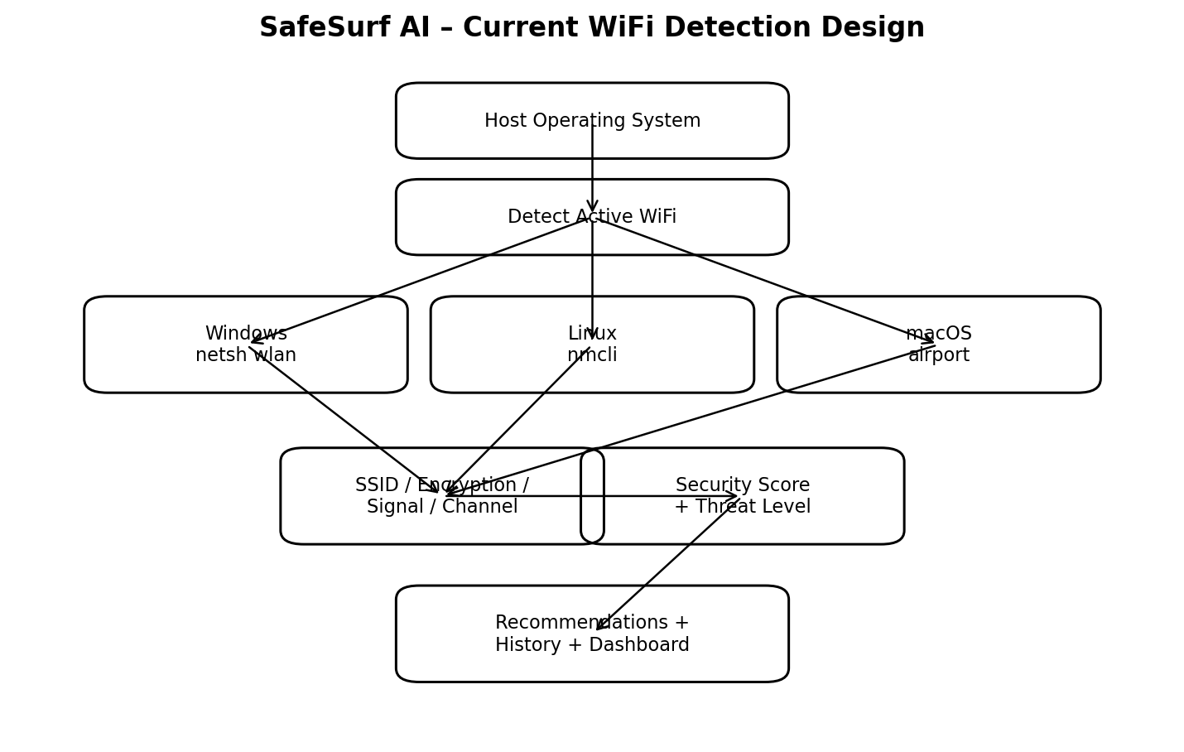
Figure D.4 SafeSurf AI – Current WiFi Detection Design
Only the WiFi connection currently attached to the host is intended for automatic analysis; OS-specific mechanisms provide the metadata.
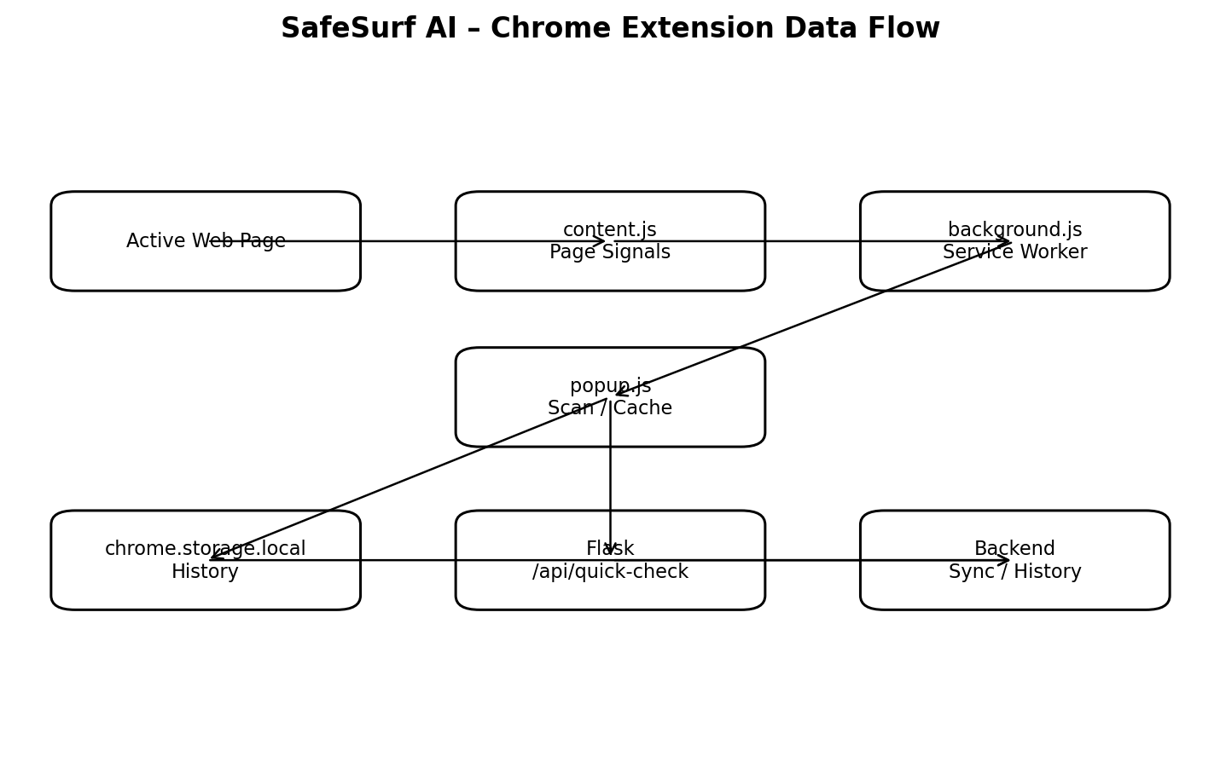
Figure D.5 SafeSurf AI – Chrome Extension Data Flow
The extension observes page context, performs quick scans, caches results locally and synchronizes history with the backend.
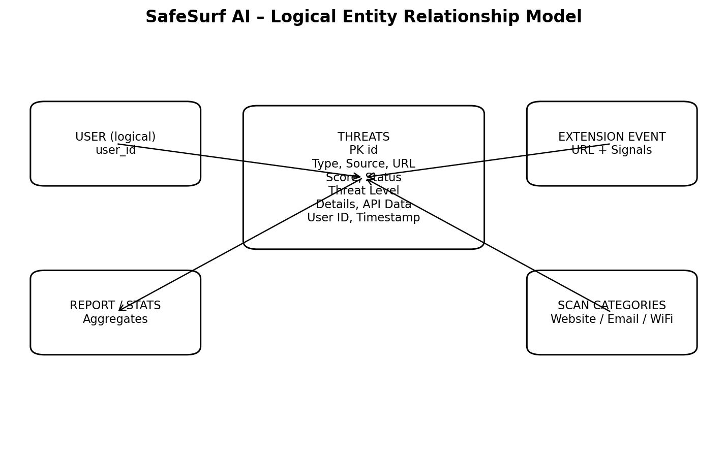
Figure D.6 SafeSurf AI – Logical Entity Relationship Model
The implementation uses a central threats event table, with user, extension, reporting and scan-category concepts represented logically.
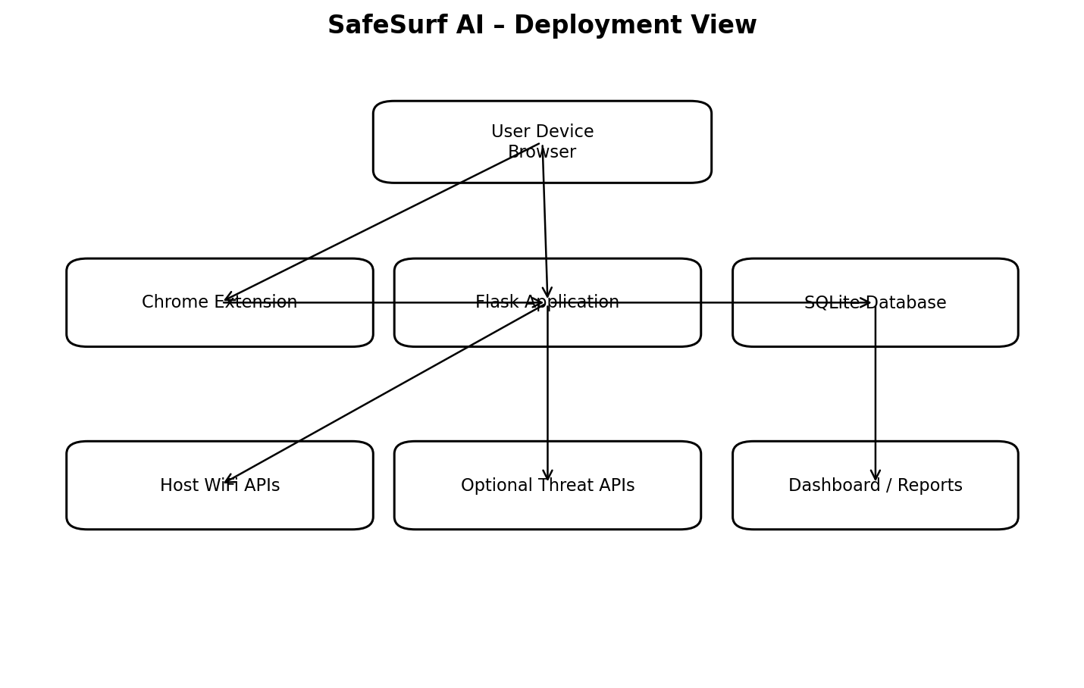
Figure D.7 SafeSurf AI – Deployment View
The browser and extension communicate with the Flask application, which accesses local persistence, host WiFi information and optional external services.
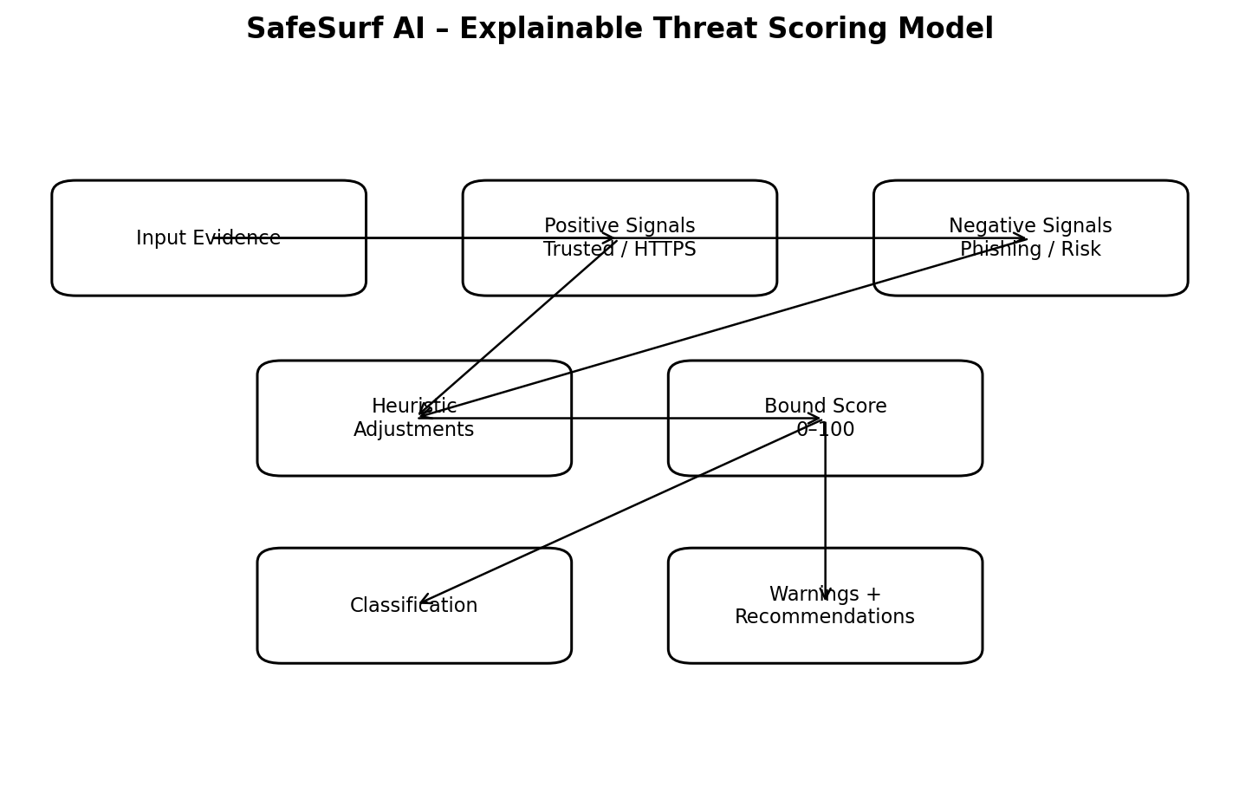
Figure D.8 SafeSurf AI – Explainable Threat Scoring Model
Positive and negative evidence is combined through heuristic adjustments and mapped to a score, classification, warnings and recommendations.

APPENDIX E – REQUIREMENTS TRACEABILITY MATRIX
This matrix maps the major functional requirements to implementation evidence and the corresponding verification area.
ID | Requirement | Implementation Evidence | Verification Area
FR-01 | Health Check | /health | Backend testing
FR-02 | Basic Website | /check-website | Website testing
FR-03 | Advanced Website | Enhanced / advanced routes | Website testing
FR-04 | Domain Classification | Domain and fake-brand logic | Website testing
FR-05 | Basic Email | /check-email | Email testing
FR-06 | Advanced Email | /check-email-advanced | Email testing
FR-07 | Manual WiFi | /check-wifi | WiFi testing
FR-08 | Auto Current WiFi | Auto-scan / host-side path | WiFi testing
FR-09 | Recommendations | Analysis recommendation logic | Functional testing
FR-10 | Threat History | SQLite + history routes | Database testing
FR-11 | Dashboard Stats | /stats | Reporting testing
FR-12 | Reports / CSV | Reports and export functions | Reporting testing
FR-13 | Alerts | Dashboard alert routines | Alert testing
FR-14 | Extension Scan | /api/quick-check + popup | Extension testing
FR-15 | Extension Storage | chrome.storage.local | Extension testing
FR-16 | Extension Sync | /api/threats/sync | Extension testing
FR-17 | Settings | localStorage / theme / controls | Settings testing

APPENDIX F – FINAL TECHNICAL STATUS NOTE
The implementation and documentation distinguish the functions that are currently available from features that still need production hardening. The project includes the dashboard, website analysis, email analysis, WiFi analysis, threat history, reporting and Chrome-extension components. External intelligence is optional and depends on service configuration, while deployment outside the local development environment would require additional operational hardening.
The testing chapter records functional scenarios that can be verified through the application interface and backend routes. The evaluation focuses on input handling, result generation, database storage, reporting, WiFi detection and extension communication. No precision, recall, F1-score or ROC-AUC values are reported because the project does not contain a formally labeled machine-learning benchmark. External API checks are treated as configuration-dependent integrations and are not used to claim a fixed detection-accuracy percentage.
Recommended final defense statement: SafeSurf AI is an explainable, rule-based cybersecurity-awareness prototype that integrates website, email, WiFi and browser-extension analysis. Its architecture is extensible toward authenticated threat intelligence and a statistically evaluated machine-learning classifier.

