Automation with Python - Miriam Janet Gallardo Santos

Contenido

Day 1. 1

Exercise 1 - Printing 1

Exercise 2 - Debugging Practice 2

Exercise 3 - Input Function 4

Exercise 4 - Variables 5

Exercise 5- Project: Band Name Generator 6

Exercise 6 - Data Types 6

Ejercicio 7 de calculadora. 7

# Day 1.

## Exercise 1 - Printing

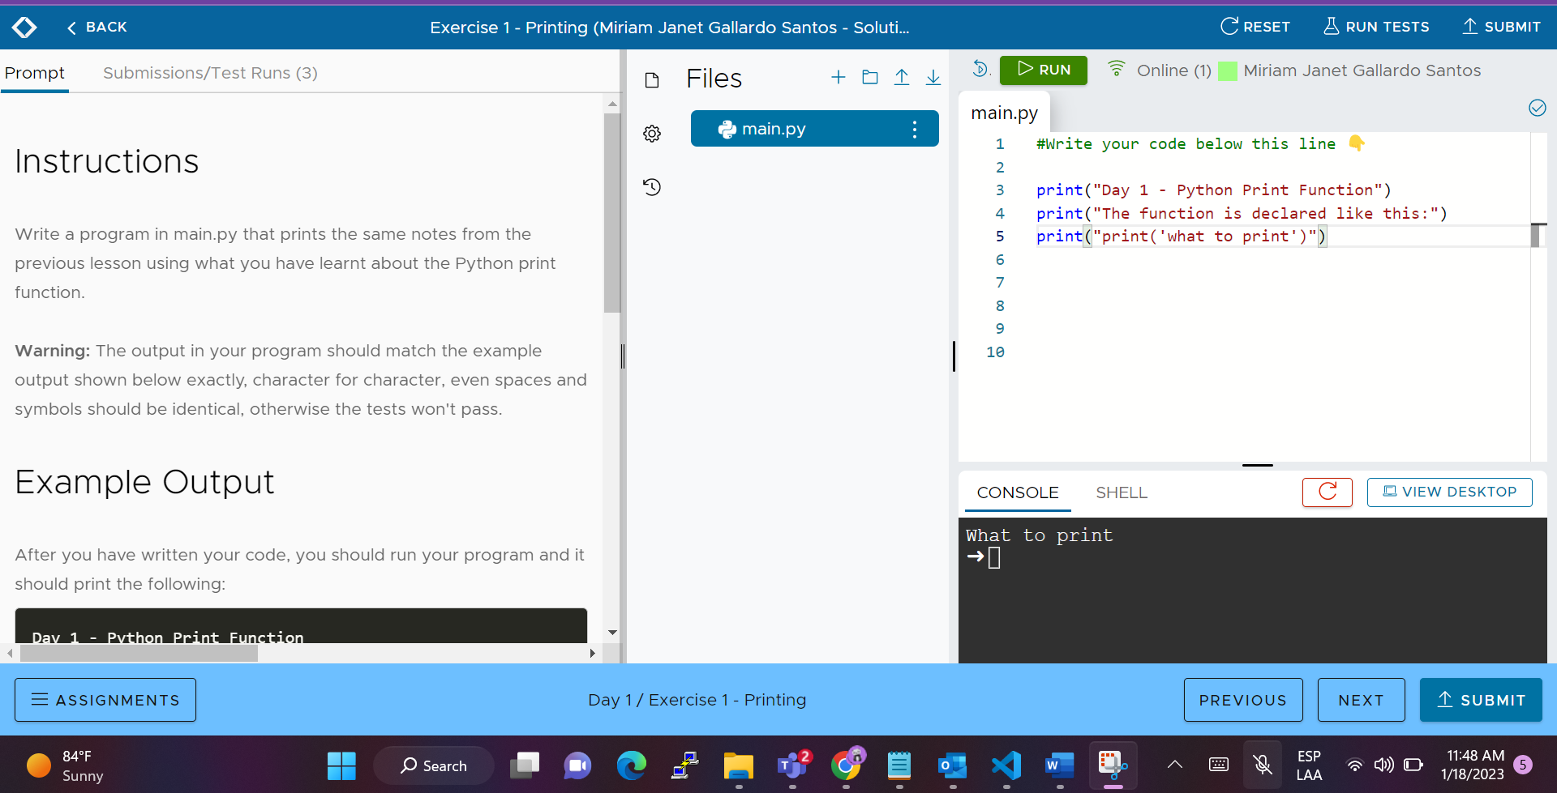

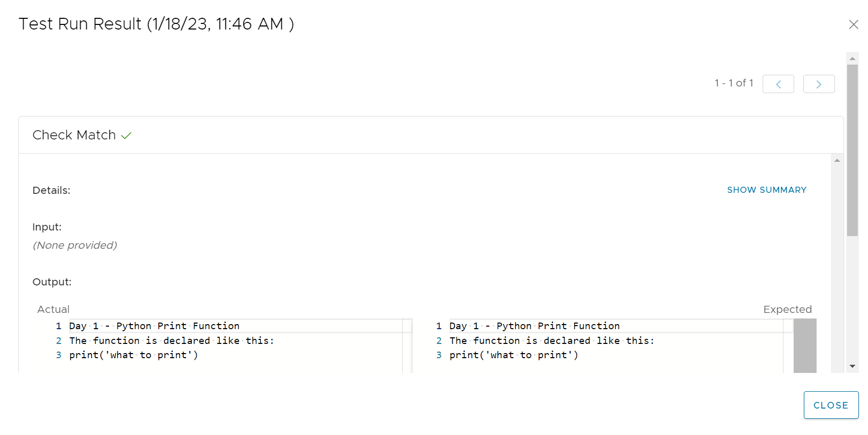

## Exercise 2 - Debugging Practice

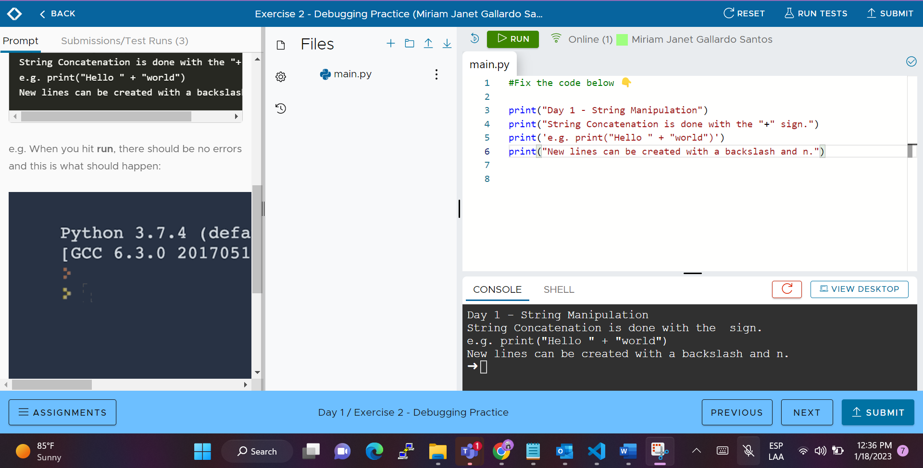

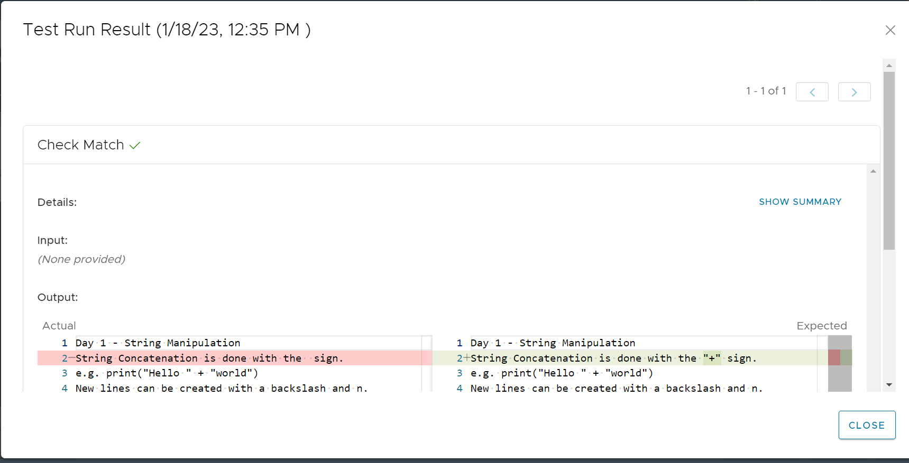

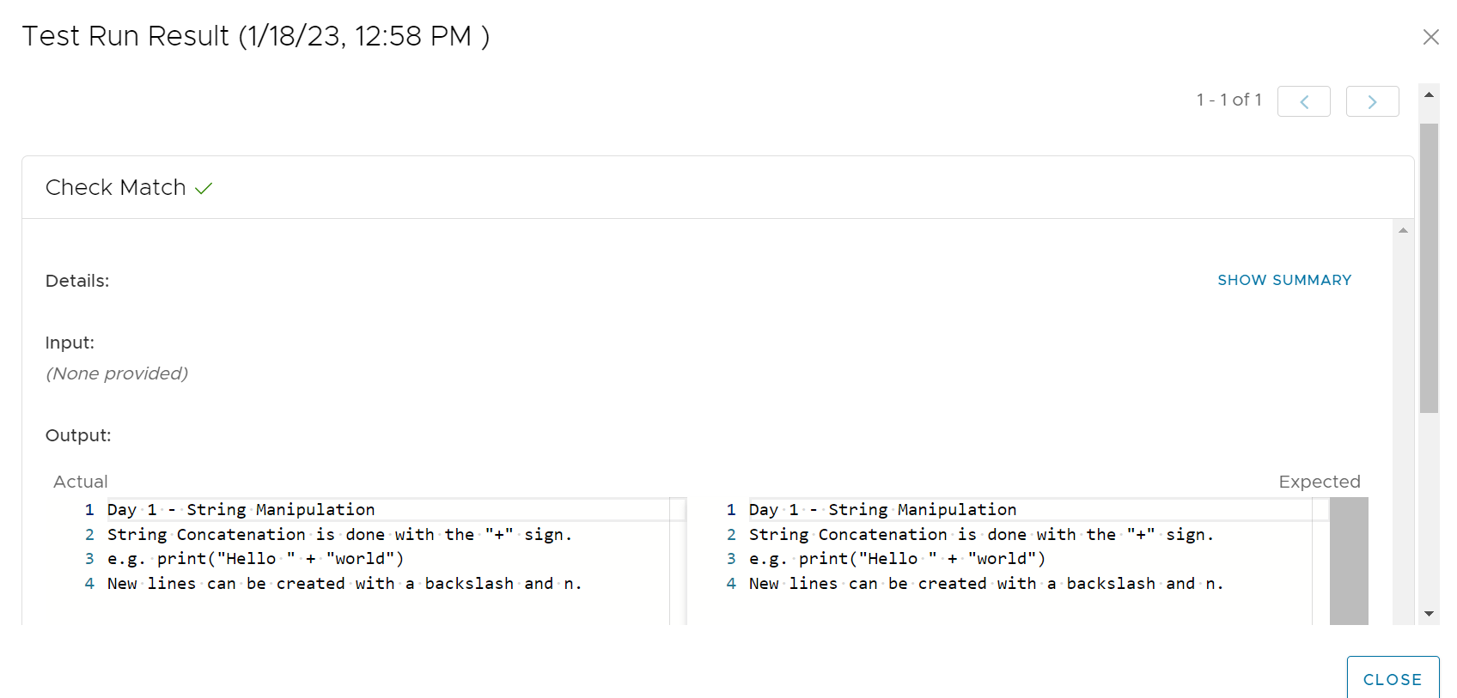

## Exercise 3 - Input Function

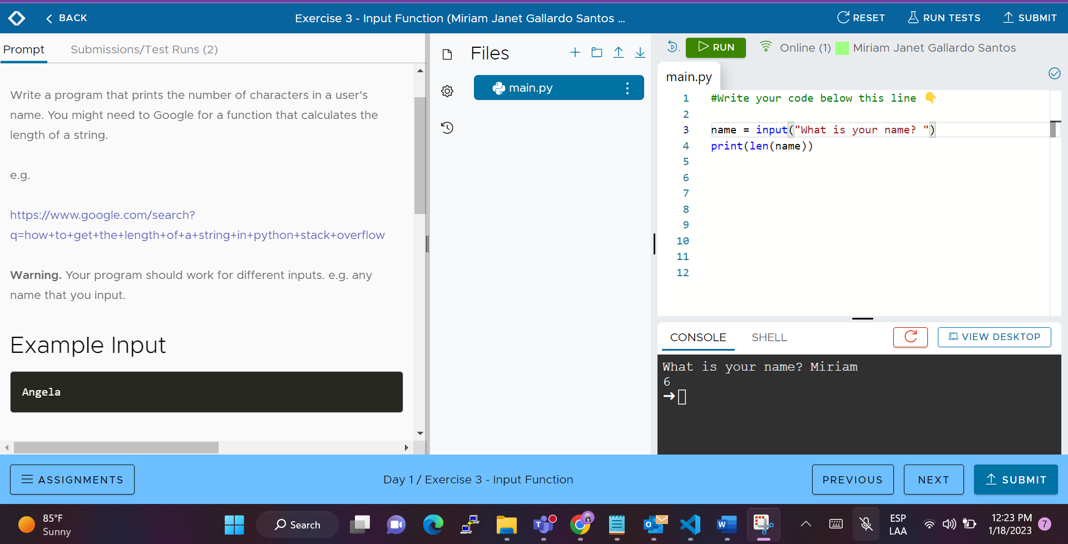

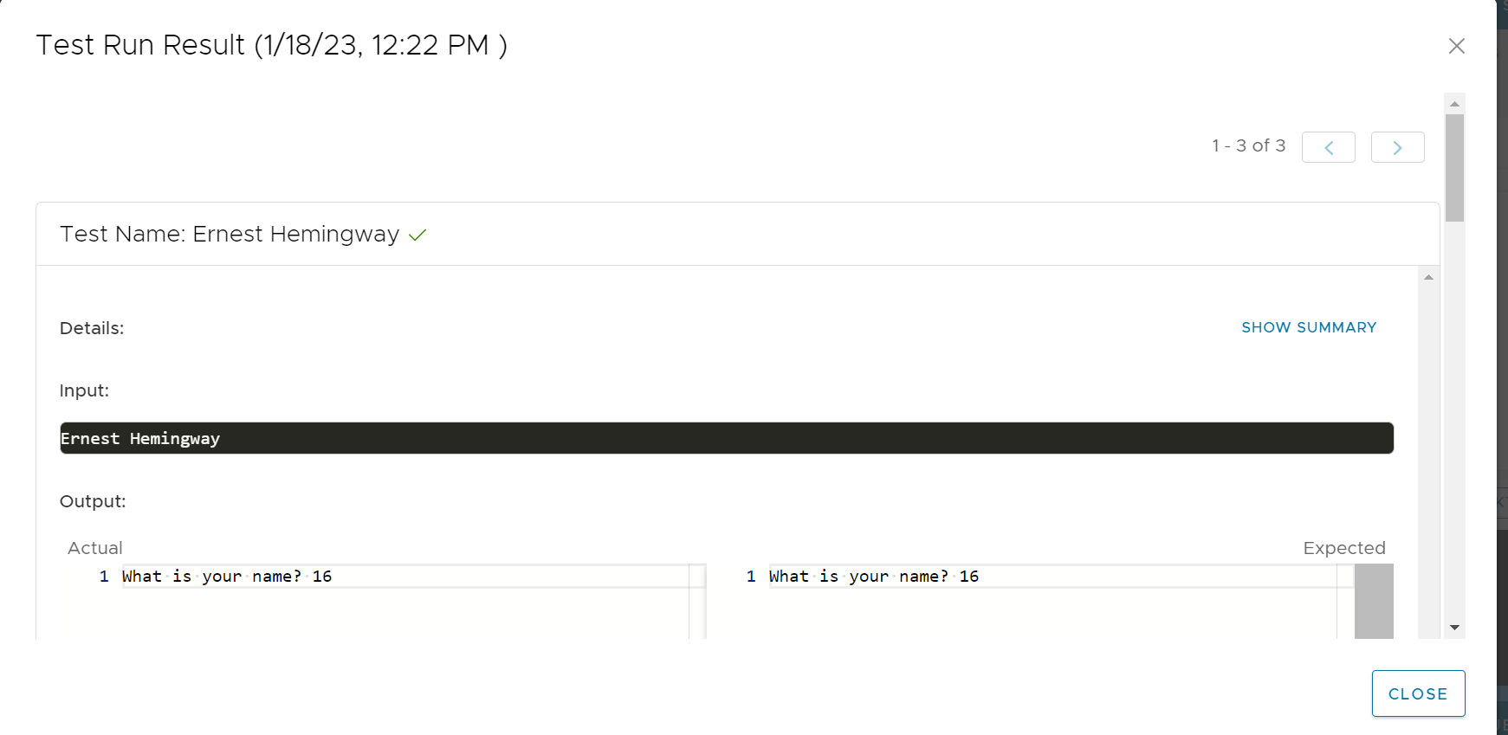

## Exercise 4 - Variables

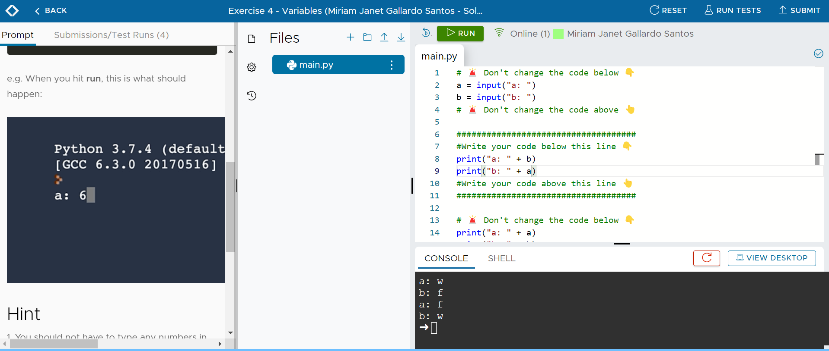

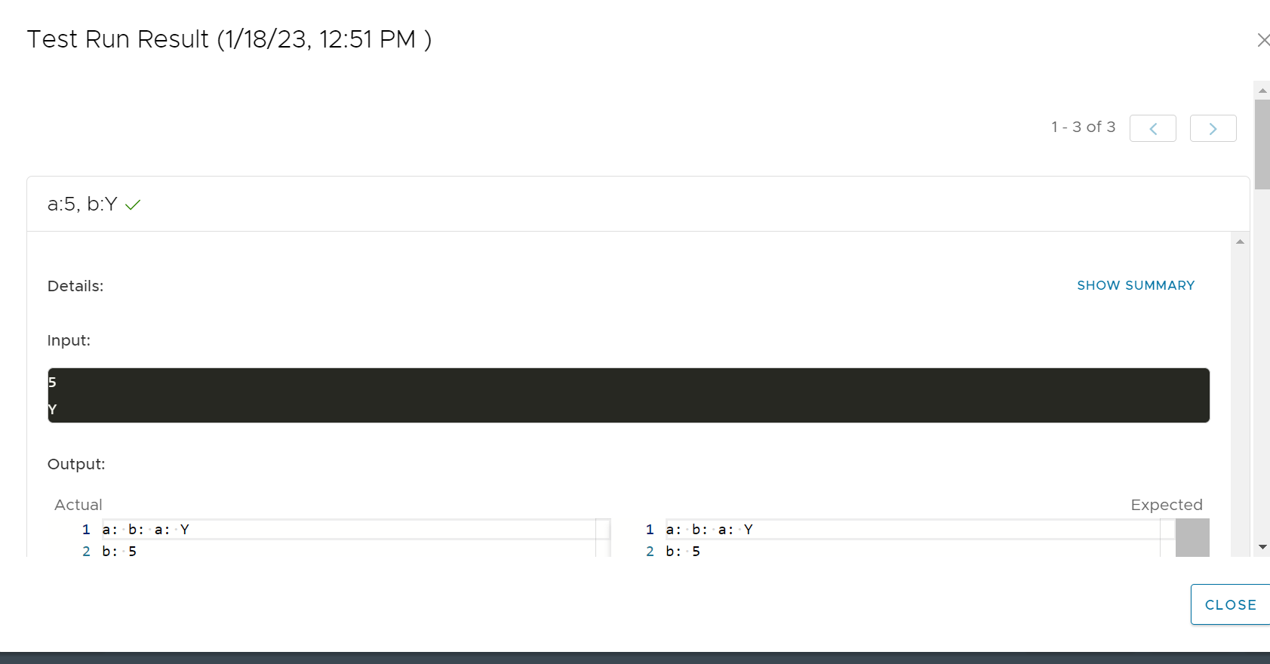

## Exercise 5- Project: Band Name Generator

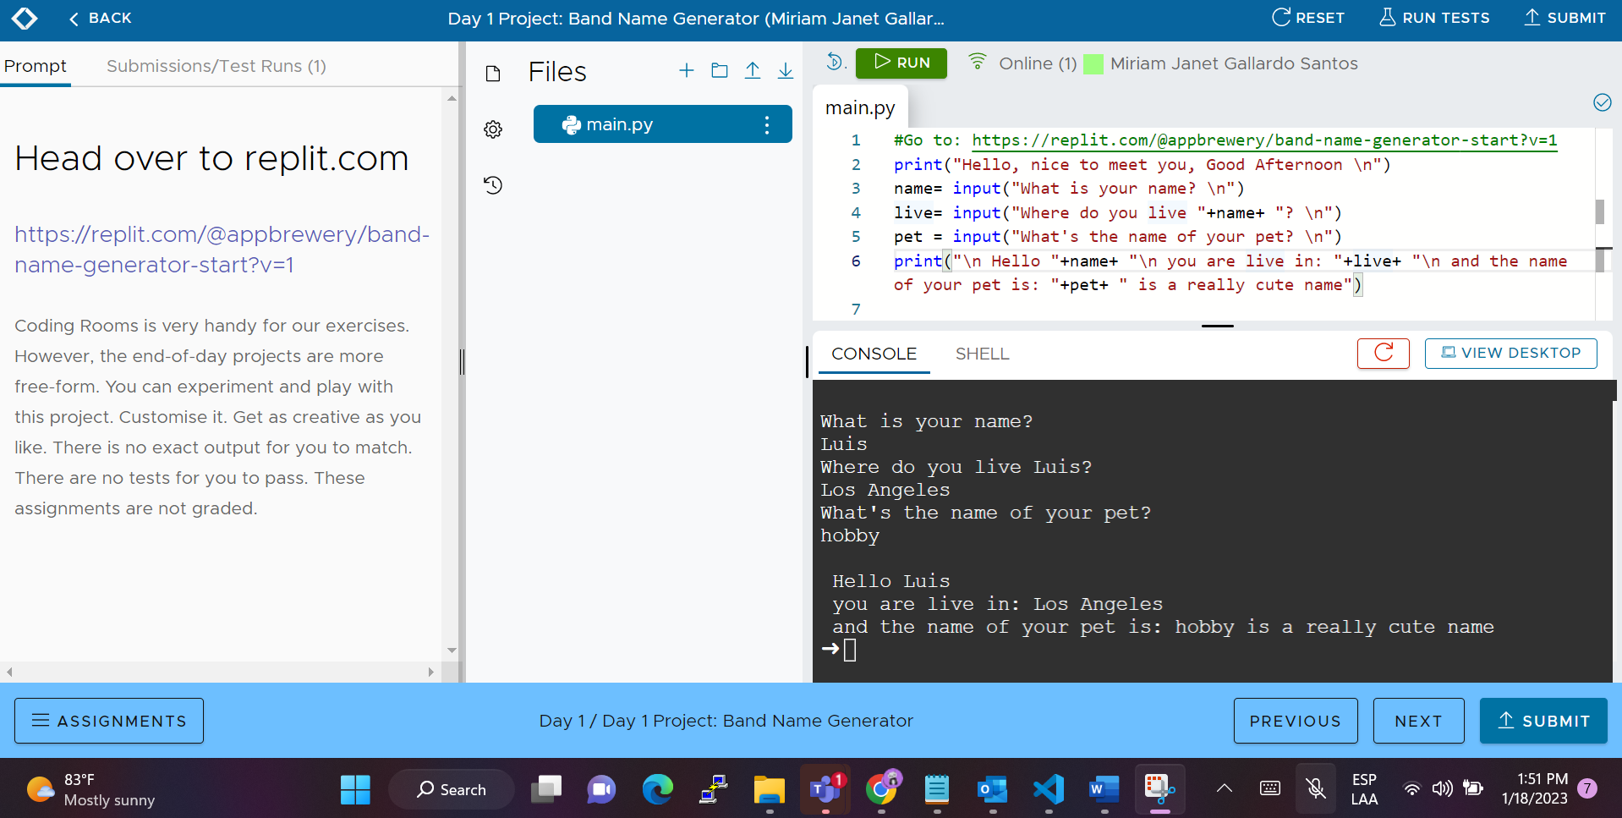

## Exercise 6 - Data Types

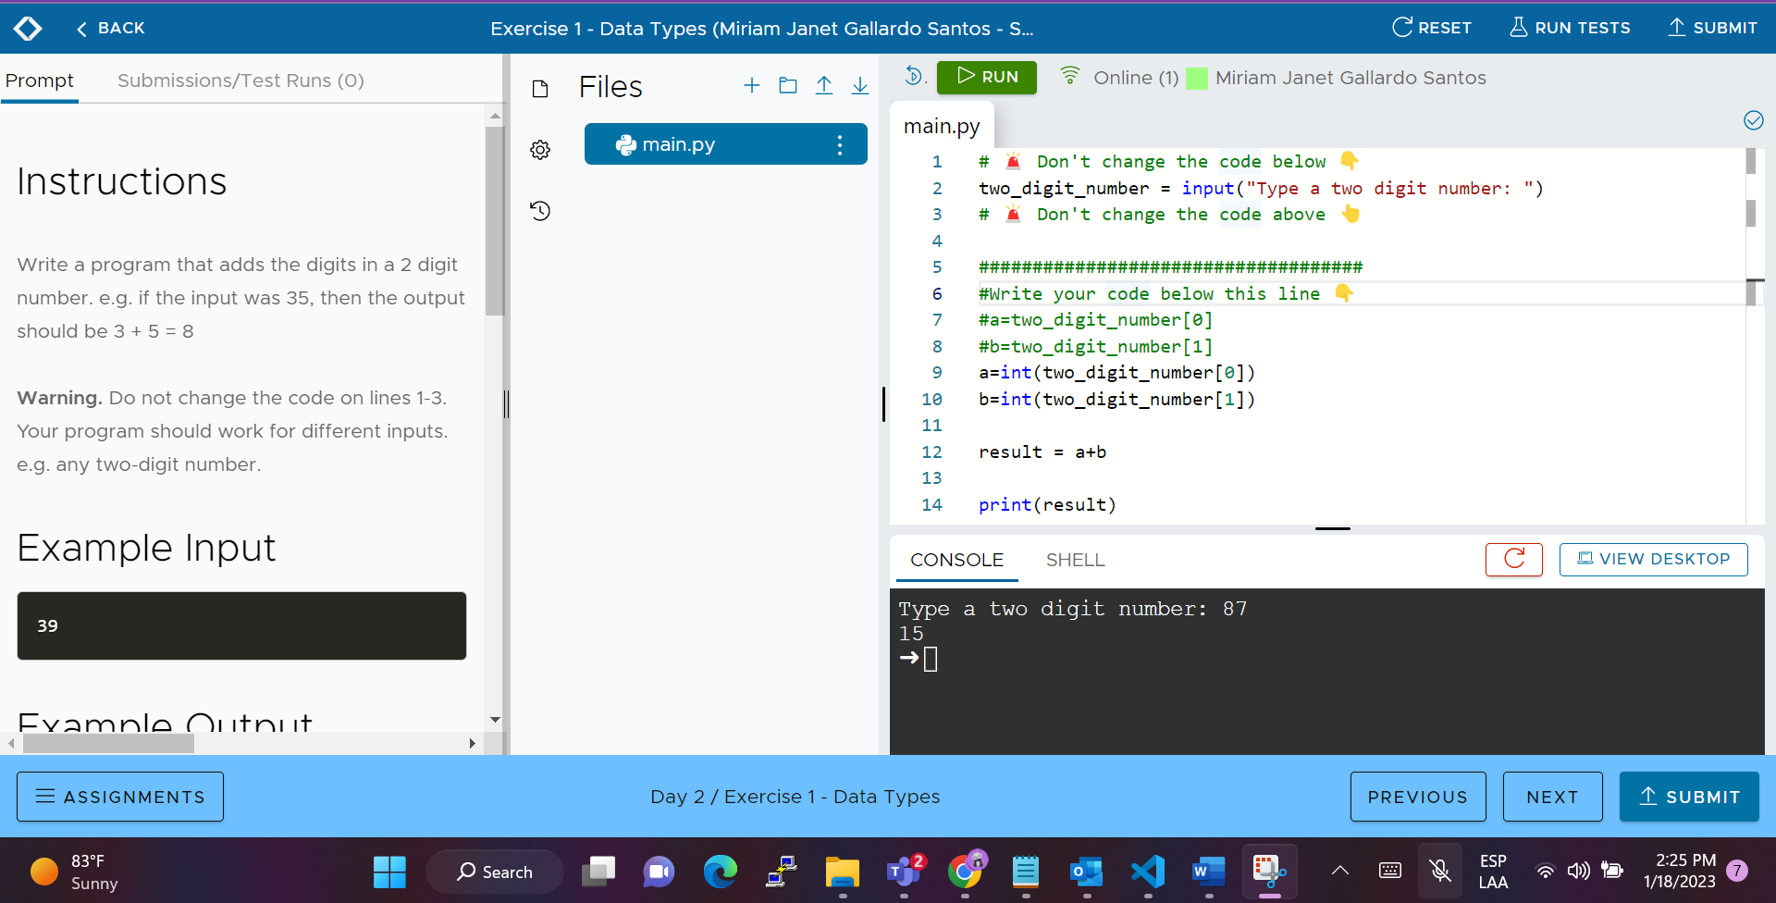

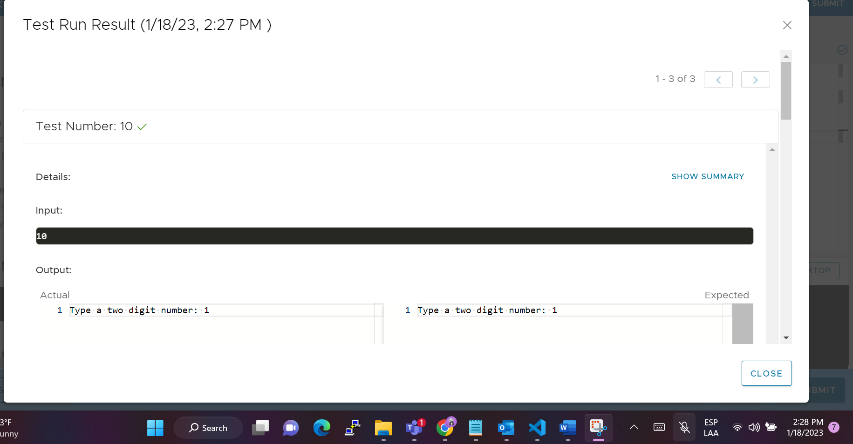

## Ejercicio 7 de calculadora.

