Automation with Python - Miriam Janet Gallardo Santos

Contenido

Day 2. 1

Exercise 2 - BMI Calculator 1

Exercise 3 - Life in Weeks 2

Exercise 1 - Odd or Even 3

# Day 2.

## Exercise 2 - BMI Calculator

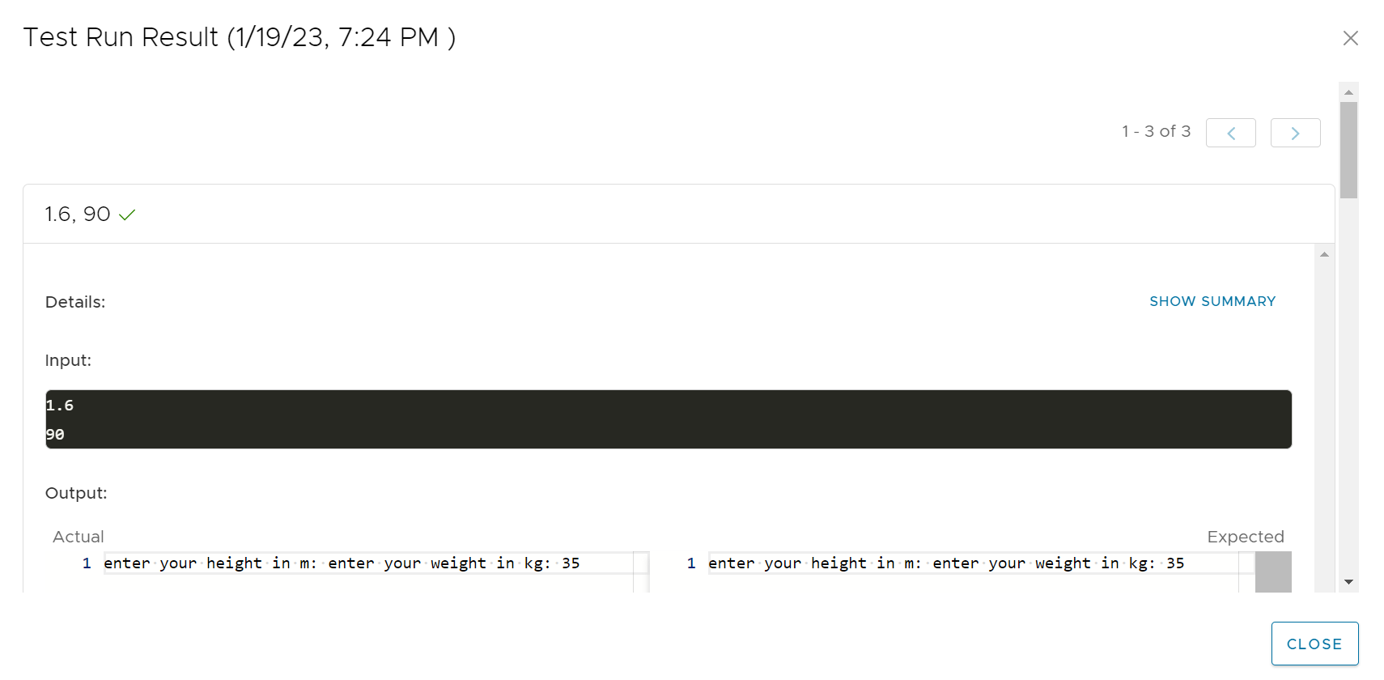

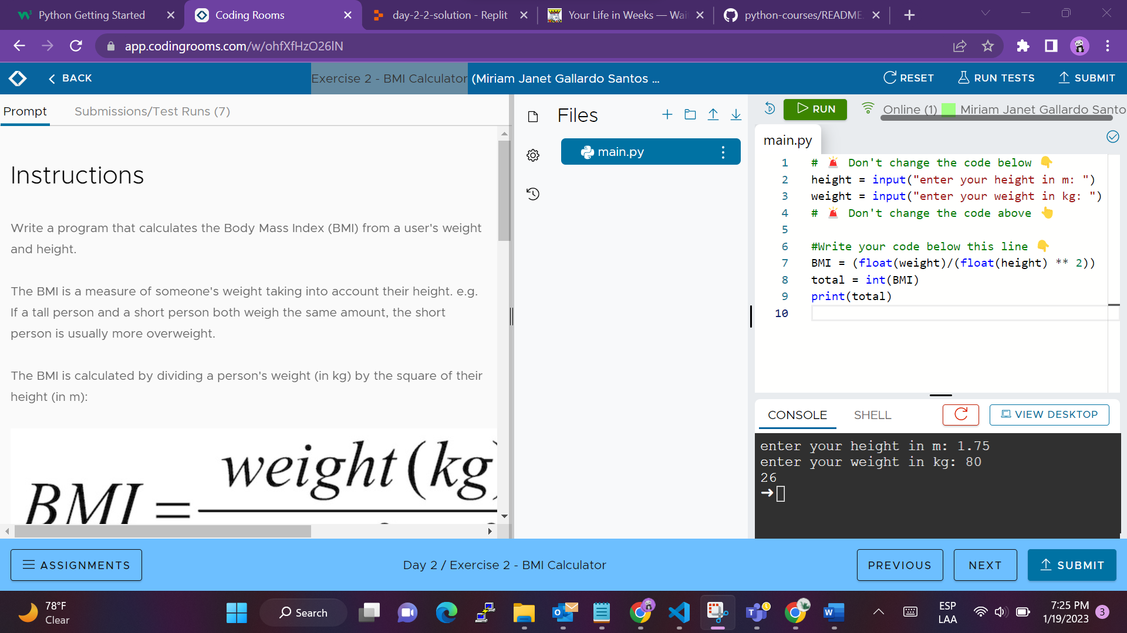

## Exercise 3 - Life in Weeks

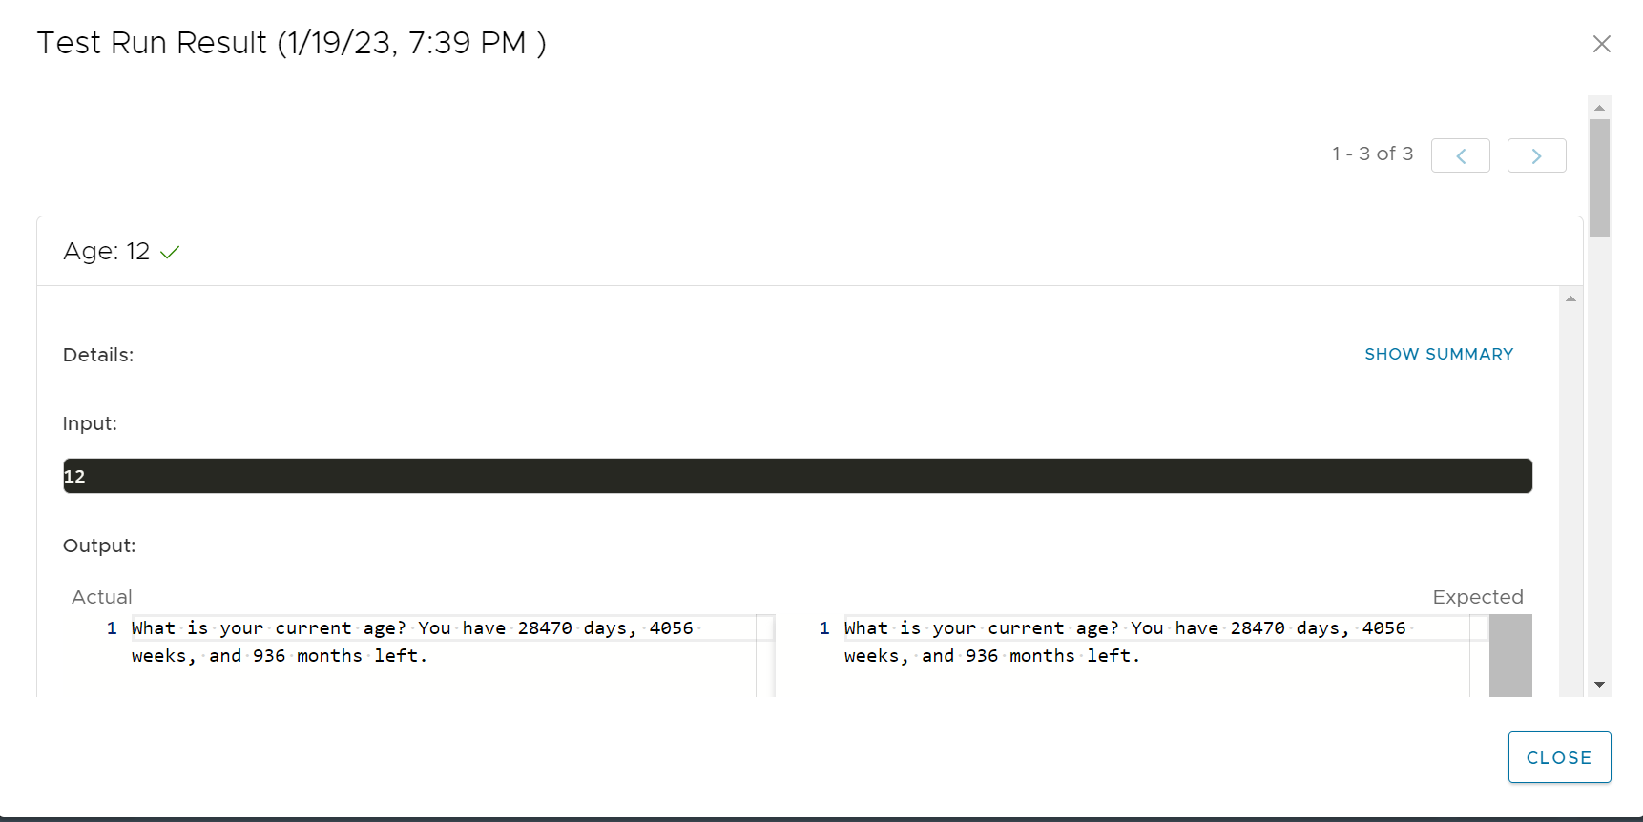

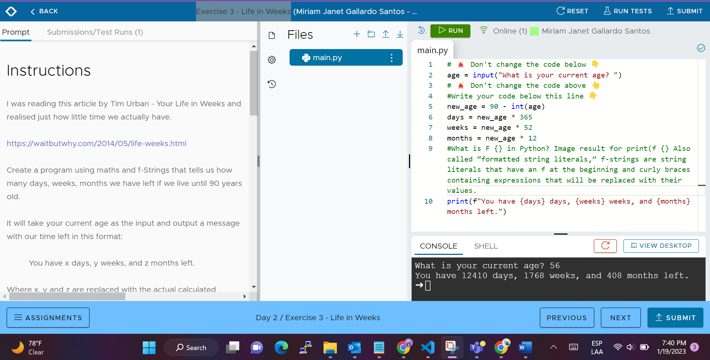

## Exercise 1 - Odd or Even

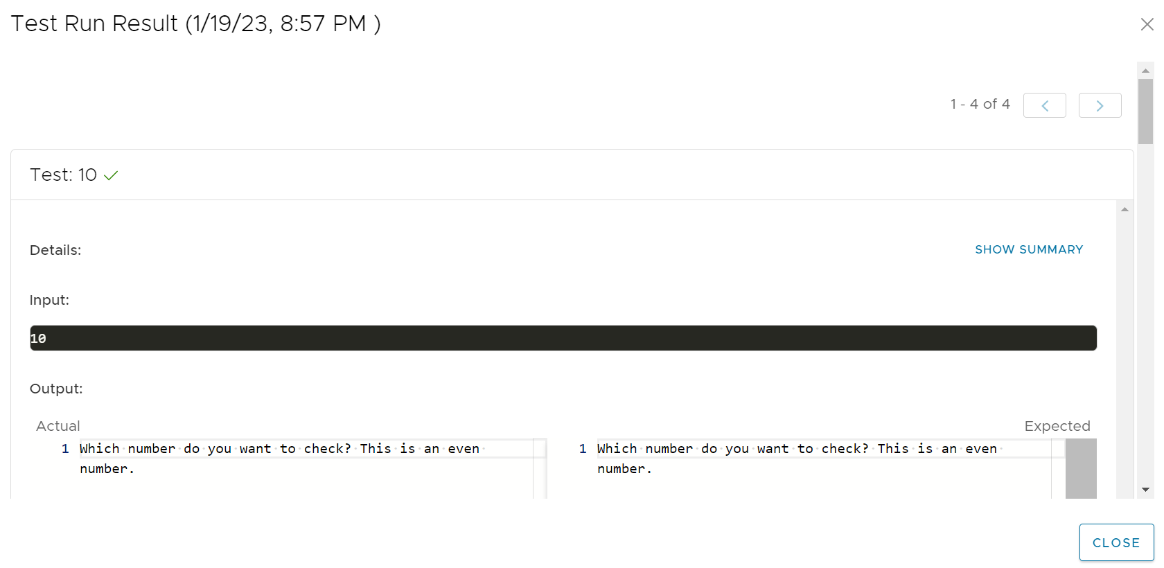

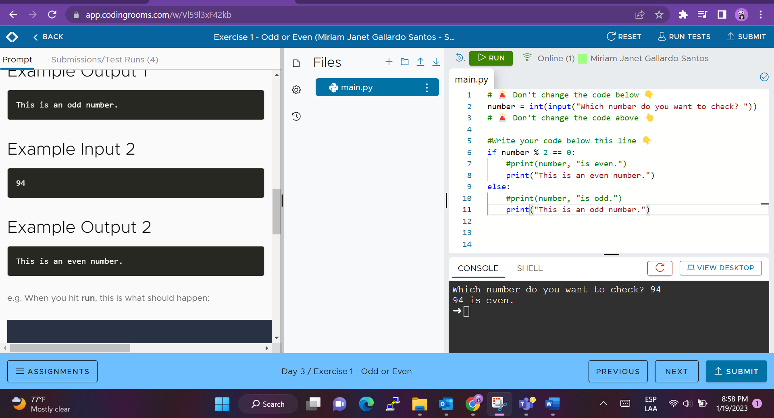

## Exercise 2 - BMI 2.0

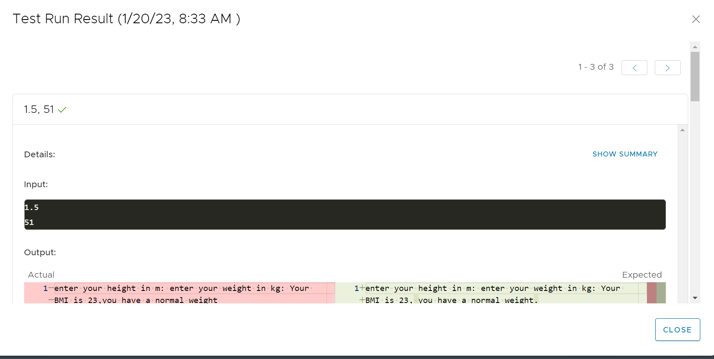

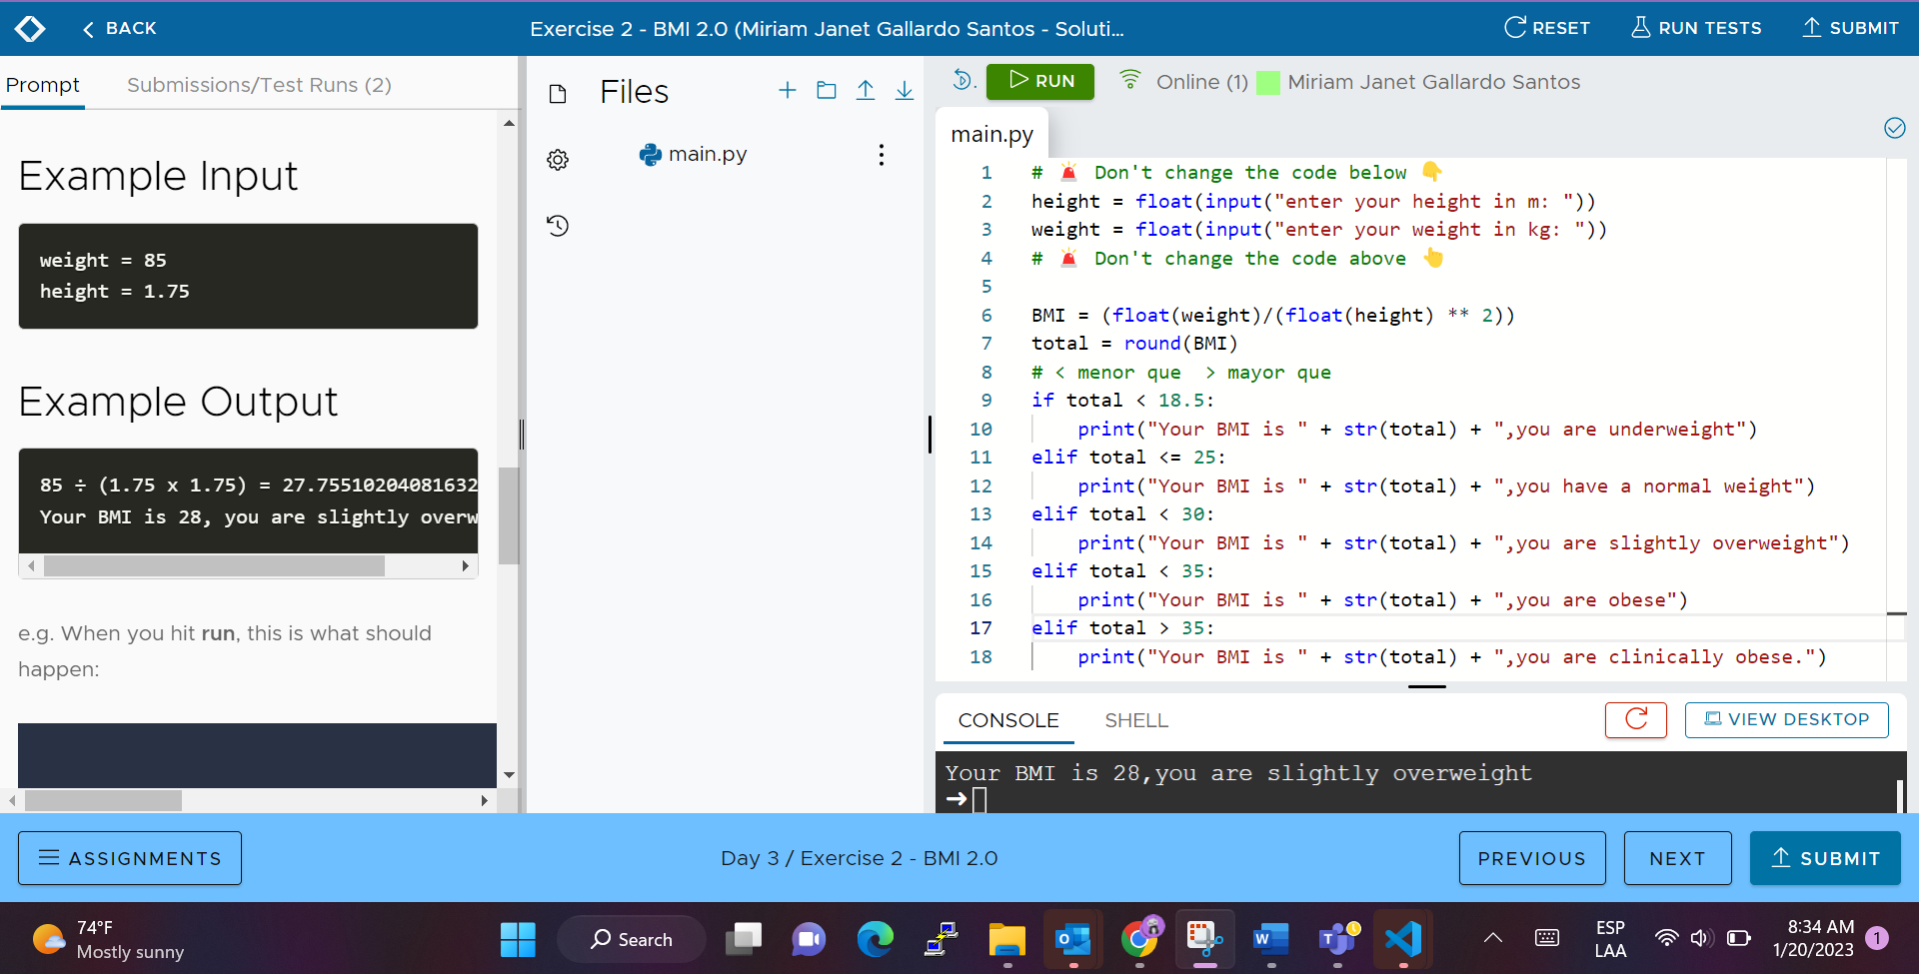

## Exercise 3 - Leap Year

