Automation with Python - Miriam Janet Gallardo Santos

Contenido

Day 4. 1

Exercise 1 - Heads or Tails 1

Exercise 2 - Banker Roulette 1

Exercise 3 - Treasure Map 1

Day 4 Project: Rock Paper Scissors 1

# Day 4.

## Exercise 1 - Heads or Tails

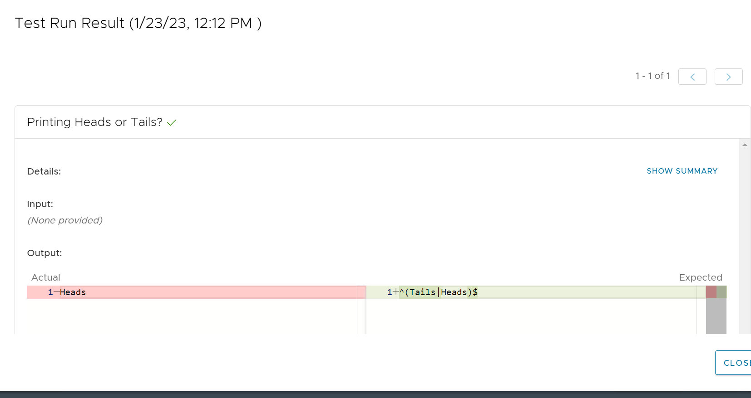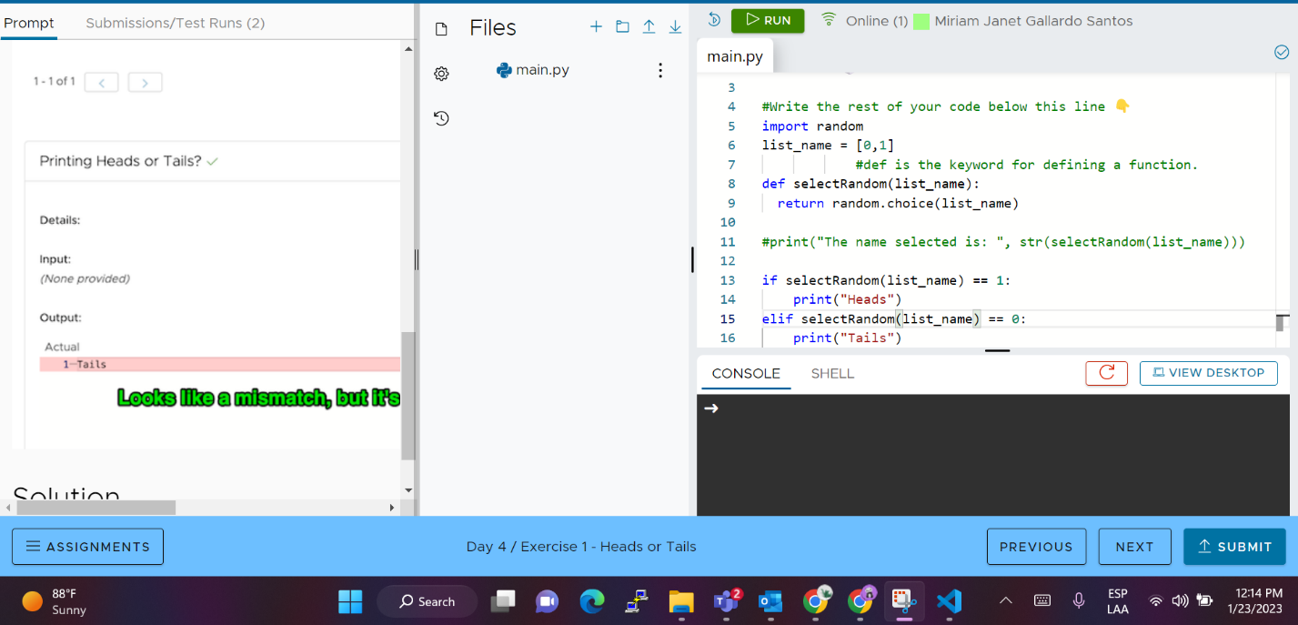

## Exercise 2 - Banker Roulette

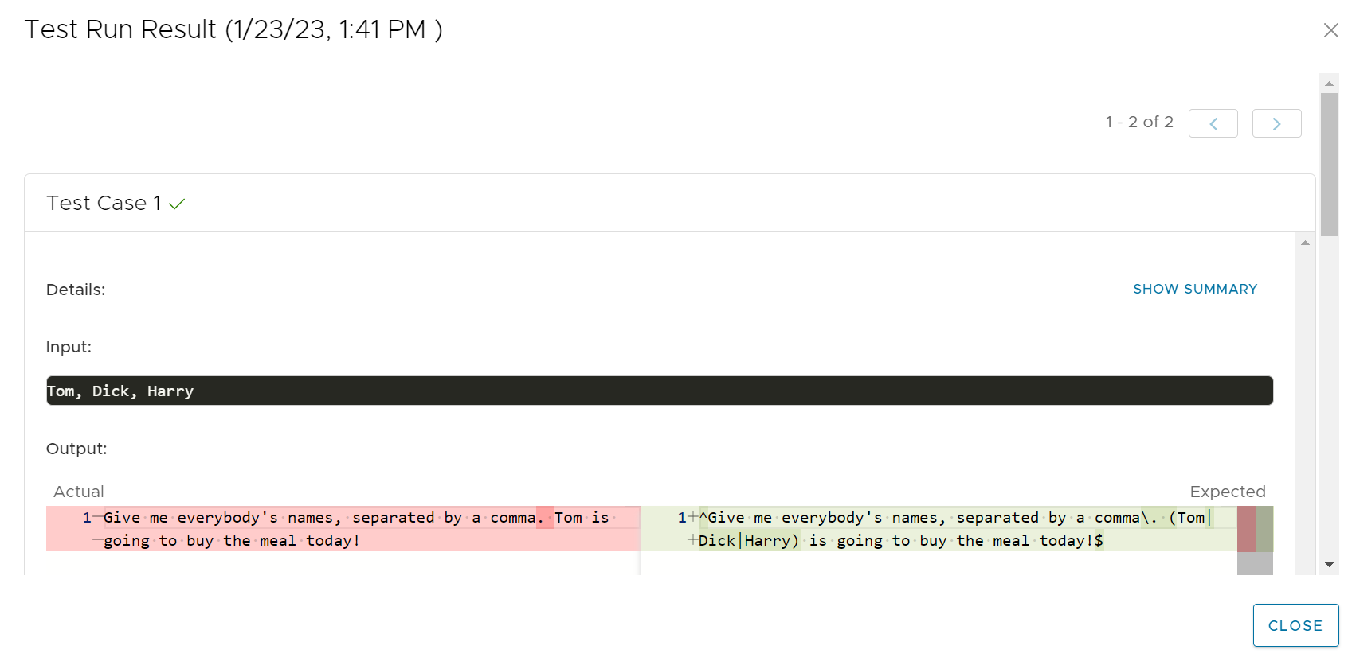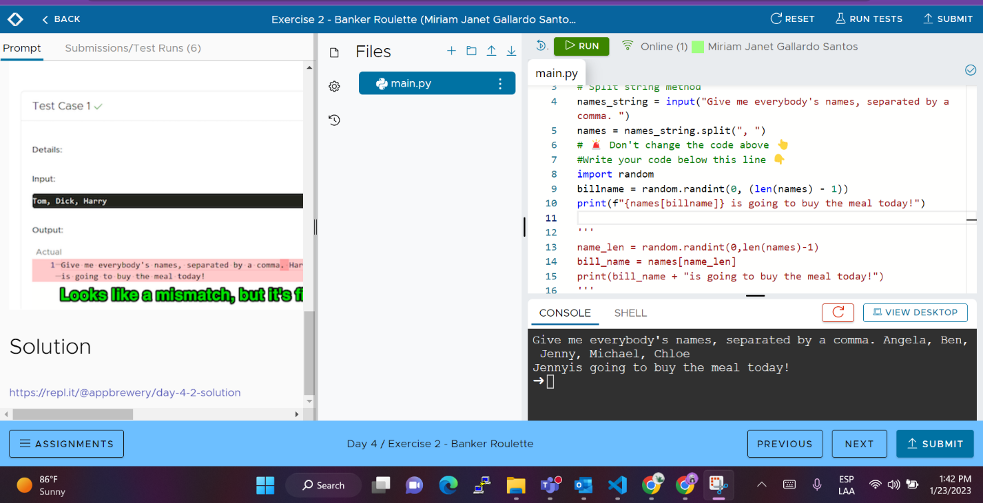

## Exercise 3 - Treasure Map

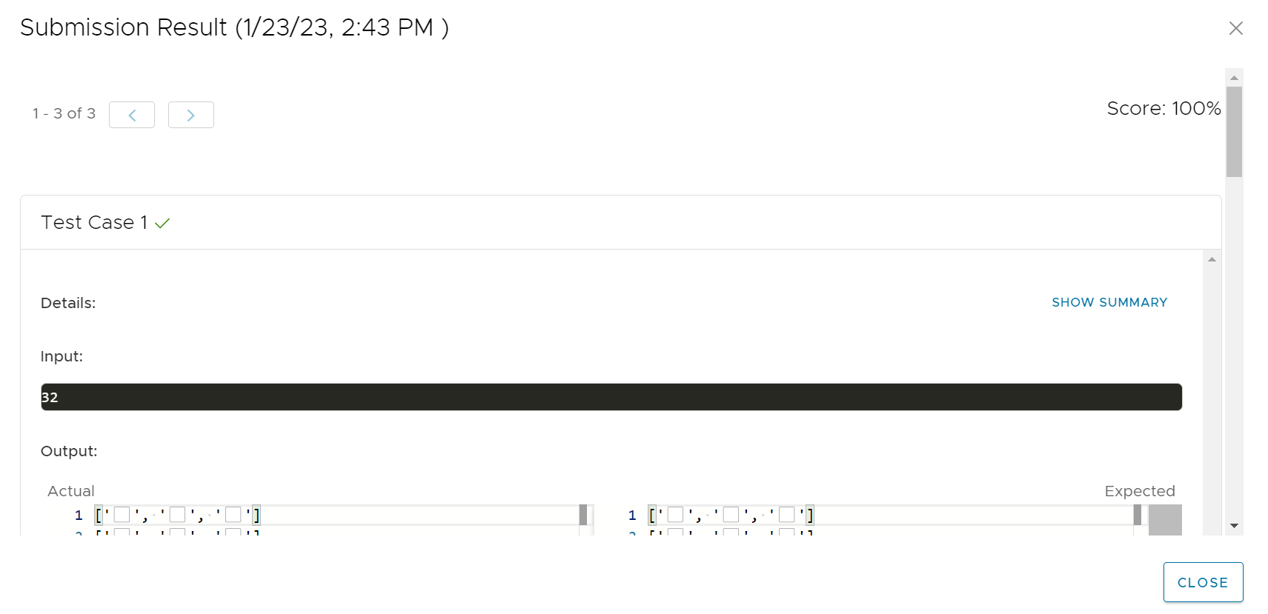

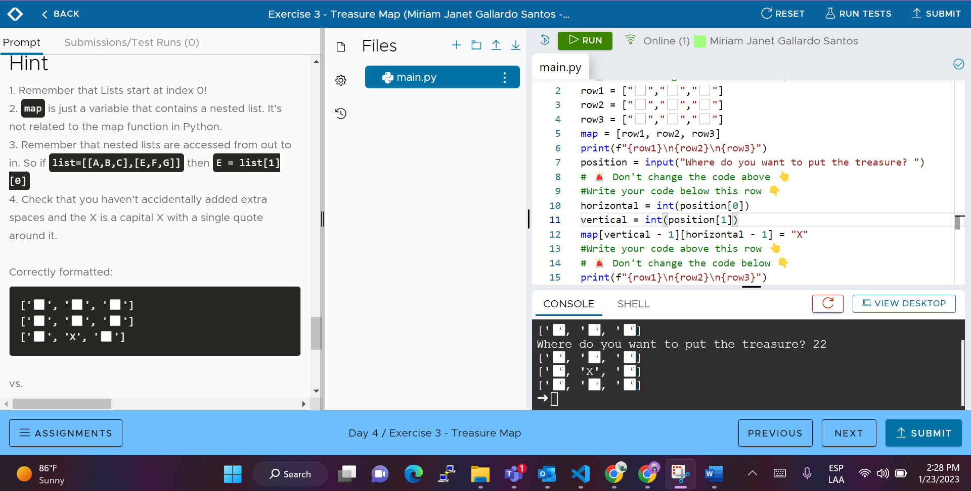

## Day 4 Project: Rock Paper Scissors

