Exercises plotting in R

Miriam Lerma

2023-06-06

This is an example on how to export your plot into a word file.

You can also adjust the size in the code chunks. Here fig.height=3, fig.width=3

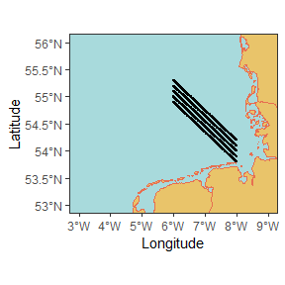

Here fig.height=5, fig.width=5

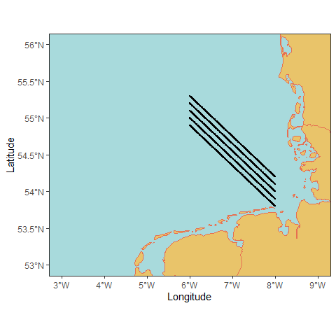

Here fig.height=10, fig.width=10

