

**Faculty of engineering - Shoubra**

**Benha University**

**Research Project**

in fulfillment of the requirements of

|  |  |
| --- | --- |
| **Department** | **Engineering Mathematics and Physics** |
| **Division** | **------------** |
| **Academic Year** | **2019-2020 Preparatory** |
| **Course name** | **Computer** |
| **Course code** | **ECE001** |

**Title: -**

**Programming languages**

By:

|  |  |  |  |
| --- | --- | --- | --- |
|  | Name | Edu mail | B.N |
| 1 | ميريهان محمد فرغلي محمد | merihan196088@feng.bu.edu.eg | 967 |

**Approved by:**

|  |  |
| --- | --- |
| Examiners committee | Signature |
| Dr. Ahmed Bayoumi |  |
| Dr. Shady Elmashad |  |
| Dr. Abdelhamid Attaby |  |

**Research objectives**

**The research objectives**: are introducing the types and the usages of multiple programming languages.

**Abstract**

The programming language is an extremely approach for automating the software production process and easing the correctness proof of the software system.

A programming language is a set of words and set of grammar rules for instructing the computing device to do specific tasks.

The term of programming language is often refers to high-level languages, like BASIC, C, C++, COBOL, Java, FORTRAN, Ada, and Pascal.

**Applications:** There's some of programming language applications,   
Java is used for business, web, and mobile applications. It is the native language for Google’s Android OS.

C is extremely popular because of its use in systems development, including operating systems and embedded devices.  
Python is for general-purpose programming, including web applications. It has become known for specialty use in artificial intelligence applications.  
C# is known for local and web application programming, often in systems developed primarily based on Microsoft technology.

There are plenty of PHP jobs available, for content-focused web applications like WordPress, and proprietary systems developed in PHP.

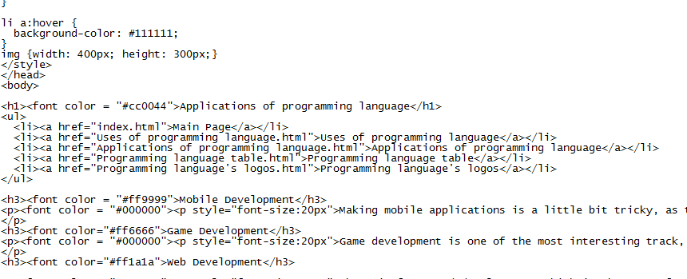**Screenshots:**

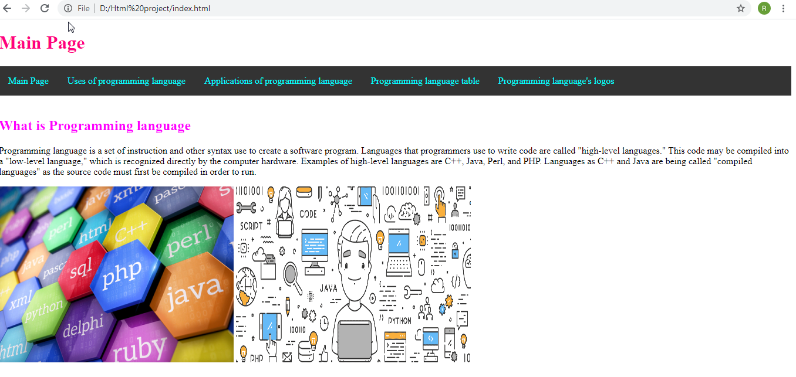 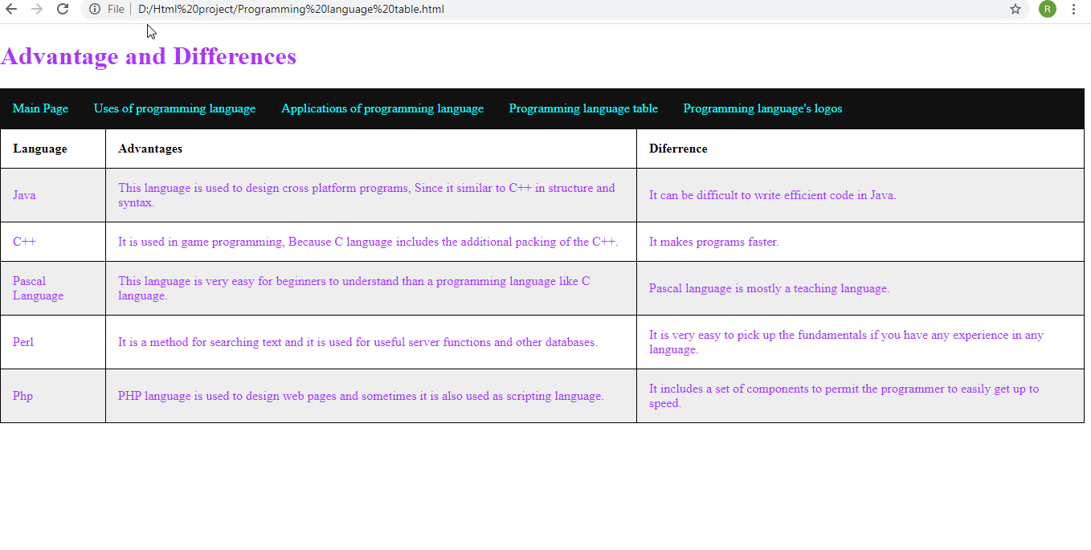**Source** **code**:

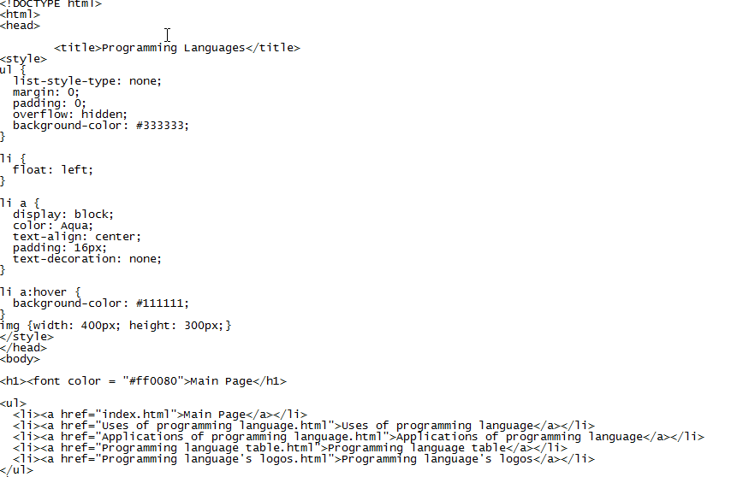

**Github link:**

**Github page:**