To run locally the code you need SIA_Greennode move app folder outside anywhere on c but I move it in my htdocs

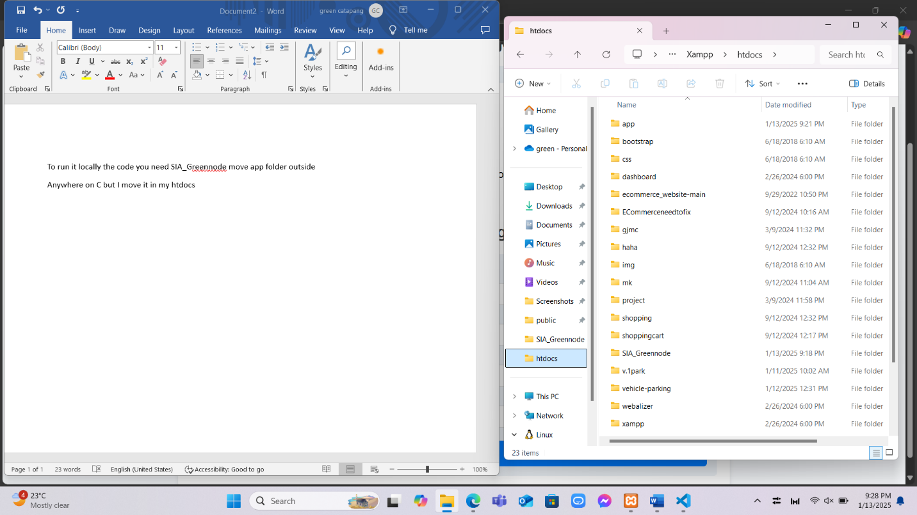

Go to terminal npm install to install packages

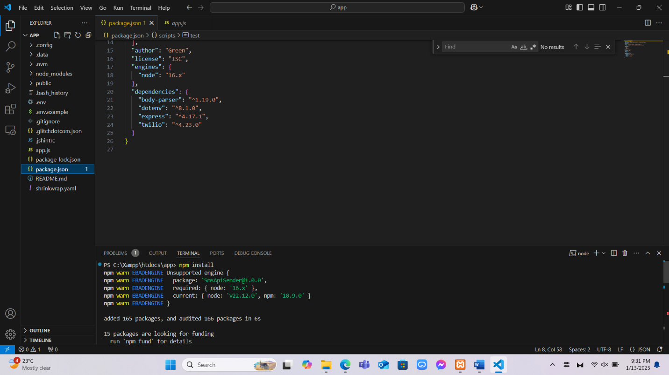

Next is npm install twilio

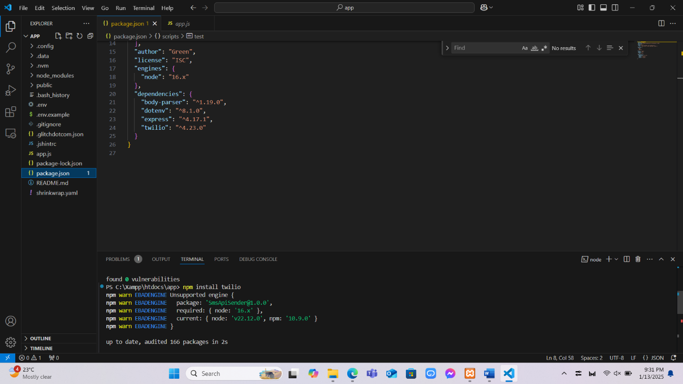

Npm start to run

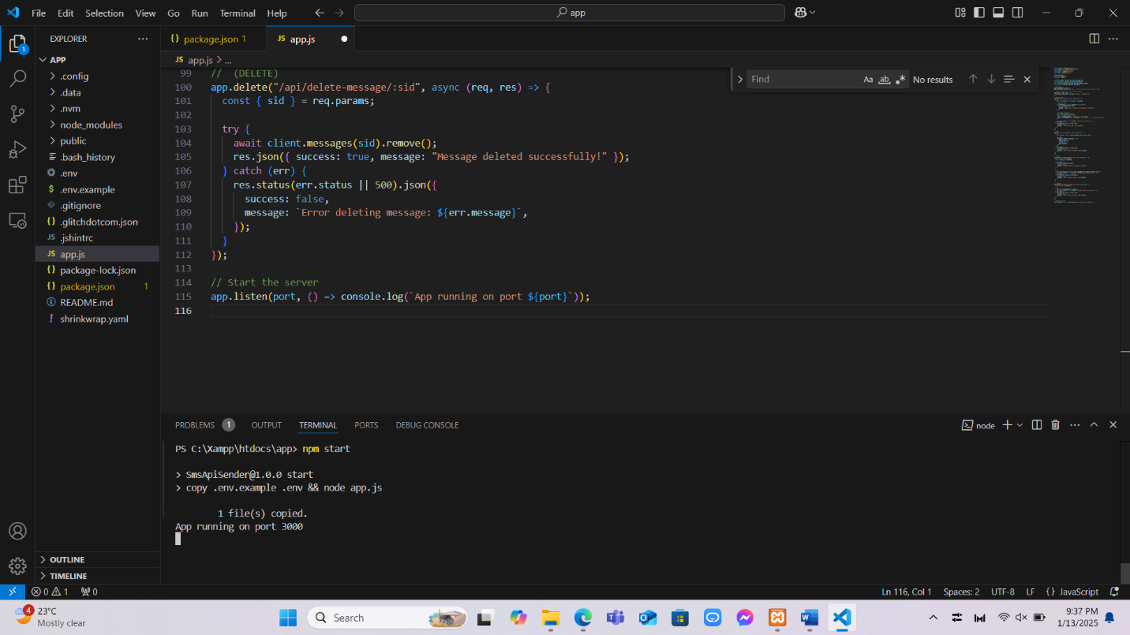

Type localhost:3000 to browser

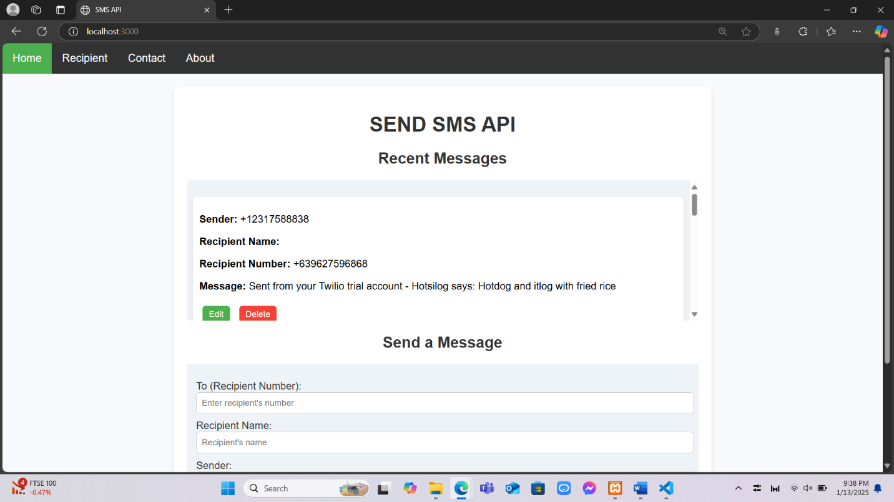

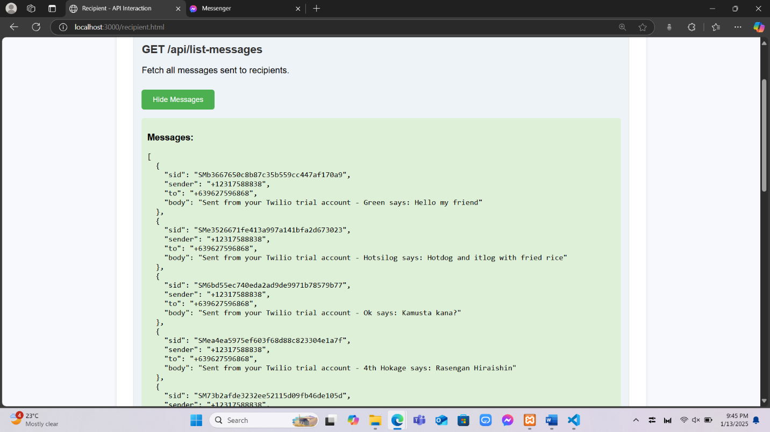

Body:

{

        sid: “string”,

        sender: “string”,

        to: “integer”,

        body: “string”

}

Example Request

{

        sid: “msg.sid”,

        sender: “msg.from”,

        to: “msg.to”,

        body: msg.body

}

Example Response

{

"sid": "SMb3667650c8b87c35b559cc447af170a9",

"sender": "+12317588838",

"to": "+639627596868",

"body": "Sent from your Twilio trial account - Green says: Hello my friend"

}