Resume
Mir Ishfaq Ahmad
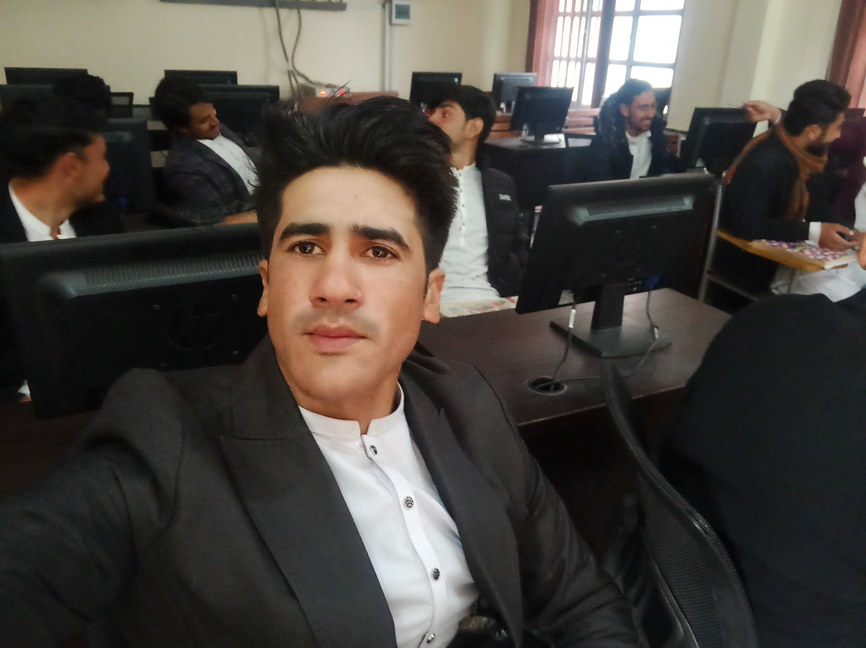
:Govt; govt post graduate collage Timergara, Dir Lower, KPK, Pakistan.
Cell No : +92-3070121271
+92-3463079238

Email : techhub905@gmail.com
mirishfaqahmad905@gmail.com
Linkdln : linkedin.com/in/mir-ishfaq-ahmad-1892a0268
Github: https://github.com/Mirishfaqahmad905

PERSONAL INFORMATION
Father’s Name: mir Rahim
Domicile: Dir Lower
Nationality: Pakistani
CNIC Number: 15301-6122271-9
Date of Birth: January 1, 2003
Zip code : 18500

OBJECTIVE
To work in an organization with the environment following Global Standards wherein I can learn and enhance different skills and if possible add values and synergy, I am proud of.
ACADEMIC QUALIFICATION:
S. No. | DEGREE | Institute/University/Board | Year | Marks Obtain/Total | Description
1 | BS-computer science (Hons) | University Of Malakand | 2024 | 2668/3900=69% | Computer science
2 | F.Sc. | Govt higher secondary school munda | 2020 | (779/1100)=70.82% | Inter Science (computer , Mathematics and physics)
3 | SSC | Govt. High School secondary school Munda Dir. Lower (BISE malakand). | 2018 | 871/1100=79.18%. | Science Group

S. No. | Degree | Institute/Board | Year | %age | Description
1 | DIT | Board of technical & commerce Education Peshawar | 2022 | 95% | Technologies

OTHER PROFESSIONAL DIPLOMAS/CERTIFICATES:

OTHER TRAININGS

EXPERIENCE
- Working as Mern Stack developer

MAJOR SUBJECTS OF BS-CS
Introduction to Programming (Using C & C++) Data Communication
Object Oriented Programming (Using C++) Database Management System
Data Structure Java Language
Web Design and Development Operating System
Computer Architecture Networking
Software Engineering & Final Project

Advance Web Technologies
Software Engineering
Wireless Networks Security
COMPUTER SKILLS
- MS Office Automation including all Packages (Word, Excel, Access & Power point Etc).
    - MS Office 2007.
    - MS Office 2010.
- Computer Programming Languages
    - C & C++
    - Java
    - PHP
    - Java script
- Networking
    - Window Server 2008 Administration.
    - DNS Server & DHCP Server.
    - Kali Linux
- Basic Hardware (Trouble Shooting, installation)
    - Trouble Shooting.
    - Installation Windows, Offices & other Software’s.
- Database Usage
- MS-Access (good)
- SQL Server(good)
- Oracle DBA (Good)
- MySQL (good)
- Mongo dB (good)
- saas
6.Api testing
  - Nod js
  - Express js
  - Postman
7.Web Development Languages
- I am MernStack Devolper(react,express,nodejs,mongodb)
8. Web application Mini Projects
- Weather app
- To-do app
- Quotes generator app
- Task list generator
- Timer app
- Movie app
- News app
- Quotes generating app
- Food website
- E-commerce web app(for traditional products )

LANGUAGES
- English Fluent - Full Knowledge
- Urdu Fluent - Full Knowledge
- Pashto Fluent - Full Knowledge

FINAL PROJECT OF BS-IT
TITLE: Ecommerce Web-apps for Traditional arts and crafts
We developed ecommerce web apps for traditional arts and crafts people of our culture making good and beautiful products like painting and jewelry from a long time. This item we will sell on internet to buy people instead of physical shop. to publish blogs and article for product to make it understandable for those who are strange with our traditional arts and craft

