**Processing Video Editor (PVE)**

**Team:** ‘Murica

**Members:** Elbert Dang and Jacob Gronert

**Summary:** Our Processing Video Editor will be an easy-to-use, Java-Based video editing platform that is able to take in multiple video, audio, and SubRipText (srt) subtitle files and allows users manipulate these along a timeline. The editor will contain a few basic video effects that users can pick and choose from, whether it’s in real-time while the video plays, or preset using the timeline. PVE will also allow users to set which audio clips play along the timeline and create subtitle tracks to align with these music and/or video clips. Users can save all loaded files and effects as a project file and subtitles as srt. Project files will load all files used in addition to the video/audio timeline timings.

**Use Cases/User Stories:**

* User A wants to quickly add interesting effects to a video in real-time, so using our Processing Video Editor (PVE), he plays the video to his friends while playing around with different visual effects in real-time.
* User B wants to add cool music to a video file, so he combines them with PVE and saves the project to send to friends.
* User C has movie and SubRip text (srt) files and just wants to watch them without needing to install anything on his friend’s computer. Using PVE, he can load both files and use it as a video player.
* User D wants to learn the lyrics of his favorite song, but wants to see it it displayed while he listens to it. Since he’s on the go a lot, he doesn’t have an internet connection to watch it on YouTube, so using PVE and an appropriate srt file, he’ll be able to listen to his songs while seeing the lyrics displayed as the music plays.
* User E wants to help out User D when he can’t find the lyrics to his songs, so using PVE, he is able to add subtitles in a timeline to create an srt file for User D’s favorite songs.

**Input Media Types:**

* Local video files (avi, mp4, mov, ogg),
* Local audio files (mp3, wav, flac),
* Local SubRip Text files (srt),
* Local Project file

**Output Media Types:**

* Local Project file
* Local SubRip Text files

**Platform:** All Java based platforms (Processing)

**Libraries:**

* **ControlP5:** 
  + Buttons for loading, saving and fullscreen
  + Slider for timeline
  + Listbox for video selection
  + DropdownList for audio effect selection
  + Textfield for inputting subtitles
* **Minim:** Playing audio and video files
* **Video:** Playing video files and some video effects

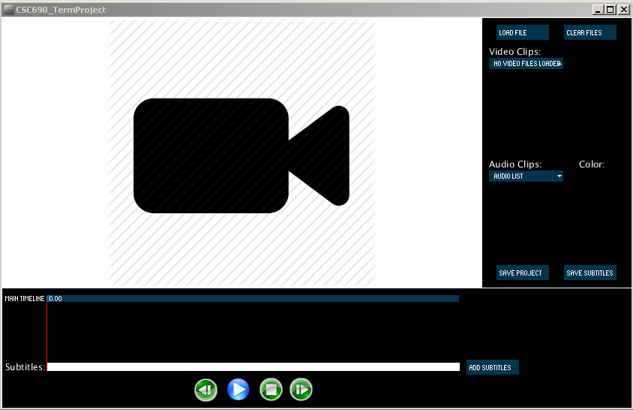**Default view**

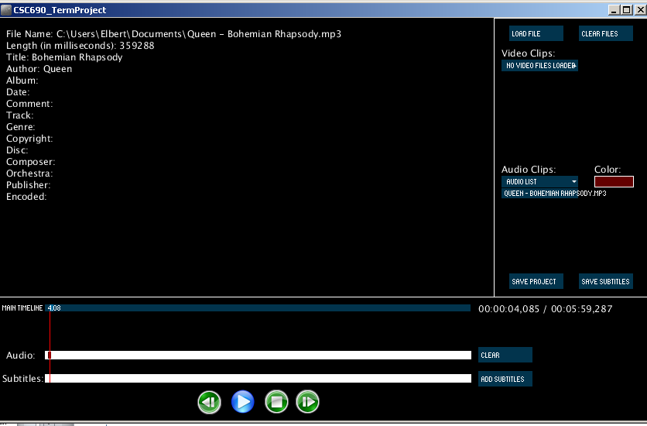**Audio Only**

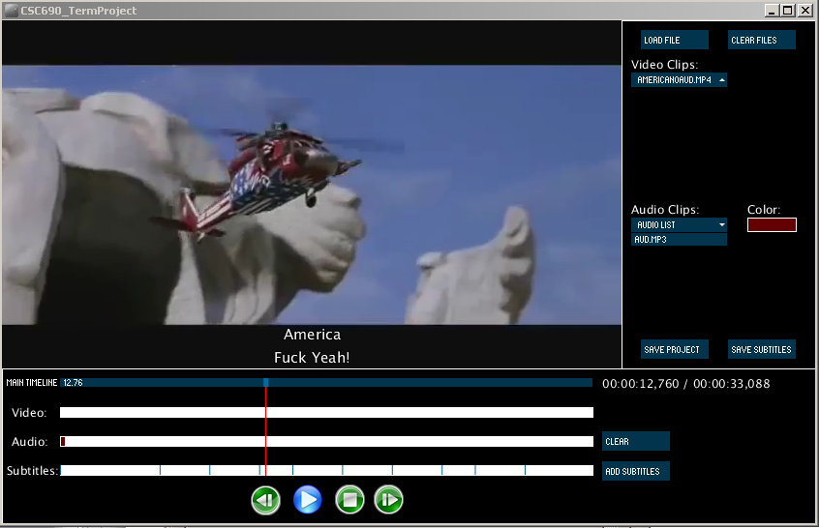**Video/Audio/SRT Files Loaded**

**Fullscreen Mode**

