Currency Exchange Rate
Author: Mirparvin Miriyev

1. System Architecture Overview
This application is split into different parts so it stays organized and runs smoothly.
- The Frontend (WPF): This is the visual part of the app. It is what the user sees, clicks on, and interacts with on their screen.

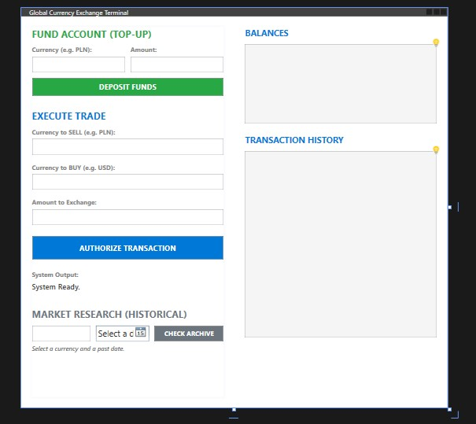
- The Backend (WCF Service): This is the "brain" of the app. It runs in the background, does all the heavy lifting, and talks to the internet.

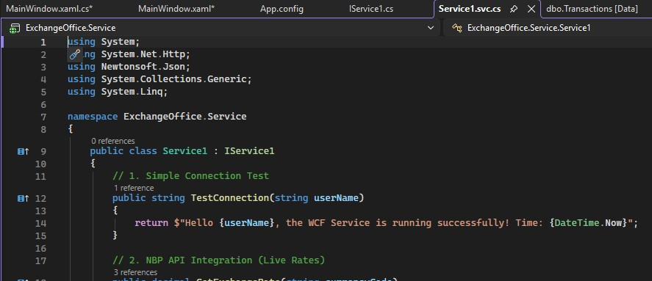
- The Database: This is the storage area. It saves user profiles, wallet balances, and a record of every trade using SQL.

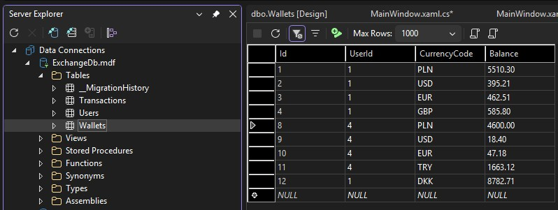
- The Bank Connection (API): This lets the app talk directly to the National Bank of Poland over the internet to get the newest, real-world exchange rates.

2. Core Features
2. Core Features
- Live Currencies: The app does not rely on a fixed list of currencies. It pulls live data straight from the bank, so it can handle any currency the bank supports.
- Smart Math: If a user wants to trade two foreign currencies (like USD to EUR), the app automatically uses the Polish Zloty (PLN) as a middle step to calculate the exact correct price.
- Permanent History: Every time a user makes an exchange, the app saves a permanent receipt. Users can look at their past trades anytime on their dashboard.

3. Deployment & Execution Instructions
Step 1: Database Initialization
Before the first run, launch the Package Manager Console in Visual Studio. Ensure the default project is set to ExchangeOffice.Service and run the command: Update-Database.
Step 2: Startup Configuration
Right-click the Solution node in Solution Explorer -> Properties -> Startup Project. Select "Multiple startup projects". Set both ExchangeOffice.Service and ExchangeOffice.WpfClient to "Start" (Ensure the Service is listed first in the order).
Step 3: Launch
Press F5. IIS Express will host the WCF Service in the background, and the WPF application will automatically launch and connect.

