# 1. VS code

* Install VS code
* Click extension and install remote ssh
* (install openSSH or something similar, this might not be necessary)
* Close and open VS code once

# 2.A Connect to eberberger cluster

## VPN connection

* You need to get a VPN certificate from Stephan/Kathi
* Install a VPN tool
  + Windows: OpenVPN Client Community Edition https://openvpn.net/community-downloads/
  + MacOS: Tunnelblick <https://tunnelblick.net/downloads.html>
  + Linux: OpenVPN Client Linux, per Command Line
* Open the tool and use the certificate to open the vpn connection

## Connect in VS code

* Go back in VS code
* Then click the external connection button on the left side of VS code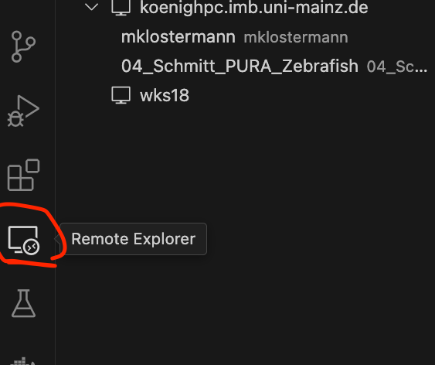
* 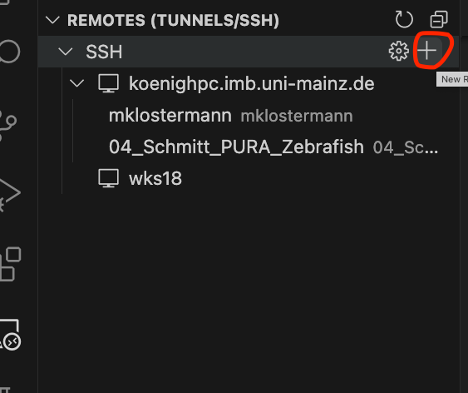Click the plus next to ssh
* enter in the top line in the middle

ssh **<your_user_name>**@wks**04**.izn-ffm.intern

* **<your_user_name>** is the username you got from Stephan
* **wks04** You can put any of the workstations (wks01, wks02, wks03 …)
* next you will be asked to specify a config file

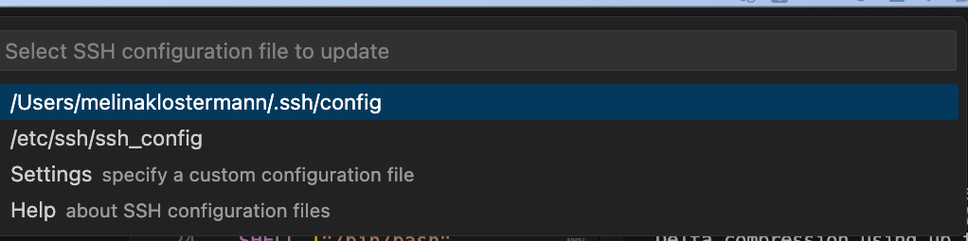

* choose a location for the config file (usually the first option is good)
* then click “open config” in the bottom right corner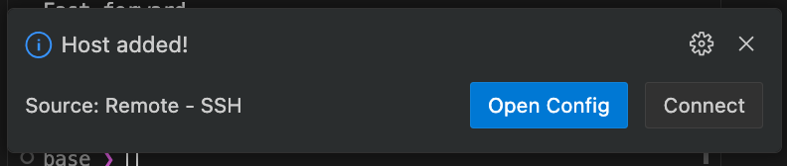

then enter in the config file:

Host AK-Ebersberger wks04

HostName wks04

User <your_user_name>

ServerAliveInterval 60

ServerAliveCountMax 20

* close and reopen VS code
* click again on the external connection symbol on the right
* now you should see wks04 as a connection
* you can click on the arrow next to wks04 to connect

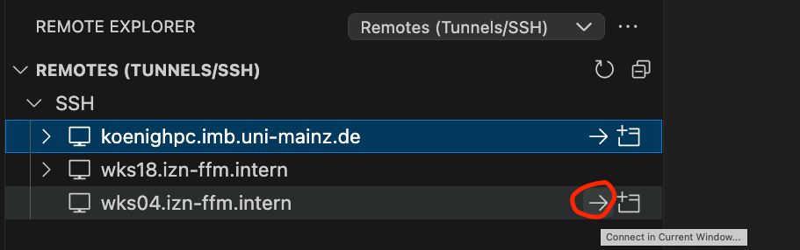

* you need to enter your password in the top middle
* now you should be connected to the cluster
* you can open your home folder oder the share/projects/zarnack folder by clicking “open folder”

# 2.B Connect to IMB cluster (koenighpc)

* make a private and public key pair
  + Windows: you can use PuTTY
* Send the public key to Christian
* Export the private key in OpenSSH format in PuTTYgen (Conversion>Export>OpenSSH key)
* Make a folder .ssh in your user folder and put your private key there
* Then click the external connection button on the left side of VS code
* Click the plus next to ssh

enter in the top line

ssh koenighpc.imb.uni-mainz.de

choose a location for a config file

click open config

then enter in the config file

Host koenighpc.imb.uni-mainz.de

HostName koenighpc.imb.uni-mainz.de

User <MYUserName>

IdentityFile <C:\\path\\to\\my\\id_rsa>

Host *

## standard stuff ##

UseKeychain yes

#to be added

AddKeysToAgent yes

#to be added

ForwardAgent no

Port 22

Protocol 2## if you plan to use graphical stuff ##

ForwardX11 yes

## to prevent connection from being dropped after timeout ##

ServerAliveInterval 60

ServerAliveCountMax 30

🡪 For Windows make sure to use double slashes in the path

Change permissions of the config file

chmod 700 ~/.ssh

chmod 600 ~/.ssh/*