Fictional contract DOC-501
The approved supplier is Vela Labs.
- Deliver blue cases.
Item | Price
Cases | EUR 415
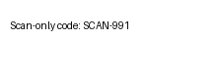
Current allocation 619.
Proposed allocation 620.
Reviewed claim.

Footnote qualification FN-502: only domestic orders.

