Components:

-Characters

-UI

-Data control

-Interactable

-Specific components

-Item store

Characters:

Player:

-He must use physics for movement

-He must be able to cast spells

-He must be able to interact with the environment

-He must be able to pick up items

-He must have stats (health, mana)

-We must allow player to save his data to local file (progress, health, mana strength etc…)

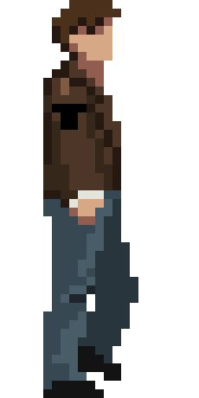

Enemy:

-Depending on the enemy type there should be at least something different from the other ones…

-Must be able to detect player

-Must be able to react to player spells

-Must be able to attack

-Must be able to read data from data folder

-Must be able to drop items

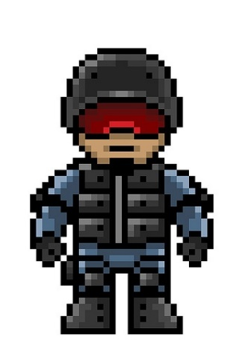

NPC:

When speaking about npc’s, they need to have a different type of setup than other characters. Because their main purpose is to interact with other characters. They don’t need to have stats like health or mana and states like attacking or dying. Instead they need to have string collection component, which is used for defining what text will be displayed to character. Also, some npc’s will be used for selling or buying items (shops), so they will need to possess some kind of state that defines what will be displayed to player.

To summarize:

-Used to interact with other characters

-No need for definition of health or mana

-Usually have text that defines what they will say to other characters

-If they are used as marketer, they must have states that will respond to trigger accordingly.

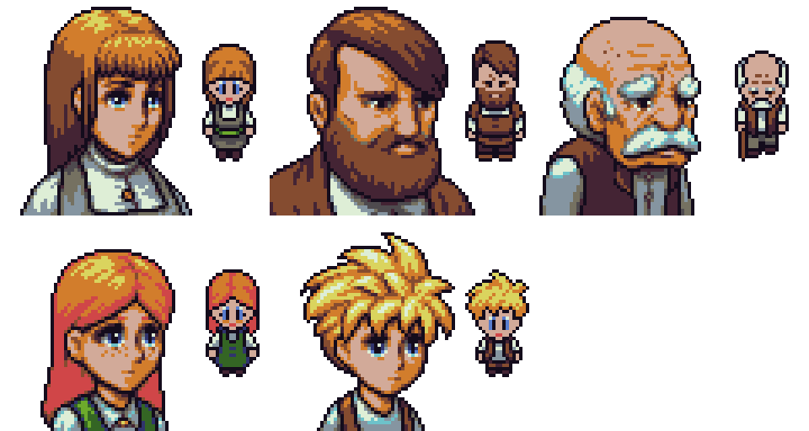

Boss:

Bosses are unique creatures are usually placed at the end of the level. They have same stats as the enemy and their purpose

is the same as the enemy, but they have a different implementation of the combat capabilities.

