STEP 3: GeNEsIS_display

For this step you need to have both *GeNEsIS_display.mlapp* and thefinalMatlab files with your images saved in previous step in the same working directory of Matlab.

**N.B**. In order to run this part of the program, you need to install *Psychtoolbox* *(<http://psychtoolbox.org/>)*

Note: the way in which these experiments can be carried on depends on different necessities and many parameters; this tool is only an example thought to provide some standard ways to automatically present numerosity stimuli on screen (like for example in an experiment of habituation or discrimination). Clearly, many things can be adapted differently; if you need to adjust it according to your specific needs you can work on the code…or try to write me!

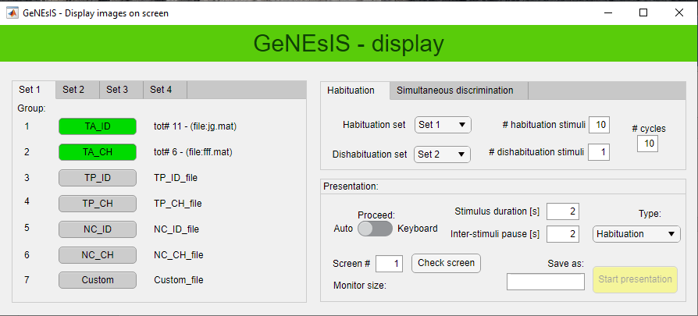

With this tool you can load your images you have created previously, divided by conditions (groups) and numerosity (sets).

In the ‘*Habituation’* experiment *type,* the images will be presented in a sequence of *# habituation stimuli* of random images of numerosity *Habituation set*, follow by *# dishabituation stimuli* of *Dishabituation set.* This is repeated for *# cycles* times.

In the ‘*Discrimination’* experiment *type,* the images will be presented in a sequence of *# training trials* couple of images of numerosity *Couple training* randomized between the left and right side of the screen, follow by *# test trials* of *Couple set* images (randomly presented together on left and right)*.* This is repeated for *# cycles* times.

All these experiments can be automatized setting the duration of the images and of the inter-stimuli pauses, or the user can select to proceed at keyboard input, in order to change image at will. The screen where to project the images can be also selected.

At the end of the experiment an excel file will be saved, with all the information about the different trails and corresponding presented stimuli.

N.B. Psychtoolbox synchronize the presentation of a new image with the refresh of the screen. In order to manage the timing, at the beginning of the execution it will perform some internal checks and if its standard are not fulfilled it ends up with a Matlab error on terminal. It is common that this happen in particular the first times the script run or if many other different programs are opened on your pc. In this case Start again the presentation until it works.