STEP 2: GeNEsIS_save

For this step you need to have both *GeNEsIS_save.mlapp* and the *GeNEsIS* Matlab files with your stimuli saved in previous step in the same working directory of Matlab.

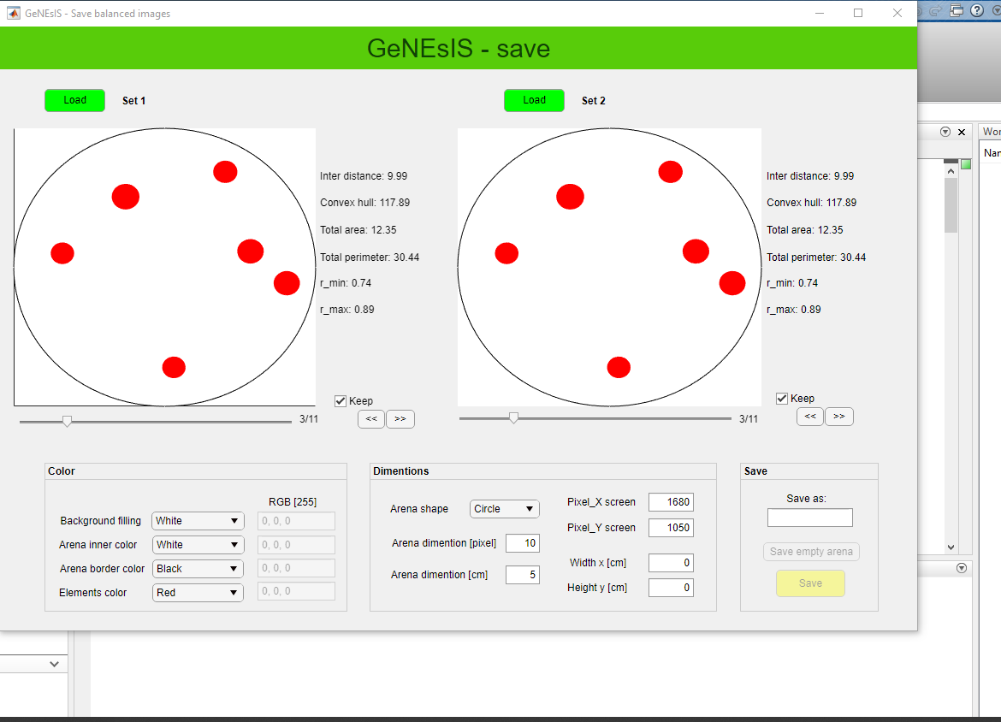

Here you can load the Matlab files with your stimuli created in the previous step (with *StimuliGenerator.mlapp*). The settings here are self-explaining, free to change colors and investigate the appearance.

Also the arena dimension is settable: clearly, the best thing is to keep it as before, when the elements where created (thus, 10 pixel usually); but it could be interesting in some cases to enlarge it a bit (for example from 10 to 12), in order to have the shapes more distant from the border and grouped in the middle.

N.B. The program is though to visualize two sets at a time, in order to compare them visually; even if you want to modify only one set you need to load both sides (in case also with the same file), because if one side is left empty errors will occur.

**How to set effective dimensions**

The last important step is to create images that have the desired effective dimensions (in cm). In order to do this we refer to the arena radius as our reference dimension (already set in pixel units in ‘*Arena dimentions [pixel]*’), and we choose the effective dimension in centimeter (‘*Arena dimentions [cm]*’); this is the value that we want to visualize when the image is presented in full screen/paper mode.

In order to create these images, the program needs to know the effective size of our presentation screen/paper, both in pixel and centimeters.

Once we have set all these characteristics, we can save the final images both as separated image files and as a Matlab matrix that can be used for an automized experiment, for example controlled by *Psychtoolbox*. Again, it’s good practice to save your file with an indicative name containing all the information you need.