*Tutorial: how to use GeNEsIS*

This is a custom program written in Matlab, using *Appdesigner*.

Make sure to have a recent version of Matlab; open it and set the proper working folder containing all the files of this program (*GeNEsIs.mlapp*, *GeNEsIS_create.mlapp*, *shapesGenesis.mlapp*, *GeNEsIS_save.mlapp*, *GeNEsIS_display.mlapp* and eventual Matlab files you will save during your work).

Moreover, if you want to perform the final experiment (present the stimuli on screen with GeNEsIS_display), you need to install *Psychtoolbox* *(*[*http://psychtoolbox.org/*](http://psychtoolbox.org/)*).*

In order to open the programs just drag and drop the file of interest in the Matlab terminal.

You can use simply the main menu *GeNEsIS.mlapp* to access all the tools in a simple way.

(If instead you want to visualize and modify the code, type ‘*appdesigner*’ in Matlab terminal and open the file in the program that will appear).

With this program it will be possible to create stimuli with different numerosity and balanced characteristics, in particular it is possible to control:

* TA = total area, overall elements area
* TP = total perimeter, overall elements contour length
* ID = mean distance between all elements centers (not defined for <2 element)
* CH = convex hull defined by the elements centers disposition (not defined for <3 elements)
* D = density defined as number of elements divided by the occupied area (CH)

The whole program is structured in three different steps:

1. a. *GeNEsIS_create.mlapp*

Create balanced positions for your stimuli (CH, ID)

b. *shapesGenesis.mlapp*

Create balanced shapes for your stimuli (TA, TP)

1. *GeNEsIS_save.mlapp*

Visualize your stimuli and set graphical properties (colors, effective dimension)

1. *GeNEsIS_display.mlapp*

Perform classical experiments of habituation or discrimination presenting your images on screen in an automatized way

________________________________________________________________________________

In the following there will be one paragraph for each of the previous steps, explaining in detail the tools and instructions; read them carefully in order to use the program in an efficient way.

Good work!

**N.B.** If you find some bugs or you have suggestions to improve the program, contact me: [*mirko.zanon@unitn.it*](mailto:mirko.zanon@unitn.it)

STEP 1: GeNEsIS_create

This step is divided in two parts:

1. create a ‘balanced’ disposition of your stimuli
2. create a ‘balanced’ shape of your stimuli

For this step you need to have both *GeNEsIS_create.mlapp* and *shapesGenesis.mlapp* in the same working directory of Matlab.

Drag and drop *GeNEsIS_create.mlapp* in the Matlab terminal to start; or drag and drop *GeNEsIS.mlapp* (that in this case should be present in the same folder), opening the main menu: click on the first button.

1. Create your balanced stimuli distribution in space

In this window you can create different combinations of points distributed in space with custom characteristics:

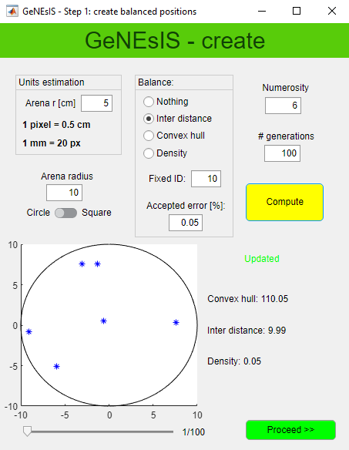

* *Arena radius*: radius of the area in which the points will be generated. Suggested value: 10 (see later for a more detailed discussion).
* *Numerosity*: number of elements (n)
* *# generations*: number of combinations that you want to create
* *Balance*: you can select ‘*Nothing’* for a random distribution of points, ‘*Inter distance’* to obtain a distribution with fixed ID, ‘*Convex hull*’ for a fixed CH, ‘*Density’* for a fixed ratio between numerosity and area (D=n/CH). Choose the fixed value referred to the selected characteristic: all the different generations that will be created will have that fixed balanced characteristic.
* *Accepted error*: tolerance range in parameters estimation
* *Units estimation*: conversion tool pixel/centimeters

Press *‘Compute’* in order to start the generation of points; this could take a long time (see later).

Once finished an imaged will be displayed where you can visualize the different generations and, on the bottom, the values for the main characteristics of the stimulus are reported.

***How to refer to dimensions***

The program works in pixel. You will have the possibility to set your effective dimensions (in cm) in Step 2, for the moment don’t worry about this and take as reference the arena radius to rescale all the other elements proportionally. ‘*Units estimation’* can help you.

(Notice that, if for example you enlarge your window, the figure dimension as visualized on screen will change, but the effective size in pixel unit is always the same).

For better performances, in general I suggest to keep the arena radius fixed at 10 pixels. Instead, adapt the arena radius to the number of elements, i.e. increase it if you need to create a large number of elements (more than 20). If you increase the arena size and you want a circular arena this could become incompatible; thus, for big arenas keep a square shape only.

***How to properly choose parameter values***

We have understood that it is important to set the proper parameters in order not to make the computation fail. In order to clarify which are acceptable values of the parameters, I suggest starting with a fast computation of points in a random way (selecting ‘*Nothing’* on ‘*Balance’*).

Since this option has no constraints it is always very fast (even for large number of generations); still, as pointed out before, problems can arise if you increase the arena radius in the circular configuration.

You can now investigate the range of values the parameters take, looking at them on the right: it is a good parameter choice a number that is inside the range of values generated randomly.

Remember that you probably would like to balance the parameters also between different numerosity, so try to investigate the range of possible values for both numerosity and choose a good one, fitting both cases!

N.B. If you don’t need a precision of 100% in your balanced parameter, you can introduce an accepted margin of error (expressed in percentage): in this way the software will accept also condition that are fulfilling your constraints ± error. Already an error of 0.1% will improve a lot the computational time!

***The computation***

Every time you press ‘*Compute’,* the program will create a set of generations with points randomly distributed according to the constraints you selected; precisely, it generates random points and it will keep them, only if they fulfill the selected characteristics. For this reason, the computation can take a long time (especially with circular arena).

It is important to notice that, if you select impossible conditions, the program will fall in an endless loop, generating always new random points and excluding them since not as desired; if you think this is the case you could have to stop the program (killing it, CtRL+C).

For example, if you have an arena radius of 10 pixel and you start a computation setting an ID of 30, clearly any combination will be never found and the program will be stacked in an endless loop. It will abort after some minutes.

Once you have found the proper values to create your balanced disposition of points you can compute the final dataset. The logic of the program in the following steps is to take these points and construct the elements with defined areas and perimeters around them. Since many different constraints can be considered in the following, most of the generations that you are creating in this first step will be discarded later: for this reason, it is important to generate a high number of generations. The final number of good figures you will end with depends on many factors, thus it is difficult to estimate the number of generations to compute, but it could be useful to set it at least around 1000 or more. Clearly it could take a long time to compute all the generations, but this is the only long-lasting part. If you are sure the computation proceeds (meaning it is not stacked at 0%) you can simply let the program run and compute a big number of data.

Once the program has finished you can proceed on next step, pushing on ‘*Proceed’*.

1. Create your balanced stimuli shape

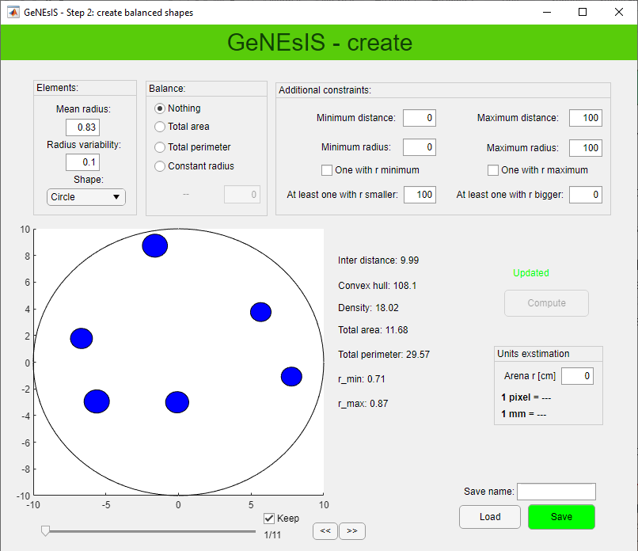In this second window you can set all your geometrical shape characteristics. The program generates the shapes around the previously computed points, and these shapes have dimensions distributed normally around a mean value *Mean* *radius* and a variability given by *Radius variability*. The bigger the variability is, the more different the dimension of the elements will be (0.1 for elements all similar in dimensions).

N.B. If you choose a different shape than the circle, the value *radius* will refer to the characteristic size of the selected shape, more precisely to the value of the side.

***Constraints***

You can choose different constraints: in the *Balance* tab you can set the total area of your stimuli, the total perimeter or choose a constant radius for all the elements. In the *Additional constraints* tab, you can set minimum and maximum distance between two elements; set the minimum or maximum radius the elements could have, and if there must be an element with that precise min/max radius (*‘One with r minimum/maximum’*); set if you want at least one element smaller/bigger than a threshold size (*‘At least one with r smaller/bigger’*).

The program generates all the shapes and then it will discard the combinations overlapping, going outside the arena or not fulfilling your constraints: for this reason, in this passage you will lose most of the generations created before. This is way it is important to have a big starting dataset from the previous point.

N.B. Every time you perform a new computation the program recreates the shapes randomly, thus, even if you set exactly the same parameters you won’t never end with the same final stimuli!

If you obtain configurations that you don’t like visually, you can still remove them by unselecting the ‘*Keep’* field.

Once you have generated all your stimuli and you have finished, you can save a Matlab file with all the generations created. At the same time an excel file with all your parameters for each generation is automatically saved too. You can also load a previously saved file and modify it.

Good practice: I suggest to save the file with a name that indicates the parameters of interest.

For example if you have balanced total area at 7 and convex hull at 30 for three elements you can save something like ‘n3_TA7_CH30’.

Your stimuli are now defined, you can close the program and pass to step 2 for the appearance and effective dimension adjustments.

STEP 2: GeNEsIS_save

For this step you need to have both *GeNEsIS_save.mlapp* and the *GeNEsIS* Matlab files with your stimuli saved in previous step in the same working directory of Matlab.

Drag and drop *GeNEsIS_save.mlapp* in the Matlab terminal to start; or drag and drop *GeNEsIS.mlapp* (that in this case should be present in the same folder), opening the main menu: click on the second button.

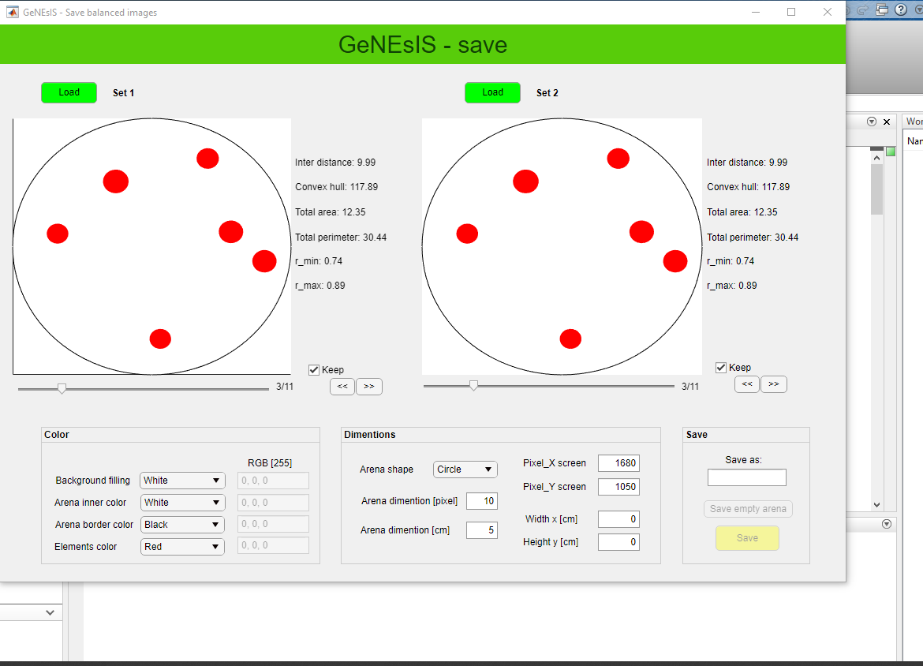

Here you can load the Matlab files with your stimuli created in the previous step (with *StimuliGenerator.mlapp*). The settings here are self-explaining, free to change colors and investigate the appearance.

Also the arena dimension is settable: clearly, the best thing is to keep it as before, when the elements where created (thus, 10 pixel usually); but it could be interesting in some cases to enlarge it a bit (for example from 10 to 12), in order to have the shapes more distant from the border and grouped in the middle.

N.B. The program is though to visualize two sets at a time, in order to compare them visually; even if you want to modify only one set you need to load both sides (in case also with the same file), because if one side is left empty errors will occur.

**How to set effective dimensions**

The last important step is to create images that have the desired effective dimensions (in cm). In order to do this we refer to the arena radius as our reference dimension (already set in pixel units in ‘*Arena dimentions [pixel]*’), and we choose the effective dimension in centimeter (‘*Arena dimentions [cm]*’); this is the value that we want to visualize when the image is presented in full screen/paper mode.

In order to create these images, the program needs to know the effective size of our presentation screen/paper, both in pixel and centimeters.

Once we have set all these characteristics, we can save the final images both as separated image files and as a Matlab matrix that can be used for an automized experiment, for example controlled by *Psychtoolbox*. Again, it’s good practice to save your file with an indicative name containing all the information you need.

STEP 3: GeNEsIS_display

For this step you need to have both *GeNEsIS_display.mlapp* and thefinalMatlab files with your images saved in previous step in the same working directory of Matlab.

Drag and drop *GeNEsIS_display.mlapp* in the Matlab terminal to start; or drag and drop *GeNEsIS.mlapp* (that in this case should be present in the same folder), opening the main menu: click on the third button.

**N.B**. In order to run this part of the program, you need to install *Psychtoolbox* *(*[*http://psychtoolbox.org/*](http://psychtoolbox.org/)*)*

Note: the way in which these experiments can be carried on depends on different necessities and many parameters; this tool is only an example thought to provide some standard ways to automatically present numerosity stimuli on screen (like for example in an experiment of habituation or discrimination). Clearly, many things can be adapted differently; if you need to adjust it according to your specific needs you can work on the code…or try to write me!

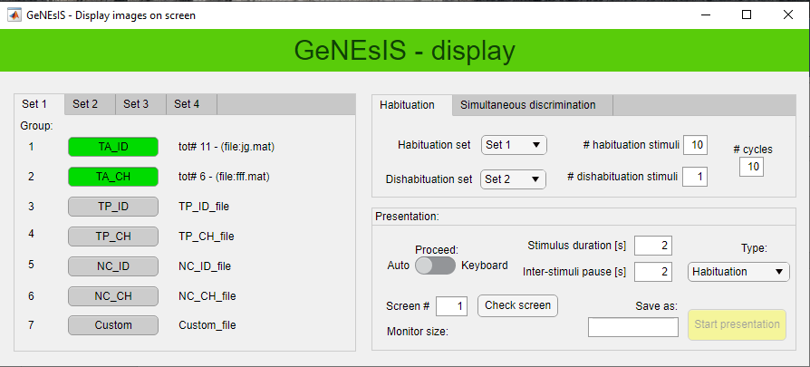

With this tool you can load your images you have created previously, divided by conditions (groups) and numerosity (sets).

In the ‘*Habituation’* experiment *type,* the images will be presented in a sequence of *# habituation stimuli* of random images of numerosity *Habituation set*, follow by *# dishabituation stimuli* of *Dishabituation set.* This is repeated for *# cycles* times.

In the ‘*Discrimination’* experiment *type,* the images will be presented in a sequence of *# training trials* couple of images of numerosity *Couple training* randomized between the left and right side of the screen, follow by *# test trials* of *Couple set* images (randomly presented together on left and right)*.* This is repeated for *# cycles* times.

All these experiments can be automatized setting the duration of the images and of the inter-stimuli pauses, or the user can select to proceed at keyboard input, in order to change image at will. The screen where to project the images can be also selected.

At the end of the experiment an excel file will be saved, with all the information about the different trails and corresponding presented stimuli.

N.B. Psychtoolbox synchronize the presentation of a new image with the refresh of the screen. In order to manage the timing, at the beginning of the execution it will perform some internal checks and if its standard are not fulfilled it ends up with a Matlab error on terminal. It is common that this happen in particular the first times the script run or if many other different programs are opened on your pc. In this case Start again the presentation until it works.