|  |  |
| --- | --- |
|  |  |

**<TO DO LIST>**

**Requirements Document**

**Version 2.0**

**Course :** Software Design and Architecture

**Instructor :** Prof. Dr. Vedat COSKUN

**Student : <** 210504506 &Mirkamol & Rakhimov>

**Document History**

|  |  |  |
| --- | --- | --- |
| **Version** | **Date** | **Document Description** |
| 1.0 | 2022 – 11 – 03 | İnitial report shall include until part (7) |
| 2.0 | 2022 – 12 – 06 | report shall include all parts until part (10) |
| 3.0 | 2022 – 12 – 13 | report shall include whole report |
| 4.0 | 2022 – 12 – 20 | Report should additionally include Database Design |
| 5.0 | 2022 – 12 – 27 | Implementation shall be complete |
|  | 2023 – 01 – 05 | Presentations |
|  | 2023 – 01 – 12 | Presenatations |

1. **Overview of the Project**

**It’s a list of tasks you need to complete or things that you want to do.**

Most typically, they’re organized in order of priority. Traditionally, they’re written on a piece of paper or post it notes and act as a memory aid. As technology has evolved, we have been able to create a to do lists with excel spreadsheets, word documents, email lists, to do list apps. You can use to do in your home and personal life, or in the workplace.

The structure of this application is so easy that everyone who has and able to use laptop can use this software without having any trouble. It will be updated monthly, added new features and fixing bug if any there.

1. **Company Details**

It will be first and debut entrprise software application for my own new company and will be produced by name of Company.

Company is named after my surname and name, and it is called MR[EmAr](Mirkamol Rakhimov). It it is established in 2022 year and this is will be first entrprise application that provides to market.The main idea of company is providing software apps to market and people,to make their life easy,s

Due to of main idea of company ,Slogan also appeared, which is, “Make App,Make People Life Easy, So That They Do not Get Lazy”

1. **System-as-is**

For First releaseing of this app will be as entrprise just one whole app , it will have good and easy interface and at that time it will have payment,which will be integrated with all cards including international and local bank cards,at the same time it can be part of some big entrprise software as notification part like for having notes

Current state analysis can focus on an entire business organization or on one or more specific processes within a department or team.

There are several key goals or motivations for implementing current state analysis, including:

* Saving money
* Improving existing processes or creating new processes
* Increasing customer satisfaction
* Improving business coordination and organizational responsiveness
* Complying with new regulatory standards
* Adapting processes following a merger or acquisition

1. **Business Purpose**

So in terms of app , it has expenses like database and hosting renting payments,which is not that much because first version going to be present to small scale of people,so it is uses smalll storage in database,so its funded and invested by myself.

In terms of getting money and profit from this software, it will be free for month,for testing and having trial,day after presenting to market,

After month it will give you offer to have subsrciption,paying monthly or annualy payment also that not much like 2 $ per month or annualy 10$ , and has offer for students as well as ,which will be two times less from ordinary price.At the same time there also offer without any payment for free users ,but want to continue using software ,which cost to them watching 1 minute ads overall which is provided by Google Ads.

To sum up ,This software brings profit from two ways, which is for free subcribers,by adverstisement like average 5$.For Premium users,those with payments, average 90$ per month.

1. **Stakeholders**

Over 6 month,will not go and Ipo and For Shareholding, in order to get strong and get stand by legs.During this months,it will add features and fix bugs if any there,if this software succed in market , it may have sponsership ,with giant company like Google, Microsoft ,even Apple, at the same it can be part of them , if both sides agree in each aspects.

After that if will shares it shares in market ,by percentage, and there will be chance selling this apps to It companies

We can both Below Stakeholders according to succes of Project:

**Internal stakeholders**

These stakeholders are coming from within the house!!! Internal stakeholders are people or groups **within** the business, such as team members, managers, executives, and so on.

**External stakeholders**

External stakeholders are — as you can probably guess — people or groups **outside** the business. This includes customers, users, suppliers, and investors.

1. **Actors**

The application will be present in two ways, which is web based web application and mobile phone portable application for both ios and Android,In case of Actors , each user who have phone or either laptop, can use this app, those who want use mobile application version have to dowload application from play market,which is called to do list by MR.After Downloading they just log in if they have account, if no then sign up,database checks if they have account matched in database, if so it let them go in and start use interface is so easy,For those want use web application one ,Actor in our case user just go any web browser and write link of app, and sign up page pop up, after that they will log in , it will let them go.P.S First version of application will be present in format web page.

1. **Context Diagram**

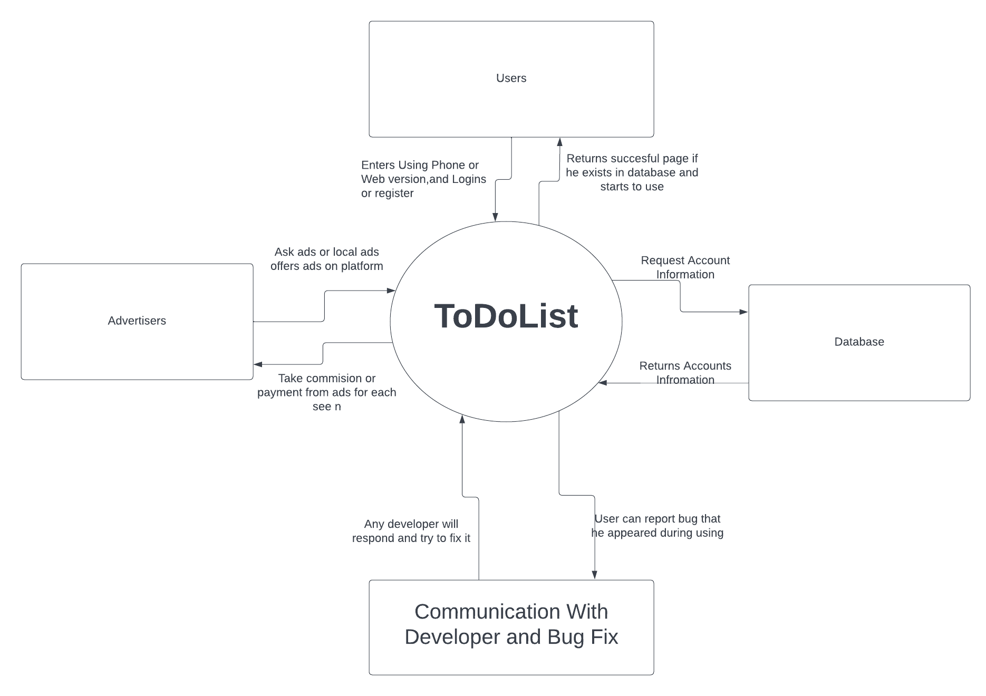

1. **Primary Flow Chart and additional Flow Charts**

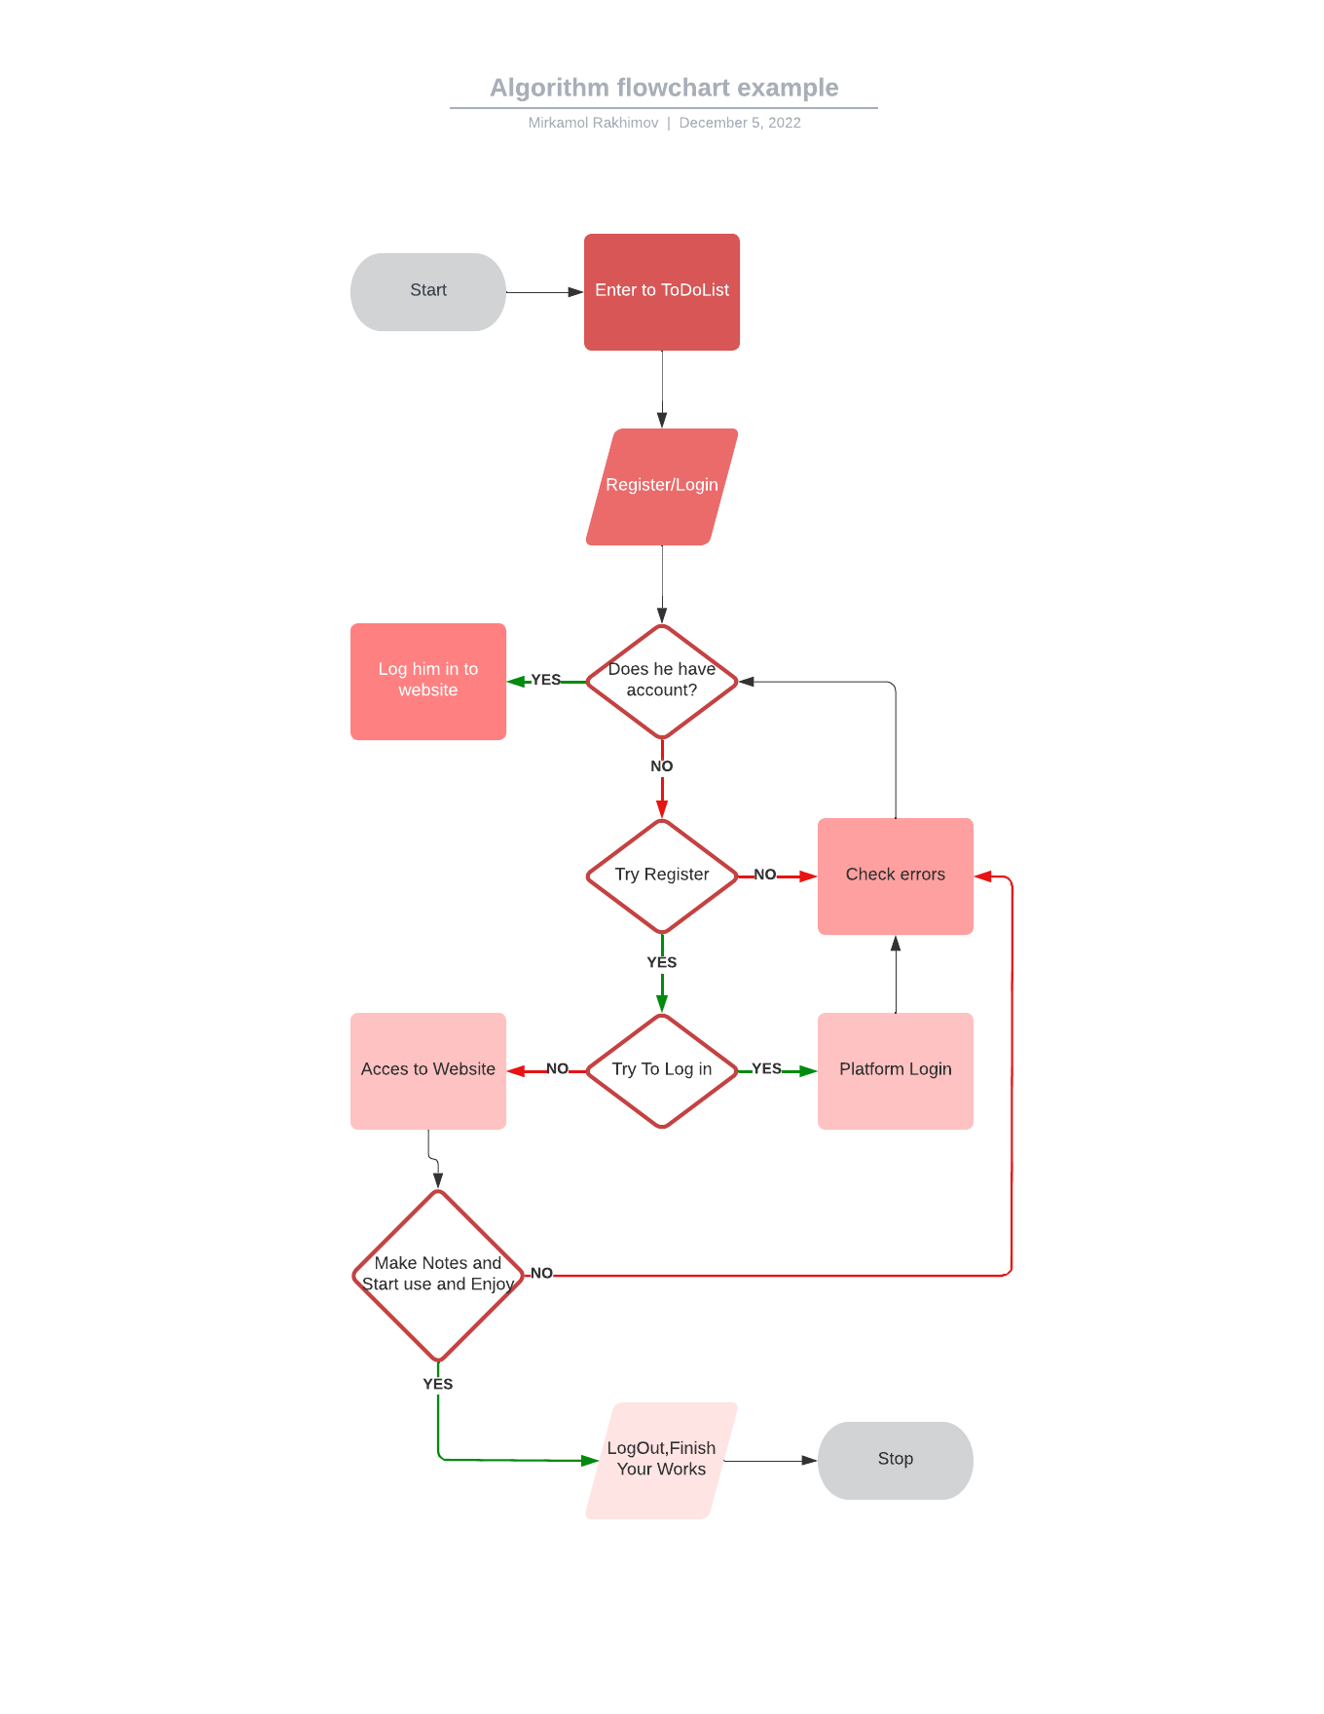

1. **Use Case Descriptions & Use Case Diagrams**

|  |  |  |
| --- | --- | --- |
| **Use-Case Number** | 1 | |
| **Use-Case Name** | Registred in both Hosting of Google and PlayMarket | |
| **Description** | PlayMarket for AnfdroidUsers for portable version , GoogleHosting for Website form | |
| **(Input) Forms** | Form-1: Registration Form  Form – 2: Login Form  Form -3 : Payment Form For Payment | |
| **(Output) Reports** | Form-1:Have an Account  Form-2: Acess to platform with account  Form-3:it pays and enjoys premimum | |
| **Flow of Events** | **Actor** | **System** |
| 1. User enters to register page 2. User fills the register form and submits the form 3. User reads the successful registration message  4.Logins and start uses and enjoys | 1. System gets the form values that user has entered 2. System checks if the entered values are correct 3. System inserts the values to the database  4. System returns successful registration message to user |

1. **Requirements, Constraints, Rules**

Functionl Requirments:

1. Project explaining how Works, small parts
2. It will show features and develops new ones
3. It will ask user requirments
4. Documentation will be given for some users
5. Origing type which user define
6. External interfaces, authentification including register and login ,auth levels

Non-functional Requirments

1. It will be focused on user expectations,which will give them chance to learn more
2. It will be defiend product properties
3. Usability Reliability and Scalibility , which can be grow long and far and wide scale
4. Document will be captured as quality attribute
5. Testing going to be performance and usabilithy and security testing

The main risk can be that this software first inital will not be Cloud version, it will be just hosted proverders databse which can lead to losing notes when database damage or user can lose their accounts

The main rules can be never share their account for anyone including developers of app.

1. **Measure of Success (QoS Parameters)**

List the measures of success for the project. (see Section 3.1.3 of BRD Guide)

* Execution of tasks and milestones
* On-time project completion
* On-budget project completion
* Positive impact on the future of firm
* Project team fulfillment with their completed work
* Quality deliverables are executed and completed to client’s satisfaction

1. **Forms (Input)**

My Project will have a variety of input forms which is very needed for all type of projects,

So i added the most essential ones i have included all of thme below here:

User Registration and Login Form – I think 99 % projects and software has this form

Password Reset, Forget, Confirmation Form – this is for those who forgets their password or account

Database Request,Sending Form – it is always work with database to take and send and save datas

Admin Registration User and Login Form – It is nesecarry for admin user to have control under system

Admin Manage Form Whole Sytem – admin will have privilage to use this

Payment Form

Adding Note Form,Manage,Manipulate,Edit,Delete

<body>

<div class="container h-100">

<div class="d-flex justify-content-center h-100">

<div class="user_card">

<div class="d-flex justify-content-center">

<h3 id="form-title">REGISTER ACCOUNT</h3>

</div>

<div class="d-flex justify-content-center form_container">

<form method="POST" action="">

<div class="input-group mb-3">

<div class="input-group-append">

<span class="input-group-text"><i class="fas fa-user"></i></span>

</div>

<input type="text" name="username">

</div>

<div class="input-group mb-2">

<div class="input-group-append">

<span class="input-group-text"><i class="fas fa-envelope-square"></i></span>

</div>

<input type="email" name="email">

</div>

<div class="input-group mb-2">

<div class="input-group-append">

<span class="input-group-text"><i class="fas fa-key"></i></span>

</div>

<input type="text" name="password1">

</div>

<div class="input-group mb-2">

<div class="input-group-append">

<span class="input-group-text"><i class="fas fa-key"></i></span>

</div>

<input type="text" name="password2">

</div>

<div class="d-flex justify-content-center mt-3 login_container">

<input class="btn login_btn" type="submit" value="Register Account">

</div>

</form>

</div>

<div class="mt-4">

<div class="d-flex justify-content-center links">

Already have an account? <a href="{% url 'login' %}" class="ml-2">Login</a>

</div>

</div>

</div>

</div>

</div>

</body>

1. **Reports (Output)**

Insert the whole set of reports here now. Important points:

Output will be according to input ,if user wants register and enter information database for user checking and registration Works,sending requests

İf user wants to pay then Works oayment integration website and database , using some api

İf user forgot his password for accout, it will be forgot reset form will be work and present

İf user want use and add note , database saving mode Works

1. **References**

# 1) To-Do Lists

## The Key to Efficiency

https://www.mindtools.com/aug8p7g/to-do-lists

## 2) The To Do List

Use CSS and JavaScript to create a "to-do list" to organize and prioritize your tasks.

<https://www.w3schools.com/howto/howto_js_todolist.asp>

# 3) What Is a Database?

<https://www.oracle.com/database/what-is-database/>

4) Project Management

<https://www.pmi.org/about/learn-about-pmi/what-is-project-management>

**Articles and Books:** There are a number of books on software engineering,that have been used to have information:

Pressman, Roger (2010) Software Engineering: A Practitioner's Approach, McGraw Hill , New York, NY.  
(Order from [amazon](http://www.amazon.com/s/ref=nb_sb_noss?field-keywords=9780073375977), order from [Barnes and Noble](http://search.barnesandnoble.com/booksearch/isbnInquiry.asp?isbn=9780073375977), compare at [bigwords](http://www.bigwords.com/search/index.php?z=easysearch&searchtype=ISBN&searchstring=9780073375977), compare at [CampusBooks4Less](http://www.campusbooks4less.com/cgi-bin/bookSearch/bookstoreSearch.cgi?searchBy=isbn&searchVal=9780073375977&func=submit), order from [Chegg](http://www.chegg.com/textbooks/9780073375977), or search [eFollett](http://www.bkstr.com/webapp/wcs/stores/servlet/StoreCatalogDisplay?catalogId=10001&langId=-1&storeId=10317&demoKey=d))

Sommerville, Ian (2011) Software Engineering, Addison-Wesley , Boston, MA.  
(Order from [amazon](http://www.amazon.com/s/ref=nb_sb_noss?field-keywords=0137035151), order from [Barnes and Noble](http://search.barnesandnoble.com/booksearch/isbnInquiry.asp?isbn=0137035151), compare at [bigwords](http://www.bigwords.com/search/index.php?z=easysearch&searchtype=ISBN&searchstring=0137035151), compare at [CampusBooks4Less](http://www.campusbooks4less.com/cgi-bin/bookSearch/bookstoreSearch.cgi?searchBy=isbn&searchVal=0137035151&func=submit), order from [Chegg](http://www.chegg.com/textbooks/0137035151), or search [eFollett](http://www.bkstr.com/webapp/wcs/stores/servlet/StoreCatalogDisplay?catalogId=10001&langId=-1&storeId=10317&demoKey=d))

Stephens, Rod (2015) Beginning Software Engineering, Wrox.  
(Order from [amazon](http://www.amazon.com/s/ref=nb_sb_noss?field-keywords=1118969146), order from [Barnes and Noble](http://search.barnesandnoble.com/booksearch/isbnInquiry.asp?isbn=1118969146), compare at [bigwords](http://www.bigwords.com/search/index.php?z=easysearch&searchtype=ISBN&searchstring=1118969146), compare at [CampusBooks4Less](http://www.campusbooks4less.com/cgi-bin/bookSearch/bookstoreSearch.cgi?searchBy=isbn&searchVal=1118969146&func=submit), order from [Chegg](http://www.chegg.com/textbooks/1118969146), or search [eFollett](http://www.bkstr.com/webapp/wcs/stores/servlet/StoreCatalogDisplay?catalogId=10001&langId=-1&storeId=10317&demoKey=d)) (Read at [Safari](http://proquestcombo.safaribooksonline.com/book/software-engineering-and-development/9781118969175))

Tsui, Frank , Orlando Karam and Barbara Bernal (2013) Essentials of Software Engineering, Jones & Bartlett Learning , Sudbury, MA.  
(Order from [amazon](http://www.amazon.com/s/ref=nb_sb_noss?field-keywords=9781449692001), order from [Barnes and Noble](http://search.barnesandnoble.com/booksearch/isbnInquiry.asp?isbn=9781449692001), compare at [bigwords](http://www.bigwords.com/search/index.php?z=easysearch&searchtype=ISBN&searchstring=9781449692001), compare at [CampusBooks4Less](http://www.campusbooks4less.com/cgi-bin/bookSearch/bookstoreSearch.cgi?searchBy=isbn&searchVal=9781449692001&func=submit), order from [Chegg](http://www.chegg.com/textbooks/9781449692001), or search [eFollett](http://www.bkstr.com/webapp/wcs/stores/servlet/StoreCatalogDisplay?catalogId=10001&langId=-1&storeId=10317&demoKey=d)) (Read at [Safari](http://proquestcombo.safaribooksonline.com/book/software-engineering-and-development/9781449691998))

Pfleeger, Shari (2001) Sofwtare Engineering: Theory and Practice, Prentice Hall , Upper Saddle River, NJ.  
(Order from [amazon](http://www.amazon.com/s/ref=nb_sb_noss?field-keywords=0130290491), order from [Barnes and Noble](http://search.barnesandnoble.com/booksearch/isbnInquiry.asp?isbn=0130290491), compare at [bigwords](http://www.bigwords.com/search/index.php?z=easysearch&searchtype=ISBN&searchstring=0130290491), compare at [CampusBooks4Less](http://www.campusbooks4less.com/cgi-bin/bookSearch/bookstoreSearch.cgi?searchBy=isbn&searchVal=0130290491&func=submit), order from [Chegg](http://www.chegg.com/textbooks/0130290491), or search [eFollett](http://www.bkstr.com/webapp/wcs/stores/servlet/StoreCatalogDisplay?catalogId=10001&langId=-1&storeId=10317&demoKey=d))

**Important information:**

* The document should be presentable, and be readable
* Do not change the font of this document
* All information within the document should be consistent with other parts of the document. For example, names of the activities must exactly match with the use case diagram etc.
* The document should be full justified
* Spell check the document before submission
* Paragraph and Font settings of your document should be the same as this document.
* Each submission shall have a major version number such as 1.0, 2.0..; and each minor update shall have a minor change such as 1.1, 1.2 etc.

**DataBase Design.**

Django officially supports the following databases:

* [PostgreSQL](https://docs.djangoproject.com/en/4.1/ref/databases/#postgresql-notes)
* [MariaDB](https://docs.djangoproject.com/en/4.1/ref/databases/#mariadb-notes)
* [MySQL](https://docs.djangoproject.com/en/4.1/ref/databases/#mysql-notes)
* [Oracle](https://docs.djangoproject.com/en/4.1/ref/databases/#oracle-notes)
* [SQLite](https://docs.djangoproject.com/en/4.1/ref/databases/#sqlite-notes)

There are also a number of [database backends provided by third parties](https://docs.djangoproject.com/en/4.1/ref/databases/#third-party-notes).

Django attempts to support as many features as possible on all database backends. However, not all database backends are alike, and we’ve had to make design decisions on which features to support and which assumptions we can make safely.

This file describes some of the features that might be relevant to Django usage. It is not intended as a replacement for server-specific documentation or reference manuals.

Connecting to the database¶

Refer to the settings documentation.

Connection settings are used in this order:

OPTIONS.

NAME, USER, PASSWORD, HOST, PORT

MySQL option files.

In other words, if you set the name of the database in OPTIONS, this will take precedence over NAME, which would override anything in a MySQL option file.

Here’s a sample configuration which uses a MySQL option file:

# settings.py

DATABASES = {

'default': {

'ENGINE': 'django.db.backends.mysql',

'OPTIONS': {

'read_default_file': '/path/to/my.cnf',

},

}

}

# my.cnf

[client]

database = NAME

user = USER

password = PASSWORD

default-character-set = utf8

Setting sql_mode¶

From MySQL 5.7 onward, the default value of the sql_mode option contains STRICT_TRANS_TABLES. That option escalates warnings into errors when data are truncated upon insertion, so Django highly recommends activating a strict mode for MySQL to prevent data loss (either STRICT_TRANS_TABLES or STRICT_ALL_TABLES).

If you need to customize the SQL mode, you can set the sql_mode variable like other MySQL options: either in a config file or with the entry 'init_command': "SET sql_mode='STRICT_TRANS_TABLES'" in the OPTIONS part of your database configuration in DATABASES.

Isolation level¶

When running concurrent loads, database transactions from different sessions (say, separate threads handling different requests) may interact with each other. These interactions are affected by each session’s transaction isolation level. You can set a connection’s isolation level with an 'isolation_level' entry in the OPTIONS part of your database configuration in DATABASES. Valid values for this entry are the four standard isolation levels:

'read uncommitted'

'read committed'

'repeatable read'

'serializable'

or None to use the server’s configured isolation level. However, Django works best with and defaults to read committed rather than MySQL’s default, repeatable read. Data loss is possible with repeatable read. In particular, you may see cases where get_or_create() will raise an IntegrityError but the object won’t appear in a subsequent get() call.

