**International Music Contest**

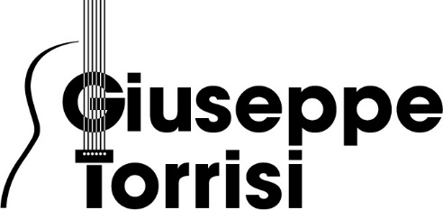

**(FIRST EDITION)**

Catania

**November 25/26/27th 2022**

**Request and registration form**

(write in block letter)

The undersigned

First Name _____________________________________________

Last Name ____________________________________________

Place and date of birth_________________________________

Municipality of residence_____________________________ ( ____ )

Via_________________________________________ n. ______

C. a. p.: ________ Telephone number: _______________________

Email ________________________________________________

Requests to participate to the

First Edition of the International Contest “G.TORRISI” 2022

Section ____________________________________ Cat. ____

Instrument: ___________________________________________

Performance programme (specify author-title-lenght):  
_____________________________________________________

_____________________________________________________

Teacher ____________________________________________

.

Catania, Signature