1. To **Change the Size of ImageView**:

Ex: in the XML File You Add Under the ImageView

<ImageView  
 android:id="@+id/imageView"  
 android:layout_width="match_parent"  
 android:layout_height="match_parent"  
 app:layout_constraintBottom_toBottomOf="parent"  
 app:layout_constraintEnd_toEndOf="parent"  
 app:layout_constraintStart_toStartOf="parent"  
 app:layout_constraintTop_toTopOf="parent"  
 app:srcCompat="@drawable/background"  
 android:scaleType="fitXY"/>

**Note**: This Will Make **the Image Expand** to **Take All the Screen**

EX: to make the image **Take All the Screen** **Without Expanding**

<ImageView  
 android:id="@+id/imageView"  
 android:layout_width="match_parent"  
 android:layout_height="wrap_content"  
 android:scaleType="fitXY"  
 android:adjustViewBounds="true"  
 app:layout_constraintBottom_toBottomOf="parent"  
 app:layout_constraintEnd_toEndOf="parent"  
 app:layout_constraintStart_toStartOf="parent"  
 app:layout_constraintTop_toTopOf="parent"  
 app:srcCompat="@drawable/art_background" />

**Note**: For **More Ways** Visit this [WebSite](https://guides.codepath.com/android/Working-with-the-ImageView)

1. **Save in SQLite**:
2. Create **DBHelper class**:

class DBHelper(  
 context: Context?,  
 name: String?= "details.db",  
 factory: SQLiteDatabase.CursorFactory?= null,  
 version: Int= 1,  
 private val tableName: String= "notes"  
)

: SQLiteOpenHelper(context, name, factory, version) {  
 override fun onCreate(p0: SQLiteDatabase?) {  
 p0?.execSQL("create table $tableName (Note Text)")  
 }  
  
 override fun onUpgrade(p0: SQLiteDatabase?, p1: Int, p2: Int) {}  
  
 fun saveNotes(note: String): Long {  
 val cv= ContentValues()  
 cv.put("Note",note)  
 return *writableDatabase*.insert(tableName,null,cv)  
 }  
}

1. **In Main Class**:

val dbHelper= DBHelper(this)

val check= dbHelper.saveNotes(noteEntry.*text*.toString())  
val wrongCode: Long= -1  
if (check != wrongCode) {  
 StyleableToast.makeText(this, "Saved Successfully!!\n$check", R.style.*mytoast*).show()  
}  
else  
 StyleableToast.makeText(this,"Something Went Wrong!!\n$check",R.style.*mytoast*).show()

1. The **Deference** between (**this** and **applicationContext**) when we need to use Context:

If we are going to use it **inside the same activity** it’s ok to use (**this**)

**But** if we need to **send it to another function** or **another class**, better to use (**applicationContext**).

Because if we pass the activity context and that activity got destroyed the **app will crash**.

1. **Read from SQLite**
2. In DBHelper class

fun gettingNotes(): ArrayList<String>{  
 return try{  
 val notes= *arrayListOf*<String>()  
 val cursor =  
 sqLiteDatabase.query(tableName, *arrayOf*("Note"), "Note=?", *arrayOf*("Good"), null, null, null)  
 cursor.moveToFirst()  
 while (!cursor.*isAfterLast*){  
 notes.add(cursor.getString(0))  
 cursor.moveToNext()  
 }  
 notes  
 } catch (e:Exception){  
 *arrayListOf*("Error")  
 }  
}

**Note: SQL Query** = select Note from tablenName where Note= Good

Note: If you want to **select all the table** you can replace all with null (Except table name)

Ex: val cursor =  
 sqLiteDatabase.query(tableName, null ,null, null, null, null, null)

Note: You can Replace the index from **set number to index that the program locate**

EX: notes.add(cursor.getString(cursor.getColumnIndexOrThrow("Note")))

1. **In Main Class**

private lateinit var notes: ArrayList<String>

notes= dpHlpr.gettingNotes()

**Note: Another Way to Read The Entire Table**

val selectQuery = "SELECT * FROM $tableName "var cursor: Cursor? = null  
try {  
 cursor = sqLiteDatabase.rawQuery(selectQuery, null)  
} catch (e: SQLiteException){  
 return ArrayList()  
}  
var noteText: String  
if(cursor.moveToFirst()){  
 do {  
 noteText = cursor.getString(cursor.getColumnIndexOrThrow("Note"))  
 noteList.add(noteText)  
 } while (cursor.moveToNext())  
}

1. **Delete From SQLite**

fun deleteNotes(pk: Int): Int{  
 return sqLiteDatabase.delete(tableName,"PK=?", *arrayOf*("$pk"))  
}

1. **Edit To SQLite**

fun updateNotes(pk:Int, newNote: String): Int{  
 val contentValue= ContentValues()  
 contentValue.put("Note",newNote)  
 return sqLiteDatabase.update(tableName,contentValue,"PK=?", *arrayOf*("$pk"))  
}

1. If we **Upgrade the version** to change the table columns or add new columns we make sure to **change onUpgrade:**

override fun onCreate(p0: SQLiteDatabase?) {  
 p0?.execSQL("create table $tableName (PK INTEGER PRIMARY KEY AUTOINCREMENT, Note Text)")  
}  
  
override fun onUpgrade(p0: SQLiteDatabase?, p1: Int, p2: Int) {  
 p0?.execSQL("DROP TABLE IF EXISTS $tableName")  
 onCreate(p0)  
}

1. **Room**

Room is a persistence library and an abstraction layer over SQLite.

Room annotations (@Entity, @Dao, @Database ) make it easier to save data to SQLite.

Room verifies SQL queries during compile time, which means there will never be any runtime errors due to query syntax.

While it may take some time to get used to the setup, once you are familiar with it, you will notice that room makes using SQL much easier.  It also makes integration with other Android architectural components easier.  This will become more evident when we look at View Models and Live Data.

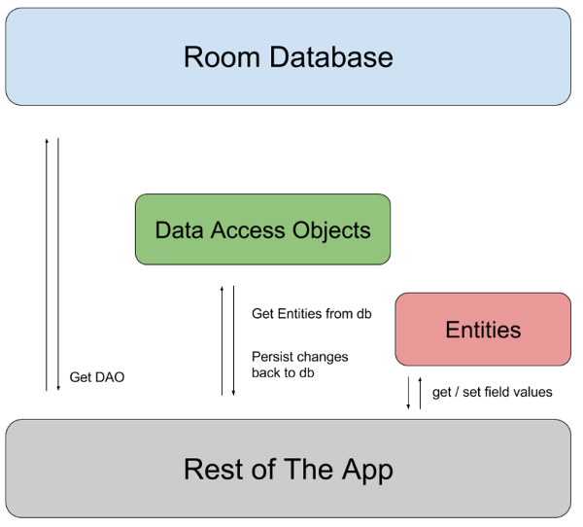

Source Code: <https://github.com/KPRanjithKumar/SQLiteRoomNameLocation>

Note: to Use Room We Need To Add To Our Gradle File

After this:

plugins **{** id 'com.android.application'  
 id 'kotlin-android'  
**}**apply plugin: 'kotlin-kapt'

and the implementations:

implementation 'androidx.room:room-common:2.3.0'  
implementation 'androidx.room:room-ktx:2.3.0'  
implementation "org.jetbrains.kotlinx:kotlinx-coroutines-android:1.4.1"  
implementation "androidx.room:room-runtime:2.3.0"  
implementation 'android.arch.persistence.room:runtime:1.1.1'  
kapt "androidx.room:room-compiler:2.3.0"

# ViewModel

ViewModel is a part of Android Architecture Components, which make our code cleaner and easier to maintain. ViewModel holds our UI data while surviving configuration changes, such as device rotation and changing of activities. It allows us to separate our logic from the UI.

NOTE:

Never pass context into your ViewModel. Doing so, will lead to memory leaks as a ViewModel outlives the activity that is passed to it. If you need access to the activity, make sure to use AndroidViewModel, which includes a reference to the application.

In this demo, we will add a ViewModel to our Button Clicker App

For more information, refer to the [Official Documentation](https://developer.android.com/topic/libraries/architecture/viewmodel?gclid=CjwKCAjwq9mLBhB2EiwAuYdMtd_UTjQsSAYebwD-8ZQJrQMooCtDIP8UeKk4cRsI-w0GA8tcOrHvBxoCnS8QAvD_BwE&gclsrc=aw.ds)

# LiveData

LiveData works in combination with ViewModel to create a reactive UI. It uses observers to update UI elements based on changes in our data.

The following video takes the Button Clicker App a step further with LiveData

You can read more about LiveData in the [Official Documentation](https://developer.android.com/topic/libraries/architecture/livedata)