Documentation to navigation controller <https://developer.apple.com/documentation/uikit/uinavigationcontroller>

Programmatic segues + Navigation Controller

<https://docs.google.com/document/d/1Wp3Lfcy_rZO3rXXpqpk_ePcy8MztE650uz1grKkypd8/edit#heading=h.8wsosigfj1k1>

**NavigationController_Updates**

Navigation controller is one of the most common used in iOS and you can note that while seeing it most of the time on different iOS Apps , eg: Settings in the iPhone, like the image below: 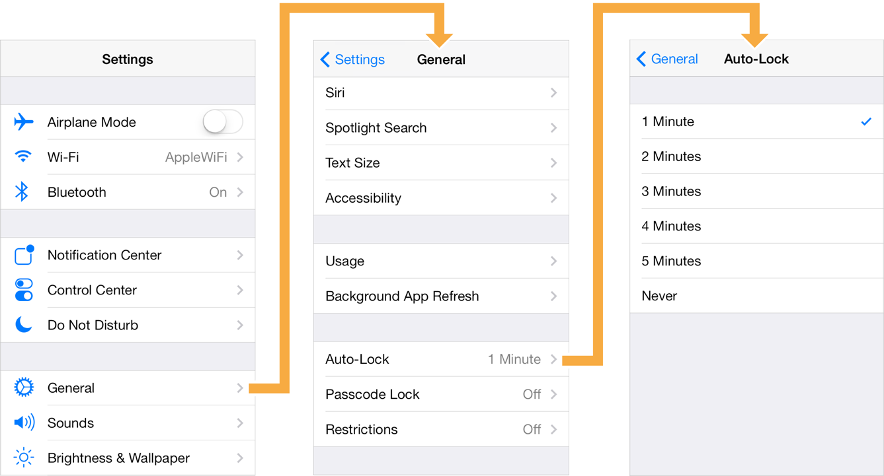

One the important things that you need to know is the hierarchy sequence that NavigationController is working with: One NavigationController is enough to hold multiple screens so No need to create one at a time: 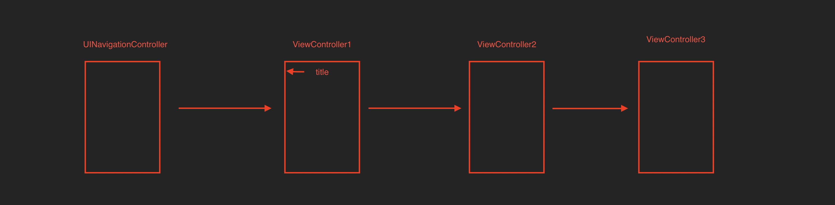

so as per the previous image, there is no need to create multiple UINavigationControllers for each view and only one is enough to be able to navigate. You have multiple options to create or to add a navigation controller:

1. Using the **XCode editor**: 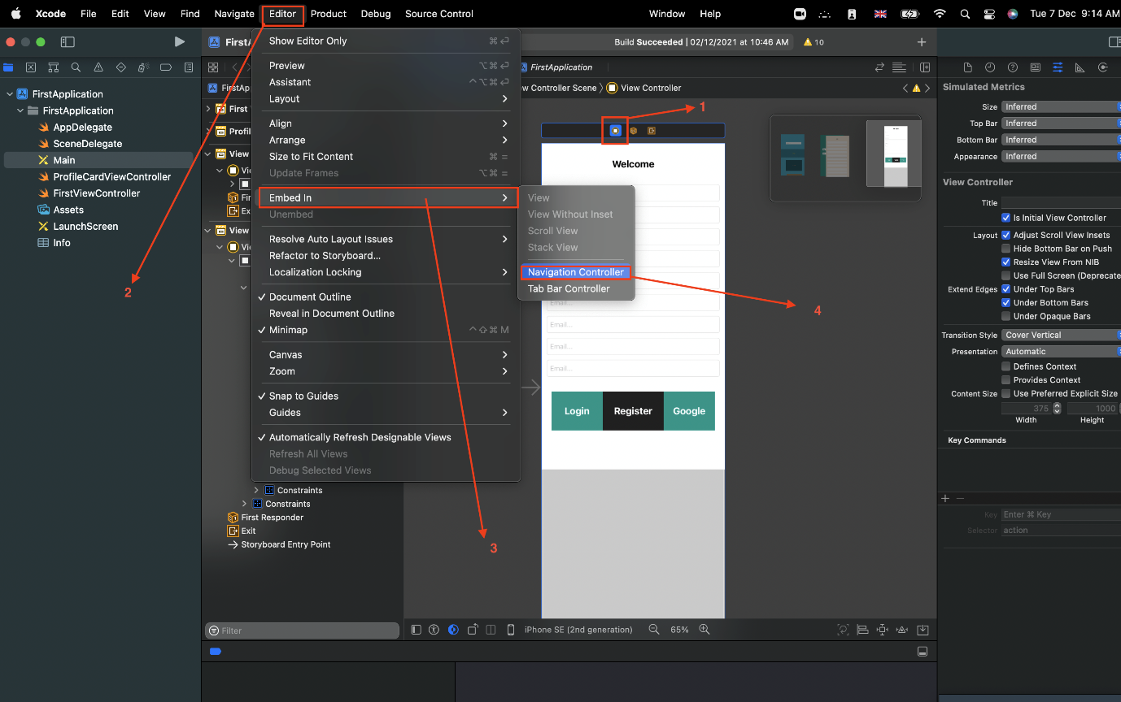
2. Using the **embed in tab** and choose navigation controller: 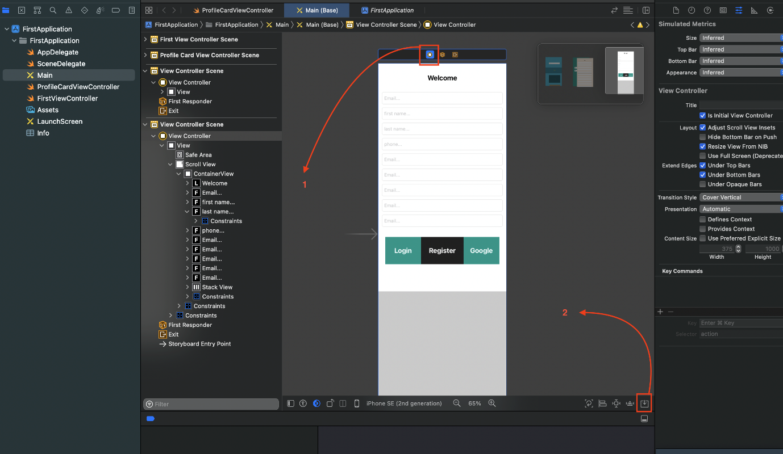

Now after doing that you have your navigation controller and you can use it to navigate between viewControllers but the question now how to do it?

Before answering the question you need to know that the ways we will use will be depending on your case so sometime you can use the code and some other times you can just drag:

**1. Drag option:** In this option you can select the button in viewController you wanna go from and click Ctrl + Drag to the viewController you need to go to and choose show from the menu: 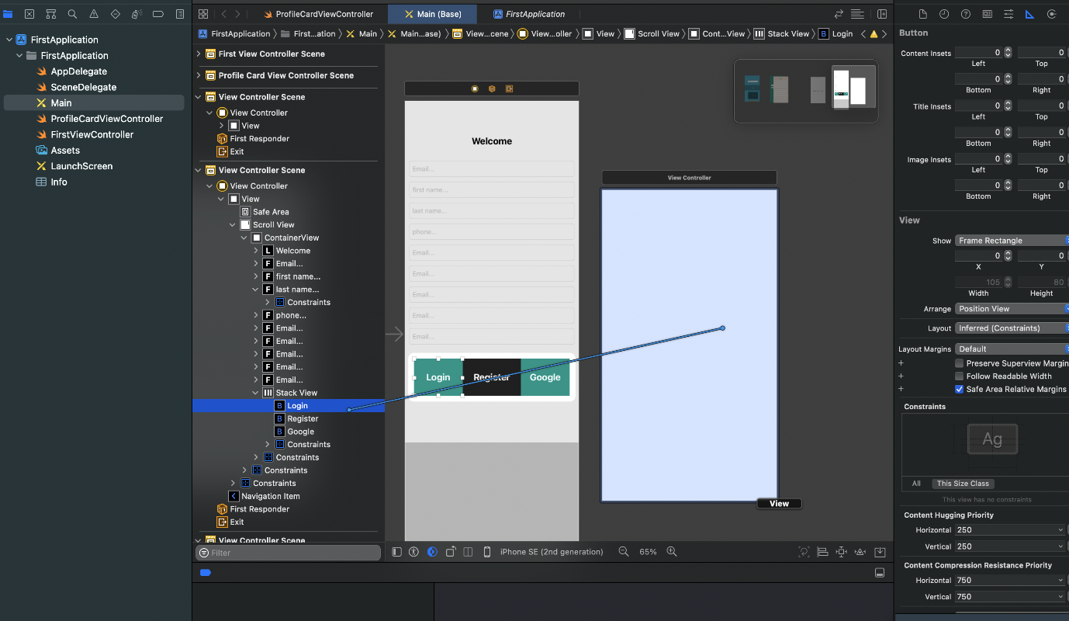

This means that once you click on login button you will be navigated to the second screen directly. **Note:** Any viewController is embed in navigationController can have attributes like the below: 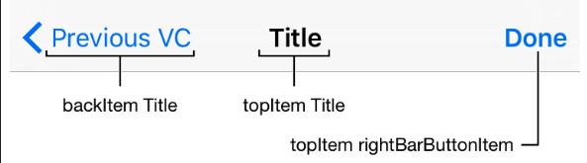

**2.Coding:** You can navigate from a ViewController to another one using the below steps:

1. create an instance from the viewController you wanna go to so let's say after logging in I need to go to profile page:

* I will create a class for the second ViewController and call it "ProfileCardViewController"
* I will set this class to the viewController to be able to connect them and at this time I will set the identifier as well: 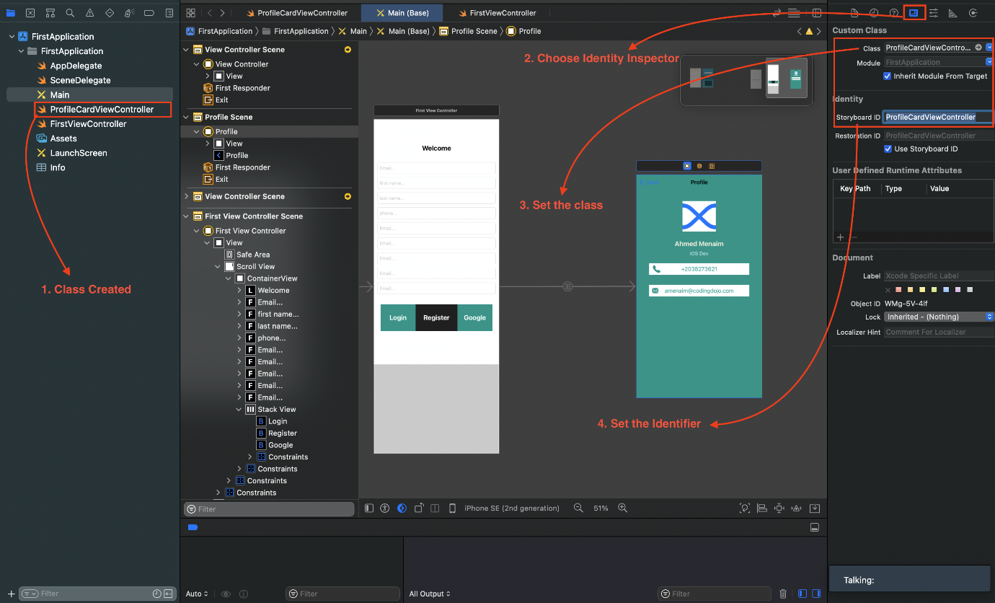

 I will go to the firstViewController class and write the below in the login button action:

@IBAction func buttonLoginAction(_ sender: Any) {

let profileVC = self.storyboard!.instantiateViewController(withIdentifier: "ProfileCardViewController") as! ProfileCardViewController

self.navigationController?.pushViewController(profileVC, animated: true)

}

If you wanna go back after navigation you can do multiple things:

1. Use the created back button by default from the navigationController
2. You can create an action on any other button on the profile to go back and I have created a button which contains an image and I will connect its action to be able to use it to go back:

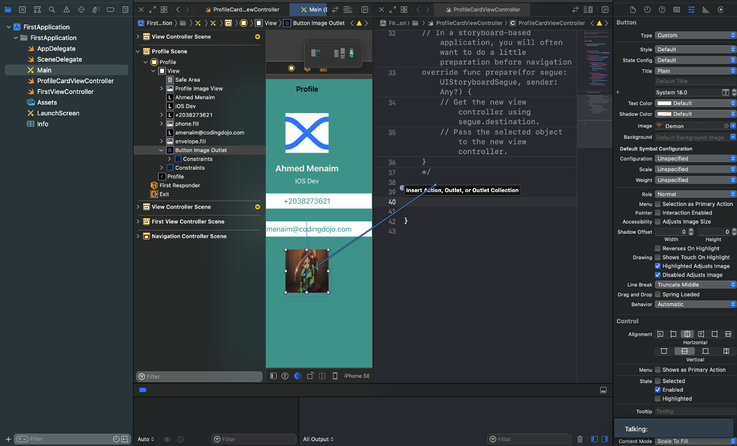

Then I will use this code inside the action:

@IBAction func buttonPopAction(_ sender: Any) {

self.navigationController?.popViewController(animated: true)

}

You can also change the navigation bar colors:

self.navigationController?.navigationBar.backgroundColor = .green // for changing the background color

self.navigationController?.navigationBar.tintColor = .magenta // for barbutton items like back button

self.navigationController?.navigationBar.titleTextAttributes = [NSAttributedString.Key.foregroundColor : UIColor.blue] // for the title