**USER’S GUIDE**

After starting the program you will see this interface (photo below):

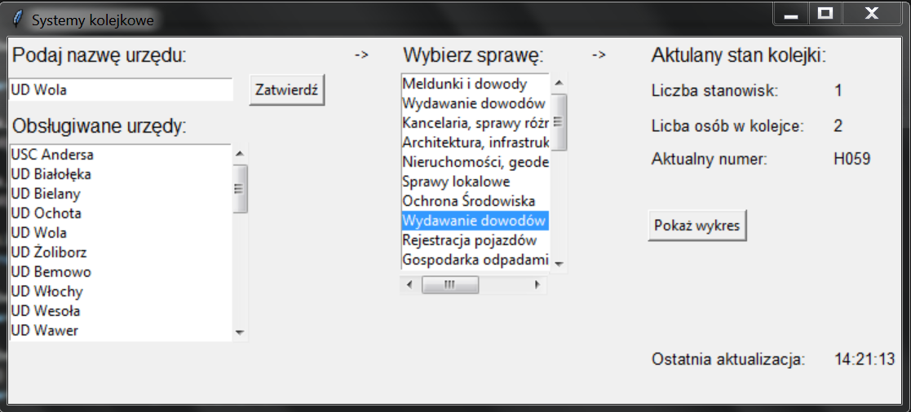

[9]

[8]

[5]

[6]

[7]

[4]

[3]

[2]

[1]

(graphic user’s interface)

To receive information about the current state of the queue for a selected case in a chosen office, follow the instructions:

1. Enter the name of the office you are interested in into the field [1] and press the “**Zatwierdź**” [3] button. All available offices are displayed in the list below [2]. You can also select an office directly from the list [2] by pressing it twice and then confirm the selection with the “**Zatwierdź**” [3] button.
2. After pressing the “**Zatwierdź**” button [3], in the list on the right [4], you will be able to see matters in the office of your choice. If you want to change the office selection, go back to the first point and follow the instructions.
3. To check the status of the queue for a chosen case, select it from the list [4] by pressing the left mouse button on it. If you want to change the office selection, go back to the first point and follow the instructions.
4. After selecting the case on the right in the boxes [5], [6], [7] information about the current queue status will appear. You can also display the plot in a separate window illustrating the number of people in the queue at a time by pressing the "**Pokaż wykres**" [8] button. To return to the interface, close the window with a plot. If you want to change the case, click on it in the list [4] and the interface will switch to selected queue. If you want to change the office selection, go back to the first point and follow the instructions.
5. In the right bottom corner [9] you can find information about the last queue status update in the fields [5], [6], [7]. They are updated automatically every 30 seconds.