Miroslav Gabor
Assignment 1
2D Animation

Table of Contents
Summary: 2
Dungeon Sanger 3
Storyboards: 4
4
Scene 1: 4
Scene 2: 5
Scene 3: 6
Scene 4: 7
Scene 5: 8
Scene 6: 9

Summary:
Two adventurers in the 35th level of a dungeon (rest area), one cooking (Danny) and one wandering into the rest area. Danny is in the process of making food for himself with some odd-looking ingredients. He is boiling three black, shiny and scaly looking eggs, roasting a leg on a spit. He has a bread slice prepared with mayo. As he is starting work on the second sandwich, Jess walks into the rest level, tired and woozy, kicking a chunk of meat that was on the floor. She smells an earthy meaty meal and goes towards Danny, grabbing a sandwich and eating it. She perks up and asks what’s inside. Danny points to the eggshells, the orc leg. She looks horrified mid chew.

Dungeon Sanger

WIDE SHOT - THE REST AREA
The camera pans across a grim, dark dungeon rest area. In the center, a small campfire illuminates DANNY, a focused adventurer. He tends to a pot of boiling black eggs and a roasting orc-leg on a spit.
CLOSE UP - HANDS AT WORK
The camera zooms to a close shot of Danny's hands. He carefully carves slices of meat from the orc-leg and places them on a thick piece of bread.
MEDIUM SHOT - DANNY'S FOCUS
The camera pans up to Danny's face. He licks his lips; eyes narrowed in concentration as he assembles the sandwich.
CLOSE UP - THE SANGER
A close-up on the finished sandwich as he places the top slice of bread. He moves it aside and begins assembling a second one.
MEDIUM TRACKING SHOT - JESS'S ENTRANCE
The camera pans left as JESS, another adventurer, stumbles into the rest area. She is slumped over, her walk a heavy, exhausted shuffle.
As she shuffles forward, her boot accidentally kicks a small chunk of scrap meat (from the orc leg Danny is cooking).
The meat chunk flies, stretches and spins, bounces and squashes into a stop.

CLOSE UP - THE SNIFF
The camera pushes and zooms in on Jess's face. She stops. Her head lifts. She closes her eyes and takes a deep, dramatic SNIFF through her nose, her body seeming to inflate with hope.
QUICK PAN - THE GRAB
Jess's eyes snap open, focused. The camera makes a swift PAN following the motion of her arm as it darts into the frame and snatches the first sandwich.
CLOSE UP - THE BLISSFUL BITE
A close-up on Jess's mouth. She takes a massive, ravenous bite of the sandwich. She chews with renewed energy. A smile breaks out. She gives a hearty thumbs-up towards Danny (off-screen).
MEDIUM SHOT - DANNY'S REVEAL
The camera cuts to Danny. He looks proud, smiles, and then helpfully points down to the black eggshells and then gestures to the large orc-leg roast.
CLOSE UP - THE REACTION
The camera cuts to a close-up on Jess's eyes. Her cheerful expression freezes. Her pupils’ contract to little dots. The camera zooms in slowly as her face transitions from bliss to pure, unadulterated horror. She freezes mid-chew.
FADE TO BLACK

Storyboards:

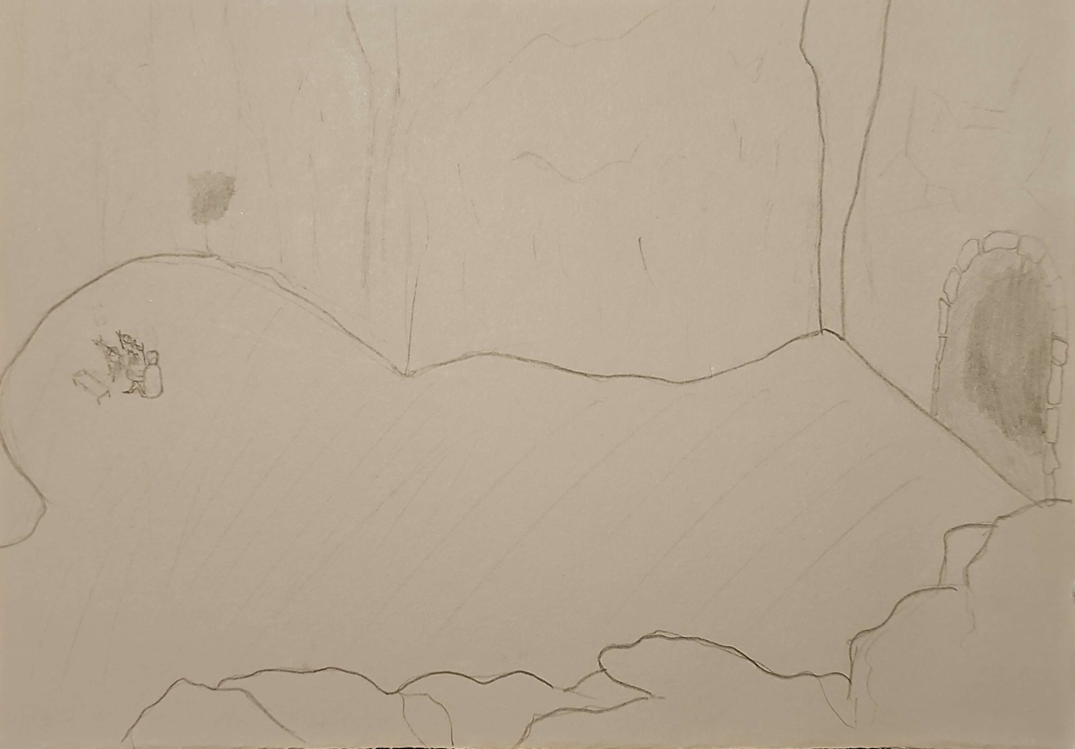

Scene 1:
Wide shot: Rest Area
Location: 35th dungeon floor
Description:
Wide shot, rocky rest area. Danny (adventurer) is crouched by a campfire, tending to a pot of boiling black eggs and roasting an orc-leg.

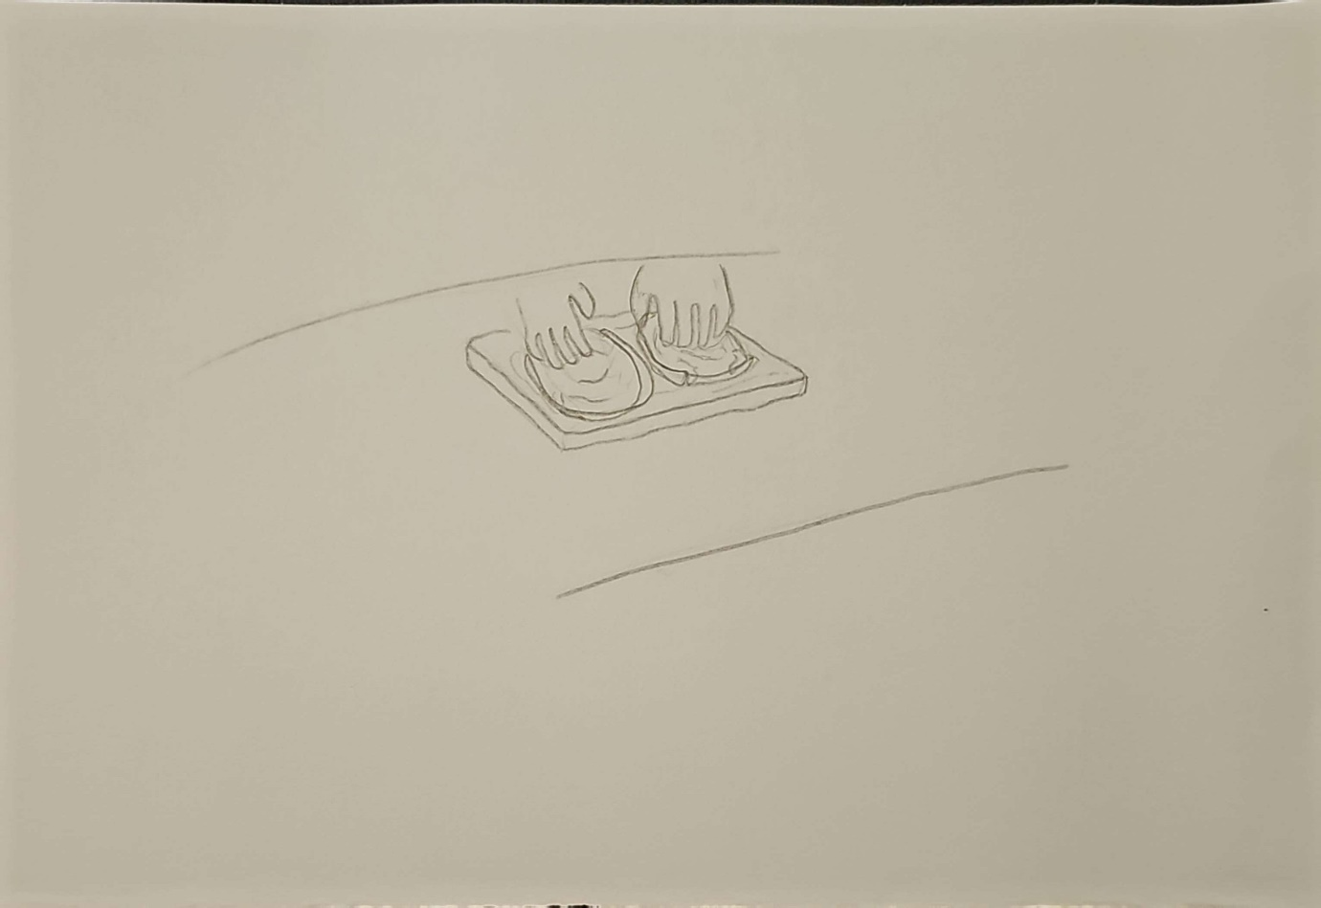

Scene 2:
Close-up shot:
Location: 35th dungeon floor
Description:
Close-up shot of Dannys hands. He is carefully placing slices of the strange orc meat onto a piece of bread.
Notes:
The meat is greasy and well marbled.

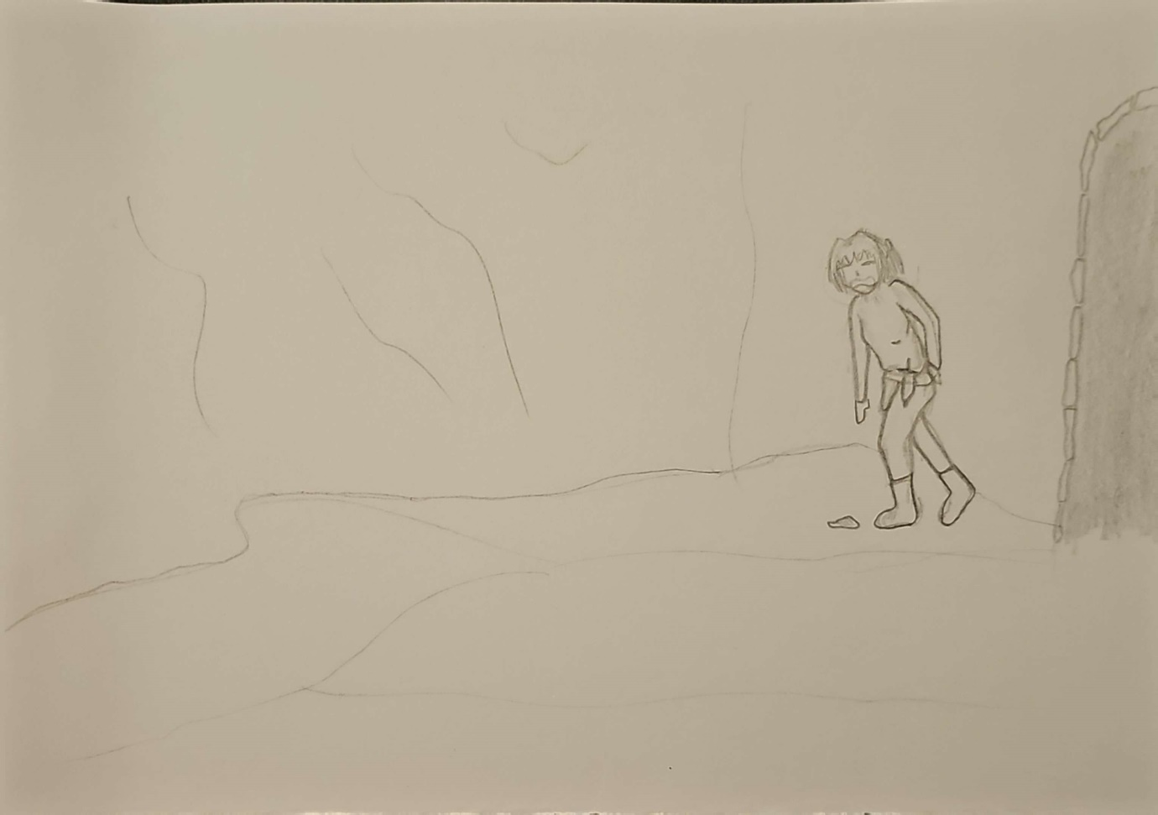

Scene 3:
Medium shot:
Location: 35th dungeon floor
Description:
Jess (adventurer) stumbles into frame from the dark dungeon entrance. She is hunched iver, dragging her feet, completely exhausted.
Notes:
Jess is holding her back

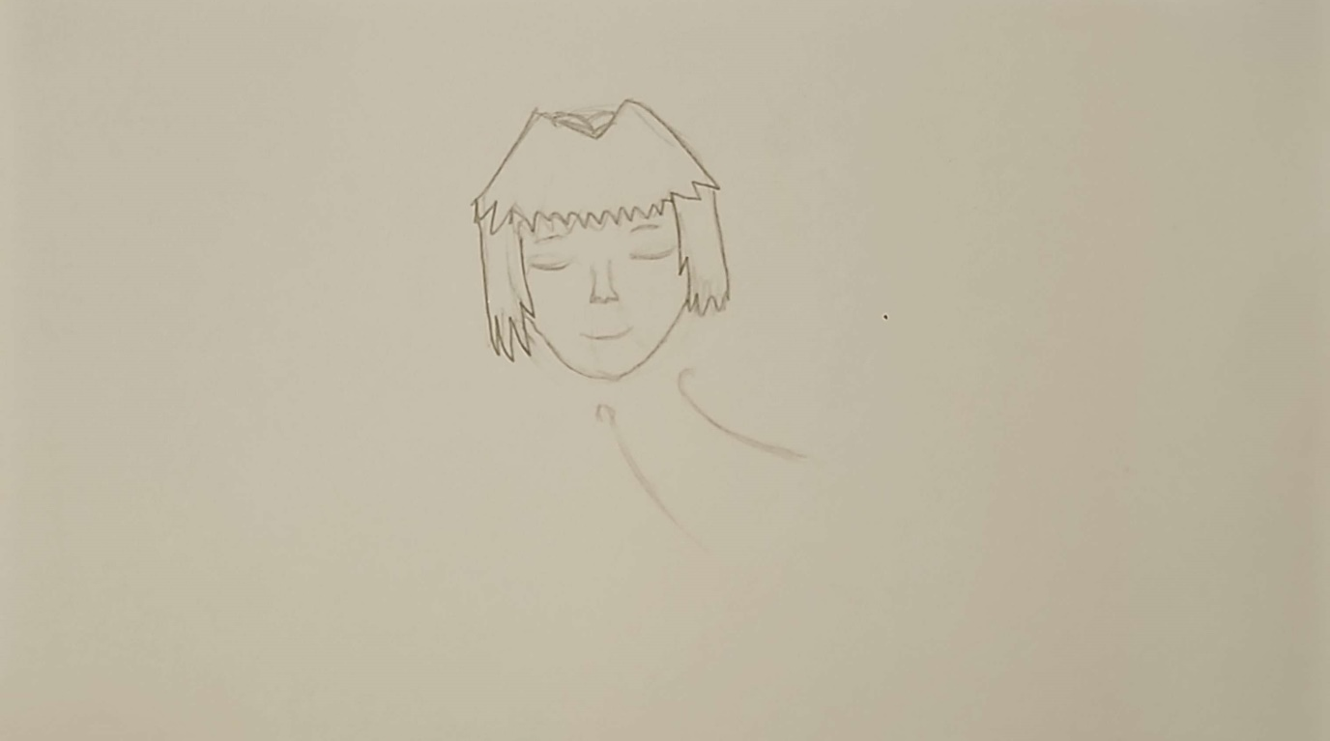

Scene 4:
Close-up shot:
Location: 35th dungeon floor
Description:
Close-up shot of Jess’s face. Her eyes are closed. She is taking a deep sniff through her nose. A look of sudden hope on her face.

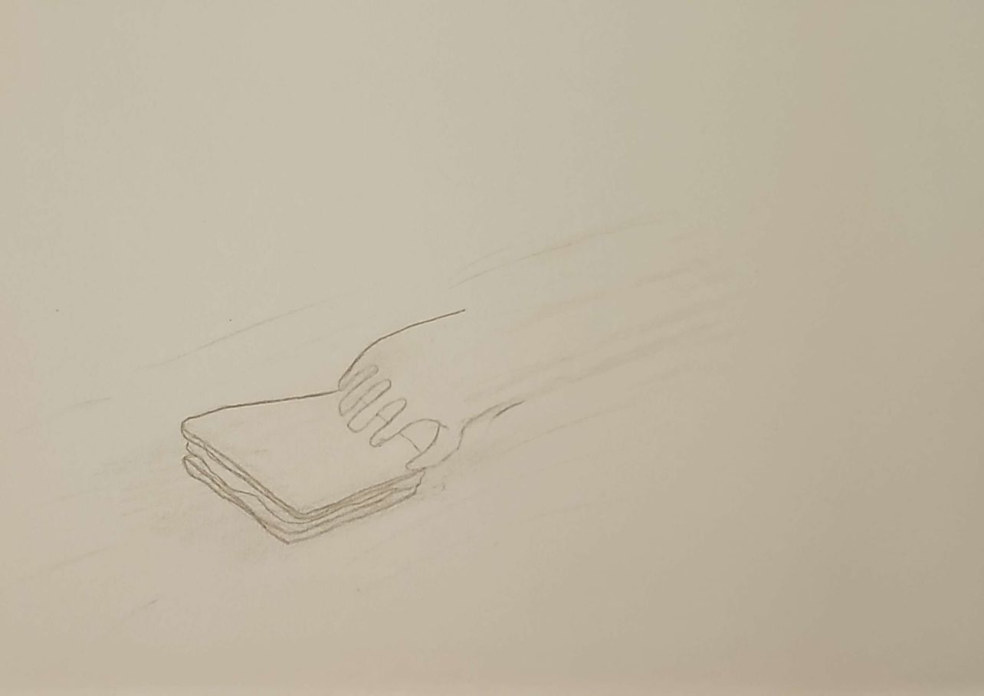

Scene 5:
Close-up shot:
Location: 35th dungeon floor
Description:
This shot is a blur of motion. Jess’s hand swoops into frame and grabs a finished sandwich.

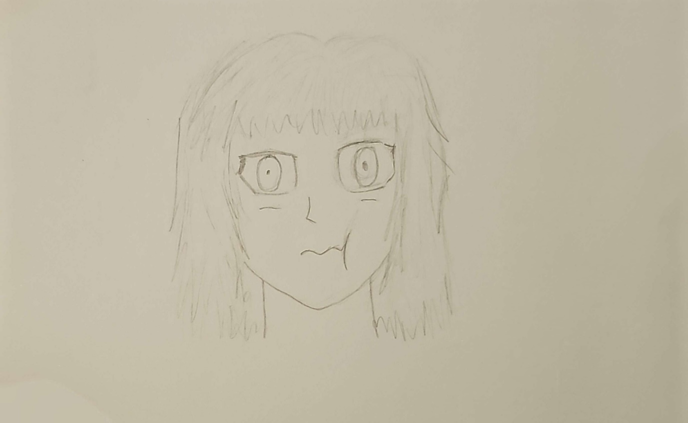

Scene 6:
Close-up shot:
Location: 35th dungeon floor
Description:
Close-up shot on Jess’s face. Her eyes wide in horror, her face frozen mid chew.
Notes:
Her face has a slight green tint.

