**The Exercise of Intelligent Control Technology**

**Exercise**

Given 3 classes of tasks $T_{1}, T_{2}, T_{3}$ and 2 classes of machines $M_{1}, M_{2}$. Now 5 $T_{1}, {3T}_{2}$ and $2T_{3}$ are scheduled on 1 $M_{1 }$ and 2 $M_{2}$. A machine only tackles a task at a time. The time taken by different machines for different tasks is showed as follows.

The problem is to minimize the makespan such that 10 tasks are completed.

|  |  |  |  |
| --- | --- | --- | --- |
|  | $$T_{1}$$ | $$T_{2}$$ | $$T_{3}$$ |
| $$M_{1}$$ | 10 | 12 | 18 |
| $$M_{2}$$ | 15 | 8 | 20 |

**Solution**

Suppose that $T_{1}, T_{2}, T_{3}$ are arranged in $1M_{1}$ and $2M_{2}$ in following quantities:

|  |  |  |  |
| --- | --- | --- | --- |
|  | $$T_{1}$$ | $$T_{2}$$ | $$T_{3}$$ |
| $$M_{1}$$ | $$x_{1}$$ | $$x_{2}$$ | $$x_{3}$$ |
| $$M_{2}$$ | $$x_{4}$$ | $$x_{5}$$ | $$x_{6}$$ |

Since $2M_{2}$ can work at the same time, the model is established as follows:

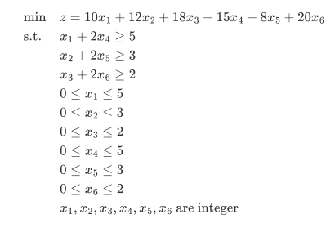

From the question, we can know that this is a integer programming model, so the solution is achieved through Python’s cplex module. See the appendix code for details. The solution is as follows:

|  |  |  |  |
| --- | --- | --- | --- |
|  | $$T_{1}$$ | $$T_{2}$$ | $$T_{3}$$ |
| $$M_{1}$$ | 1 | 0 | 0 |
| $$M_{2}$$ | 2 | 2 | 1 |

Since $2M_{2}$ work at the same time, a $M_{2}$ completes $2T_{2}$ in the result, that it can finally complete $4T_{2}$, which is greater than $3T_{2}$ required by its task. Therefore, after a $M_{2}$ completes $2T_{2}$, another one can only complete $1T_{2}$, and then immediately start $T_{3}$, so the total makespan is reduced by 8 makespan, and the final result is:

$$\min{z}=1×10+15×2+8×2+20×1-8=68$$

So the minimum makespan such that 10 tasks are completed is 68.

**Appendix**

|  |
| --- |
| from docplex.mp.model import Model  # initialize model  cp = Model()  # initialize variables  x1 = cp.integer_var(ub=5, name="x1")  x2 = cp.integer_var(ub=3, name="x2")  x3 = cp.integer_var(ub=2, name="x3")  x4 = cp.integer_var(ub=5, name="x4")  x5 = cp.integer_var(ub=3, name="x5")  x6 = cp.integer_var(ub=2, name="x6")  # defind minimize object function  cp.minimize(10 * x1 + 12 * x2 + 18 * x3 + 15 * x4 + 8 * x5 + 20 * x6)  # defind constraints  cp.add_constraint(x1 + x2 + x3 + 2 * (x4 + x5 + x6) >= 10)  cp.add_constraint(x1 + 2 * x4 >= 5)  cp.add_constraint(x2 + 2 * x5 >= 3)  cp.add_constraint(x3 + 2 * x6 >= 2)  # solve the problem  solution = cp.solve()  # print result  if solution:  print(solution)  else:  print("fail") |