**Economic Policies and Crime Dynamics: Assessing the Impact of Minimum Wage on Crime Rates in the United States**

**Abstract**

Recent studies show mixed results about how changing the minimum wage affects crime. Many studies indicate that higher wages might lower crime rates. For example, the Brennan Center for Justice suggests that increasing income is important for reducing crime(Eisen et al. 2015). Also, empirical research and city-level data support the idea that higher wages can help prevent crime and reduce overall crime rates(Fone et al., 2019). However, contrasting this view, a 2023 Brookings article highlights that a 1% increase in minimum wage might lead to a small increase in property crime arrests among young adults(Fone et al., 2023). This project aims to shed more light on this topic by merging state-level minimum wage data with crime rate statistics, offering insights into the impact of state economic policies on criminal activities through quantitative analysis.

**Introduction**

This project aims to explore two related hypotheses regarding the impact of state-level minimum wage on crime rates: 1) Lower state’s average minimum wages are associated with higher state’s average rates of violent and property crimes, particularly focusing on murder and rubbery for violent crimes analysis. 2) An annual increase in the state minimum wage leads to a corresponding decrease in violent and property crime rates over time.

The primary dataset for this study has been prepared by merging two pre-cleaned datasets from Kaggle: Minimum Wage Data(minimum wage information across 45 states from 2007-2014) and Crime Data(Detailed crime count statistics by 45 states from 2007-2014, including violent crimes and property crimes, with specific counts for murder, robbery, burglary, larceny and vehicle theft). Initially, data for all states were considered. However, after addressing missing data and resolving mismatches between 'State' and 'Year' of two datasets, the analysis was narrowed down to 45 states during 8 years. Importantly, the crime rate data utilized in our analysis represents these crime counts normalized per 100,000 inhabitants, providing a more accurate reflection of the crime landscape across different states with varying population sizes.

**Methodology**

* Data Preparation:

The two pre-cleaned datasets have been merged based on combination of 'State' and 'Year' as unique column to align minimum wage and crime rate data for each state across continuous years.

* Statistical Analysis with visualization:

1. Descriptive statistics to summarize the data.

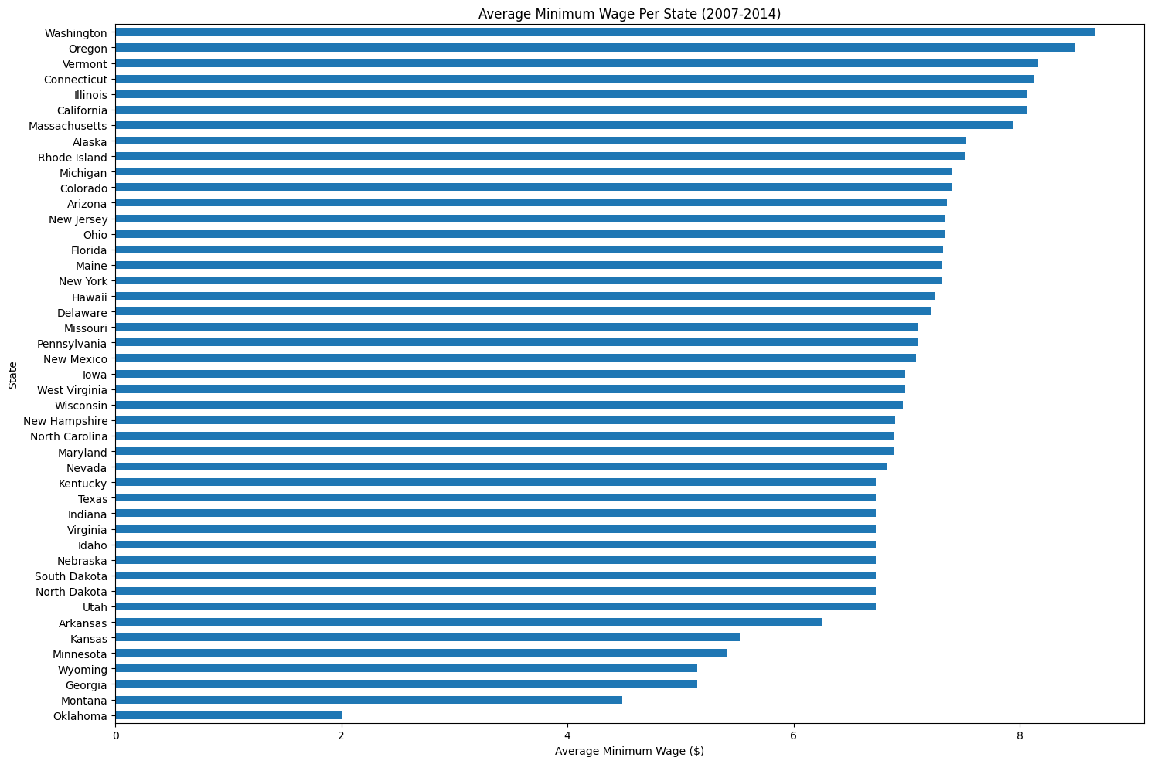

The bar chart displays the state-by-state average minimum wage from 2007 to 2014, ranking states from the highest to the lowest wages. Washington has the highest average, above $8, and Oklahoma the lowest, around $2. Most states(73%) fall between $6 and $8, showing diverse wage policies across the U.S.

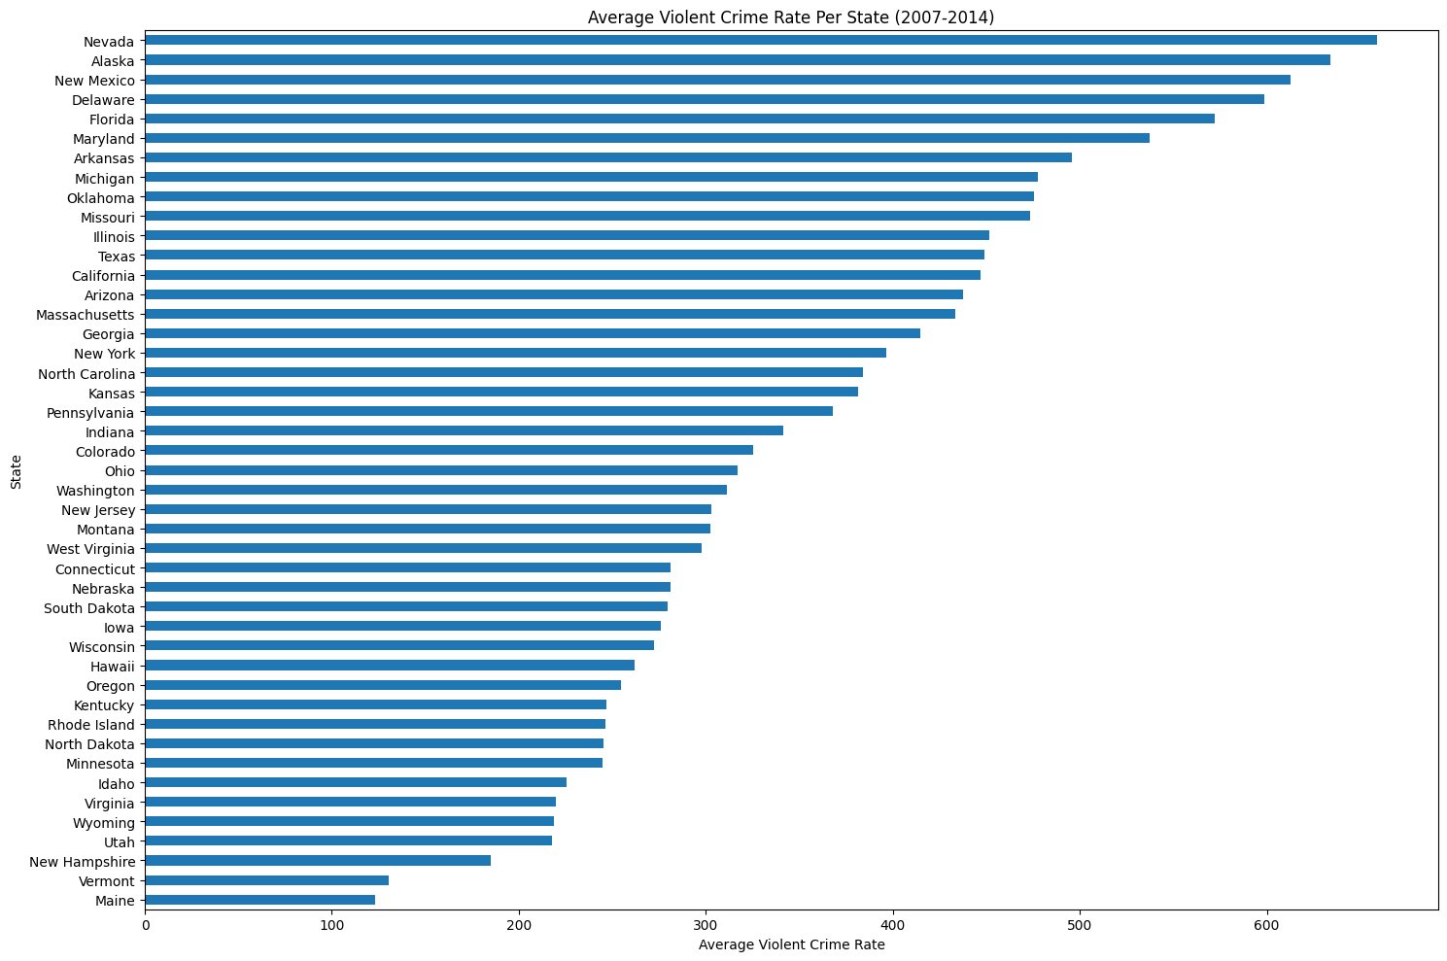

The bar chart displays the average violent crime rate per state from 2007 to 2014, Nevada, Alaska, and New Mexico are at the top of the chart, indicating they have the highest average violent crime rates(>600) among the states shown. States like Maine, Vermont, and New Hampshire have the shortest bars(<200), suggesting they have the lowest average violent crime rates.

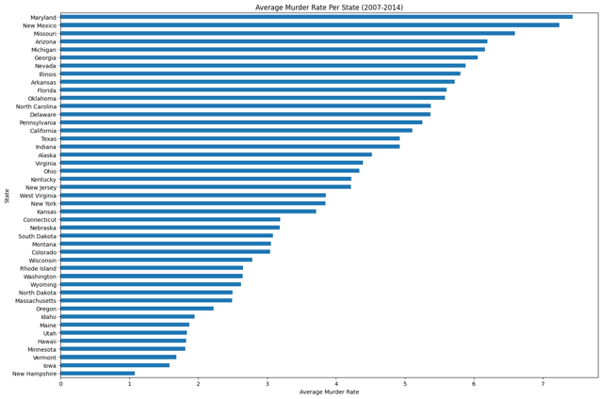 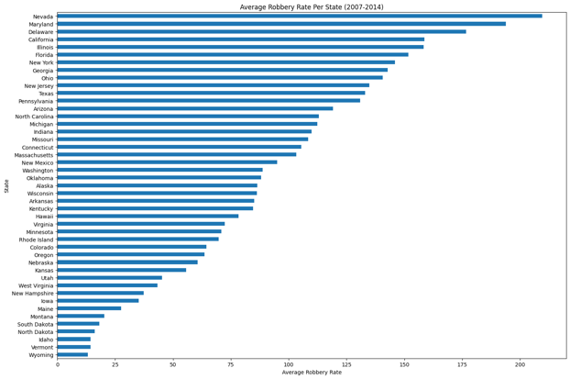

The two bar charts display the average murder rate and robbery rate per state from 2007 to 2014, individually. Maryland has the highest average murder rate over 7, followed by New Mexico and Missouri. New Hampshire has the lowest average murder rate around 1, with other states like Vermont, Iowa, and Minnesota also having relatively low rates. Nevada tops the chart with the highest average robbery rate around 215, followed closely by Maryland and Delaware. States like Wyoming, Vermont, and Idaho have the lowest average robbery rates around 15, indicated by the shortest bars.

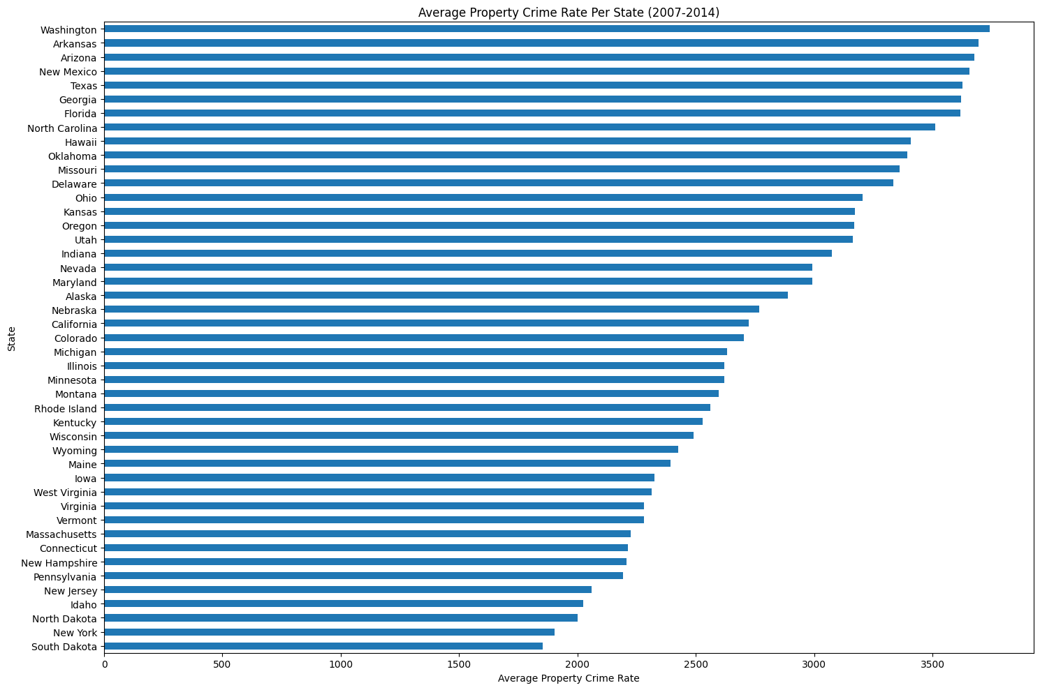

The bar chart depicts the average property crime rate per state from 2007 to 2014. Washington state has the highest average property crime rate around 3750. On the lower end, states like South Dakota, New York and North Dakota has lower average property crime rates under 2000.

1. Correlation analysis to explore the relationship between the average minimum wage and various crime rates across states:

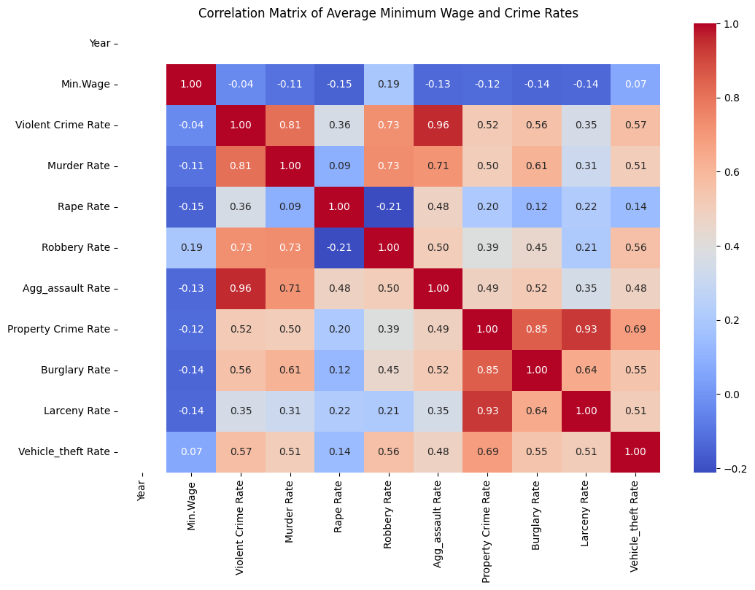

The correlations between average minimum wage and various crime rates are generally weak. The most notable correlation is a weak negative relationship between the minimum wage and certain types of crime rates (rape, burglary, larceny, etc.) around -0.15, suggesting that higher average minimum wages might be associated with slightly lower rates of these crimes. The correlation with the robbery rate is slightly positive but still very weak with 0.19, indicating that an increase in minimum wage might be associated with a minor increase in robbery rates.

1. Trend analysis to examine whether increases in state’s average minimum wage over 8 years are followed by increases or decreases in average crime rates.

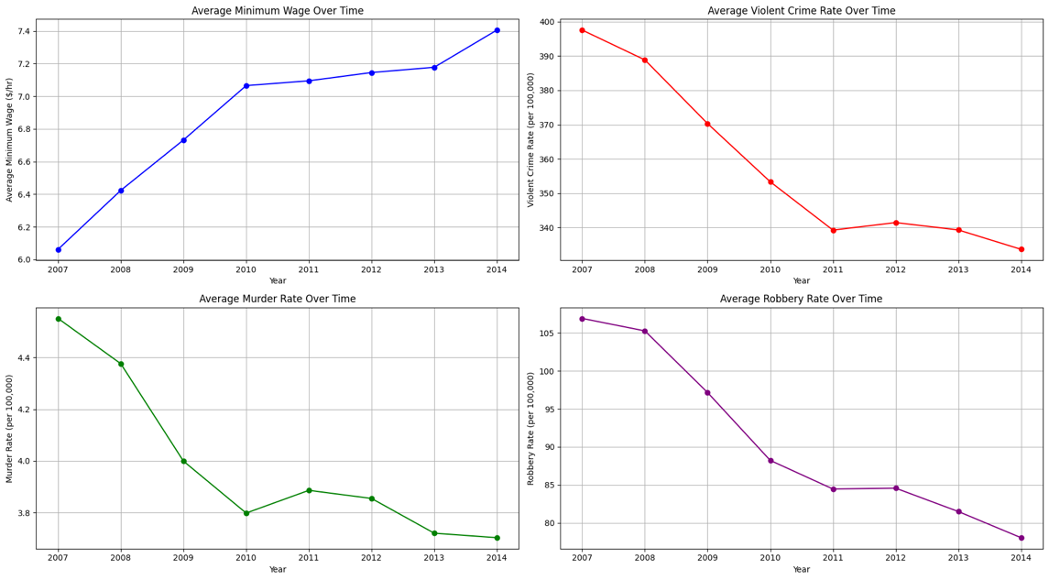

Minimum wage has consistently risen over the years, albeit at a slowing pace after 2010. Violent crime rates have decreased significantly, particularly from 2007 to 2010, with a more stable but still declining trend thereafter. Murder rates saw a sharp decline initially and then stabilized from 2010 onwards. Robbery rates also decreased over the years.

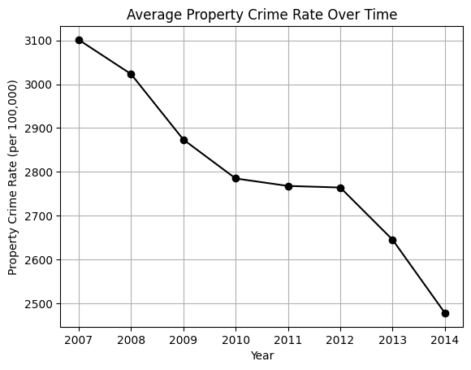

The property crime rate, like the other crime rates, also shows a significant downward trend, reinforcing the suggestion that better economic conditions may correlate with lower crime rates.

All these trends can provide insights about a possible improvement in economic conditions or effective crime prevention strategies.

1. Geographic analysis to study if certain regions have consistently higher crime rates or minimum wages.

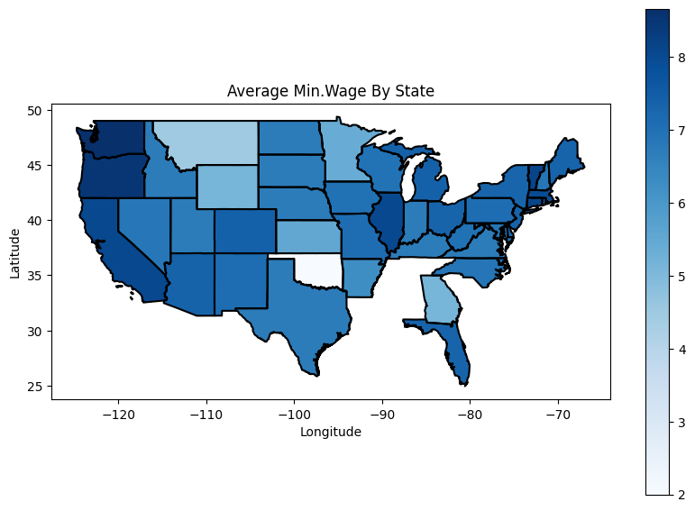

The minimum wage map showed a range of wages across states, with higher wages generally seen in the Northeast and West Coast states, and lower wages in the South and Midwest. Coastal states, especially in the Northeast and along the Pacific, appeared to have higher minimum wages, potentially reflecting higher living costs and more progressive labor policies in those areas.

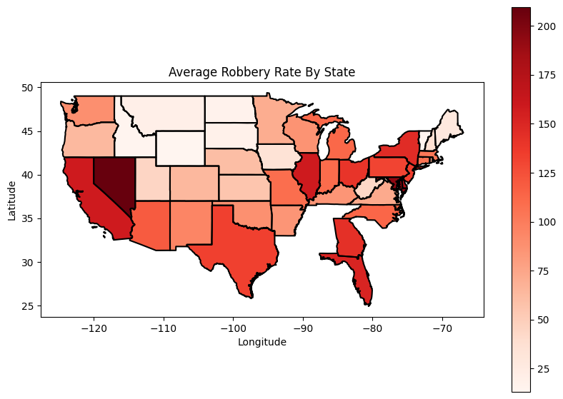

The robbery rate map illustrated varying rates of robbery across states, with higher rates noticeable in some states like Nevada and California, and lower rates in many central and Mountain states. There was no clear uniform regional pattern for robbery rates, suggesting that factors influencing robbery rates might be more complex and localized.

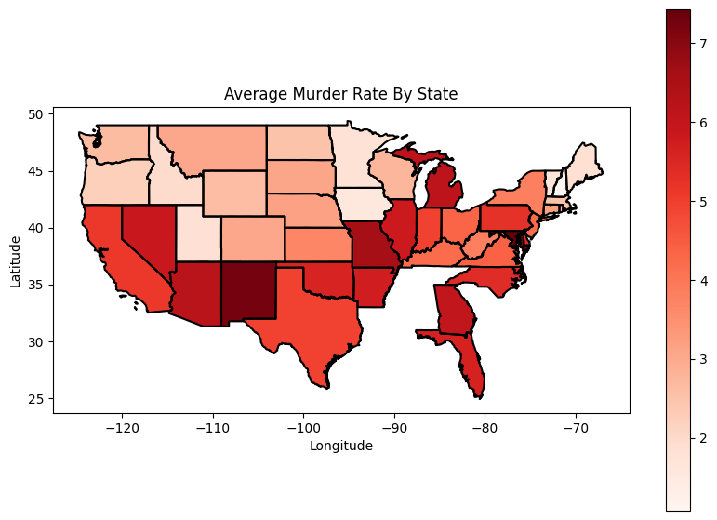

The murder rate map suggests regional disparities in murder rates across the United States, with the South and Southwest exhibiting consistently higher rates. States in the Mountain West generally show lower murder rates.

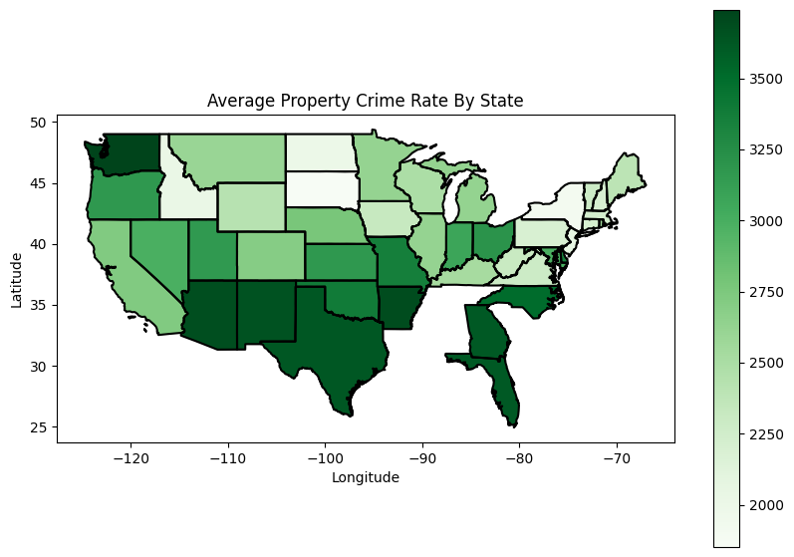

The property crime rate map illustrated varying rates of property crime across states. Regional disparities are evident, with certain regions like parts of the West and some Southern states showing higher average property crime rates. The Midwest and North seems to have a consistently lower range of property crime rates. There is not a single region that stands out as having uniformly high or low property crime rates, suggesting that within-region variations are significant.

Through comparison analysis for these maps, some of these maps exhibit regional variations. But there is no clear pattern that suggests higher minimum wages correspond to higher or lower crime rates across regions. For instance, some states with higher minimum wages have moderate robbery rates, and vice versa.

**Analysis Results**

Based on the exploration of the relationship between state-level minimum wages and crime rates, the findings suggest a complex and nuanced interaction. While there is a weak negative correlation between average minimum wages and certain types of crime rates (e.g., rape, burglary, larceny), indicating that higher minimum wages might be associated with marginally lower incidences of these crimes, the relationship is not strong. Interestingly, the correlation with robbery rates is slightly positive, albeit weak, suggesting a minor potential increase in robbery rates with rising minimum wages. Over time, as minimum wages have generally increased, violent crime rates including murder and robbery, and property crime rates have shown a significant decrease, particularly between 2007 and 2010, with a more stable but still declining trend thereafter. This trend indicates a potential positive impact of rising minimum wages on reducing violent and property crime rates. However, regional variations observed through comparison analysis do not present a clear, consistent pattern that aligns higher minimum wages with either higher or lower crime rates across different states. This indicates that while there might be a relationship between state minimum wages and crime rates, it is influenced by a variety of other factors, making it difficult to draw a direct causal link.

**Summary**

The analysis of the data indicates a tentative association between state-level minimum wages and crime statistics. However, this relationship appears to be modulated by a multitude of contributing factors, which obscures the establishment of a direct causative connection. This research underscores the imperative for more comprehensive investigations, incorporating a broader spectrum of socio-economic determinants, to elucidate the intricate dynamics governing this association. Such an in-depth understanding is crucial for informing policy decisions aimed at effectively leveraging economic measures to mitigate crime rates.

**Reference**

Fone, Z. S., Sabia, J. J., &amp; Cesur, R. (2023). The unintended effects of minimum wage increases on crime. Journal of Public Economics, 219, 104780. <https://doi.org/10.1016/j.jpubeco.2022.104780>

Fone, Z., Sabia, J., & Cesur, R. (2019). *Do Minimum Wage Increases Reduce Crime?* <https://doi.org/10.3386/w25647>

Eisen, L.-B., Roeder, O., &amp; Bowling, J. (2015, February 12). What caused the crime decline?. Brennan Center for Justice. <https://www.brennancenter.org/our-work/research-reports/what-caused-crime-decline>

Data Source:

<https://www.kaggle.com/datasets/lislejoem/us-minimum-wage-by-state-from-1968-to-2017>

<https://www.kaggle.com/datasets/christophercorrea/prisoners-and-crime-in-united-states?select=ucr_by_state.csv>