Group Project Report - Project Plan

CS3343

Group 13



Group Members:

|  |  |  |
| --- | --- | --- |
| Full Name | SID | Role |
| Luka Moderc | 55594415 | Project Manager |
| Andela Basic | 55594403 | Assistant Project Manager |
| Uros Cvijanovic | 55304127 | Testing Engineer |
| Phudis Dawieang | 55411086 | Programmer |
| Balaji Varun Aditya | 55304510 | Programmer |
| Jeffers Chan | 55606049 | Testing Engineer |

# Project Plan

### Project Team Organization

|  |  |  |
| --- | --- | --- |
| Name | Title | Job Description |
| Luka | Project Manager | Management, Development, Documentation |
| Andela | Assistant Project Manager | Management, Development,Design |
| Uros | Testing Engineer | Testing, Documentation |
| Phudis | Programmer | Coding, Testing, Documentation |
| Varun | Programmer | Coding, Documentation |
| Jeffers | Testing Engineer | Testing, Documentation |

### Software Development Methodology

After an extensive examination of our team members, project requirements and objectives, our team decided to use Rapid Application Development as a project management strategy. Originally, RAD project management strategy consists of four phases - requirements planning, user design, construction and cutover.

The short description of each phase is provided below.

1. Requirements planning - defining and researching project requirements; this stage involves communication between developers and clients to finalize the objectives of the project
2. User Design - Each version of Software is tested by the clients and problems (if exist) are fixed with every next version
3. Construction - Converts the prototype from the previous phase into working model
4. Cutover - Testing and Code refactoring, Launch, User Training

As our project requires more detailed testing phase than suggested by the original RAD methodology, we decided to modify it by extract Testing and Code Refacoring from the Cutover Phase.

### 

### Figure 1

### Work Breakdown Structure

### 

Regarding the WBS, we combined the deliverable-based WBS (focusing on the product) and phase-based WBS (focusing on the work).

1. Topic Discussion

1.1. Topic Selection

1.2. Research

2. User Interface Prototype Design

3. Development

3.1. Cycle 1

3.1.1. Requirement Capture

3.1.1.1. Problem Scope Definition

3.1.1.2. Identify Requirements

3.1.1.3. Create Preliminary Version of Use Case Diagrams

3.1.1.4. Create Project Plan

3.1.2 Setting Up

3.1.2.1. Install the IDEs

3.1.3.2. Install the required packages and dependencies

3.1.3 First Version of Software

3.1.3.1. First version of Class DIagram

3.1.3.2. First Version of Code

3.1.3.2.1. Stable Matching Algorithm

3.1.2.3. FIrst Version Testing

3.1.2.4. Version 1 Summary

3.2. Cycle 2

3.2.1. Code Refactoring

3.2.1.1. Code Refactoring on Version 1

3.2.1.2. Testing after Code Refactoring

3.2.2. Feedback

3.2.2.1. Collect Feedback

3.2.2.2, Debug and release documentation

3.3. Cycle 3

3.3.1. Second Version of Software

3.3.1.1. Second Version of Class Diagram

3.3.1.2. Second Version of the Code

3.1.2.1. Floyd Warshall Algorithm

3.1.2.2. Stable Matching Algorithm

3.3.1.3. Second Version Testing

3.3.1.4. Version 2 Summary

4. Testing Second Version

4.1. Defining Testing Approach

4.2. Unit Testing

4.3. Integration Testing

4.4. System Testing

4.5. Feedback from the Users

5. Documentation

5.1. Final Version of Use Case Diagrams

5.2. Final Version of Class Diagram

5.4. Bug Report

5.5. Final Report

### Tools

1. Development Tools

1.1. Eclipse IDE 2019-09 (4.13)

2. Development Platform

2.2. Windows 10 with Java Development Kit 13 (13.0.1)

3. Test Cases

3.1. Junit 5

4. Coverage Checking

4.1. Junit 5

5. Documentation

5.1. Visual Paradigm 12.0 for use case diagrams, class diagrams and sequence diagrams

5.2. Bugzilla for recording bugs

5.3. Microsoft Word for report

7. Project Management

a. TeamGantt for scheduling (Gantt Diagram) and Teambition for workload management

b. GitHub for general team collaboration and version control

c. Google Drive for general file sharing

8. Presentation

a. Microsoft PowerPoint

b. Proto.io for app prototyping

### Project Schedule

As stated in the previous section, the tools used for Project Management are Teambition - for workload management and tasks assignment and TeamGantt for progress tracking. Refer to the Figure 2 below for the screenshot of the Gantt’s Diagram.

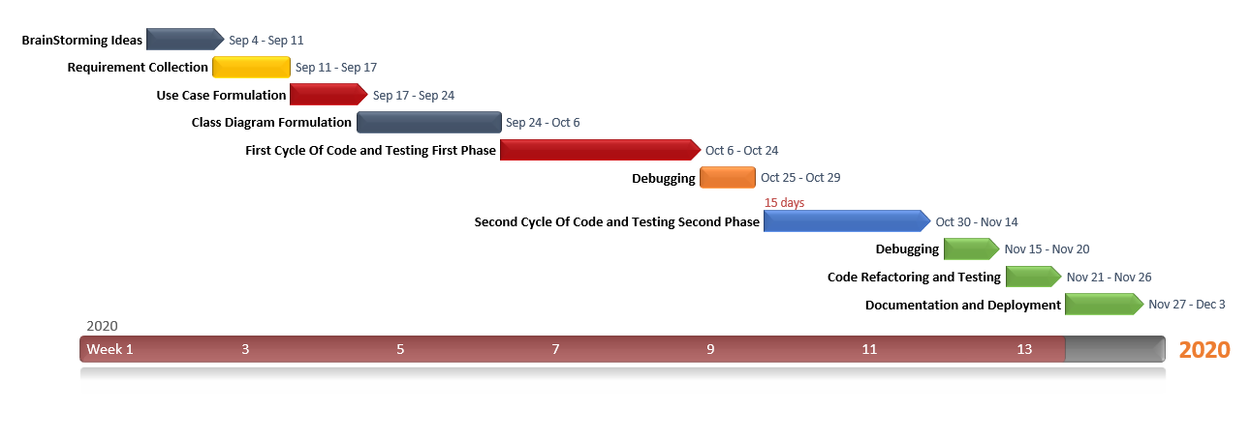

### Activity Network Diagram

The Activity Network Diagram is displayed in the figure below. As shown in the figure, the total duration of the project was estimated to be 82 days, and the project is scheduled to be completed on 3rd December.

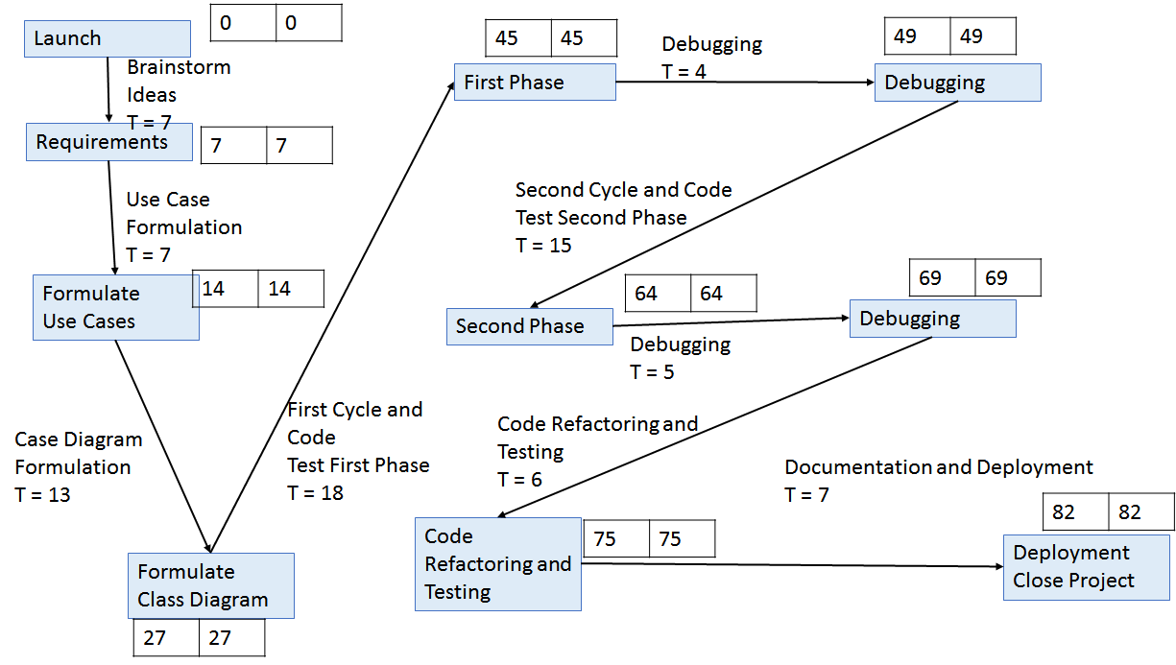

Figure 3

### 

### 

### Future Plan

Throughout the project development, we faced two major difficulties. The first refers to the User Interface Design, and the second refers to the score calculation precision. The detailed analysis of such difficulties is provided in the next section, “Analysis and Design - Design Constraints”.

Thus, our two major objectives for the future planning are:

1. Enhancing User Interface (better design, increased interactivity and responsiveness)
2. Enhancing the score calculation precision i.e. improving the type, format (possibly changing the domain and codomain) of the function used for score calculation in Stable Matching Algorithm