ZD 9  
1)  
a 15PLN w Euro  
b Manchester United

C Nelson Mandela

2)

a Rafal Jaworski site:wmi.amu.edu.pl

b related:amu.edu.pl

3)

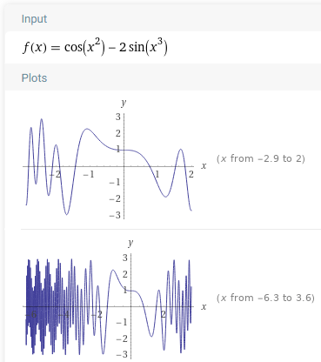a

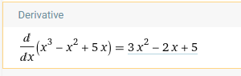b

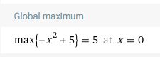

C

4)

a 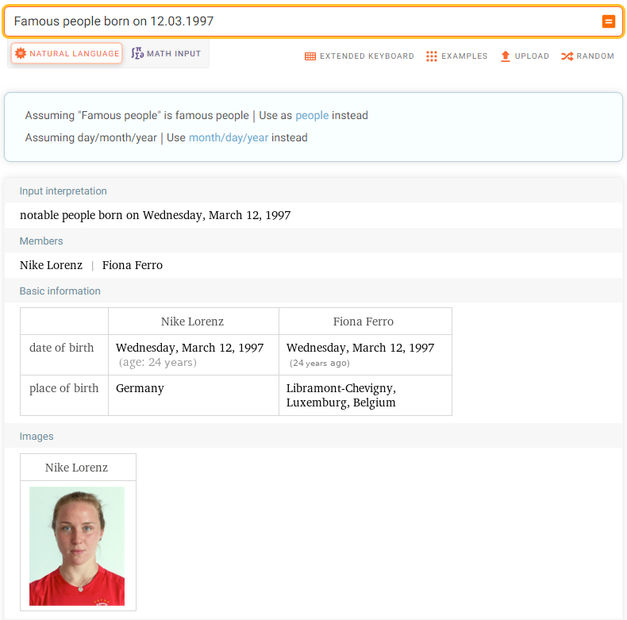

b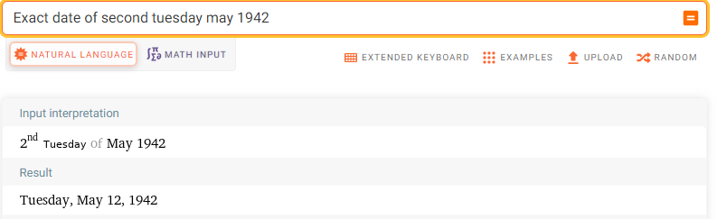

c 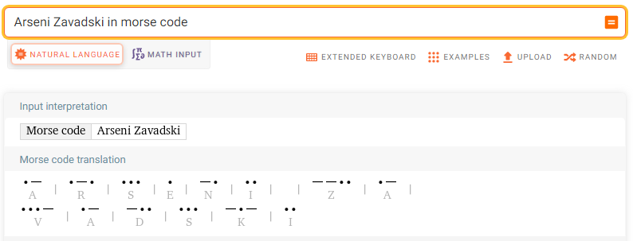

5 https://docs.google.com/document/d/1A5TUY06xf4b5D3QbAYtlbLsRbzKtVuhMWwdGUtB9ujQ/edit?usp=sharing