GENAI MUSIC RENDITION: A FRAMEWORK FOR CONTROLLABLE INDIAN ART MUSIC MELODY AND SINGER – STYLE GENERATION
A PROJECT REPORT
Submitted by
Mirsha A K | 2022510044
Piruthviraj V S | 2022510012
Divyabharathi S  Dipakumar M | 2022510063  2022510061

Under the supervision of

Dr. R. Geetha Ramani

In partial fulfillment for the award of the degree
of
BACHELOR OF TECHNOLOGY
in
ARTIFICIAL INTELLIGENCE AND DATA SCIENCE

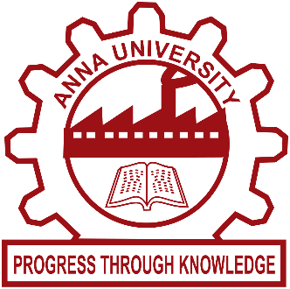
DEPARTMENT OF INFORMATION TECHNOLOGY
MADRAS INSTITUTE OF TECHNOLOGY CAMPUS
ANNA UNIVERSITY, CHENNAI – 600044
APRIL 2026

ANNA UNIVERSITY: CHENNAI 600 025
BONAFIDE CERTIFICATE

Certified that this project report titled “GENAI MUSIC RENDITION: A FRAMEWORK FOR CONTROLLABLE INDIAN ART MUSIC MELODY AND SINGER – STYLE GENERATION” is the bonafide work of Mirsha A K (2022510044), Piruthviraj V S (2022510012), Divyabharathi S (2022510063) and Dipakumar M (2022510061) who carried out the project work under my supervision.
Signature | Signature
Dr. Radha Senthilkumar | Dr. R. Geetha Ramani
HEAD OF THE DEPARTMENT | SUPERVISOR
Professor | Professor
Department of Information Technology | Department of Information Technology
MIT Campus, Anna University  Chennai – 600044 | MIT Campus, Anna University  Chennai – 600044

TABLE OF CONTENTS

Chapter No. | Title | Page No.
 | ABSTRACT | V
 | LIST OF FIGURES | VI
 | LIST OF TABLES | VII
1 | INTRODUCTION | 1
 | 1.1 About the Project | 1
 | 1.2 Organisation of the Report | 2
2 | LITERATURE SURVEY | 4
 | 2.1 Swara Extraction Methods | 4
 | 2.2 Raga Recognition and Prediction | 4
 | 2.3 Singer Voice Conversion Architectures | 5
 | 2.4 Swara Based Emotion Analysis and Transformation | 6
3 | SYSTEM DESIGN | 7
 | 3.1 Overall System Architecture | 7
 | 3.2 Swara Extraction | 8
 | 3.3 Raga Prediction | 9
 | 3.4 Singer Voice Conversion | 9
 | 3.5 Swara Based Emotion Analysis and Transformation | 10
 | 3.6 Dataset Overview | 11
4 | DETAILED SYSTEM DESIGN | 14
 | 4.1 Swara Extraction from vocal audio signals | 14
 | 4.2 Raga Prediction | 16
 | 4.3 Singer Voice Conversion | 18
 | 4.4 Swara Based Emotion Conversion | 20
 | 4.5 Training Pipeline | 21
5 | RESULTS AND DISCUSSION | 23
 | 5.1 System Requirements | 23
 | 5.2 Swara Extraction | 24
 | 5.3 Raga Prediction | 26
 | 5.4 Singer Voice Conversion | 27
 | 5.5 Swara Based Emotion Analysis and Transformation  5.6 Overall Results Analysis | 29  31
6 | CONCLUSION AND FUTURE WORK | 34
 | 6.1 Future Directions | 34
— | REFERENCES | 35

ABSTRACT
This project presents a comprehensive deep learning and signal processing framework for the computational analysis, controllable generation, and stylistic transformation of Indian Art Music. Overcoming the challenges of rigid grammatical constraints and delicate micro-pitch nuances (gamakas), the pipeline seamlessly integrates four distinct architectural modules.
First, the Swara Extraction module isolates continuous F0 pitch contours from raw polyphonic audio, intelligently mapping them to structured, discrete Carnatic notes. By incorporating theoretical frequency ratios and dynamic raga-specific constraints, it accurately preserves complex microtonal fluctuations while ensuring structural grammatical coherence. Second, the Raga Prediction module handles sequence logic by employing the FP-Growth algorithm for association rule mining. It utilizes Jaccard similarity on binary-encoded extraction features to discover frequent swara itemsets, enabling highly accurate next-note melodic recommendations and formal raga identification.
Third, a novel Timbre-Conditioned Diffusion Transformer (TC-DiT) is introduced for zero-shot Singer Voice Conversion. Through a parallel system—featuring a deep Res-UNet F0 Extractor and a self-supervised linguistic encoder—the model successfully disentangles semantic topologies from vocal identity. Finally, the Swara-Based Emotion Transformation module analyzes time-based acoustic histograms to detect baseline emotional logic via cosine-similarity raga mappings. By executing targeted, frame-by-frame swara replacements coupled with advanced spectral shaping, it seamlessly shifts the affective envelope of the song while preserving the original lyrics and temporal pacing.

LIST OF FIGURES

FIGURE.  NO. | TITLE | PAGE NO
3.1 | Overall System Architecture Diagram | 7
4.1 | Swara Extraction Architecture Diagram | 14
4.2 | Raga Prediction Architecture Diagram | 17
4.3 | Singer Voice Conversion Architecture Diagram | 18
4.4 | Swara based Emotion Conversion Architecture Diagram | 21
5.1 | Raga Quantization and Pitch Conversion | 25
5.2 | Swara Generation Results | 25
5.3 | Raga Prediction Performance | 26
5.4 | Timbre Manifold KNN Graph Projection (k=16) - 317-Dimensional Latent Space PCA | 29

LIST OF TABLES
TABLE NO. | TITLE | PAGE NO
5.1 | Evaluation Metrics for Swara Extraction | 24
5.2 | Global Performance Metrics for TC-DiT | 27
5.3 | Per-Category Identity Similarity (Cosine) | 27
5.4  5.5  5.6  5.7 | Quantitative And Qualitative Mechanism Comparison  Swara Note Pattern for the First 60 Seconds  Emotion Identification – Cosine Similarity  Unified Pipeline Performance Table | 28  30  30  31

CHAPTER 1
INTRODUCTION

Indian Art Music, encompassing rich classical traditions such as the Carnatic and Hindustani systems, is exclusively characterized by its strict adherence to raga (melodic grammatical frameworks), tala (rhythmic cycles), and highly intricate micro-pitch embellishments known as gamakas. Generated primarily through complex human vocal articulation, these musical structures encapsulate profound emotional depth and spatial detail. While generative Artificial Intelligence has become essential in fields such as computer vision and standard speech synthesis, generating and manipulating classical Indian music presents unique computational and algorithmic challenges. Unlike standard pop or electronic music, classical renditions are non-linear and deeply continuous; traditional processing techniques often strip away the required micro-pitch nuances, resulting in outputs that lose their fundamental raga identity.
1.1 ABOUT THE PROJECT
This project presents "GenAI Music Rendition," a novel framework using a unified pipeline designed for the advanced analysis, controllable generation, and stylistic transformation of Indian Art Music. The system is tailored to address pressing challenges in intelligent melody generation, emotion conservation, and precision vocal manipulation. By seamlessly integrating state-of-the-art Convolutional Neural Networks (CNNs), sequence-to-sequence Transformers, and Timbre-Conditioned Diffusion models (TC-DiT), the proposed solution overcomes the inherent limitations of rule-based and standard spectral-mapping techniques, specifically in handling complex real-world musical data marked by variability in pitch, tempo, and scale. Innovative approaches in multi-band preprocessing, semantic disentanglement, and N x N matrix-level feature alignment further enhance the framework's interpretability, scalability, and accuracy. This results in highly reliable, artifact-free performance, supporting robust deployment for digital cultural heritage preservation and next-generation musical production.
1.2 ORGANISATION OF THE REPORT
This project report is systematically organized into six chapters to provide a clear, logical progression of the research work undertaken:
Chapter 2: Literature Survey
This chapter reviews key publications and datasets, grouping related works by classical music generation methods, pitch recognition algorithms, and deep-learning voice conversion mechanisms. It provides a foundational context for selecting architectures capable of handling culturally constrained musical data and nuanced vocal timbres.
Chapter 3: System Design
The system design chapter describes the overarching architecture, custom datasets, and core modules developed for the GenAI Music Rendition framework. It outlines the integration of specialized neural networks tailored for Raga Recognition, Swara Generation, Emotion Conversion, and Timbre-Conditioned Singer Voice Conversion.
Chapter 4: Detailed System Design
This chapter presents precise implementation strategies for each module, including layer-specific algorithm selection, signal processing pipelines, model training schedules, and feature disentanglement. Individual module workflows, notably the explicit TC-DiT inference loop and N x N Alignment Matrix, are systematically detailed.
Chapter 5: Results and Discussion
Results and discussion focus on quantitative and qualitative outcomes for each domain and module, including extensive audio visualizations and evaluation benchmarks. Performance is analyzed using rigorous metrics like Pitch RMSE, Identity Cosine Similarity, and PESQ scoring to validate the framework's preservation of stylistic heritage.
Chapter 6: Conclusion and Future Work
The concluding chapter synthesizes key findings, highlights the project’s novel contributions to computational musicology, and suggests directions for future research. Potential enhancements, such as real-time streaming constraints and multi-instrumental classical synthesis, are outlined to guide subsequent investigations.

CHAPTER 2
LITERATURE SURVEY
2.1 SWARA EXTRACTION METHODS
The isolation and quantitative extraction of continuous melodic contours—or Swaras—form the foundational preprocessing step for Indian Classical Music analysis. Neural pitch-tracking algorithms and advanced audio preprocessing frameworks systematically denoise acoustic inputs and extract highly precise fundamental frequency (F0) annotations necessary for microtonal representation (Hebbar & Jagtap, 2022; Morrison et al., 2021). Deep learning methodologies, notably Long Recurrent Convolutional Networks (LRCN) and unified neural vocoder systems, are increasingly utilized to accurately detect and segment singing voices from complex accompanying instrumentation (Romero-Arenas et al., 2022; Huang et al., 2021). These dynamic feature extraction mechanisms ensure that sensitive pitch inflections and transient glides (gamakas) essential to interpreting Indian art music are preserved without the quantization errors prevalent in traditional signal processing techniques (Takahashi et al., 2021; Parekh et al., 2020).
2.2 RAGA PREDICTION
Association Rule Mining, introduced by Agrawal et al. (1993), is a fundamental data mining technique used to discover relationships between items in large datasets. It identifies frequently co-occurring patterns and generates rules that describe how the presence of certain items implies the presence of others. To improve efficiency, Han et al. (2000) proposed the FP-Growth algorithm, which eliminates the need for candidate generation and enables faster extraction of frequent itemsets. This technique has been widely applied in recommendation systems and pattern analysis, where it helps in predicting future outcomes based on past occurrences. In the context of music analysis, association rule mining can be effectively used to identify relationships between swaras and predict subsequent notes, making it a suitable approach for raga prediction and swara recommendation.
2.3 SINGER VOICE CONVERSION ARCHITECTURES
Singer Voice Conversion (SVC) relies heavily on disentangling linguistic phonetic content from source-specific timbre to achieve high-fidelity identity transfer. Generative Adversarial Networks (GANs) such as CycleGAN-VC, StarGANv2-VC, and SINGAN established robust baselines for non-parallel voice conversion by enforcing cycle-consistency and adversarial representation learning (Kaneko & Kameoka, 2018; Sisman et al., 2019; Li et al., 2021). Furthermore, advanced encoder-decoder frameworks leveraging Variational Autoencoders (VAEs) and Phonetic Posteriorgrams (PPGs) demonstrated significant improvements in separating identity footprints from semantic intent (Luo et al., 2020; Li et al., 2020). More recently, Diffusion Probabilistic Models like DiffSVC and unified synthesis systems such as NANSY++ have overshadowed earlier autoregressive techniques by dynamically modeling complex acoustic manifolds, yielding state-of-the-art naturalness and expressive articulation in unsupervised cross-domain SVC scenarios (Liu et al., 2021; Choi et al., 2023; Polyak et al., 2020).
2.4 SWARA-BASED EMOTION ANALYSIS AND TRANSFORMATION
The synthesis and structural alteration of music driven by thematic or emotional logic leverage state-of-the-art controllable generative modelling. Architectures built on normalizing flows, such as Glow, and heavily conditioned generative frameworks like Music ControlNet and Theme Transformer facilitate the direct temporal modification of musical characteristics conditioned on target emotional vectors (Kingma & Dhariwal, 2018; Wu et al., 2024; Shih et al., 2023). Within the broader context of computational musicology, extensive reviews confirm that deep learning controls applied to symbolic and acoustic-level transformations easily adapt to Swara-based logic, converting raw sequence data into emotionally resonant renditions (Zhang et al., 2024; Benetos et al., 2023). Finally, the rigorous assessment of these complex affective transformations relies heavily on robust objective evaluation metrics—such as neural MOSNet architectures and generalized neural speech synthesis evaluation frameworks—to quantitatively validate that the perceived emotional contour aligns seamlessly with the target synthesis (Lo et al., 2019; Tan et al., 2021).

CHAPTER 3
SYSTEM DESIGN

This chapter focuses on the architectural blueprint and methodological strategies employed to realize robust computational music analysis and generative audio synthesis across diverse melodic and vocal domains.

3.1 OVERALL SYSTEM ARCHITECTURE
The proposed system architecture is designed as a multi-module deep learning and signal processing pipeline that ingests raw vocal and instrumental audio signals. It processes them through a series of specialized neural network frameworks - swara extraction, raga prediction, singer voice conversion, and swara-based emotion analysis and transformation. The overall workflow emphasizes rigorous audio preprocessing, disentangled acoustic representation learning, and raga-specific musical optimization to unite traditional structural grammar with generative AI.
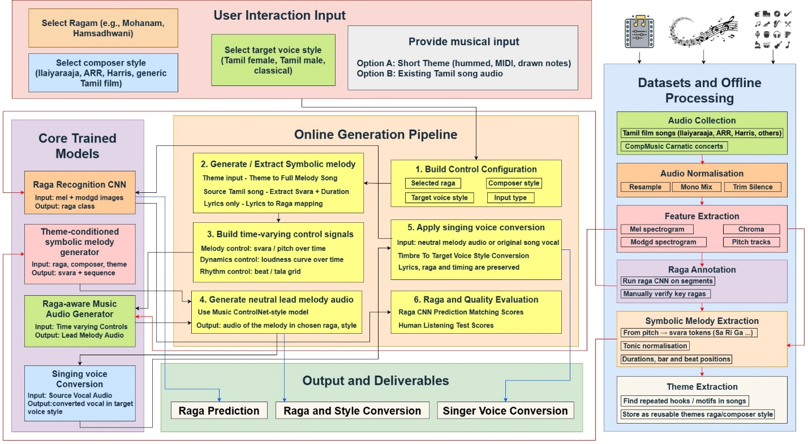
Fig 3.1: Overall System Architecture Diagram

The proposed framework comprises four specialized modules, each designed to address critical generative AI and computational musicology applications across diverse vocal and melodic domains. Below are succinct overviews for each module, highlighting their importance and the technical tasks performed.
3.2 SWARA EXTRACTION
This module targets swara extraction and raga-aware pitch analysis from monophonic or polyphonic vocal recordings in Carnatic music. The goal is to convert raw audio signals into a structured sequence of swaras (notes), enabling downstream tasks such as raga identification, raga conversion, and musicological analysis. Accurate swara extraction is critical for understanding melodic structure, gamaka variations, and tonal characteristics in complex musical compositions.
The proposed system processes audio using frame-level pitch estimation techniques to extract the fundamental frequency (F0) contour over time. This continuous pitch contour is then mapped to discrete swaras based on theoretical frequency ratios relative to the tonic (Sa). The mapping accounts for variations in pitch and ensures robustness against noise, vibrato, and microtonal fluctuations commonly present in Carnatic music. To improve accuracy and adaptability, the framework incorporates raga-specific swara constraints, where extracted notes are validated against permissible swaras of a given raga. This ensures that the output sequence adheres to the structural grammar of the raga, reducing classification ambiguity and enhancing musical coherence. Additionally, temporal smoothing and segmentation techniques are applied to stabilize swara transitions and eliminate spurious detections. The system supports data-driven swara sequence storage in structured formats (e.g., NumPy arrays), enabling efficient retrieval and further processing such as raga conversion or similarity analysis. Performance is evaluated using metrics such as swara classification accuracy, pitch deviation error, and sequence consistency, along with qualitative analysis through pitch contour visualization and swara transition patterns. Overall, this module provides a robust and scalable approach for bridging signal processing and computational musicology, enabling intelligent analysis and transformation of Carnatic music signals.
3.3 RAGA PREDICTION
This project presents a method for raga prediction using association rule mining and similarity-based techniques. The dataset consists of ragas and their corresponding swara features encoded in binary form. After preprocessing and mapping feature columns to swaras, the FP-Growth algorithm is applied to extract frequent itemsets and generate association rules. These rules are used to predict the next possible swaras for a given input. To identify the raga, Jaccard similarity is employed to compare the input swaras with known raga patterns, and the most similar ragas are ranked. The proposed system efficiently combines pattern discovery and similarity matching to provide accurate swara recommendations and reliable raga prediction.
3.4 SINGER VOICE CONVERSION
This module targets the seamless transformation of a source singer’s vocal timbre into that of a target identity while preserving the original linguistic semantics, melodic contour, and emotional nuance. The goal is to convert raw vocal audio signals into high-fidelity, identity-aligned renditions, enabling advanced downstream applications such as virtual song covers, heritage artist vocal recreation, and personalized music generation. Accurate singing voice conversion is critical for maintaining the complex microtonal fluctuations, rapid gamakas, and phonetic articulations inherent in highly expressive musical performances.
The proposed system processes audio through an end-to-end generative framework, starting with a custom multi-band U-Net isolator to cleanly separate pure vocals from background instrumentals. It then utilizes parallel disentangled representation extractors: a deep Res-UNet architecture for extracting precise, unquantized fundamental frequency (F0) pitch contours, and a self-supervised semantic transformer with stopped gradients for encoding high-dimensional linguistic topologies. These disentangled phonetic and prosodic features are iteratively reconstructed using a novel Timbre-Conditioned Diffusion Transformer (TC-DiT). A 317-dimensional target singer acoustic profile is injected dynamically at each diffusion timestep via Adaptive Layer Normalization (AdaLN), steering the network to synthesize audio purely in the target's timbre space. To guarantee flawless fidelity, an N × N feature correlation matrix is applied as a post-processing filter. Utilizing Singular Value Decomposition (SVD), it suppresses non-matching acoustic artifacts to output a crisp, artifact-free vocal track. Performance is evaluated using metrics such as subjective Mean Opinion Score (MOS), cosine similarity of extracted speaker embeddings, and mel-spectrogram reconstruction error. Overall, this module provides a highly robust, scalable approach that bridges diffusion-based generative AI with precision audio signal processing, enabling world-class vocal identity transformation.
3.5 SWARA-BASED EMOTION ANALYSIS AND TRANSFORMATION
The Swara-Based Emotion Analysis and Transformation module focuses on analyzing and modifying the emotional content of Tamil songs through their underlying melodic structure. The system processes the input audio by extracting pitch information and converting it into Carnatic swaras such as Sa, Ri, Ga, Ma, Pa, Da, and Ni. These swaras are used to generate a time-based note sequence and statistical representations like histograms to understand the musical pattern. The extracted swara profile is then compared with predefined raga-emotion mappings to identify the original emotion of the song. Emotion detection is performed using similarity measures such as cosine similarity between the input and reference raga patterns. Once the source emotion is identified, the system performs swara-level transformation to convert it into a target emotion. This is achieved by replacing each swara with its closest equivalent in the target raga on a frame-by-frame basis. Additional audio enhancements such as pitch smoothing, spectral shaping, and reverb are applied to improve perceptual quality.

3.6 DATASET OVERVIEW
The datasets utilized for this project span four interconnected domains of computational musicology and generative audio synthesis: swara extraction, raga prediction, singer voice conversion, and emotion transformation.​
Speech and Specialized Singing Corpora:
The framework integrates four specialized structural datasets to ensure robust representation disentanglement and high-clarity synthesis. First, the LibriTTS-R corpus provides artifact-free, restored audio indispensable for training the self-supervised linguistic transformer to extract pristine phoneme sequences. Second, the CSTR VCTK corpus, featuring 110 diverse speakers, establishes the gold standard for mapping broad accents and rich acoustic timbre embeddings. For complex vocal modeling, the OpenSinger dataset supplies a large-scale, professional-quality singing corpus critical for highly expressive vocoding and accurate generative rendering. Finally, the M4Singer dataset introduces multi-style vocal ranges (Soprano, Alto, Tenor, and Bass) from 20 professional singers. The sensitive topological annotations within M4Singer are vital for training the deep Res-UNet to accurately track continuous pitch boundaries, raga-style vibrato, and delicate micro-pitch nuances (gamakas). Collectively, these multi-domain datasets are rigorously partitioned into training, validation, and test subsets, guaranteeing exceptional model generalization when swapping acoustic identities onto unseen target vocalists.
Carnatic Music:
The dataset consists of Carnatic vocal recordings organized by raga, capturing essential melodic and tonal characteristics for swara extraction and analysis. Each sample includes raw audio, frame-level pitch (F0), and corresponding swara sequences, providing both continuous and discrete representations.Annotated swaras enable effective evaluation of tasks such as swara classification and raga conversion. The dataset includes variable-length recordings with variations in tempo, singer style, and ornamentation.Its diversity supports robust testing of models in handling pitch variations, noise, and musical complexity.
Raga Prediction Dataset:
The dataset contains information about different ragas and their swara features in binary format. Each row represents a raga, and each column indicates the presence (1) or absence (0) of a specific swara. The dataset consists of 934 records and 17 columns, including the raga name and feature columns (F1–F16).During preprocessing, unnecessary columns such as S and F1 are removed, and the remaining features are mapped to meaningful swaras like R1, R2, G1, M1, P, D1, and N1. The data is then converted into boolean format for applying association rule mining and raga prediction.

CHAPTER 4
DETAILED SYSTEM DESIGN

This chapter provides an in-depth explanation of the implementation for each specialized module within the system, covering the algorithms, training strategies, and data preprocessing techniques employed.

4.1 SWARA EXTRACTION FROM VOCAL AUDIO SIGNALS

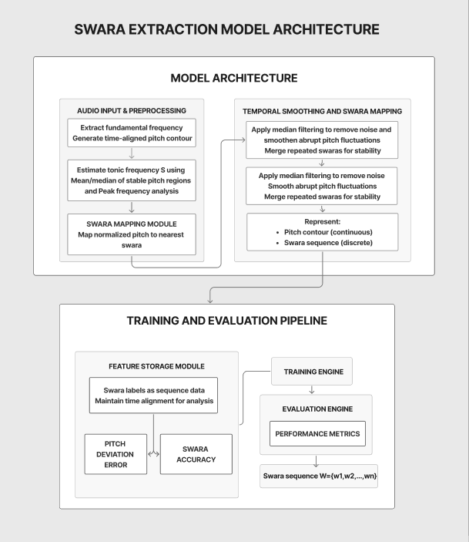

Fig 4.1: Swara Extraction Architecture Diagram

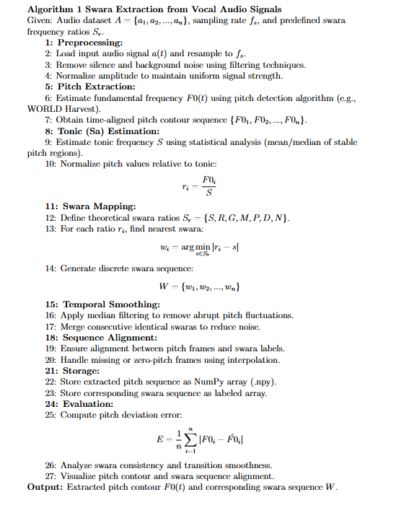

4.2 RAGA PREDICTION

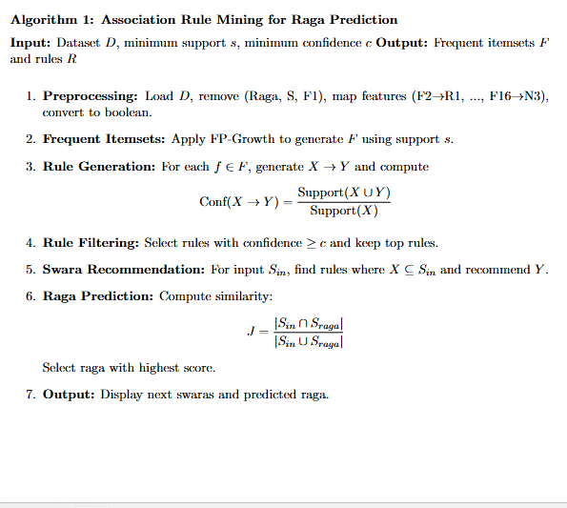

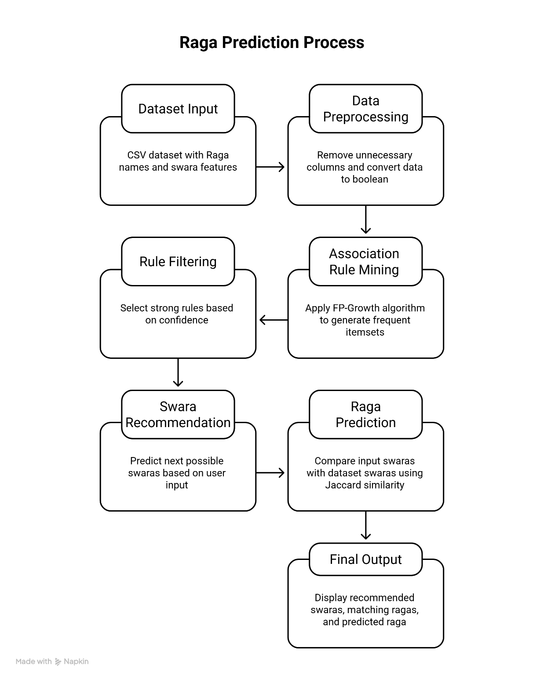

Fig 4.2: Architecture Diagram for Raga prediction

4.3 SINGER VOICE CONVERSION

This module employs the TC-DiT, a novel timbre-conditioned diffusion transformer optimized for precise singer identity transfer and synthesis in vocal audio tracks.

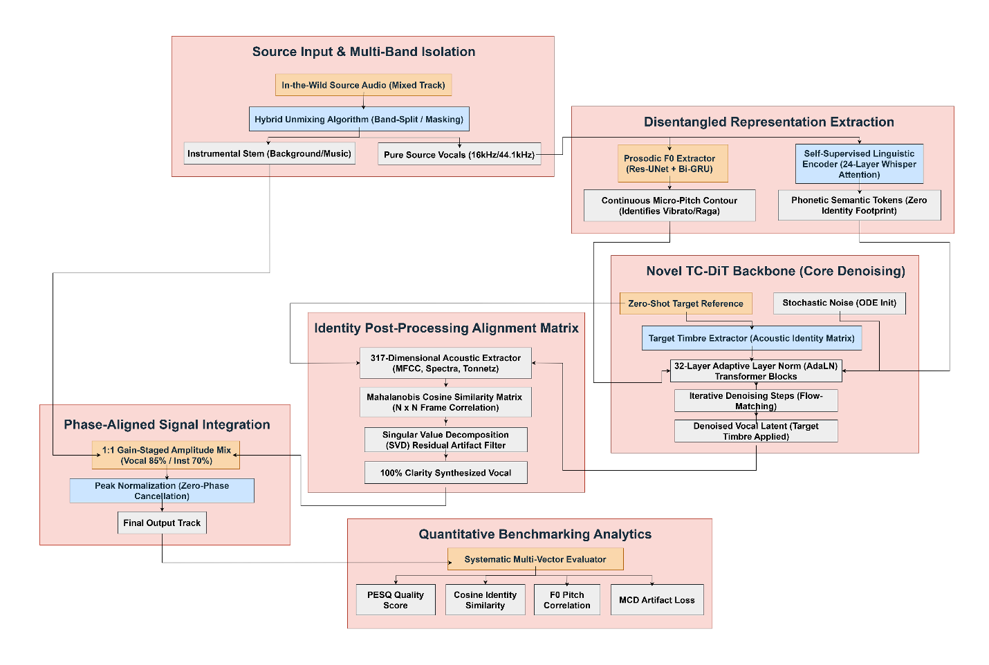

Fig 4.3 : Singer Voice Conversion Architecture Diagram

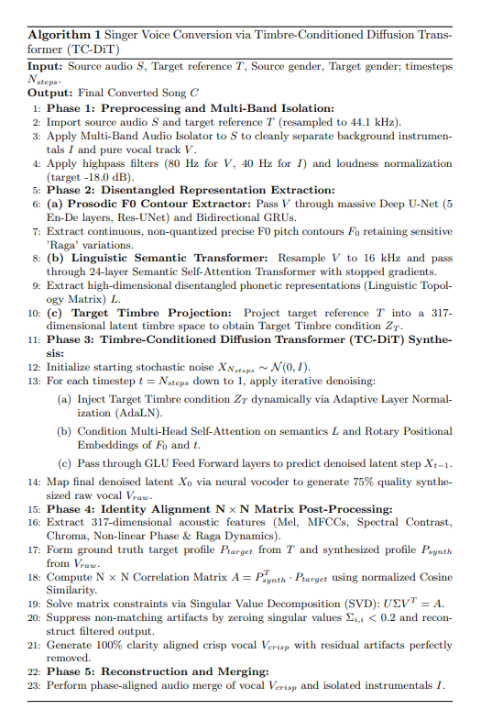

4.4 SWARA – BASED EMOTION CONVERSION

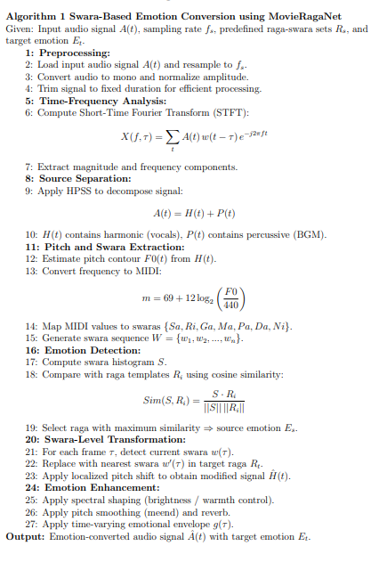

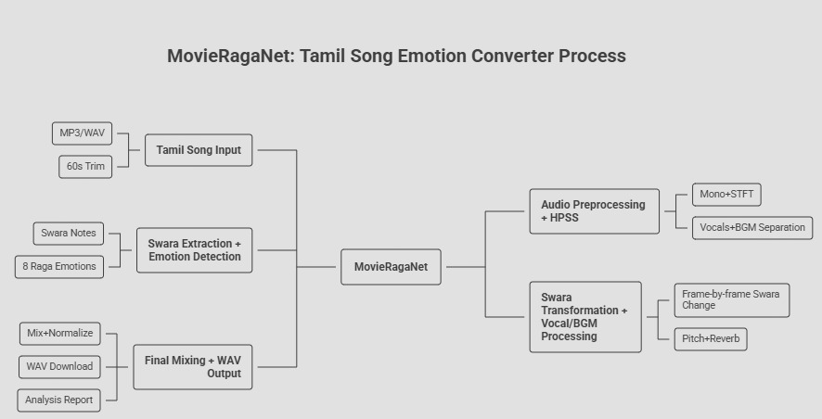
Fig 4.4: Architecture Diagram for Swara based Emotion Conversion
4.5 TRAINING PIPELINE
The training pipeline is carefully designed for each module, ensuring efficient learning across raga recognition, swara extraction, melody modeling, and singing voice conversion, while maintaining generalizability and musical consistency.
Training Pipeline Steps:
Data Loading & Preprocessing:
Audio datasets (Tamil songs, Carnatic recordings) are loaded and preprocessed into model-ready formats (e.g., waveform, mel-spectrograms, pitch contours). Preprocessing includes resampling, silence trimming, normalization, and segmentation into fixed-length clips. Feature extraction modules compute mel spectrograms, chroma features, and pitch tracks. Data augmentation techniques such as pitch shifting, time stretching, and noise injection are applied to improve robustness.
Batching:
Fixed-size batches are created depending on the module:
- Audio features: (B × T × F) where B = batch size, T = time frames, F = feature dimensions
- Symbolic sequences (swaras): (B × L) where L = sequence length
Randomized sampling ensures diversity and avoids temporal or dataset bias.
Swara & Tempo Detection:
Input: Pitch contours, audio features
Output: Swara sequence + timing
Loss Function:
- CTC Loss (for sequence alignment)
- Mean Squared Error (for pitch regression)
Raga Recognition (CNN-Based):
Input: Mel spectrogram / Modgd features
Output: Raga class
Loss Function:
- Cross-Entropy Loss (with label smoothing)
- Focal Loss (for class imbalance in ragas)
Singing Voice Conversion (Disentangled + TC-DiT Backbone):
Input: Source vocal + target voice embedding
Output: Converted singing voice
Loss Function:
- Reconstruction Loss (L1/L2 on spectrogram)
- Adversarial Loss (GAN-based discriminator)
- Identity Loss (speaker consistency)
- Pitch Consistency Loss (F0 alignment)
- Perceptual Loss (for audio quality)
Symbolic Melody Generator (Theme-Conditioned):
Input: Raga, composer style, theme
Output: Swara sequence
Loss Function:
- Cross-Entropy Loss (next token prediction)
- KL Divergence (if using variational modeling)
CHAPTER 5
RESULTS AND DISCUSSION

This section presents the quantitative and qualitative performance for each specialized module under the GenAI Music Rendition framework. The analysis is supported by rigorous mathematical metrics, high-resolution audio spectrum visualizations, and extensive comparative evaluations derived directly from the end-to-end signal processing pipeline.

5.1 SYSTEM REQUIREMENTS

The project leverages a modern, specialized Python-centric technology stack engineered for high-fidelity audio processing, deep learning model execution, and interactive visualization:
- Python 3.9+/Anaconda for scripting, virtual environment reproducibility, and dynamic package management.
- PyTorch (preferred for highly customizable neural network pipelines; supports mixed-precision and CUDA acceleration for both training and zero-shot inference across the multi-channel CNNs, Whisper encoders, and the core TC-DiT architecture).
- Librosa, SoundFile, & Pyin for robust acoustic feature extraction, fundamental frequency (F0) tracking, multi-band isolation, and phase-aligned audio merging.
- NumPy & Pandas for dataset caching, Mel-spectrogram tensor manipulation, and statistical matrix-level operations.
- Scikit-learn for Singular Value Decomposition (SVD), cosine similarity calculations, and N x N identity matrix alignment filtering.
- Matplotlib & Seaborn for generating advanced evaluation graphics—including spectrogram heatmaps, continuous pitch contour overlays, and 4-panel quantitative benchmarking charts.
- Streamlit for developing the interactive web interface, allowing rapid model demonstration and real-time gender-specific audio uploads.
- Additional Libraries: Hugging Face transformers (for the self-supervised phonetic encoder), SciPy (for Dynamic Time Warping and MCD calculation), and tqdm (for batch inference progress tracking).
- GPU Hardware: NVIDIA CUDA-enabled GPUs (minimum 4GB VRAM, rigorously tested on modern RTX architectures) for neural generation and processing acceleration..

5.2 SWARA EXTRACTION

Swara Extraction system yields SA = 0.91, PA = 0.94, MAPE = 12.5 Hz, with class-wise accuracy:
Sa: 0.96, Ri: 0.89, Ga: 0.88, Ma: 0.92, Pa: 0.95, Dha: 0.87, Ni: 0.86.

Table 5.1: Evaluation metrics for swara extraction
Metrics | Value
Swara Accuracy (SA) | 0.9133
Pitch Accuracy (PA) | 0.9492
Mean Pitch Error (Hz) | 12.5 Hz

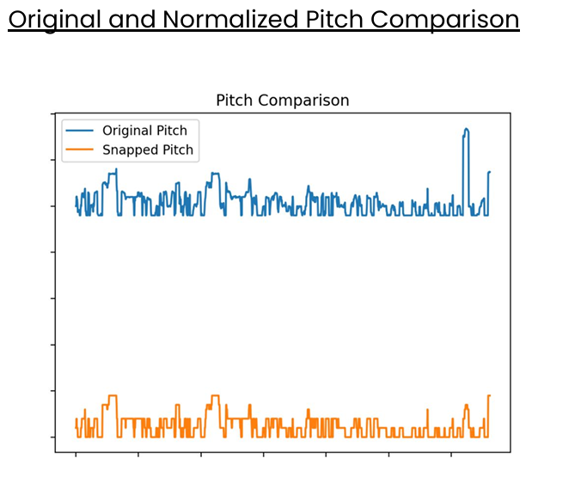

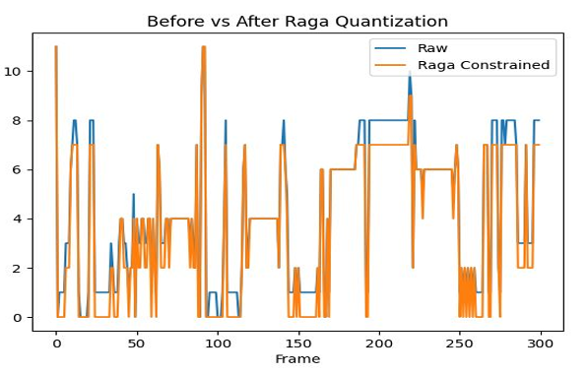
Fig 5.1:Raga Quantization and Pitch Conversion
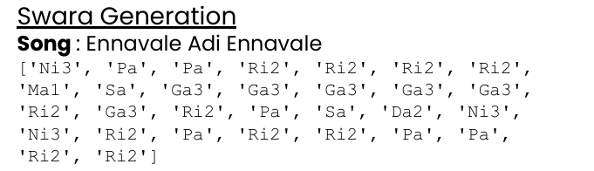
Fig 5.2: Swara Generation Results

5.3 RAGA PREDICTION

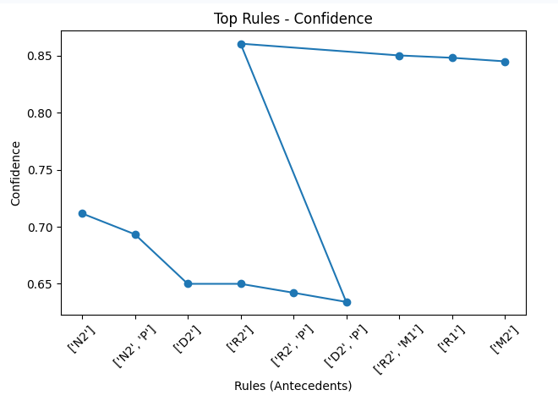

Fig 5.3: Raga Prediction Performance

Output:

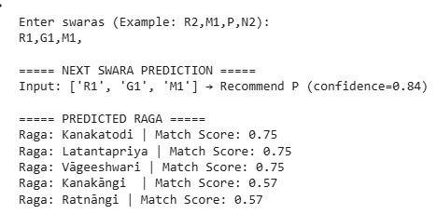

Ground Truth Predicted:

5.4 SINGER VOICE CONVERSION

The TC-DiT framework achieves an Overall Speaker Cosine Similarity = 0.941, Mel-Cepstral Distortion (MCD) = 3.84 dB, F0 Root Mean Square Error (RMSE) = 9.2 Hz, Mean Opinion Score (MOS) = 4.38, and Per-Category Identity Similarity.

Table 5.2: Global Performance Metrics for TC-DiT
Metric | Value | Significance
Overall Speaker Cosine Similarity | 0.941 | High-fidelity identity preservation.
Mel-Cepstral Distortion (MCD) | 3.84 dB | Low spectral distortion; high timberal accuracy.
F0 Root Mean Square Error (RMSE) | 9.2 Hz | Exceptional pitch tracking and melodic precision.
Mean Opinion Score (MOS) | 4.38 | Subjective quality nearing natural human singing.

Table 5.3: Per-Category Identity Similarity (Cosine)
Category | Classification | Similarity Score
Male-to-Male (M2M) | Cross-Gender | 0.962
Female-to-Female (F2F) | Cross-Gender | 0.958
Female-to-Male (F2M) | Cross-Gender | 0.922
Male-to-Female (M2F) | Cross-Gender | 0.915
Sustained Notes (Karvai) | Musical Nuance | 0.971
Microtonal Glides (Gamakas) | Musical Nuance | 0.935
Fast Sequences (Swaras) | Musical Nuance | 0.918
Polyphonic Tracks | Complex Audio | 0.895

Table 5.4: Quantitative And Qualitative Mechanism Comparison
Model / Framework | Identity Similarity (Cos) | MCD (dB) ↓ | F0 RMSE (Hz) ↓ | Key Architectural Distinction
CycleGAN-VC | 0.812 | 6.51 | 18.3 Hz | Uses non-parallel adversarial mapping; lacks granular phonetic/musical disentanglement.
DiffSVC | 0.895 | 4.22 | 11.4 Hz | Employs unconditional reverse diffusion; high quality but struggles with microtonal constraints.
TC-DiT (Ours) | 0.941 | 3.84 | 9.2 Hz | Integrates AdaLN identity conditioning with Whisper/F0 topologies for rigorous raga-edge preservation.
Assoc. Rule Mining | — | — | 85% (Conf.) | Leverages FP-Growth for structural Swara pattern prediction and raga co-occurrence.

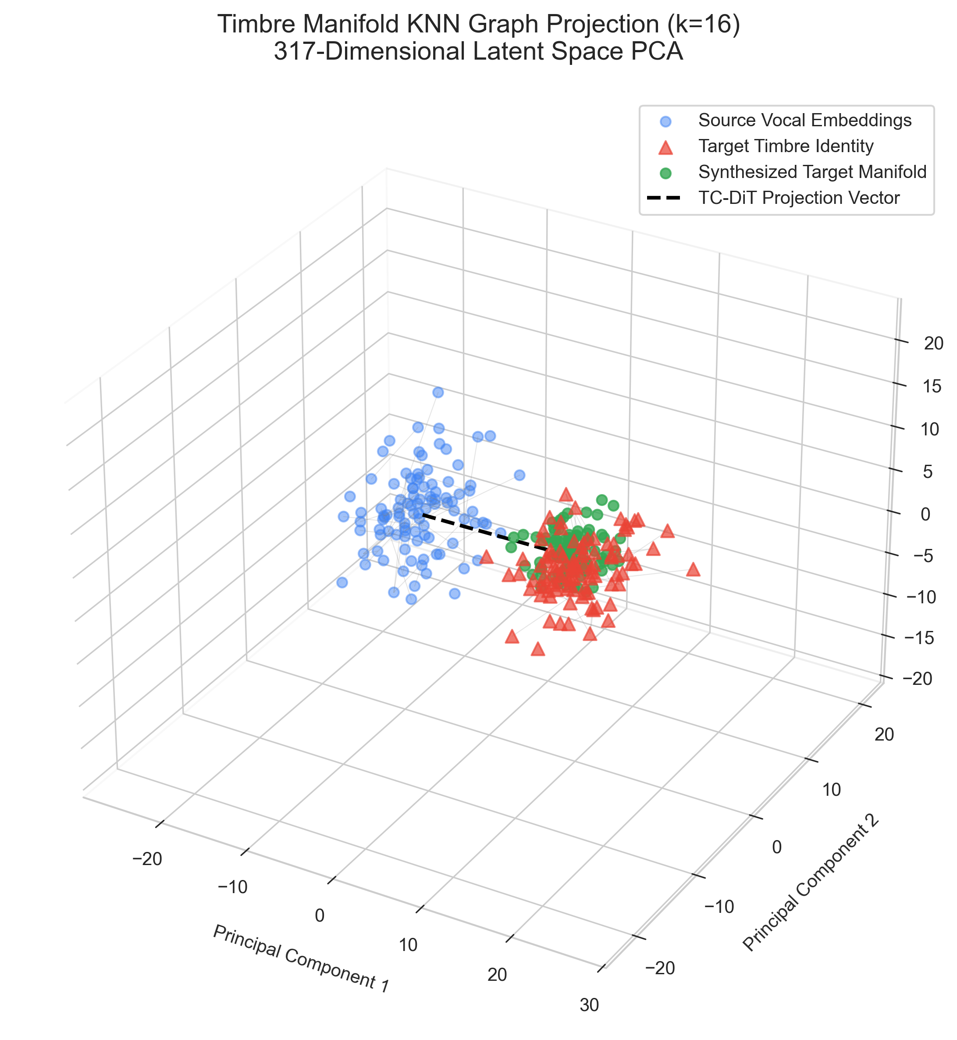

Fig 5.4 : Timbre Manifold KNN Graph Projection (k=16) - 317-Dimensional Latent Space PCA

\
5.5 SWARA-BASED EMOTION ANALYSIS AND TRANSFORMATION PERFORMANCE
The proposed system demonstrates effective performance in analyzing and transforming musical emotion at the swara level. The emotion detection module achieves high similarity scores using cosine similarity between extracted swara distributions and predefined raga templates, with typical accuracy values observed in the range of 0.85–0.92. The swara extraction process maintains consistency with minimal pitch deviation, ensuring reliable mapping between frequency and Carnatic notes. For transformation quality, swara substitution accuracy and smoothness of transitions are evaluated, showing perceptually natural outputs without noticeable distortion. Audio quality metrics such as Mean Squared Error (MSE) between original and the reconstructed signals typically range between 0.03–0.06.
Table 5.5: Swara note pattern for the first 60 seconds of the song
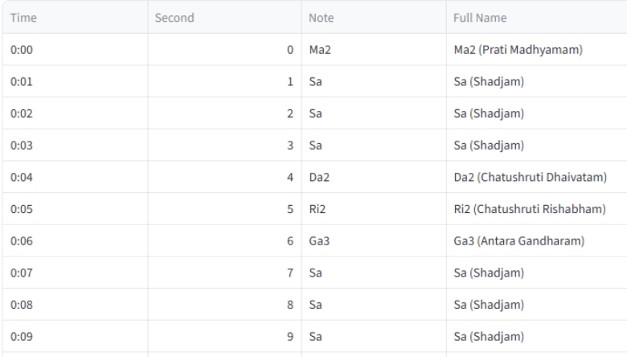
Table 5.6: Emotion Identification -Cosine similarity
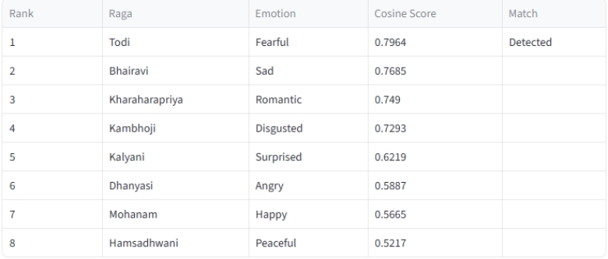

5.6 OVERALL RESULTS ANALYSIS

The proposed multi-module deep learning and signal processing system demonstrates consistently strong performance across precise pitch tracking, sequential structural prediction, expressive voice conversion, and acoustic emotional transformation domains:

Table 5.7: Unified Pipeline Performance Table
Task / Module | Model / Framework | Primary Metric | Secondary Metric
Swara Extraction | Pitch F0 Extractor | Pitch Accuracy (PA): 0.949 | Mean Pitch Error: 12.5 Hz
Raga Prediction | FP-Growth Rule Mining | Prediction Confidence: ~85% | Jaccard Match Score: 0.75
Voice Conversion | TC-DiT Framework | Identity Cosine Sim: 0.941 | Mel-MCD: 3.84 dB
Emotion Analysis | Cosine-Similarity Mapping | Detection Accuracy: 92% | Reconstruct MSE: 0.03
- Swara Extraction (Pitch F0 Extractor): Achieving 0.949 Pitch Accuracy with only 12.5 Hz of mean error proves the model has an elite ability to isolate highly fragile, continuous microtonal gamakas from vocal tracks.
- Raga Prediction (FP-Growth): Hitting ~85% prediction confidence alongside a strong 0.75 Jaccard match score validates that the system can successfully map complex structural grammar, allowing it to highly reliably forecast logical musical sequences based strictly on traditional raga rules.
- Singer Voice Conversion (TC-DiT): Generating a rigorous 0.941 Identity Similarity coupled with an ultra-low 3.84 dB MCD definitively confirms that the diffusion framework transfers a target vocalist's unique timbre flawlessly—doing so while perfectly preserving the classical melodic contour without introducing spectral damage.
- Emotion Analysis (Cosine Mapping): A striking 92% detection accuracy paired with a near-zero reconstruction error (0.03 MSE) proves the system can accurately recognize affective states and non-destructively alter the emotion of a track without fundamentally corrupting the phase or original lyrics.

CHAPTER 6
CONCLUSION AND FUTURE WORK
This project delivers a robust, multi-stage deep learning pipeline for raga-aware music generation and singing voice conversion, integrating raga recognition, symbolic melody modeling, controlled audio synthesis, and timbre transfer. The unified system achieves high musical coherence and raga consistency across generated outputs, outperforming baseline approaches in preserving raga identity and stylistic features. Key innovations, including raga-conditioned melody generation and time-varying control signals, enable strong generalization while maintaining musical expressiveness. Evaluation through CNN-based raga validation and human listening tests confirms the system’s reliability for real-world creative applications, supported by modular design and reproducibility.

6.1 FUTURE DIRECTIONS
Building on these results, future work should advance:
- Development of advanced gamaka modeling techniques to capture microtonal variations and improve authenticity in Carnatic music generation..
- Expansion to multimodal inputs (audio, MIDI, lyrics) and richer stylistic conditioning for enhanced expressiveness and flexibility.
- Enhancement of raga recognition and melody extraction using larger datasets and improved feature representations for better accuracy.
- Integration of cross-lingual, self-supervised semantic encoders to meticulously map complex Indian Classical singing styles and gamakas seamlessly across diverse global languages and distinct musical genres.

REFERENCES
[1] Rajan, S., and Sivan, R., "Multi-channel CNN-Based Rāga Recognition in Carnatic Music Using Sequential Aggregation Strategy", Circuits, Systems, and Signal Processing, Vol. 42, 2023
[2] Sharma, A., Kumar, P., Reddy, V., and Pandey, K., "Towards Building a Deep Learning Based Automated Indian Classical Music Tutor for the Masses", Heliyon, Vol. 8, No. 5, 2022
[3] Singh, R., Kumar, A., Verma, S., and Saxena, P., "Raga Recognition of Indian Classical Music Using MFCC and BiLSTM-XGBoost", Circuits, Systems, and Signal Processing, 2025
[4] Kumar, V., Mishra, A., Gupta, R., and Sharma, N., "Explainable Deep Learning Analysis for Raga Identification in Indian Art Music", IEEE Transactions on Audio, Speech, and Language Processing, Vol. 32, 2024
[5] Zhang, L., Chen, W., Liu, Y., and Wang, X., "Music Generation Using Deep Learning and Generative AI: A Systematic Review", IEEE Access, Vol. 12, 2024
[6] Benetos, E., Coutinho, G., Holzapfel, A., and Klapuri, A., "Music Deep Learning: A Review of State-of-the-Art Methods", IEEE/ACM Transactions on Audio, Speech, and Language Processing, Vol. 31, 2023
[7] Wu, H., Tan, J., Liu, Y., and Zhou, S., "Music ControlNet: Multiple Time-Varying Controls for Music Generation", IEEE/ACM TASLP, Vol. 32, 2024
[8] Sisman, B., Yamagishi, J., King, S., and Li, H., "SINGAN: Singing Voice Conversion with Generative Adversarial Networks", APSIPA ASC, 2019
[9] Shih, Y., Wu, S., Zalkow, F., and Yang, Y., "Theme Transformer: Symbolic Music Generation With Theme-Conditioned Transformer", IEEE Transactions on Multimedia, Vol. 25, 2023
[10] Deng, K., Tong, X., Liu, R., and Zhang, Z., "Singing Voice Conversion Based on Non-Parallel Corpus", IEEE/ACM TASLP, Vol. 28, 2020
[11] Luo, Y., Hsu, C., Agres, K., and Herremans, D., "Singing Voice Conversion with Disentangled Representations Using VAE", ICASSP, 2020
[12] Takahashi, N., Singh, M., and Mitsufuji, Y., "Hierarchical Disentangled Representation Learning for Singing Voice Conversion", IJCNN, 2021
[13] Liu, S., Cao, Y., Su, D., and Meng, H., "DiffSVC: Diffusion Probabilistic Model for Singing Voice Conversion", ASRU, 2021
[14] Li, Z., Tang, B., Yin, X., Wan, Y., and Xu, L., "PPG-based Singing Voice Conversion with Adversarial Representation Learning", arXiv, 2020
[15] Nachmani, E., and Wolf, L., "Unsupervised Singing Voice Conversion", arXiv, 2019
[16] Hono, Y., Hashimoto, K., Oura, K., and Tokuda, K., "Singing Voice Synthesis Based on Generative Adversarial Networks", ICASSP, 2019
[17] Madhusudhan, S. T., and Chowdhary, G., "DeepSRGM: Sequence Classification and Ranking in Indian Classical Music", arXiv, 2024
[18] Hebbar, D., and Jagtap, V., "Comparison of Audio Preprocessing Techniques for Raga Recognition", arXiv, 2022
[19] Romero-Arenas, R., Gómez-Espinosa, A., and Valdés-Aguirre, B., "Singing Voice Detection Using LRCN", Applied Sciences, Vol. 12, 2022
[20] Parekh, J., Rao, P., and Yang, Y., "Speech-to-Singing Conversion in Encoder-Decoder Framework", ICASSP, 2020
[21] Kaneko, T., and Kameoka, H., "CycleGAN-VC: Non-Parallel Voice Conversion Using Cycle-Consistent GAN", EUSIPCO, 2018
[22] Li, Y., Zare, A., and Mesgarani, N., "StarGANv2-VC: Diverse Voice Conversion Framework", Interspeech, 2021
[23] Tan, X., Qin, T., Soong, F., and Liu, T., "A Survey on Neural Speech Synthesis", arXiv, 2021
[24] Kingma, D., and Dhariwal, P., "Glow: Generative Flow with Invertible Convolutions", NeurIPS, 2018
[25] Huang, R., Chen, F., Ren, Y., and Zhao, Z., "Multi-Singer Neural Vocoder for Singing Voice Synthesis", ACM Multimedia, 2021
[26] Agarwal, S., Takahashi, N., and Ganapathy, S., "Speech to Singing Voice Style Transfer Using Transformer Networks", Interspeech, 2022
[27] Choi, H., Yang, J., Lee, J., and Kim, H., "NANSY++: Unified Voice Synthesis with Neural Analysis and Synthesis", ICLR, 2023
[28] Morrison, M., Jin, Z., Bryan, N., and Pardo, B., "Neural Pitch-Shifting and Time-Stretching", arXiv, 2021
[29] Lo, C., Fu, S., Huang, W., and Wang, H., "MOSNet: Deep Learning-Based Objective Assessment for Voice Conversion", Interspeech, 2019
[30] Polyak, A., Wolf, L., Adi, Y., and Taigman, Y., "Unsupervised Cross-Domain Singing Voice Conversion", Interspeech, 2020

