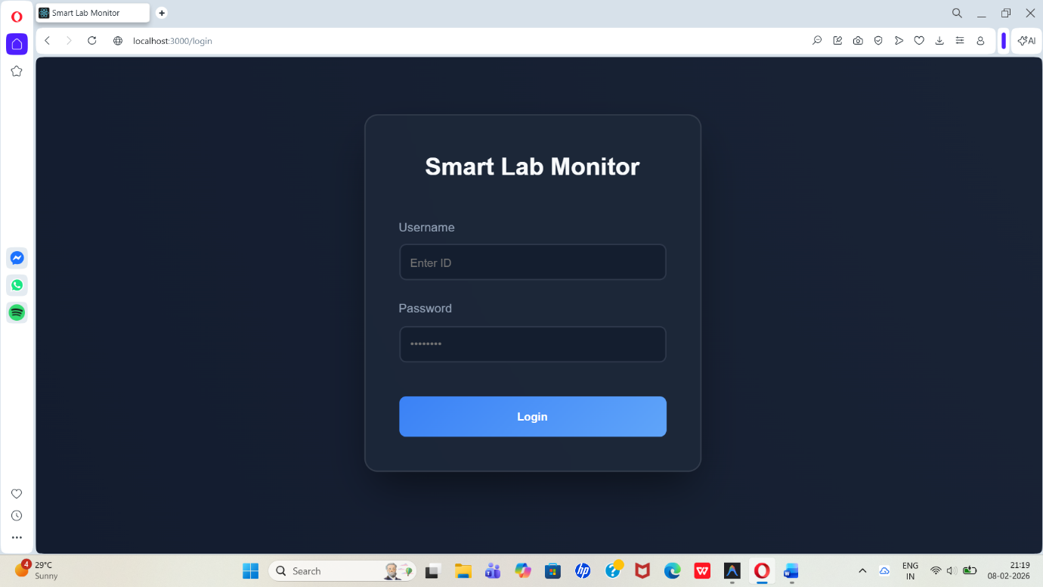
Fig. 1: User Login

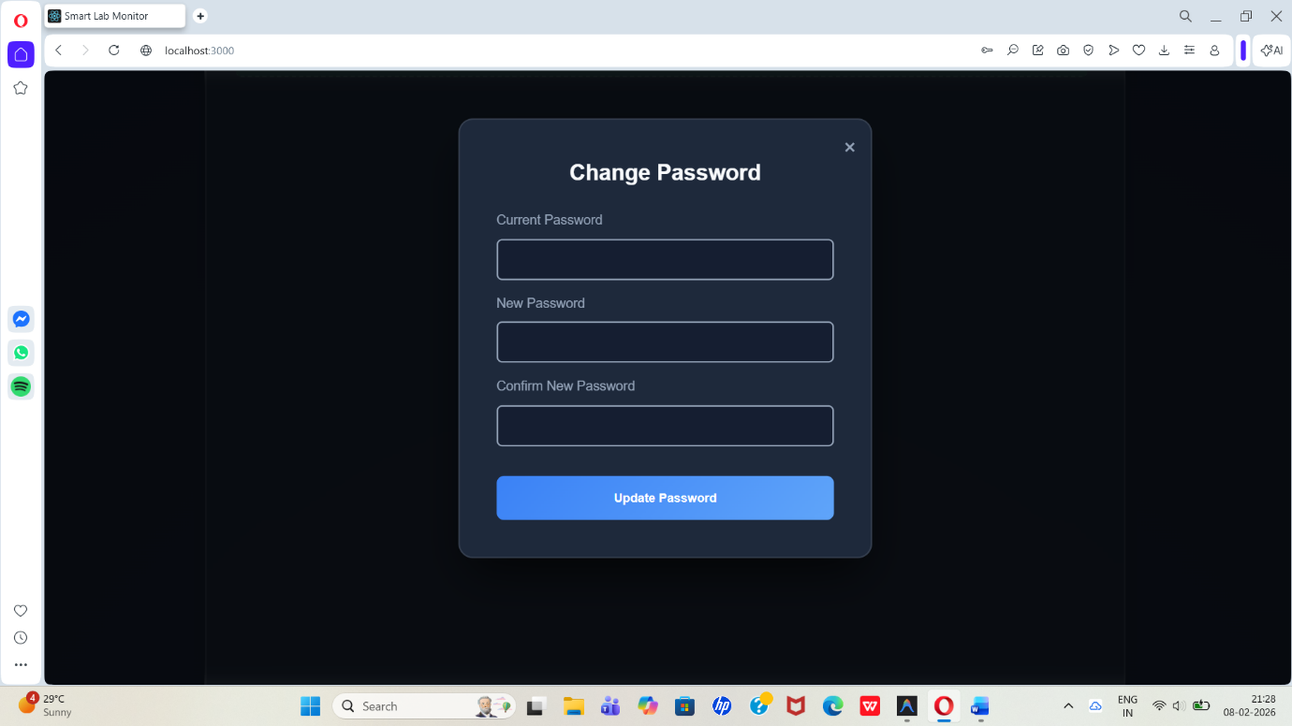
Fig. 2: Change Password

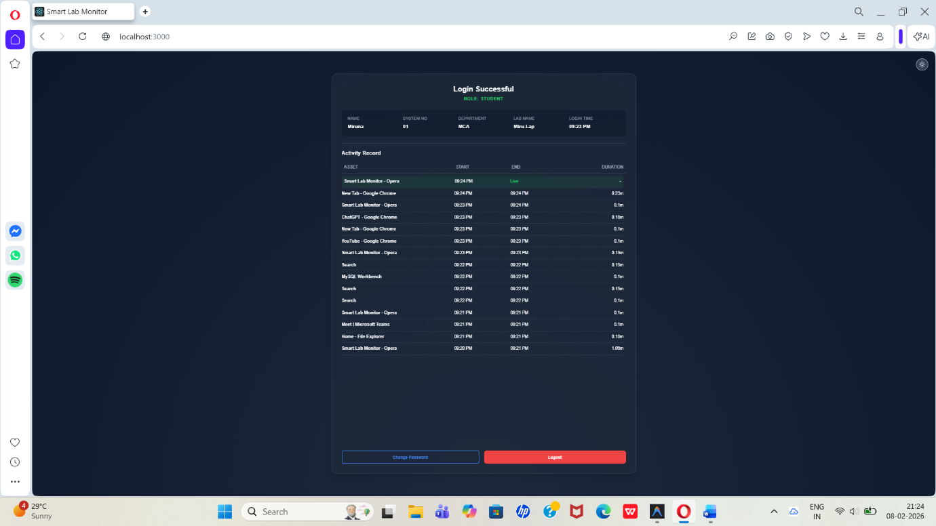
Fig. 3: Student Dashboard

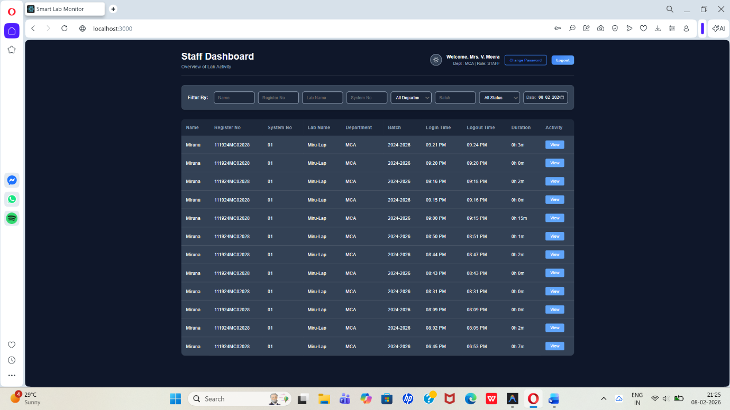
Fig. 4: Staff Dashboard

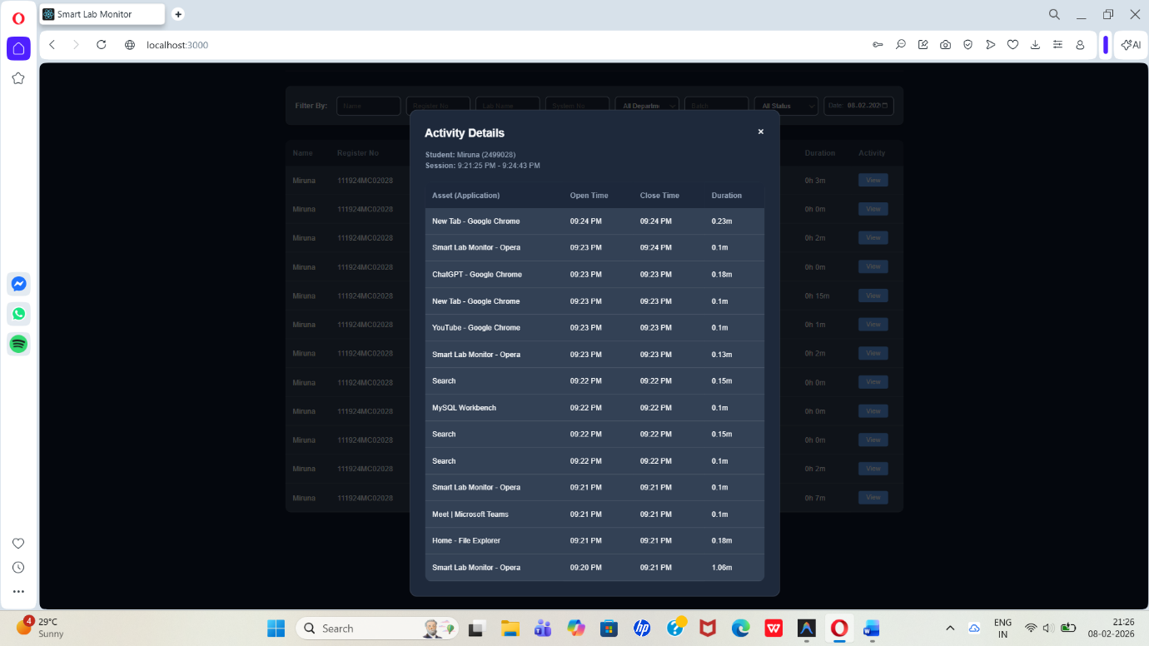
Fig. 5: Staff Monitoring (Student Activity)

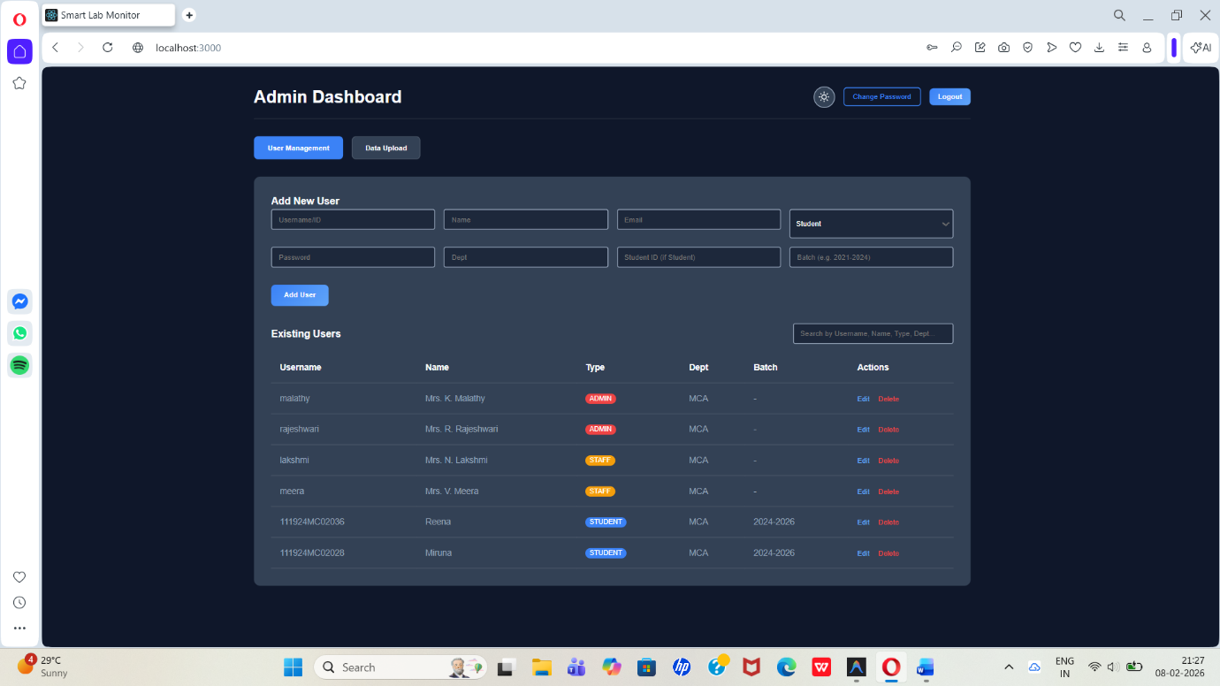
Fig. 6: Admin Dashboard

