Industrial Internship Report on
” Prediction of Remaining Useful Life (RUL) of Turbofan Engines using Machine Learning”
Prepared by
[Mirulaa Srithar]

Executive Summary
This report presents the work carried out during the Industrial Internship provided by upskill Campus and The IoT Academy in collaboration with UniConverge Technologies Pvt Ltd (UCT).
The internship was focused on solving a real-world industrial problem related to Predictive Maintenance. The assigned project involved predicting the Remaining Useful Life (RUL) of turbofan aircraft engines using machine learning techniques and sensor data.
The project was completed over a period of six weeks and covered understanding the problem, data analysis, model development, evaluation, and documentation. This internship provided valuable exposure to industrial datasets, real-world constraints, and practical implementation of machine learning solutions.

TABLE OF CONTENTS
1 Preface 3
2 Introduction 4
2.1 About UniConverge Technologies Pvt Ltd 4
2.2 About upskill Campus 8
2.3 Objective 9
2.4 Reference 9
2.5 Glossary 10
3 Problem Statement 11
4 Existing and Proposed solution 12
5 Proposed Design/ Model 13
5.1 High Level Diagram (if applicable) 13
5.2 Low Level Diagram (if applicable) 13
5.3 Interfaces (if applicable) 13
6 Performance Test 14
6.1 Test Plan/ Test Cases 14
6.2 Test Procedure 14
6.3 Performance Outcome 14
7 My learnings 15
8 Future work scope 16

Preface
This internship was designed to provide practical industrial exposure in the field of Machine Learning and Predictive Maintenance. Over six weeks, I worked on a real industrial problem that required understanding complex time-series data and building a predictive model.
The project helped me understand the importance of internships in career development, as it bridged the gap between academic knowledge and real-world applications. The opportunity provided by upskill Campus and UniConverge Technologies Pvt Ltd enabled me to work on an industry-relevant problem using modern tools and methodologies.
How Program was planned
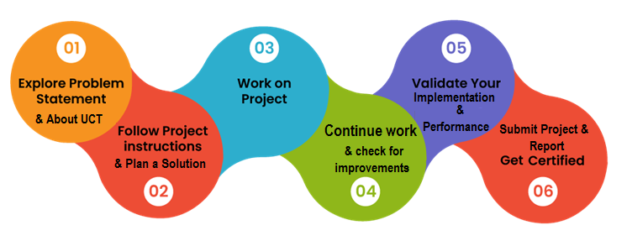
The internship program was well structured, starting with problem understanding, followed by implementation, testing, and documentation. I am thankful to the mentors and coordinators who guided me throughout the internship. This experience has significantly improved my technical skills, confidence, and problem-solving abilities.

Introduction

About UniConverge Technologies Pvt Ltd
A company established in 2013 and working in Digital Transformation domain and providing Industrial solutions with prime focus on sustainability and RoI.
For developing its products and solutions it is leveraging various Cutting Edge Technologies e.g. Internet of Things (IoT), Cyber Security, Cloud computing (AWS, Azure), Machine Learning, Communication Technologies (4G/5G/LoRaWAN), Java Full Stack, Python, Front end etc.
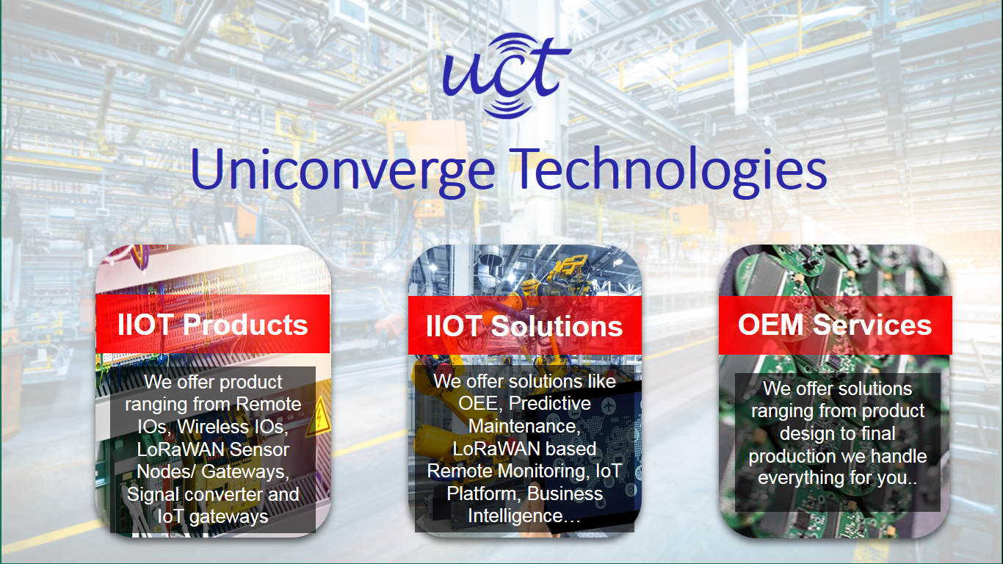
- UCT IoT Platform ()
UCT Insight is an IOT platform designed for quick deployment of IOT applications on the same time providing valuable “insight” for your process/business. It has been built in Java for backend and ReactJS for Front end. It has support for MySQL and various NoSql Databases.
- It enables device connectivity via industry standard IoT protocols - MQTT, CoAP, HTTP, Modbus TCP, OPC UA
- It supports both cloud and on-premises deployments.
It has features to
• Build Your own dashboard
• Analytics and Reporting
• Alert and Notification
• Integration with third party application(Power BI, SAP, ERP)
• Rule Engine

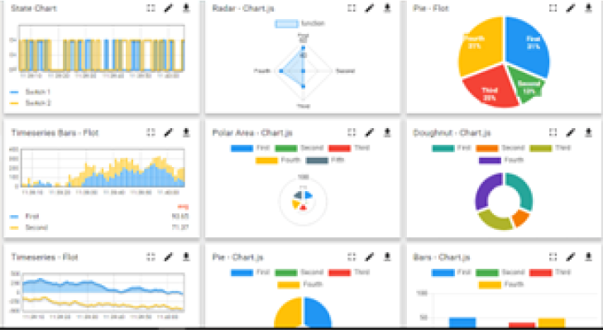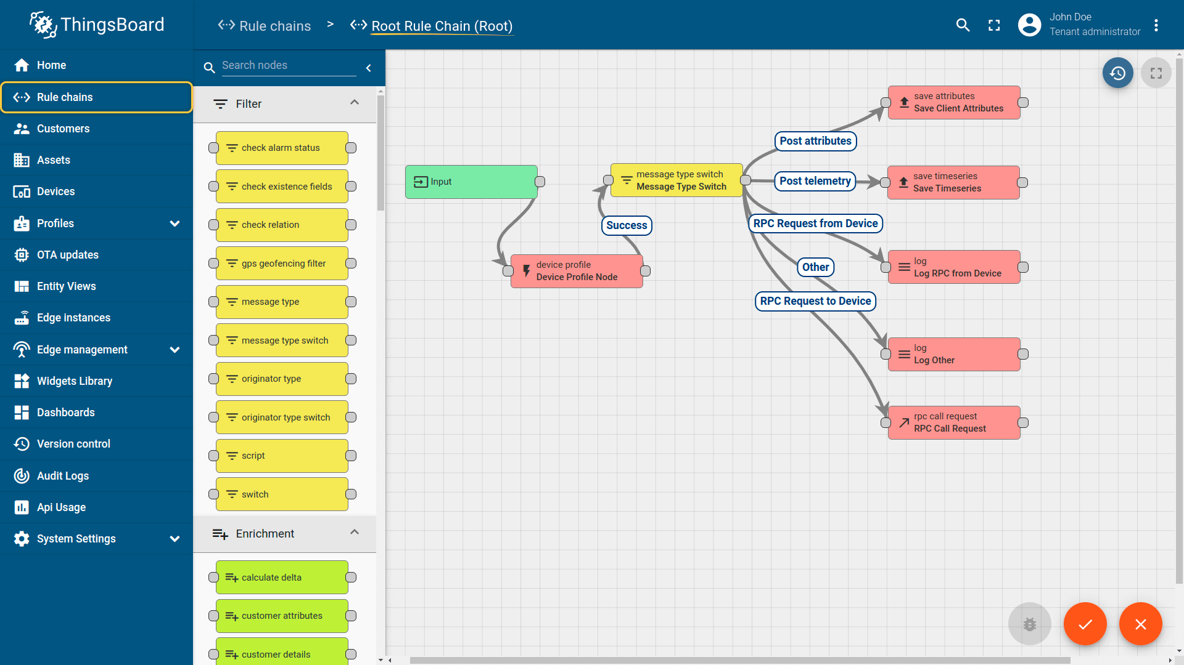

- Smart Factory Platform ()
Factory watch is a platform for smart factory needs.
It provides Users/ Factory
- with a scalable solution for their Production and asset monitoring
- OEE and predictive maintenance solution scaling up to digital twin for your assets.
- to unleased the true potential of the data that their machines are generating and helps to identify the KPIs and also improve them.
- A modular architecture that allows users to choose the service that they what to start and then can scale to more complex solutions as per their demands.
Its unique SaaS model helps users to save time, cost and money.
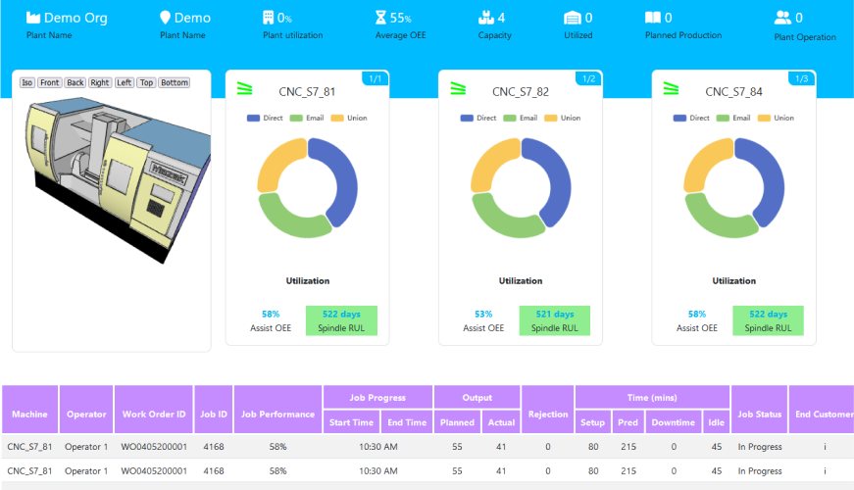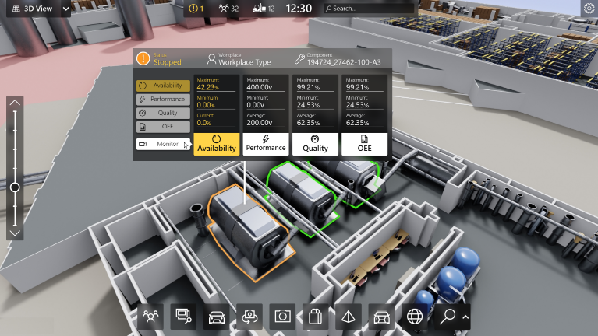

- 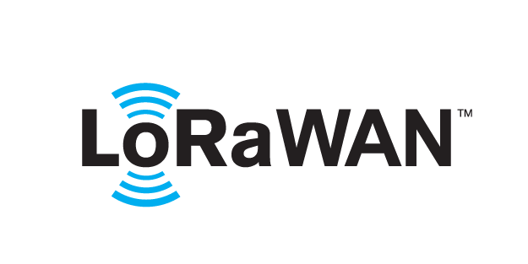 based Solution
UCT is one of the early adopters of LoRAWAN teschnology and providing solution in Agritech, Smart cities, Industrial Monitoring, Smart Street Light, Smart Water/ Gas/ Electricity metering solutions etc.
- Predictive Maintenance
UCT is providing Industrial Machine health monitoring and Predictive maintenance solution leveraging Embedded system, Industrial IoT and Machine Learning Technologies by finding Remaining useful life time of various Machines used in production process.
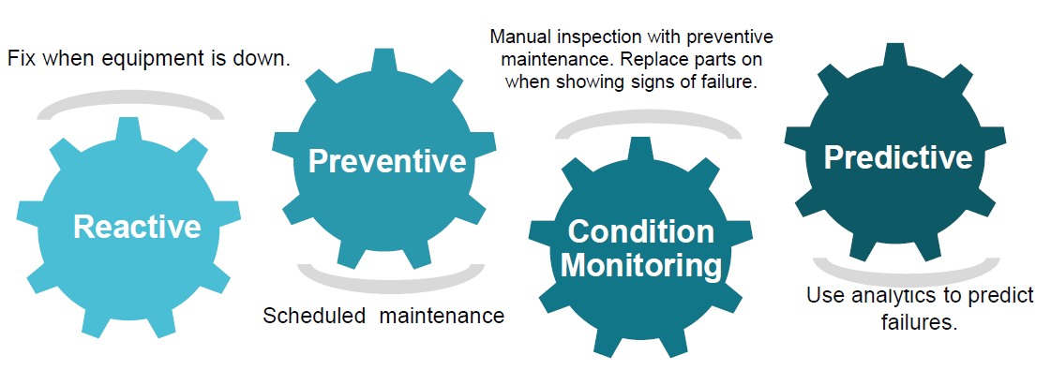

About upskill Campus (USC)
upskill Campus along with The IoT Academy and in association with Uniconverge technologies has facilitated the smooth execution of the complete internship process.
USC is a career development platform that delivers personalized executive coaching in a more affordable, scalable and measurable way.




Seeing need of upskilling in self paced manner along-with additional support services e.g. Internship, projects, interaction with Industry experts, Career growth Services

upSkill Campus aiming to upskill 1 million learners in next 5 year

https://www.upskillcampus.com/

The IoT Academy
The IoT academy is EdTech Division of UCT that is running long executive certification programs in collaboration with EICT Academy, IITK, IITR and IITG in multiple domains.

Objectives of this Internship program
The objective for this internship program was to
☛ get practical experience of working in the industry.
☛ to solve real world problems.
☛ to have improved job prospects.
☛ to have Improved understanding of our field and its applications.
☛ to have Personal growth like better communication and problem solving.

Reference
[1] Scikit-learn Documentation
[2] Research papers on Predictive Maintenance

Glossary
Terms | Acronym
RUL | Remaining Useful Life
CMAPSS | Commercial Modular Aero-Propulsion System Simulation
ML | Machine Learning

Problem Statement
The objective of the project is to predict the Remaining Useful Life (RUL) of turbofan engines using historical sensor data. The dataset consists of multiple time-series readings from different engines operating under various conditions. Predicting RUL helps in scheduling maintenance before failure occurs, thereby reducing downtime and improving safety.

Existing and Proposed solution

Existing Solution
Traditional maintenance strategies rely on fixed schedules or manual inspections, which can lead to unnecessary maintenance or unexpected failures. These methods do not utilize real-time sensor data effectively.
Proposed Solution
The proposed solution uses machine learning models trained on historical sensor data to predict the Remaining Useful Life of engines. This approach enables predictive maintenance, reducing costs and preventing unexpected breakdowns.

Code submission (Github link)

Report submission (Github link) : first make placeholder, copy the link.

Proposed Design/ Model

The solution follows a structured machine learning pipeline:
- Data loading and preprocessing
- RUL label generation
- Feature scaling and cleaning
- Sequence generation using sliding windows
- Model training and evaluation

Performance Test

This is very important part and defines why this work is meant of Real industries, instead of being just academic project.

Test Plan/ Test Cases
• Train-test split validation
• RMSE-based evaluation

Test Procedure
The model was trained on historical engine data and tested on unseen data to measure prediction accuracy

Performance Outcome
The model achieved acceptable RMSE values, validating its ability to predict engine degradation trends effectively.

My learnings

This internship enhanced my understanding of:
- Predictive maintenance concepts
- Time-series data handling
- Machine learning model development
- Industrial constraints and evaluation metrics
These learnings will be valuable for my future career in data science and machine learning

Future work scope

- Implement deep learning models such as LSTM
- Improve model accuracy using feature engineering
- Apply the solution to real-time industrial systems
- Extend the model to other types of machinery

