

**Capstone Project Documentation**

**Detection of Surface Cracks in Reinforced Concrete Infrastructures Using**

**Deep Learning Techniques**

**Dr Nariman Saeed**

**1-December-2020**

**Introduction**

Reinforced concrete are the main structural elements in infrastructures. These elements need to be annually inspected which is basically carried out through a manual and visual inspection. This process is very routine but can be challenging when it is about inspecting tall structures such as cooling towers and silos or the soffits of the bridges which is not easy to access. This project aims at developing an AI model to substitute the visual inspection for this risky situation through processing some images. The final product will get an image, processes it and says if any crack is detected or not.

**Process overview**

The following diagram shows the overall end-to-end process for defining, designing and delivering the Capstone project.

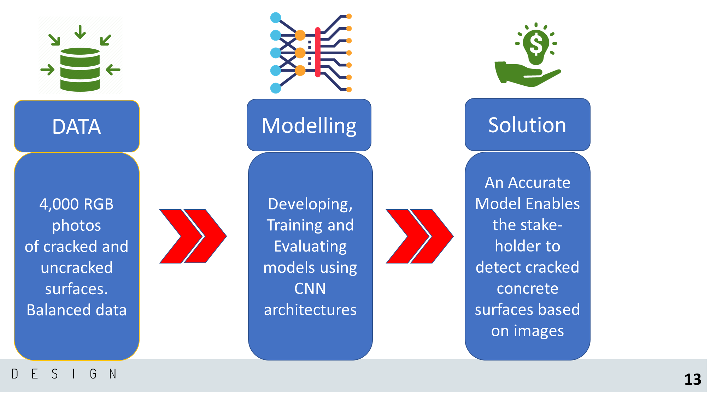

**Industry’s need**

Performing a visual inspection manually is very human dependent. It means that result of each inspection can be very variable depending the level of experience and commitment of the inspector. Working in height and difficult conditions are also other sort of problems which can be even life threatening. That’s why construction industry is always looking for automation.

**Stakeholders**

The main stakeholders are:

* Asset Owners
* Consultants
* QA/QC units
* Maintenance planners

**Business Question**

* How can reduce safety risk in visual inspection of difficult to access RC elements while minimising human related errors? “Killing two birds with one stone”

**Data Question**

* What is the best Deep Learning algorithm for this Image Processing concept?

**Data science process**

**Data extraction**

* 40000 Images were downloaded from Kaggle website
* Due to short of computational resources. 10% were randomly selected for this project

**Images Preprocessing**

* Resize images to 128x128 pixels to preserve features and less computational power.
* Normalization images by 255 to reduce the variance in pixel.
* Splitting the images into Train, Validation and Test sets using Python commands

**Modelling**

* LenNet, ResNet50 as two well-known models were used.
* A CNN model was also developed and was tested for two different discretization process AveragePooling and MaxPooling.
* The models were trained on Window 10 OS on CPU.
* The total loss and accuracy graphs indicated LeNet was not as accurate as the others.
* Compare training speed the CNN model using AveragePooling is the optimal model in term of accuracy, and speed

**Outcomes**

* The model correctly predicted all the test images.

**Implementation**

* Have the photos taken by camera and feeding them to the model can predict the cracking status of the concrete surface.

**Data answer**

* Using AI in the field of Reinforced Concrete infrastructure maintenance and rehabilitation is demonstrated.

**Business answer**

* Visual inspection of High and problematic structures is made easy now.
* Eliminate risks, neglecting and human errors in visual inspection.

**Recommendations to stakeholders**

* Depend on the type of the inspecting infrastructures and their different conditions, them model shall be continuously trained to improve accuracy.
* By taking advantage of the technology, we can improve decision-making of asset owners and for higher level of inspection or repairs.
* Two extra capability including, image chopping software, real time segmentation and detection of the length and with of cracks can be added to the model package.