MACHINE LEARNING INTERNSHIP
Task 2
Predictive Linear Regression Model Pipeline
Predicting California house prices with a regularized Ridge Regression pipeline
Prepared by: Muhammad Bilal Mirza
Organisation: Progree
GitHub: github.com/Mirza1358
Date: October 2026

Table of Contents
1. Introduction 3
1.1 Objective 3
1.2 Tools Used 3
2. Dataset Description 3
3. Exploratory Data Analysis (EDA) 3
4. Methodology 5
4.1 Features and Target 5
4.2 Train/Test Split 6
4.3 Preprocessing Pipeline 6
4.4 Model: Ridge Regression 6
4.5 Evaluation Metrics 6
5. Results 7
6. Discussion 7
7. Conclusion 7
Future Improvements 8

1. Introduction
Regression is a supervised learning technique used to predict a continuous numerical value. In this task, a complete machine learning pipeline was built to predict the median house value of districts in California. The pipeline covers data loading, exploration, preprocessing (feature scaling, mean imputation and categorical encoding), training a regularized Ridge Regression model, and evaluating it with R² and RMSE.

1.1 Objective
- Build a supervised regression model that predicts a continuous value (house price).
- Implement preprocessing: feature scaling, mean imputation and categorical encoding.
- Train a regularized Linear/Ridge regression model and log R² and RMSE scores.

1.2 Tools Used
Python, Jupyter Notebook, Pandas, NumPy, Scikit-learn (Pipeline, ColumnTransformer, SimpleImputer, StandardScaler, OneHotEncoder, LinearRegression, Ridge), Matplotlib and Seaborn.

2. Dataset Description
The California Housing Prices dataset (Kaggle version of the 1990 California census data) was used. It contains 20,640 rows (districts) and 10 columns. This version was chosen instead of Scikit-learn's built-in version because it contains missing values and a categorical column, which are needed to demonstrate mean imputation and categorical encoding.
Column | Type | Description
longitude, latitude | Numeric | Location of the district
housing_median_age | Numeric | Median age of houses
total_rooms, total_bedrooms | Numeric | Total rooms and bedrooms (total_bedrooms has 207 missing values)
population, households | Numeric | Number of people and households
median_income | Numeric | Median income (in tens of thousands of USD)
ocean_proximity | Categorical | Distance to the ocean (5 categories)
median_house_value | Numeric (Target) | Median house value in USD – the value to predict
Table 1: Dataset columns
Data quality findings: the column total_bedrooms has 207 missing values, and ocean_proximity is a text column with five categories: <1H OCEAN (9,136), INLAND (6,551), NEAR OCEAN (2,658), NEAR BAY (2,290), ISLAND (5).

3. Exploratory Data Analysis (EDA)
The data was explored using df.head(), df.info(), df.describe() and isnull().sum(), followed by visualisations.
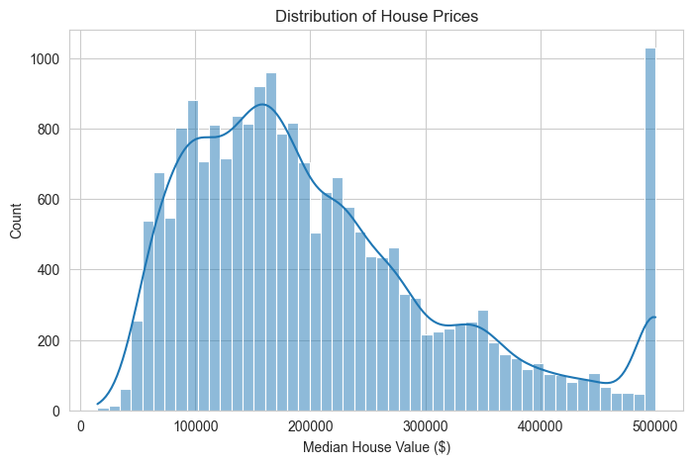
Figure 1: Distribution of median house values
- The house value distribution is right-skewed and has a visible cap at $500,001, a known limit in the original census data.
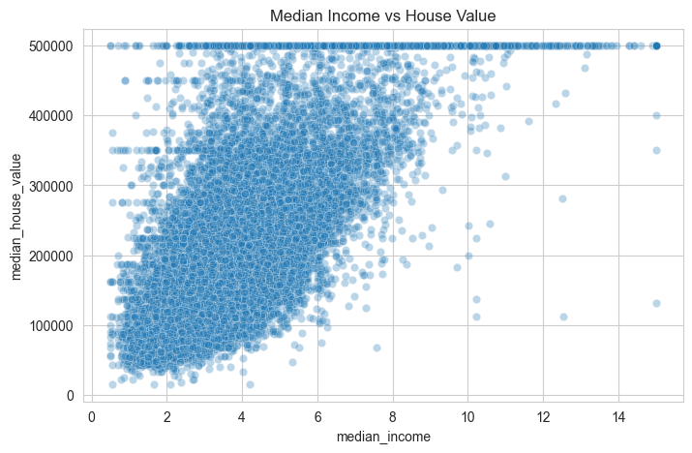
Figure 2: Median income vs median house value
- Median income has the strongest relationship with house value (correlation ≈ 0.688): districts with higher income have more expensive houses.
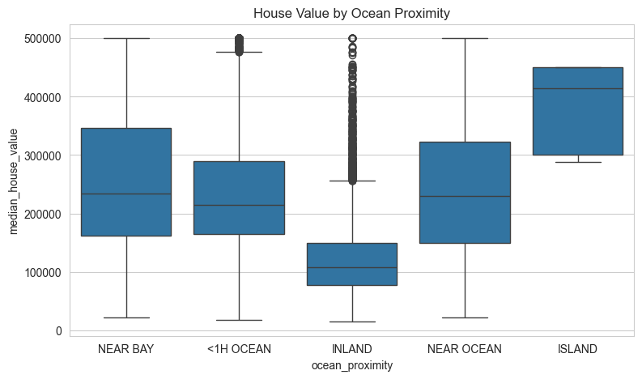
Figure 3: House value by ocean proximity
- Houses near the ocean or bay are more expensive, while INLAND houses have the lowest values. This shows that ocean_proximity is a useful feature and should be encoded, not dropped.
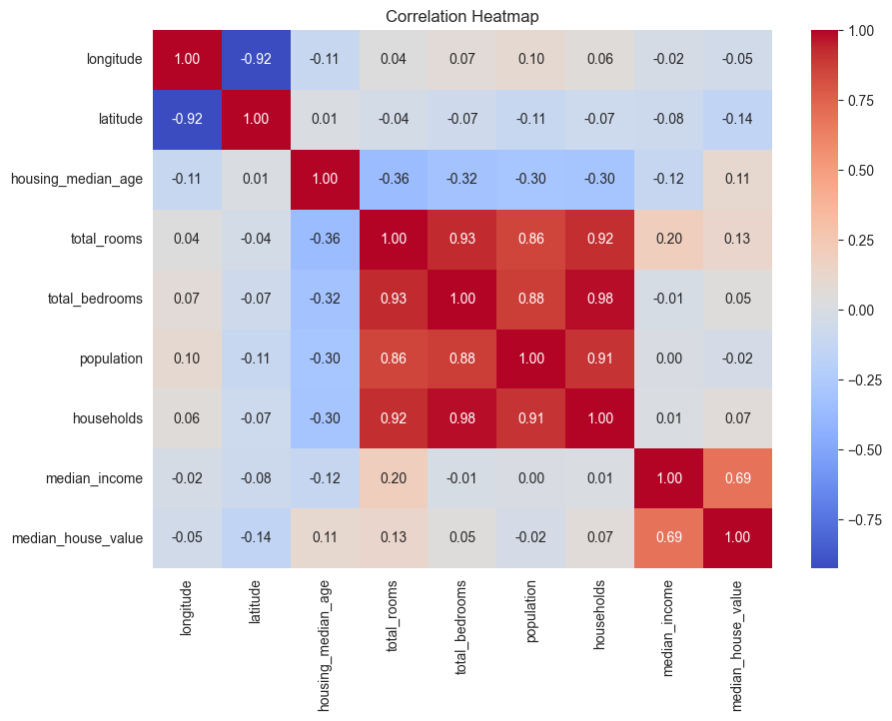
Figure 4: Correlation heatmap of numerical features
- median_income has the highest correlation with median_house_value. total_rooms, total_bedrooms, population and households are very strongly correlated with each other (multicollinearity), which is one situation where Ridge regularization can help.

4. Methodology

4.1 Features and Target
The target y is median_house_value. All other columns form the feature set X. Features were split into 8 numerical columns and 1 categorical column (ocean_proximity).

4.2 Train/Test Split
The data was split into 80% training (16,512 rows) and 20% testing (4,128 rows) using random_state=42 for reproducibility. The test set was kept unseen until final evaluation.

4.3 Preprocessing Pipeline
A Scikit-learn ColumnTransformer was used to apply the correct preprocessing to each type of column:
Requirement | Technique | Applied to | Why
Mean imputation | SimpleImputer(strategy="mean") | Numerical columns | Fills the 207 missing total_bedrooms values with the column average
Feature scaling | StandardScaler() | Numerical columns | Puts features on the same scale so large values (e.g. rooms) do not dominate
Categorical encoding | OneHotEncoder() | ocean_proximity | Converts text categories into 0/1 columns the model can use
Table 2: Preprocessing steps
numeric_pipeline = Pipeline([
('imputer', SimpleImputer(strategy='mean')), # mean imputation
('scaler', StandardScaler()) # feature scaling
])
preprocessor = ColumnTransformer([
('num', numeric_pipeline, num_cols),
('cat', OneHotEncoder(handle_unknown='ignore'), cat_cols) # encoding
])

4.4 Model: Ridge Regression
Ridge Regression is linear regression with L2 regularization. It adds a penalty for large coefficients, which keeps the model simpler and reduces the risk of overfitting. The strength of the penalty is controlled by alpha: alpha = 0 is plain Linear Regression, and a larger alpha means a stronger penalty.
The preprocessor and model were combined into a single Pipeline. This guarantees that exactly the same preprocessing is applied to training and test data, and prevents data leakage, because the mean and scaling values are learned only from the training data.
ridge_model = Pipeline([('preprocessing', preprocessor),
('model', Ridge(alpha=1.0))])
ridge_model.fit(X_train, y_train)

4.5 Evaluation Metrics
- R² (coefficient of determination): the share of variation in house prices explained by the model (0 to 1; higher is better).
- RMSE (root mean squared error): the average prediction error in dollars (lower is better).
Three models were compared: Linear Regression, Ridge (alpha = 1) and Ridge (alpha = 10). The metrics were logged to a file named metrics_log.csv.

5. Results
Model | R² | RMSE (USD)
Linear Regression | 0.6257 | $70,031.49
Ridge (alpha=1) | 0.6257 | $70,038.41
Ridge (alpha=10) | 0.6255 | $70,055.89
Table 3: Test set performance (logged in metrics_log.csv)
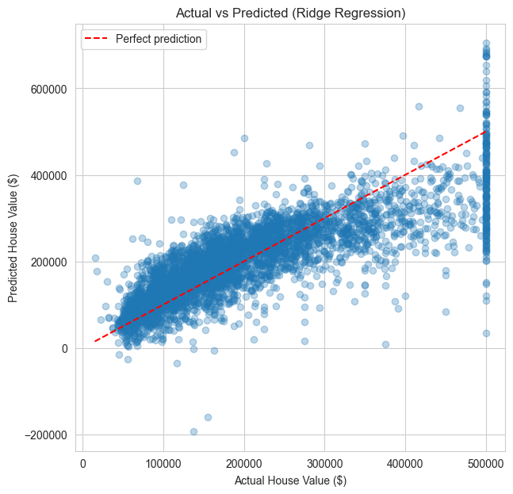
Figure 5: Actual vs predicted house values (Ridge, alpha = 1)
The Ridge model achieved R² ≈ 0.63, meaning it explains about 63% of the variation in house prices, with an average error (RMSE) of about $70,038. In the actual vs predicted chart, most points follow the red diagonal line, but predictions spread out for very expensive houses and the cap at $500,001 is visible.

6. Discussion
- Ridge vs Linear Regression: all three models gave almost the same results. The dataset is large (over 16,000 training rows) with few features, so the risk of overfitting was already low and regularization had little effect. Ridge is more useful when there are many features or strongly correlated features.
- Feature importance: median_income was the strongest numerical predictor. The ISLAND category had a large coefficient, but it contains only 5 houses, so this effect is not reliable.
- Limitations: a linear model cannot fully capture non-linear relationships (for example, location effects), and the $500,001 price cap limits accuracy for expensive houses.

7. Conclusion
A complete, leakage-free regression pipeline was built using Scikit-learn. Missing values were handled with mean imputation, numerical features were standardised, and the categorical feature was one-hot encoded. A regularized Ridge Regression model achieved an R² of about 0.63 and an RMSE of about $70,000 on unseen test data.

Future Improvements
- Try non-linear models such as Random Forest or XGBoost for higher accuracy.
- Create new features (e.g. rooms per household, bedrooms per room).
- Tune alpha with RidgeCV and cross-validation, and handle the capped target values.

