MACHINE LEARNING INTERNSHIP
Task 3
Multi-Class Image Classification using a Convolutional Neural Network (CNN)
Classifying CIFAR-10 images into 10 classes with TensorFlow/Keras
Prepared by: Muhammad Bilal Mirza
Organisation: Progree
GitHub: github.com/Mirza1358
Date: October 2026

Table of Contents

1. Introduction 3
1.1 Objective 3
1.2 Tools Used 3
2. Dataset Description 3
3. Methodology 4
3.1 Preprocessing: Normalization 4
3.2 Data Augmentation 4
3.3 CNN Architecture 5
3.4 Training Setup 6
4. Results 6
4.1 Training and Validation Curves 6
4.2 Test Set Performance 7
4.3 Confusion Matrix 8
4.4 Sample Predictions 8
5. Discussion 9
6. Conclusion 9
Future Improvements 9

1. Introduction
Image classification means teaching a computer to recognise what is in a picture. Convolutional Neural Networks (CNNs) are deep learning models designed for images: they learn simple patterns such as edges in the first layers and more complex shapes and objects in deeper layers. In this task, a custom multi-layer CNN was built with TensorFlow/Keras to classify images from the CIFAR-10 dataset into 10 classes.

1.1 Objective
- Train a deep learning vision pipeline that classifies raw pixel image arrays.
- Design custom convolutional, max-pooling and fully connected layers.
- Use data augmentation to reduce overfitting.
- Plot training and validation accuracy curves.

1.2 Tools Used
Python, Jupyter Notebook, TensorFlow/Keras, NumPy, Matplotlib, Seaborn and Scikit-learn (classification report and confusion matrix).

2. Dataset Description
CIFAR-10 is a standard computer vision dataset that is built into Keras (keras.datasets.cifar10), so no manual download was needed.
Property | Value
Total images | 60,000 colour images
Training / Test split | 50,000 training / 10,000 test
Image size | 32 × 32 pixels, 3 colour channels (RGB)
Number of classes | 10 (balanced: 6,000 images per class)
Classes | airplane, automobile, bird, cat, deer, dog, frog, horse, ship, truck
Table 1: CIFAR-10 dataset summary
CIFAR-10 was chosen over MNIST because it is more challenging (real-world colour objects instead of handwritten digits), which makes the effect of data augmentation and regularization easier to see.
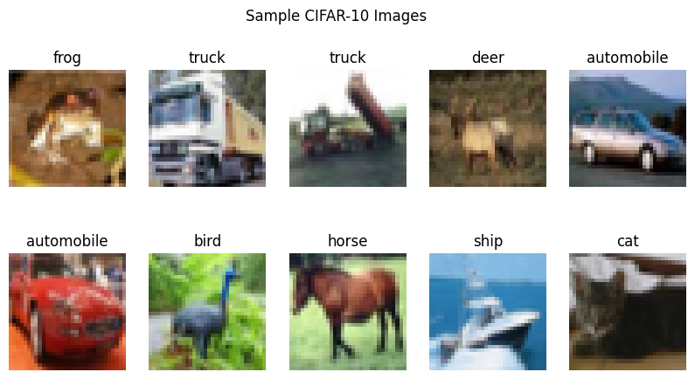
Figure 1: Sample CIFAR-10 training images with their labels
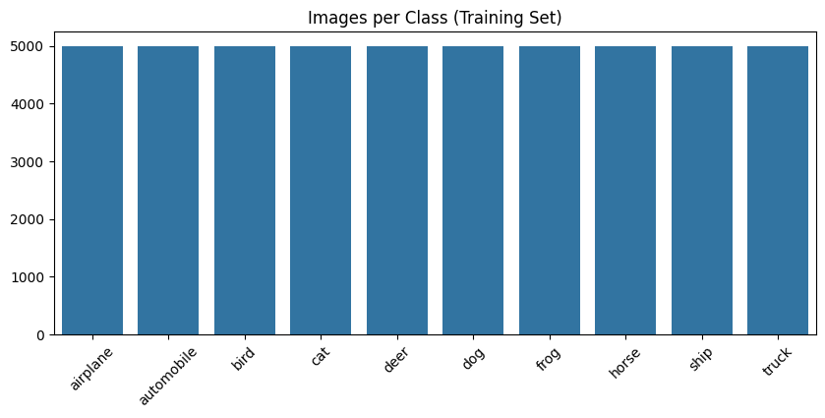
Figure 2: Number of training images per class
Every class has exactly 5,000 training images, so the dataset is perfectly balanced and accuracy is a fair overall metric.

3. Methodology

3.1 Preprocessing: Normalization
Pixel values range from 0 to 255. They were divided by 255 to scale them to the range 0–1, which helps the network train faster and more stably.
x_train = x_train.astype('float32') / 255.0
x_test = x_test.astype('float32') / 255.0

3.2 Data Augmentation
Data augmentation creates slightly changed versions of the training images during training. The model sees a different variation each time, so it learns general features instead of memorising the exact images. This reduces overfitting. The augmentation was built into the model as Keras layers, so it is applied only during training.
Augmentation layer | Setting | Effect
RandomFlip | horizontal | Mirrors the image left-to-right
RandomRotation | 0.1 | Rotates the image slightly (up to about ±36°)
RandomZoom | 0.1 | Zooms in or out by up to 10%
RandomTranslation | 0.1, 0.1 | Shifts the image up/down and left/right by up to 10%
Table 2: Data augmentation techniques
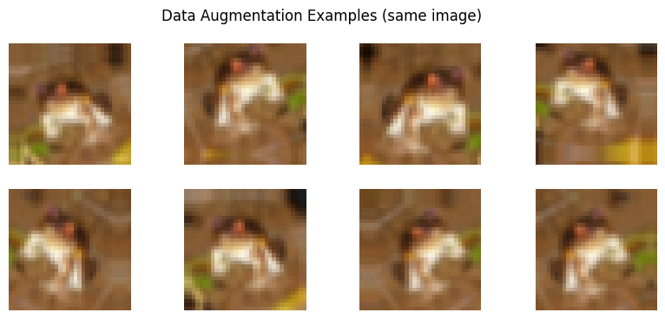
Figure 3: Eight augmented versions of the same training image

3.3 CNN Architecture
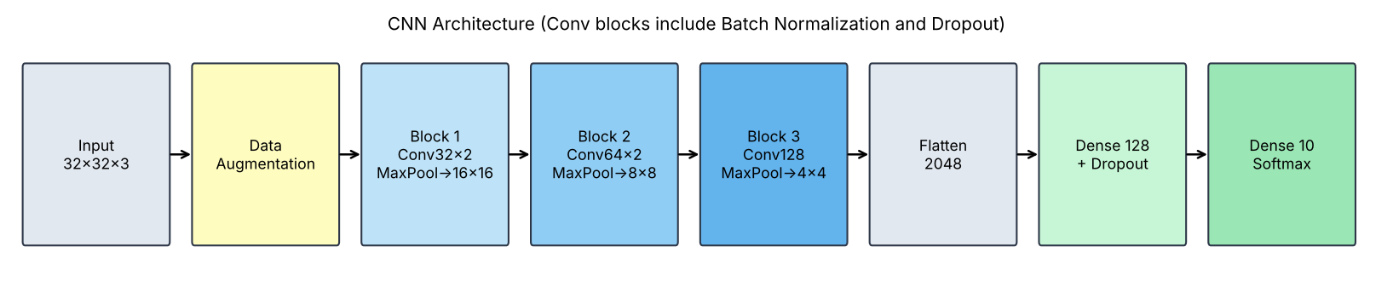
Figure 4: Custom CNN architecture
Layer | Output shape | Parameters
Data augmentation | 32 × 32 × 3 | 0
Conv2D (32, 3×3, ReLU) + BatchNorm | 32 × 32 × 32 | 896 + 128
Conv2D (32, 3×3, ReLU) | 32 × 32 × 32 | 9,248
MaxPooling2D (2×2) + Dropout 0.25 | 16 × 16 × 32 | 0
Conv2D (64, 3×3, ReLU) + BatchNorm | 16 × 16 × 64 | 18,496 + 256
Conv2D (64, 3×3, ReLU) | 16 × 16 × 64 | 36,928
MaxPooling2D (2×2) + Dropout 0.25 | 8 × 8 × 64 | 0
Conv2D (128, 3×3, ReLU) + BatchNorm | 8 × 8 × 128 | 73,856 + 512
MaxPooling2D (2×2) + Dropout 0.30 | 4 × 4 × 128 | 0
Flatten | 2,048 | 0
Dense (128, ReLU) + Dropout 0.5 | 128 | 262,272
Dense (10, Softmax) | 10 | 1,290
Total |  | 403,882
Table 3: Model summary
Role of each layer type:
- Conv2D (convolutional): slides small 3×3 filters over the image to detect patterns: edges first, then shapes, then object parts.
- MaxPooling2D: halves the image size (32 → 16 → 8 → 4) and keeps the strongest features, reducing computation.
- Batch Normalization: keeps layer outputs on a stable scale, making training faster and more stable.
- Dropout: randomly switches off some neurons during training so the model does not depend too heavily on any one of them (reduces overfitting).
- Flatten + Dense (fully connected): combine all learned features to make the final decision.
- Softmax output: gives a probability for each of the 10 classes; the highest is the prediction.

3.4 Training Setup
Setting | Value | Reason
Optimizer | Adam | Adaptive learning rate; reliable default for CNNs
Loss function | Sparse categorical cross-entropy | Multi-class problem with integer labels (0–9)
Batch size | 64 | Balance between speed and stability
Epochs | Up to 30 | With early stopping
Validation split | 10% of training data | Monitors overfitting during training
Early stopping | patience = 5, restore best weights | Stops when validation accuracy stops improving
Table 4: Training configuration

4. Results

4.1 Training and Validation Curves
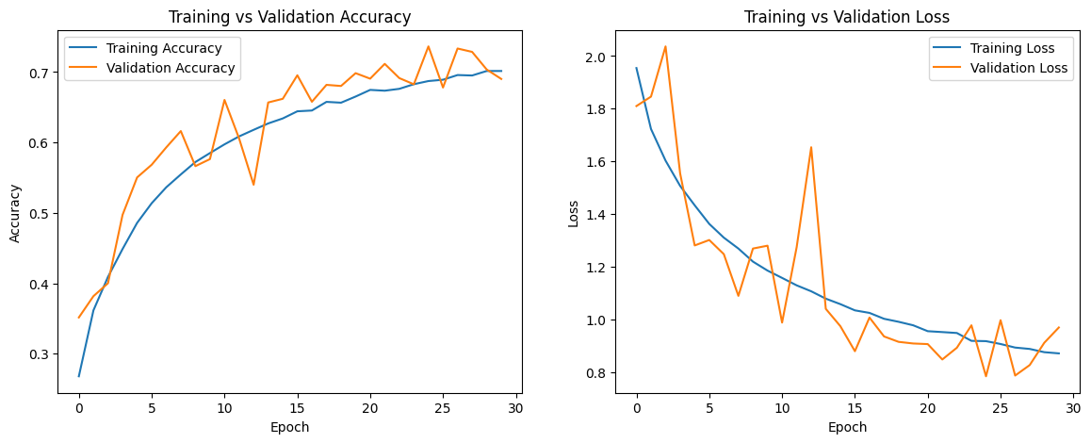
Figure 5: Training vs validation accuracy (left) and loss (right)
The model was trained on a GPU (about 11–20 seconds per epoch) for all 30 epochs. Early stopping did not stop training early, because validation accuracy kept improving until late in training. The best validation accuracy, 73.64% at epoch 25, was restored as the final model.
Epoch | Training accuracy | Training loss | Validation accuracy | Validation loss
1 | 26.81% | 1.9544 | 35.16% | 1.8101
5 | 48.59% | 1.4332 | 55.04% | 1.2807
10 | 58.50% | 1.1853 | 57.64% | 1.2798
15 | 63.41% | 1.0579 | 66.20% | 0.9743
20 | 66.52% | 0.9775 | 69.84% | 0.9084
25 (best) | 68.72% | 0.9173 | 73.64% | 0.7839
30 | 70.15% | 0.8709 | 69.02% | 0.9692
Table 5: Training progress at selected epochs
Observations from the curves:
- Training and validation accuracy rose together throughout training, and there is no large gap between them, so the model did not overfit.
- Validation accuracy was often higher than training accuracy. This is expected: data augmentation and Dropout are active only during training, which makes training harder, while validation images are clean.
- Validation curves are noisy (e.g. dips at epochs 3, 13 and 26), which is normal with augmentation and a small validation set (5,000 images).
- Accuracy was still rising slowly at epoch 30, so training longer could improve results further.

4.2 Test Set Performance
Metric | Value
Test accuracy | 71.64%
Test loss | 0.8242
Epochs trained | 30 (best weights from epoch 25 restored)
Total parameters | 403,882
Table 6: Final results on 10,000 unseen test images
Class | Precision | Recall | F1-score
airplane | 0.82 | 0.63 | 0.71
automobile | 0.76 | 0.93 | 0.84
bird | 0.74 | 0.52 | 0.61
cat | 0.65 | 0.45 | 0.53
deer | 0.73 | 0.57 | 0.64
dog | 0.65 | 0.72 | 0.68
frog | 0.59 | 0.86 | 0.70
horse | 0.78 | 0.81 | 0.79
ship | 0.86 | 0.78 | 0.82
truck | 0.68 | 0.89 | 0.77
Macro average | 0.73 | 0.72 | 0.71
Table 7: Classification report per class (test set, 1,000 images per class)
The best-recognised classes were automobile (F1 0.84), ship (0.82) and horse (0.79). The hardest were cat (F1 0.53, recall only 0.45), bird (0.61) and deer (0.64).

4.3 Confusion Matrix
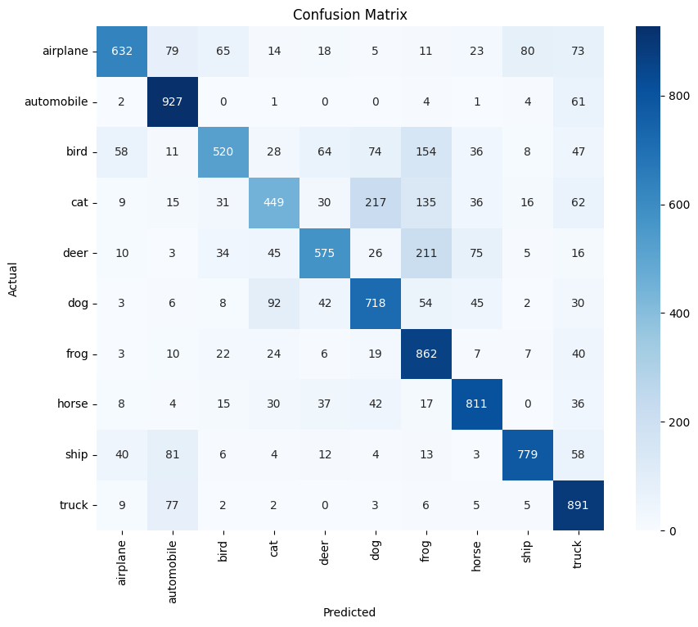
Figure 6: Confusion matrix on the test set
The diagonal shows correct predictions. The largest mistakes are between visually similar classes:
- Cat → dog: 217 images, the biggest single confusion (both are four-legged furry animals).
- Deer → frog: 211, bird → frog: 154 and cat → frog: 135. The model over-predicts frog for animals on natural, green or brown backgrounds, which also explains frog's low precision (0.59).
- Truck ↔ automobile: 77 trucks were predicted as automobiles and 61 automobiles as trucks.
- Airplane ↔ ship: 80 airplanes were predicted as ships, probably because of the shared blue sky and sea backgrounds.

4.4 Sample Predictions
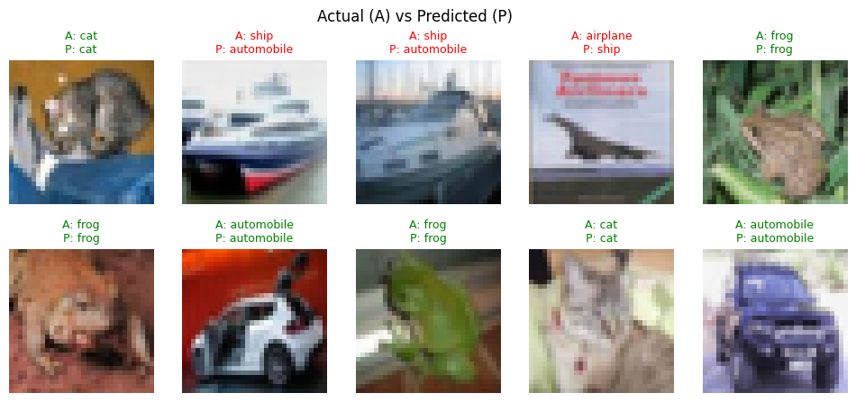
Figure 7: Sample test predictions (green = correct, red = wrong)
7 of these 10 test images were classified correctly. The mistakes were two ships predicted as automobiles and an airplane predicted as a ship, which matches the confusions seen in the matrix.

5. Discussion
- Overfitting control worked: data augmentation, Dropout and Batch Normalization kept training and validation accuracy close; validation accuracy was even slightly higher for most epochs.
- Early stopping restored the best weights (epoch 25), so the final model is not the noisier epoch-30 version.
- Accuracy of 71.64% is a solid result for a small custom CNN (about 400,000 parameters) trained from scratch for 30 epochs; random guessing would give only 10%.
- Hard classes: animals with similar shapes and colours (cat, dog, deer, bird) were the hardest, while vehicles with clear shapes (automobile, truck, ship) were the easiest.
- Limitations: CIFAR-10 images are very small (32×32), which makes some classes hard to tell apart even for humans. A deeper network would need more training time.

6. Conclusion
A custom multi-layer CNN was designed and trained with TensorFlow/Keras to classify CIFAR-10 images into 10 classes. The model combines convolutional, max-pooling and fully connected layers, and uses data augmentation, Dropout and Batch Normalization to reduce overfitting. Training and validation accuracy curves were plotted to monitor learning, and the model was evaluated on 10,000 unseen test images.
The final model achieved a test accuracy of 71.64% (macro F1-score 0.71) on 10,000 unseen images, with no signs of overfitting.

Future Improvements
- Use transfer learning with pre-trained models (e.g. ResNet, MobileNet) for higher accuracy.
- Train for more epochs (accuracy was still rising at epoch 30) with a learning rate scheduler.
- Try stronger augmentation such as random contrast or cutout.

