MACHINE LEARNING INTERNSHIP
Task 4
High-Imbalance Clinical Disease Predictor Pipeline
Detecting malignant breast tumours with SMOTE, class weighting, tuned SVM, Random Forest and XGBoost, and recall-focused cross-validation
Prepared by: Muhammad Bilal Mirza
Organisation: Progree
GitHub: github.com/Mirza1358
Date: October 2026

Table of Contents

1. Introduction 3
1.1 Objectives 3
1.2 Why Recall? 3
1.3 Tools Used 3
2. Dataset Description 3
3. Methodology 4
3.1 Pipeline Overview 4
3.2 Stratified Train/Test Split 5
3.3 Handling Imbalance – Approach 1: SMOTE 5
3.4 Handling Imbalance – Approach 2: Class Weighting 5
3.5 Models and Hyperparameter Tuning 5
4. Results 5
4.1 Baseline (No Imbalance Handling) 6
4.2 Cross-Validation Recall (SMOTE + Tuned Models) 6
4.3 Test Set Performance 6
4.4 Class Weighting Results 7
4.5 Decision Threshold Tuning 7
5. Discussion 8
6. Conclusion 8
Future Improvements 8

1. Introduction
In medical diagnosis, datasets are often imbalanced: there are far fewer patients with a disease than without it. A model trained on such data can look accurate simply by predicting "healthy" most of the time, while missing the very patients who need help. This project builds an end-to-end classification system that detects malignant (cancerous) breast tumours, handles class imbalance, and is optimised for recall (sensitivity): the ability to catch as many true disease cases as possible.

1.1 Objectives
- Load a diagnostic dataset from the UCI repository and analyse its class imbalance.
- Handle imbalance using SMOTE (Synthetic Minority Oversampling Technique) and adjusted class weighting.
- Train and tune hyperparameters for SVM, Random Forest and XGBoost.
- Evaluate and maximise recall, backed by 5-fold stratified cross-validation.

1.2 Why Recall?
In cancer screening, the two possible errors have very different costs:
Error type | Meaning | Impact
False Negative (FN) | Patient has cancer, model says benign | Very dangerous: diagnosis and treatment are delayed
False Positive (FP) | Patient is healthy, model says malignant | Less serious: leads to extra tests, which then clear the patient
Table 1: Cost of errors in medical diagnosis
Recall = TP / (TP + FN) measures how many real cancer cases the model catches. Maximising recall minimises dangerous false negatives, so it was chosen as the main metric. Precision, F1-score and ROC-AUC were also tracked so that recall was not improved at an unreasonable cost.

1.3 Tools Used
Python, Jupyter Notebook, Pandas, NumPy, Scikit-learn (SVC, RandomForestClassifier, GridSearchCV, StratifiedKFold, metrics), imbalanced-learn (SMOTE and imblearn Pipeline), XGBoost, Matplotlib and Seaborn.

2. Dataset Description
The Breast Cancer Wisconsin (Diagnostic) dataset from the UCI Machine Learning Repository was used. It is available directly through Scikit-learn (load_breast_cancer). Each record describes the cell nuclei in a digitised image of a breast mass.
Property | Value
Records (patients) | 569
Features | 30 numeric features (radius, texture, perimeter, area, smoothness, concavity, symmetry, etc.: mean, standard error and worst values)
Target | Malignant (1) or Benign (0)
Missing values | None
Class distribution | 357 benign (62.7%) and 212 malignant (37.3%)
Table 2: Dataset summary
In Scikit-learn the original labels are 0 = malignant and 1 = benign. They were reversed so that 1 = malignant (disease), following medical convention, and so that recall is calculated for the disease class.
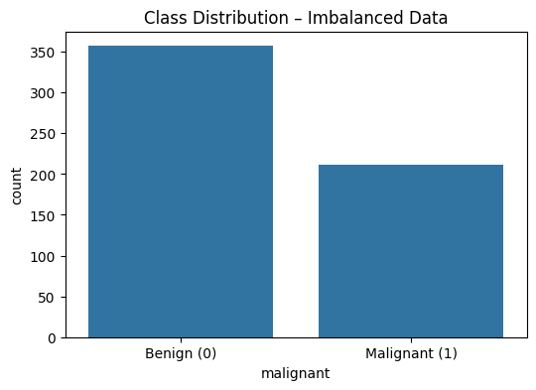
Figure 1: Class distribution: malignant cases are the minority class
The malignant class makes up only 37.3% of the data (imbalance ratio about 1.7 : 1). Without special handling, a model is biased towards the majority (benign) class.
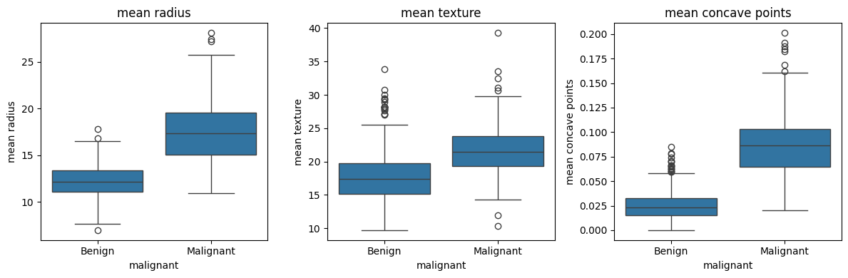
Figure 2: Key features for benign vs malignant tumours
Malignant tumours have clearly larger mean radius, higher mean texture and many more mean concave points than benign tumours. These strong differences show that the features carry useful diagnostic information.

3. Methodology

3.1 Pipeline Overview
- Load the data and set 1 = malignant.
- Run exploratory analysis and check class balance.
- Create a stratified train/test split.
- Build a baseline model without imbalance handling.
- Build imblearn pipelines: scaling → SMOTE → classifier.
- Tune each model with GridSearchCV (5-fold stratified CV, scoring = recall).
- Compare against the class-weighting approach.
- Evaluate on the unseen test set: recall, precision, F1, ROC-AUC and confusion matrix.
- Tune the decision threshold to increase recall further.

3.2 Stratified Train/Test Split
The data was split into 80% training (455 patients) and 20% testing (114 patients, of which 42 are malignant). stratify=y keeps the same 37% malignant ratio in both sets, which is essential for imbalanced data.

3.3 Handling Imbalance – Approach 1: SMOTE
SMOTE creates new synthetic minority (malignant) samples. It picks a malignant patient and one of its nearest malignant neighbours, and creates a new point between them. This balances the classes without simply copying records.
Training data | Benign (0) | Malignant (1)
Before SMOTE | 285 | 170
After SMOTE | 285 | 285
Table 3: Effect of SMOTE on the training set
Avoiding data leakage: SMOTE was placed inside an imblearn Pipeline. During cross-validation, synthetic samples are therefore created only from the training folds and never from the validation fold. Applying SMOTE before splitting would leak information and give over-optimistic results.
pipe = ImbPipeline([
('scaler', StandardScaler()),
('smote', SMOTE(random_state=42)),
('clf', model)
])

3.4 Handling Imbalance – Approach 2: Class Weighting
Instead of creating new samples, class weighting tells the model that misclassifying a malignant case is more costly. SVM and Random Forest used class_weight="balanced", and XGBoost used scale_pos_weight = (number of benign) / (number of malignant).

3.5 Models and Hyperparameter Tuning
Three different model families were tuned with GridSearchCV, using StratifiedKFold (5 folds, shuffled) and scoring = "recall", so that the best settings were chosen for catching malignant cases.
Model | How it works | Hyperparameters searched
Support Vector Machine (SVM) | Finds the boundary with the largest margin between classes; the RBF kernel allows curved boundaries | C: 0.1, 1, 10; kernel: linear, rbf; gamma: scale, 0.01
Random Forest | Many decision trees vote on the result (bagging) | n_estimators: 100, 300; max_depth: None, 5, 10; min_samples_leaf: 1, 3
XGBoost | Trees built one after another, each correcting the previous errors (boosting) | n_estimators: 100, 300; max_depth: 3, 5; learning_rate: 0.05, 0.1
Table 4: Models and hyperparameter grids
StandardScaler was included in every pipeline. Scaling is essential for SVM, which is distance-based, and harmless for tree-based models.

4. Results

4.1 Baseline (No Imbalance Handling)
A Random Forest without SMOTE or class weights achieved 5-fold CV recall scores of [0.912, 1, 0.882, 0.971, 0.941], with a mean of 0.941. This baseline is used for comparison.

4.2 Cross-Validation Recall (SMOTE + Tuned Models)
Model | Best hyperparameters | 5-fold CV recall scores | Mean
SVM | C=1, gamma=scale, kernel=rbf | 0.912, 1, 0.971, 0.971, 0.971 | 0.965
Random Forest | max_depth=null, min_samples_leaf=3, n_estimators=100 | 0.941, 1, 0.912, 0.941, 0.971 | 0.953
XGBoost | learning_rate=0.1, max_depth=5, n_estimators=300 | 0.941, 0.971, 0.971, 0.971, 0.971 | 0.965
Table 5: Cross-validation recall arrays on the training set
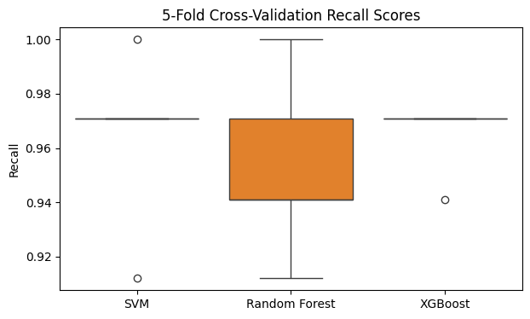
Figure 3: Distribution of 5-fold cross-validation recall scores
All three tuned SMOTE models improved on the baseline mean recall (0.941). SVM and XGBoost tied for the highest mean CV recall (0.965), with XGBoost showing the most consistent fold scores.

4.3 Test Set Performance
Model | Recall | Precision | F1-score | ROC-AUC | Missed cancers (FN)
SVM ★ | 0.952 | 0.976 | 0.964 | 0.996 | 2 of 42
Random Forest | 0.929 | 1.000 | 0.963 | 0.998 | 3 of 42
XGBoost | 0.929 | 1.000 | 0.963 | 0.993 | 3 of 42
Table 6: Performance on the unseen test set (114 patients, 42 malignant)
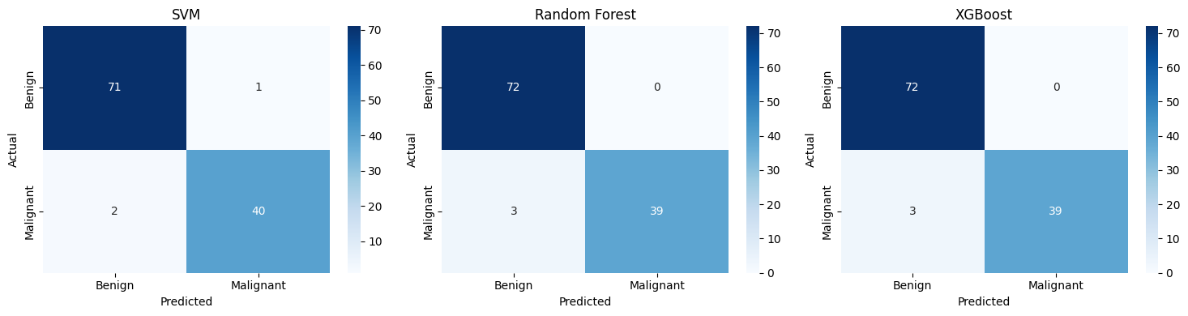
Figure 4: Confusion matrices of the tuned models on the test set
SVM achieved the highest test recall: it correctly identified 40 of 42 malignant tumours and missed only 2, with just 1 false alarm. Random Forest and XGBoost made no false alarms (precision 1.0), but both missed 3 cancers, which is the more dangerous type of error.
Classification report of the best model (SVM): benign precision 0.97 and recall 0.99; malignant precision 0.98 and recall 0.95; overall accuracy 97% on 114 test patients.
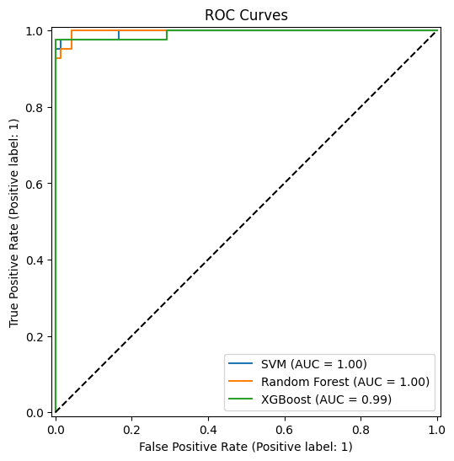
Figure 5: ROC curves of the tuned models
All models achieved ROC-AUC values above 0.99, which shows excellent ability to separate malignant from benign tumours across all thresholds.

4.4 Class Weighting Results
Model (class weighting, no SMOTE) | Mean 5-fold CV recall
SVM (class_weight=balanced) | 0.953
RF (class_weight=balanced) | 0.947
XGBoost (scale_pos_weight) | 0.959
Table 7: Class weighting approach
Class weighting gave recall similar to SMOTE. Both are valid ways to handle imbalance; SMOTE with SVM gave the best overall test result in this project.

4.5 Decision Threshold Tuning
By default a patient is labelled malignant when the predicted probability is at least 0.5. Lowering this threshold makes the model more sensitive. The table below uses the predicted probabilities of the best model (SVM).
Threshold | Recall | Precision
0.5 | 0.976 | 0.976
0.4 | 0.976 | 0.953
0.3 | 0.976 | 0.953
0.2 | 0.976 | 0.932
Table 8: Effect of the decision threshold (SVM)
Using predicted probabilities, recall reached 0.976 (41 of 42 cancers caught). Lowering the threshold further kept recall at this level but reduced precision, so a threshold around 0.4–0.5 offers a good balance. (The SVM's predict() method uses its decision function, which gave a recall of 0.952; probability-based thresholds allow finer control, which is useful in clinical settings.)

5. Discussion
- Imbalance handling matters: SMOTE and class weighting both improved recall over the baseline, so the models paid more attention to malignant cases.
- Recall vs precision trade-off: SVM accepted one false alarm to catch more cancers. In screening, this is the right trade-off, because a false alarm leads only to further tests, while a missed cancer can be life-threatening.
- Cross-validation: using 5-fold stratified CV, rather than a single split, gave a more reliable estimate of recall. The small spread of fold scores shows the models are stable.
- Leakage prevention: placing scaling and SMOTE inside the pipeline ensured that cross-validation results are honest.
- Limitations: the dataset is small (569 patients) and only moderately imbalanced (37% minority). Real clinical data can be far more skewed, so the approach should be tested on larger, more imbalanced datasets. A model like this should support doctors, not replace them.

6. Conclusion
An end-to-end, recall-focused classification pipeline was built to detect malignant breast tumours from the UCI Breast Cancer Wisconsin dataset. Class imbalance was handled with SMOTE (inside a leakage-free imblearn pipeline) and with class weighting. SVM, Random Forest and XGBoost were tuned with GridSearchCV using 5-fold stratified cross-validation optimised for recall. The best model, SVM, achieved a test recall of 0.952, precision of 0.976 and ROC-AUC of 0.996, missing only 2 of 42 cancer cases. Threshold tuning raised recall to 0.976.

Future Improvements
- Test on a more highly imbalanced clinical dataset (e.g. diabetes or rare-disease records).
- Try other resampling methods such as ADASYN, SMOTE-Tomek or SMOTE-ENN.
- Use RandomizedSearchCV or Bayesian optimisation for a wider hyperparameter search.
- Add explainability with SHAP so doctors can see why a tumour was flagged as malignant.

